A

Project report

On

**ONLINE COFFEE SHOP**

IN PARTIAL FULFILLMENT OF THE

REQUIREMENT OF

BACHELOR OF COMPUTER APPLICATION

BY

**SARTHAK SANJAY SHAHA (3052)**

AND

**YASH SUNIL DHUMAL (3016)**

**THE PRINCIPAL**

**HIRACHAND NEMCHAND COLLEGE OF COMMERCE,**

**SOLAPUR**

2024-25

REPORT SUBMITTED

TO

SOLAPUR UNIVERSITY, SOLAPUR

IN PARTIAL FULFILLMENT OF THE

REQUIREMENT OF

BACHELOR OF COMPUTER APPLICATION

TITLE

**Online coffee website**

BY

**SARTHAK SANJAY SHAHA (3051)**

AND

**YASH SUNIL DHUMAL (3016)**

THE PRINCIPAL

HIRACHAND NEMCHAND COLLEGE OF COMMERCE,

SOLAPUR

2024-25

EXTERNAL EXAMINER PRINCIPAL

***CERTIFICATE***

*This is to certify that work on the Project Report entitled “ Online Coffee Shop” in partial fulfillment of the requirement for the award of BACHELOR OF COMPUTER APPLICATION (B.C.A.) to the Solapur University, Solapur has been carried out under my guidance.*

*To the best of my knowledge and belief the matter presented in this report has not been submitted earlier.*

*Date:*

*Signature of the Guide*

*Name:*

DECLARATION

To,

The Principal

H. N. College Of Commerce

Solapur.

Dear Sir,

I the undersigned hereby declare that Project entitled “The Coffee Shop” written and submitted under the guidance of “Mr. Hemant konade ” is my original work.

The empirical findings in this report are based on the data collected by myself. While preparing this report, I have not copied from any other report.

We understand that any such copying is liable to be punished in a way the university authorities may deem fit.

*Date* :

*Signature Of the student*

Sarthak Sanjay Shaha (3051)

Yash Sunil Dhumal (3016)

**Acknowledgement**

Before embarking into a detailed explanation of our project on “Online coffee shop” at Our College. We would like to say a few words about the people who helped us to make this project what it is today.

We are extremely grateful for the necessary information, support and guidance provided by our principal Dr.S.K.Shah, H.O.D. Dr .Pravin Bajaj and also our lab assistant Tamboli Sir & Dhumal Sir with whom we had several conversations about present system we also want to thank our project guide Ms. Hemant konade sir who gave us a proper guidance for making our project. We are grateful to all of them for their constant encouragement and guidance throughout this project.

***INDEX***

|  |  |  |
| --- | --- | --- |
| Chapter no. | Particulars | Page Number |
| **1** | **Introduction** | 8 |
| 1.1 | Introduction to organization | 8 |
| 1.2 | Introduction to existing system | 9 |
| 1.3 | Objective of proposed system | 10 |
| 1.4 | Scope of proposed system | 11 |
| 1.5 | Limitations of proposed system | 12 |
| **2** | **Data Requirement Analysis** | **13** |
| 2.1 | Fact finding technique | 13 |
| 2.2 | Feasibility study | 15 |
| 2.2.1 | Technical feasibility | 15 |
| 2.2.2 | Economical feasibility | 15 |
| 2.2.3 | Operational feasibility | 15 |
| 2.3 | Website & hardware requirement | 16 |
| 2.4 | Context level | 17 |
| 2.5 | Data Flow Diagram | 18 |
| 2.6 | Entity Relationship Diagram | 19 |
| 2.8 | Table Design | 20 |
| **3** | **System Design** | 21 |
| 3.1 | Site map | 21 |
| 3.2 | Screen Layouts | 22 |
| 3.3 | Coding | 26 |
| **4** | **System testing** | 36 |
| 4.1 | Program Specification & validation | 36 |
| 4.2 | Types of testing | 37 |
| **5** | **Implementation** | 38 |
| 5.1 | User manual | 38 |
| **6** | **Conclusion and suggestion** | 39 |
| 6.1 | Conclusion | 39 |
| 6.2 | Enhancement suggestion | 40 |
| **7** | **Bibliography** | 41 |
| 7.1 | References | 41 |

**1.INTRODUCTION**

1.1 Introduction to Organization:

Welcome to Online Coffee Shop Website where passion for exceptional coffee meets convenience. Established in 2024 we are dedicated to bringing you a curated selection of premium coffee beans from around the world. Our team of coffee enthusiasts meticulously roasts and packages each batch to ensure you receive only the finest quality.

We believe in delivering not just coffee, but an experience that celebrates flavor and craftsmanship. Whether you’re a casual drinker or a connoisseur, Online Coffee Shop Website is committed to providing you with an outstanding product and excellent service.

Thank you for choosing us—your gateway to great coffee.

**1.2 Introduction to Existing System**

Our current system is built on a reliable e-commerce platform that supports all aspects of our online coffee business. We use Online Coffee Shop Website for managing our store, including product listings, orders, and customer interactions. Secure payment processing is handled through cash on delivery and UPI, ensuring safe transactions. Our inventory is monitored in real-time . This setup provides a smooth and efficient shopping experience, though we are always looking for ways to enhance and refine our processes.

1.3 Objective of Proposed System:

* Provide customers with a user-friendly platform to purchase coffee products online.
* Enable efficient order processing and management.
* Offer personalized recommendations to enhance customer experience.
* Support business growth through increased online visibility and sales.
* Facilitate better inventory management for coffee products.
* Promote customer engagement and loyalty programs.
* Highlight sustainability and ethical sourcing practices.
* Ensure the system is scalable for future growth.

**1.4 Scope of proposed system**

• Place an Order

* Cancel an Order
* View menu and item details
* Update product items
* Update order details

In placing an order, customers can do so from any location, and their orders are automatically updated across all coffee shop branches. This integration ensures that all staff members at different locations have accurate and up-to-date information, reducing any confusion and streamlining the ordering process.

The various advantages of Using the Online Coffee Shop System are as follows:

Convenient-Customers can place, cancel, or modify their orders from the comfort of their home or office, at any time that suits them.

Saves Time and Effort- Avoids the need to travel to the coffee shop and wait in line, saving time and reducing effort for customers.

Eco-Friendly-Supports a paperless approach by allowing customers to receive order confirmations, receipts, and updates via email or mobile notifications. This reduces the need for physical receipts and contributes to a greener planet.

Real-Time Updates- Ensures that all orders are processed promptly and accurately, providing real-time status updates and minimizing errors.

Enhanced Customer Experience- With features like order tracking and menu customization, customers have a seamless and enjoyable experience, leading to increased satisfaction and loyalty.

1.5 Limitations of proposed system:

* Complexity: The website's navigation and ordering process may be overwhelming, especially for new users. Simplifying the interface and providing a clear step-by-step guide could improve the experience.
* Limited Availability: Popular items or promotions might sell out quickly, which can lead to disappointment and frustration among customers. Implementing a real-time inventory system and offering alternatives can help mitigate this issue.
* Order Allocation: The website might have issues with fulfilling special requests or ensuring that orders are prepared according to customer preferences, which could lead to inconsistencies. Implementing a more robust system for handling customizations and special requests can address this.
* Technical Issues: The online ordering system can occasionally experience glitches or downtime, impacting customers' ability to place orders. Regular maintenance and robust technical support can help minimize these disruptions.
* Data Redundancy**:** In a manual system, duplicate customer information and order details can be problematic. In an online system, preventing duplicate entries and maintaining a single, updated database for customer information and orders can streamline operations and reduce errors.
* Unsatisfactory Security Measures: In a manual system, security might be lacking. An online coffee shop website should implement strong password protection, encryption for payment information, and secure login methods to protect customer data and transactions.

**2.DATA REQUIREMENT ANALYSIS**

2.1 Fact Finding technique:

Fact finding technique is the system of methods used as an activity or study and actually this is decided by the organization. The techniques that we have used are,

Interviews:

1. Open-ended Questions:
   * Can you describe the current ordering process on the website?
   * What are the main challenges or pain points with the current online ordering system?
   * How do you think the online coffee shop experience can be improved?
2. Structured Questions:
   * How many orders do you process daily through the website?
   * What is the average time taken from order placement to delivery?
   * How do you handle issues such as order cancellations and customer complaints?

Questionnaire:

1. Multiple-choice Questions:
   * How often do you order from the online coffee shop website? (Options: Daily, Weekly, Monthly, Rarely)
   * What is your preferred ordering method? (Options: Website, Mobile App, Phone, In-store)
   * How satisfied are you with the current online ordering system? (Scale: 1-5)
2. Open-ended Questions:
   * What features or improvements would you like to see on the online coffee shop website?
   * Have you encountered any issues with the current online ordering system? If yes, please describe them.

Observation:

1. Observe the Online Ordering Process:
   * Website Interface: Navigation, user experience, and ease of use.
   * Mobile App: Performance, features, and user interaction.
   * Customer Support Channels**:** Response times and effectiveness.
2. Note:
   * Customer Behavior and Interactions: How users interact with the website or app, common issues faced, and their feedback.
   * Staff Workflows and Challenges**:** How the backend system supports order processing, staff interactions, and any challenges faced.
   * System Errors or Glitches**:** Any recurring technical issues, performance bottlenecks, or areas causing user frustration.
3. Observe Peak and Off-Peak Hours to Understand**:**
   * Variations in Customer Volume**:** Differences in order frequency, peak times, and traffic patterns.
   * Staff Workload and Stress Levels**:** How staff manage varying order volumes and their impact on service quality and efficiency.

2.2 Feasibility study:

A Feasibility Study for the online coffee website evaluates key aspects to ensure the project's success. Technical feasibility assesses whether the necessary technology and expertise are available to build and maintain the site. Economic feasibility looks at the costs versus projected revenue to ensure financial viability. Operational feasibility ensures the system integrates smoothly with existing business processes like order and inventory management. Legal feasibility checks compliance with laws and regulations. Market feasibility analyzes demand and competition. Schedule feasibility assesses whether the project can be completed on time, and resource feasibility ensures the availability of necessary personnel and partnerships.

**2.2.1 Technical feasibility**

This included the study of function, performance and constraints that may affect the ability to achieve an acceptable system. For this feasibility study, we studied complete functionality to be provided in the system, as described in the System Requirement Specification (SRS), and checked if everything was possible using different type of frontend and backend platforms.

**2.2.2 Economical feasibility**

**Economic Feasibility** evaluates whether the financial investment required for your online coffee website is justified by the expected returns. It involves estimating initial costs such as development, design, and marketing, and ongoing expenses like maintenance and operational costs. This analysis compares these costs to projected revenue and profitability, ensuring that the investment will generate a positive return and make financial sense for your business

**2.2.3 Operational feasibility**

No doubt the proposed system is fully GUI based that is very user friendly and all inputs to be taken all self-explanatory even to a layman. Besides, a proper training has been conducted to let know the essence of the system to the users so that they feel comfortable with new system. As far our study is concerned the clients are comfortable and happy as the system has cut down their loads and doing.

**2.3 Website and Hardware requirement**

The following website and hardware are required for my application:

**Minimum Hardware:**

* Any Web-Enabled Device.

**Minimum Website:**

* Web Browser.

**Other Requirement:**

*  Internet connection is a must .

2.4 Context Level

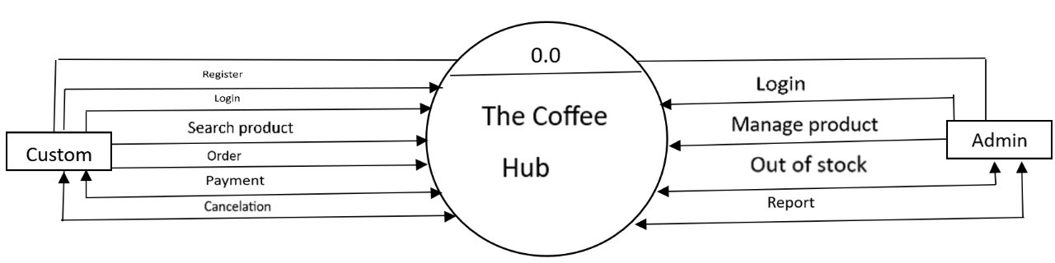

2.5 Data flow diagram.

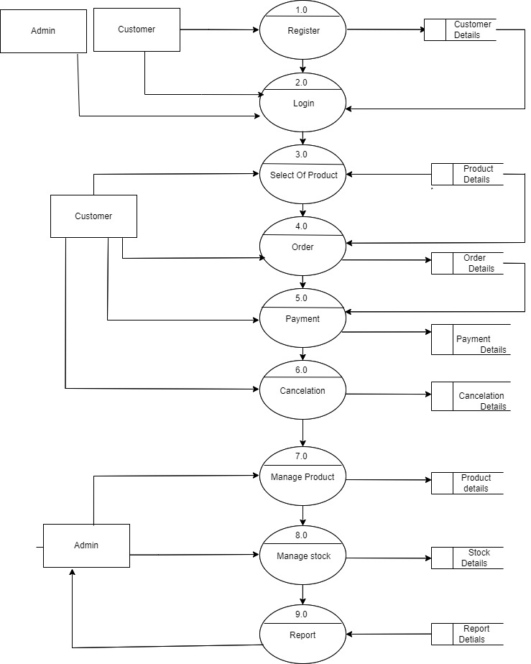

Entity Relationship Diagram

Customer details

Certain

Order details

Searchhhsearch

Payment details

Pay

V

Product details

Cancelation details

Can

2.8 Table Design

|  |  |
| --- | --- |
| 1. User Table |  |

|  |  |  |
| --- | --- | --- |
| Attribute name | Data type | Constraints |
| Customer-Id | Int(20) | PRIMARY KEY |
| User name | Varchar(225) | NOT NULL |
| Email | Text(225) |  |
| Password | Text(225) |  |
| Phone no | Int(10) | UNIQUE |

|  |
| --- |
| 2. Product Table |
|  |

|  |  |  |
| --- | --- | --- |
| Attribute Name | Data type | Constraints |
| Id | Int(10) | PRIMARY KEY |
| Name | Varchar(225) |  |
| Price | Int(10) |  |
| Discount | Int(10) |  |
| Price | Int(10) |  |

|  |
| --- |
| 3.Order Table |

|  |  |  |
| --- | --- | --- |
| Attribute Name | Data type | Constraints |
| Id | Int (10) | Primary key |
| Product_id | Int(20) |  |
| Price | Int(10) |  |
| Quantity | Itn(20) |  |

|  |
| --- |
| 4. Payment Table |

|  |  |  |
| --- | --- | --- |
| Attributes | Data type | Constraints |
| Payment_id | Int(250) | Primary key |
| Order_id | Int(250) |  |
| Transaction_id | Int(250) |  |
| price | Int(250) |  |

|  |
| --- |
| 5. Cancelation Table |

|  |  |  |
| --- | --- | --- |
| Attributes | Data type | Constraints |
| Cancelation_id | Int(250) | Primary key |
| Order_id | Int(250) |  |
| price | Int(250) |  |

**3 SYSTEM DESINE**

3.1 Site map

Log in/Register

Home

Log out

View Products

Add/Delete

Products

View Products

Add/Delete

records

View Customer

Admin

Dashbord

Concat us

Products

Order

Bill

Payment

Cancle order

3.2 Screen layout



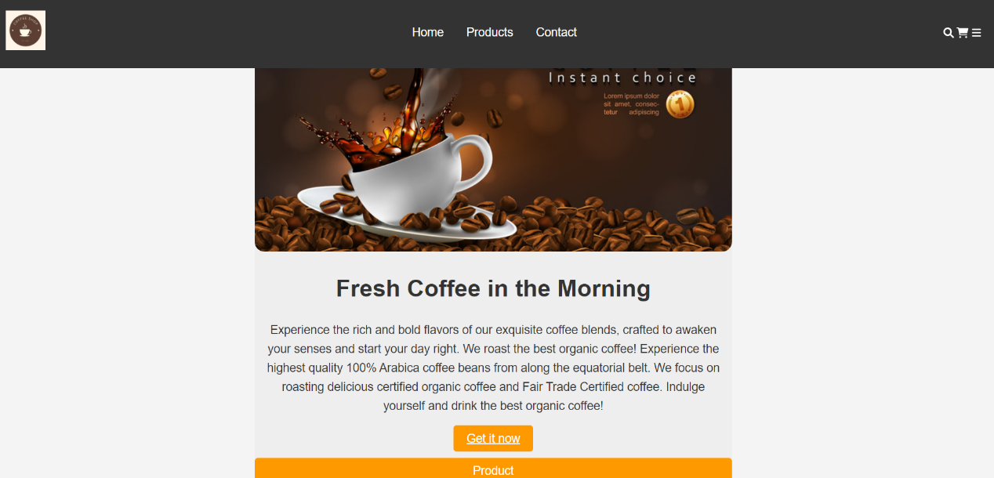

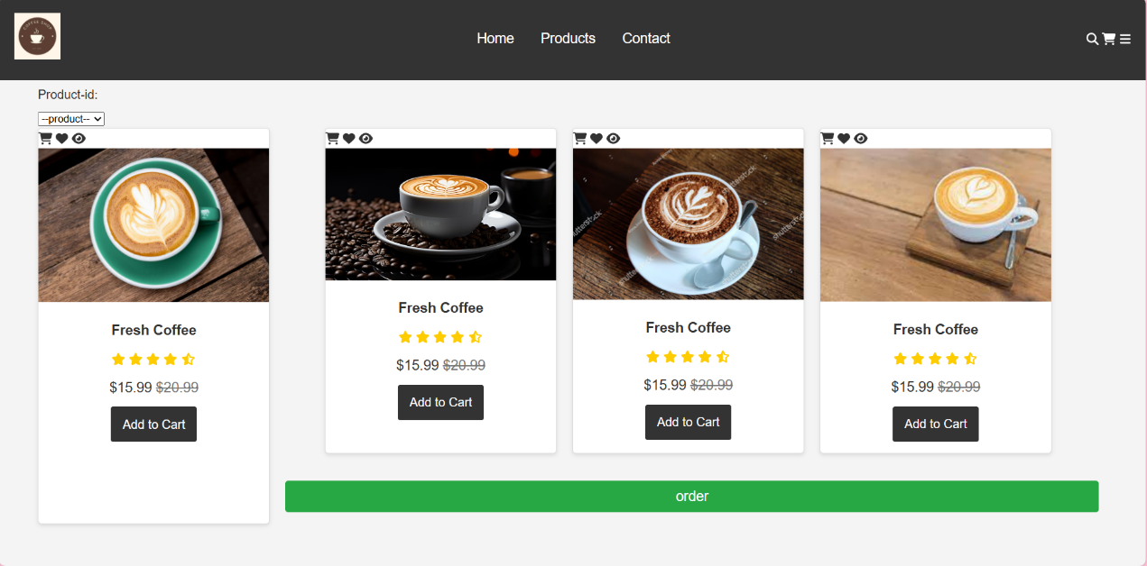

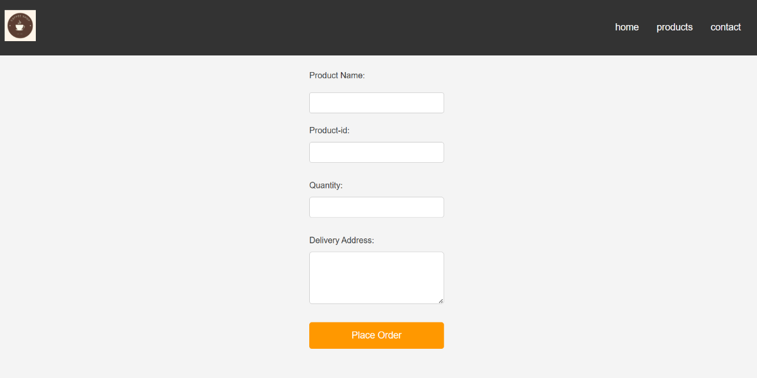

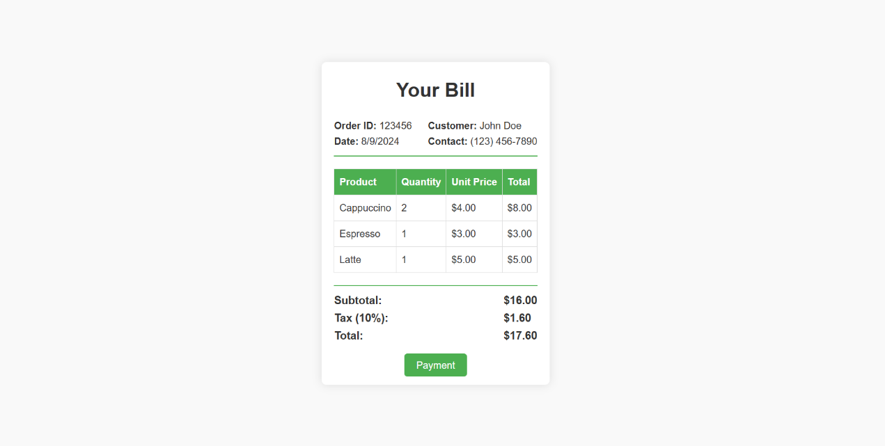

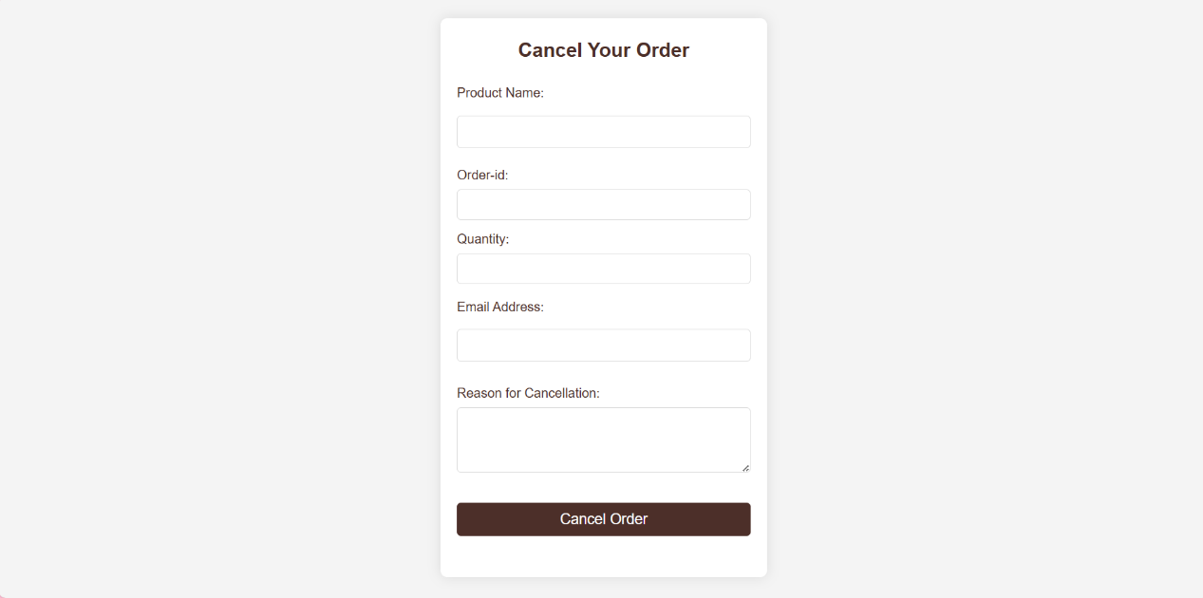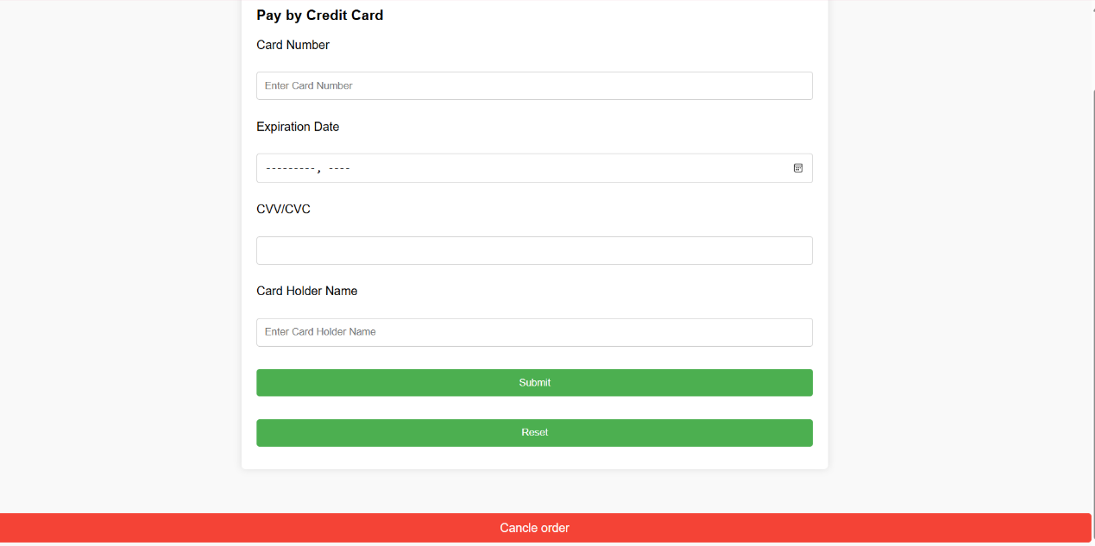

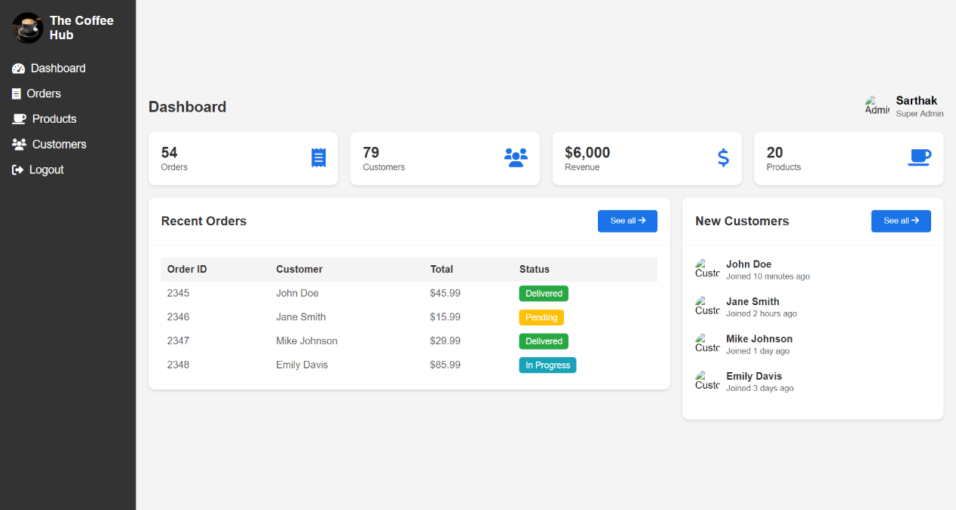

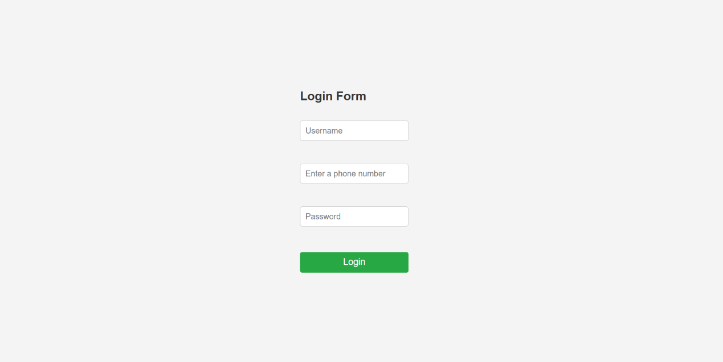

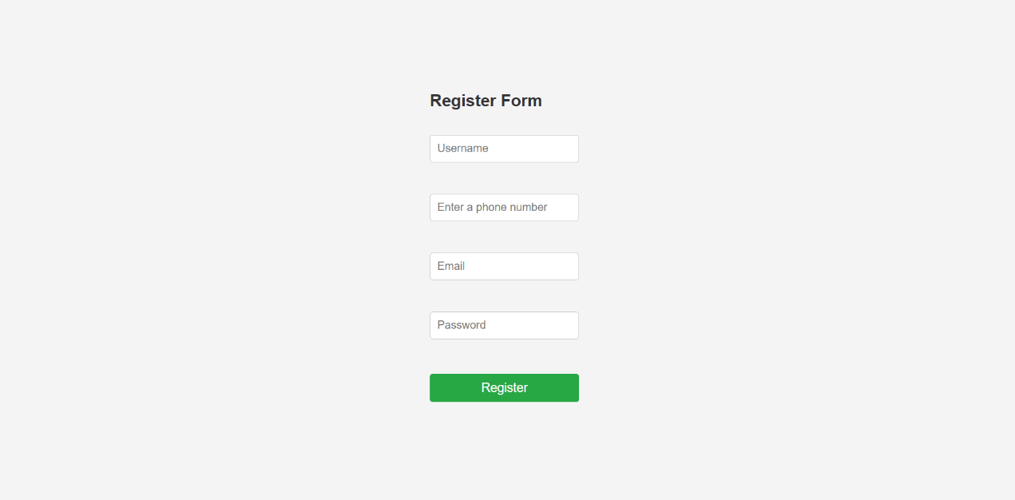

**3.3 Coding**

**ADD PRODUCTS:HTML**

<!DOCTYPE html>

<html lang="en">

<head>

<meta charset="UTF-8">

<meta name="viewport" content="width=device-width, initial-scale=1.0">

<title>Products - Coffee Shop Admin</title>

<link rel="stylesheet" href="admin.css">

</head>

<body>

<div class="sidebar">

<div class="logo">

<img src="logo.jpg" alt="Logo">

<h2>The Coffee Hub</h2>

</div>

<ul>

<li><a href="Dashbord.html"><i class="fas fa-tachometer-alt"></i> Dashboard</a></li>

<li><a href="orders.html"><i class="fas fa-receipt"></i> Orders</a></li>

<li><a href="products.html" class="active"><i class="fas fa-coffee"></i> Products</a></li>

<li><a href="Customers.html"><i class="fas fa-users"></i> Customers</a></li>

<li><a href="logout.html"><i class="fas fa-sign-out-alt"></i> Logout</a></li>

</ul>

</div>

<div class="main-content">

<header>

<h2>Products</h2>

<div class="user-wrapper">

<img src="admin.jpg" alt="Admin" class="admin-profile">

<div>

<h4>Sarthak</h4>

<small>Super Admin</small>

</div>

</div>

</header>

<main>

<div class="products-header">

<h3>All Products</h3>

<button id="addProductBtn">Add Product</button>

</div>

<div class="products-table">

<table>

<thead>

<tr>

<th>Product ID</th>

<th>Name</th>

<th>Category</th>

<th>Price</th>

<th>Stock</th>

<th>Image</th>

<th>Actions</th>

</tr>

</thead>

<tbody>

<tr>

<td>001</td>

<td>Espresso</td>

<td>Beverage</td>

<td>$2.99</td>

<td>120</td>

<td><img src="product.jpg" alt="Espresso" class="product-image"></td>

<td>

<button class="btn edit-btn">Edit</button>

<button class="btn delete-btn">Delete</button>

</td>

</tr>

<tr>

<td>002</td>

<td>Latte</td>

<td>Beverage</td>

<td>$3.99</td>

<td>85</td>

<td><img src="product-1.jpg" alt="Latte" class="product-image"></td>

<td>

<button class="btn edit-btn">Edit</button>

<button class="btn delete-btn">Delete</button>

</td>

</tr>

<tr>

<td>003</td>

<td>Croissant</td>

<td>Pastry</td>

<td>$2.49</td>

<td>50</td>

<td><img src="product-2.jpg" alt="Croissant" class="product-image"></td>

<td>

<button class="btn edit-btn">Edit</button>

<button class="btn delete-btn">Delete</button>

</td>

</tr>

<tr>

<td>004</td>

<td>Mocha</td>

<td>Beverage</td>

<td>$4.49</td>

<td>65</td>

<td><img src="product-3.jpg" alt="Mocha" class="product-image"></td>

<td>

<button class="btn edit-btn">Edit</button>

<button class="btn delete-btn">Delete</button>

</td>

</tr>

</tbody>

</table>

</div>

</main>

</div>

<div id="productModal" class="modal">

<div class="modal-content">

<span class="close-btn">&times;</span>

<h3 id="modalTitle">Add Product</h3>

<form id="productForm">

<label for="productName">Product Name:</label>

<input type="text" id="productName" name="productName" required>

<label for="productCategory">Category:</label>

<input type="text" id="productCategory" name="productCategory" required>

<label for="productPrice">Price:</label>

<input type="number" id="productPrice" name="productPrice" required>

<label for="productStock">Stock Quantity:</label>

<input type="number" id="productStock" name="productStock" required>

<label for="productImage">Image Name:</label>

<input type="text" id="productImage" name="productImage" required>

<button type="submit" id="saveProductBtn">Save</button>

</form>

</div>

</div>

**ADD TO CART:HTML**

<section class="products" id="products">

    <h1 class="heading">Our <span>Products</span></h1>

    <label for="Product-id"> Product-id:</label>

    <select id="Product-id" name="Product-id">

        <option value="">--product--</option>

        <option value="Product-id">1</option>

        <option value="Product-id"> 2</option>

        <option value="Product-id"> 3</option>

        <option value="Product-id"> 4</option>

        <option value="Product-id"> 5</option>

        <!-- Add other products similarly -->

        <option value="Product-15">Product 15</option>

    </select>

    <div class="box-container">

        <div class="box">

            <div class="icons">

                <a href="#" class="fas fa-shopping-cart" aria-label="Add to Cart"></a>

                <a href="#" class="fas fa-heart" aria-label="Add to Wishlist"></a>

                <a href="#" class="fas fa-eye" aria-label="View Details"></a>

    </div>

            <div class="image">

                <img src="product.jpg" alt="Fresh Coffee">

            </div>

            <div class="content">

                <h3>Fresh Coffee</h3>

                <div class="stars">

                    <i class="fas fa-star"></i>

                    <i class="fas fa-star"></i>

                    <i class="fas fa-star"></i>

                    <i class="fas fa-star"></i>

                    <i class="fas fa-star-half-alt"></i>

                </div>

                <div class="price">$15.99 <span>$20.99</span></div>

                <a href="Order-2.html" class="btn">Add to Cart</a>

            </div>

        </div>

  <div class="box-container">

            <div class="box">

                <div class="icons">

                    <a href="#" class="fas fa-shopping-cart" aria-label="Add to Cart"></a>

                    <a href="#" class="fas fa-heart" aria-label="Add to Wishlist"></a>

                    <a href="#" class="fas fa-eye" aria-label="View Details"></a>

                </div>

                <div class="image">

                    <img src="product-1.jpg" alt="Fresh Coffee">

                </div>

                <div class="content">

                    <h3>Fresh Coffee</h3>

                    <div class="stars">

                        <i class="fas fa-star"></i>

                        <i class="fas fa-star"></i>

                        <i class="fas fa-star"></i>

                        <i class="fas fa-star"></i>

                        <i class="fas fa-star-half-alt"></i>

                    </div>

                    <div class="price">$15.99 <span>$20.99</span></div>

                    <a href="Order-2.html" class="btn">Add to Cart</a>

                </div>

</div>

            <div class="box-container">

                <div class="box">

                    <div class="icons">

                        <a href="#" class="fas fa-shopping-cart" aria-label="Add to Cart"></a>

                        <a href="#" class="fas fa-heart" aria-label="Add to Wishlist"></a>

                        <a href="#" class="fas fa-eye" aria-label="View Details"></a>

                    </div>

                    <div class="image">

                        <img src="product-2.jpg" alt="Fresh Coffee">

                    </div>

                    <div class="content">

                        <h3>Fresh Coffee</h3>

                        <div class="stars">

                            <i class="fas fa-star"></i>

                            <i class="fas fa-star"></i>

                            <i class="fas fa-star"></i>

                            <i class="fas fa-star"></i>

                            <i class="fas fa-star-half-alt"></i>

                        </div>

                        <div class="price">$15.99 <span>$20.99</span></div>

                        <a href="Order-2.html" class="btn">Add to Cart</a>

                    </div>

                </div>

                <div class="box-container">

                    <div class="box">

                        <div class="icons">

                            <a href="#" class="fas fa-shopping-cart" aria-label="Add to Cart"></a>

                            <a href="#" class="fas fa-heart" aria-label="Add to Wishlist"></a>

                            <a href="#" class="fas fa-eye" aria-label="View Details"></a>

                        </div>

                        <div class="image">

                            <img src="product-4.jpg" alt="Fresh Coffee">

                        </div>

                        <div class="content">

                            <h3>Fresh Coffee</h3>

                            <div class="stars">

                                <i class="fas fa-star"></i>

                                <i class="fas fa-star"></i>

                                <i class="fas fa-star"></i>

                                <i class="fas fa-star"></i>

                                <i class="fas fa-star-half-alt"></i>

                            </div>

                            <div class="price">$15.99 <span>$20.99</span></div>

                            <a href="Order-2.html" class="btn">Add to Cart</a>

                        </div>

                    </div>

</div>

    </div>

    <br>

    <button onclick="location.href='order-2.html';">order</button>

</section>

***4.SYSTEM TESTING***

Testing:

Testing is the process of software with the intent of finding errors and ultimately correcting them. The Following testing techniques have been used to make this project free of errors.

Content Review:

For the coffee shop website, the content needs to be checked for spelling, grammar, and clarity. This ensures that product descriptions, pricing, and other information are accurate and easy to understand. It's important that no ambiguous sentences confuse the customer when browsing the menu or placing orders.

Navigation Errors:

The usability of the website should be tested by allowing different users to navigate through the pages, such as the homepage, menu, cart, checkout, and cancellation page. Feedback on ease of use, layout, and overall navigation should be considered and improvements made to make the site more user-friendly.

Unit Testing:

Each section of the website, such as the menu display, order form, and payment gateway, should be tested in isolation to ensure it works as expected. For example:

* Menu display: Test that it accurately shows coffee items, prices, and availability.
* Order form: Test that it collects the correct customer details (name, address, and contact information).
* Payment gateway: Test that it processes payments correctly without errors.

Integration Testing:

Once the individual sections of the website are functioning, they should be tested together. For example:

* Cart and checkout process: Ensure the items added to the cart reflect correctly in the checkout page and the payment gateway works seamlessly.
* Order confirmation: Test that after payment, the system sends an order confirmation email to the customer and updates the shop’s order management system.
* Cancellation system: Test that a customer can successfully cancel an order, and that it reflects in the shop's backend.

System Testing:

Finally, the entire website, including all functionalities (browsing, adding to cart, payment, confirmation, and cancellation) should be tested in a live environment to ensure everything works together as intended. This includes checking the site’s performance under different conditions, ensuring security for customer data (especially payment info), and making sure the system can recover from errors like failed payments.

**5.IMPLEMENTATION**

5.1 User Manual

Step 1: Open Web browser.

Step 2: Open the Website.

Step 3: Login if you are existing user else register.

Step 4: Select product you want to order click on purchase.

Step 5: Select Quantity and colour if applicable.

Step 5: Click on order now.

Step 6: If you want cancel order when click on cancle order.

Step 7: Click on payment Option.

Step 8 : Click on Logout to logging out

***6.CONCLUSION AND SUGGESTIONS***

6.1 Conclusion:

An online coffee shop website provides a seamless and user-friendly experience for customers. The menu display showcases all available coffee and food items with detailed descriptions, prices, and customization options. The system tracks the real-time availability of items, marking them as unavailable if out of stock. Customers can easily browse the menu, add items to their cart, and place orders for delivery or pickup through the order booking system. Secure payment options are integrated to ensure safe and convenient transactions. Once an order is placed, real-time updates are provided, allowing customers to track their order status from preparation to delivery.

User accounts store customer information, including order history and preferences, providing a personalized experience. Notifications are sent via email or SMS to keep customers informed about order updates, special offers, and promotions. Additionally, loyalty programs can offer rewards, discounts, and other incentives to regular customers. The website may also feature a review and rating system, enabling customers to provide feedback for continuous improvement. In the future, the system can be upgraded with new features like subscription services, AI-driven recommendations, or integration with other platforms, making the online coffee shop even more convenient and engaging.

6.2 Enhancement Suggestion:

* Automatic Refund for Cancelled Orders: Impement an automatic refund system for prepaid orders when the customer cancels, or when the shop cannot fulfill the order due to unavailability of items. This will streamline the refund process, improving customer satisfaction.
* Special Discounts for Senior Citizens and Physically Disabled Customers: Introduce special discounts or loyalty programs for senior citizens and individuals with disabilities, ensuring the website is inclusive and offers benefits to those in need.
* Automatic Preparation of Orders: Automate the process of preparing orders in the system to ensure that kitchen staff or baristas are notified in advance, especially during peak hours. This can help in reducing waiting time and ensuring timely order processing for both pickup and delivery.

***7.BIBLIOGRAPHY***

7.1 References:

We have referenced from many a sites to get information / for knowledge gathering to understand the current scenario of the market, below are the references we have got help from, and we acknowledge the same:

* [Coffee Culture – Unculture yourself](https://coffeeculture.co.in/)
* <https://youtu.be/8ZnB2jYlGl0?si=gNd_dzWw-Er5P4A_>
* <http://www.wikipedia.org/>
* <https://youtu.be/TVFu4-Kd4oM?si=HTLhI0eMCiMO7RaA>