Echo Garden Prototype Implementation Report
Week 2 • Core Game Mechanics • Version 1.0
Prepared for: Sarthak Shelar | Submission date: 03/11/2026
This report accompanies a functional three-room browser prototype of Echo Garden. It documents movement, collision detection, action recording, Echo replay, pressure plates, gates, completion and a basic score system. The source archive contains the playable project, instructions, automated tests and their captured results.

Objective and implemented result
The Week 2 objective is to translate the game concept into a working demonstration of its core mechanics. This prototype lets the player guide Pip through three small puzzle rooms and cooperate with a recorded Echo to restore the water terminals. There is no timer or combat; each movement or wait command advances one deterministic turn.

Technology and change from Week 1
Week 1 proposed Godot. This implementation uses HTML, CSS and plain JavaScript with the Canvas 2D API instead. The browser serves as the runtime, making the project runnable from its extracted folder without an engine installation or build step. This is a change in implementation platform; the game concept and central mechanic remain the same. If the internship requires a specific game engine, this browser build should be confirmed with the mentor or ported before submission.

Deliverables and operation
- Playable source: index.html, core.js, game.js and style.css. Open index.html after extracting the whole archive.
- Three rooms: First steps, A helping echo and The long way round. All can be selected directly for review.
- Documentation: this report, README, a submission description and test results. No repository URL or native executable is claimed.

Controls
Arrow keys or WASD move Pip. Space waits. E starts or finishes recording. Enter activates a terminal when Pip stands on its tile. R or Backspace resets the room. Equivalent buttons support pointer input. Tab selects buttons and Enter activates the focused control.

Mechanics and implementation

Movement and collision
Each room is a character grid. The player has integer x and y coordinates, and commands request a move to a neighbouring tile. Walls and closed gates reject entry. A blocked movement still consumes a turn, keeping the player and Echo timelines predictable. A robot inside a gate may leave when that gate closes. Pip and the Echo do not block one another.

Recording and Echo replay
Recording saves Pip’s current coordinate and stores up to eight commands in an array. Finishing recording restores Pip to that coordinate and places an Echo there. The recording does not permanently restore a terminal. Recording zero commands is rejected; the eighth command automatically finishes recording. During replay, each player movement or wait advances one recorded command. After its last command, the Echo remains on its final tile until reset.

Pressure plates and gate timing
A sun plate opens its linked gate while either actor occupies the plate. At the start of each turn, the controller captures the gate state. Both actors then resolve their moves against that same state. The following turn uses the updated occupancy. This prevents the order in which the actors are processed from changing a puzzle solution. Gate state is derived from positions, so reset does not need to synchronize a separate gate flag.

Completion and scoring
Only Pip can activate the water terminal, and activation is disabled during recording. Completion freezes gameplay, opens a result dialog and marks the room restored. The score is max(100, 1000 − 10 × turns − 20 × resets). Recording moves are excluded from the replay turn counter. The score rewards efficient attempts without imposing a time limit. Best room scores are saved locally when browser storage is available; gameplay continues in memory if saving is blocked.

Code organization
core.js contains the Game class, level data and pure state rules. game.js connects those rules to keyboard input, pointer controls, Canvas rendering, the memory strip and local storage. index.html defines the interface and style.css handles layout. The rule layer does not depend on the DOM, enabling direct automated tests. Tests use the Node.js built-in runner and do not need npm packages.

Representative turn logic
const open = this.gateOpen();
this.player = this.move(this.player, command, open);
// During replay, the Echo uses the same gate state.
this.echo = this.move(this.echo, recordedCommand, open);
The excerpt illustrates the shared gate-state decision; the complete step method also handles recording, replay bounds, turn counts and status messages.

Playable levels and visual plan
The first room teaches navigation without recording. The second introduces a plate on a side route. The third lengthens the two routes and uses wait commands to make coordination clear. Every room has a verified command sequence in README and the automated tests.
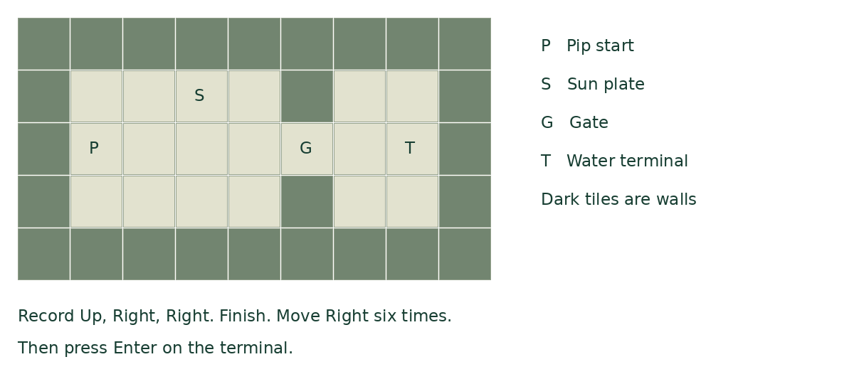
Figure 1. Schematic of implemented room 2, generated from its grid data. This is a level diagram, not a screenshot of browser rendering.

Interface and visual feedback
The board is drawn from code with a maintenance robot, outlined Echo, plant-covered walls, a sun plate and a water terminal. Opening a gate changes its appearance. Completing a room changes the floor colour and displays a result dialog. The interface shows the recording mode, eight command slots, turn count, reset count and restored-room count. Hints reveal explicit solutions so a reviewer can check each mechanic quickly.

Scope decisions
The prototype uses one tileset and one Echo per attempt. It excludes enemies, inventory, sound, cutscenes and procedural generation. The six-level expansion from Week 1 is reduced to the planned three-level prototype. All three room buttons remain accessible for review. The drawn route is a planning aid under closed-gate assumptions; the command strip and live replay are authoritative if the route involves gates.

Testing and troubleshooting

Completed automated verification
The included tests were run with Node.js during preparation. All 17 passed, with zero failures or skipped tests. TEST_RESULTS.txt captures the runner output. Thirteen tests exercise the game rules; four exercise UI integration with a small DOM and canvas substitute. These tests establish rule behavior and event wiring, not real-browser appearance or cross-browser compatibility.
- Collision and input: wall blocking, invalid commands, closed-gate entry and leaving a closing gate.
- Recording: empty-record rejection, room 1 restriction, eight-command auto-finish, rewind and blocked-command consumption.
- Replay and puzzles: one command per turn, Echo holding a plate, all three room solutions and shared gate-state timing.
- State management: reset clearing the attempt, terminal restrictions, completion freezing movement, room switching and invalid-level rejection.
- UI integration: three room buttons, eight memory slots, keyboard completion, next-room navigation, room 2 replay and storage-failure fallback.

Implementation challenges and resolutions
Synchronized gate timing was resolved by capturing the gate state once per turn and sharing it between both actors. Recording and replay were separated into explicit planning, recording and replay modes. Position-based plates avoid a stale gate state after rewind. Browser-storage access is wrapped in error handling so storage restrictions do not stop the game. Keyboard handling preserves native Enter and Space behavior on focused buttons while allowing movement keys.

Verification limits and manual checklist
A browser executable was unavailable in the preparation environment, so real-browser rendering, mobile interaction and visual responsiveness have not been verified. No external playtest results or completed work hours are claimed. Before submitting, open index.html in a desktop browser and perform these checks:
- Confirm the board, text, buttons, command strip and completion dialog are readable and visible.
- Solve each room using the documented routes; check recording, wait, gate opening and reset.
- Resize the window and test keyboard navigation and pointer controls.
- Refresh after completing a room to check local saving. Storage behavior may differ for file URLs.

Next steps
After browser review, fix any layout or input issues found on the target device. Further development could add audio, key remapping, improved route previews and additional rooms. A Godot port remains an option if required. The current deliverable demonstrates core gameplay; it is not a finished commercial game.

Submission instructions and description

Files and repository
Upload this DOCX in the report field. Extract the source archive and upload its contents to a repository under your own GitHub account, ensuring the reviewer can access it. Paste the actual repository URL into the form. This package does not create a remote repository and does not contain an invented GitHub link. The source archive is the functional prototype deliverable.

Description for the submission form
This submission presents the Week 2 implementation of Echo Garden, a single-player 2D puzzle prototype based on the game concept developed in Week 1. The player controls Pip, a maintenance robot that restores water to an abandoned rooftop garden by reaching and activating water terminals.
The prototype implements the central recording and replay mechanic. Pip can record up to eight movement or wait commands, rewind to the recording position, and cooperate with an Echo that repeats those commands. The Echo can remain on a pressure plate to hold a gate open while the player travels to the terminal. Turn-based movement makes the interaction predictable and allows players to solve puzzles without time pressure.
Three playable rooms demonstrate movement, collision detection, Echo recording, synchronized replay, gate activation, level completion, and increasing route-planning complexity. The interface displays the current mode, recorded commands, turns, resets, and restored rooms. It includes hints, keyboard and button controls, a completion dialog, and a simple restoration score. Best scores are stored locally when browser storage is available.
The implementation uses HTML, CSS, and JavaScript with Canvas rendering instead of the Godot engine proposed in Week 1. The attached report explains this decision, the code structure, gameplay rules, implementation challenges, testing, limitations, and possible improvements. The source archive includes automated tests and captured results. All 17 automated tests passed during preparation. These include game-rule tests and UI integration tests using a DOM and canvas substitute; real-browser visual verification and external player testing remain separate review steps.

