Echo Garden Game Asset Creation and Integration Report
Week 3 • Version 1.0 • Prepared for Sarthak Shelar
Submission date: 03/11/2026
This report accompanies the updated Echo Garden browser prototype and its packaged visual and audio assets. The Week 3 work replaces the earlier procedural placeholder art with dedicated SVG files, adds character animation and visual effects, and integrates file-based audio. The three puzzle rooms and turn-based rules from Week 2 are preserved.

Objective and result
The objective is to improve the prototype’s visual identity and feedback through a consistent set of garden-themed assets. The deliverable contains 17 SVG images, six WAV files, an asset manifest, the integrated game, reproducible generation code and validation results. The asset package is inside the project’s assets folder.

Art and sound direction
Cream character bodies, muted green stone, golden sun switches and teal water terminals connect the game to its restoration story. The main robot has a leaf antenna and a dark face display. Its Echo reuses the same silhouette with a translucent teal body and dashed outline. Soft tonal cues reinforce movement and puzzle actions without replacing their visual feedback.

Tools and provenance
The assets were prepared programmatically with AI assistance. The included Python script writes SVG shapes and paths and synthesizes PCM audio using the standard library. SVG is used as an editable source format suited to the existing HTML Canvas prototype. No external image packs, sampled audio, Photoshop workflow or Blender workflow are claimed. The generation script provides reproducible creation details rather than a record of manually logged work hours.

Project organization
- assets/art contains the 17 runtime SVG files; assets/audio contains the six runtime WAV files.
- assets/manifest.json records roles, dimensions, durations and audio properties.
- assets/ASSET_SHEET.png is a visual contact sheet; tools/make_assets.py recreates the runtime assets.
- assets.js and renderer.js handle loading, audio and visual animation. The unchanged core.js retains the puzzle rules.

Visual assets and animation
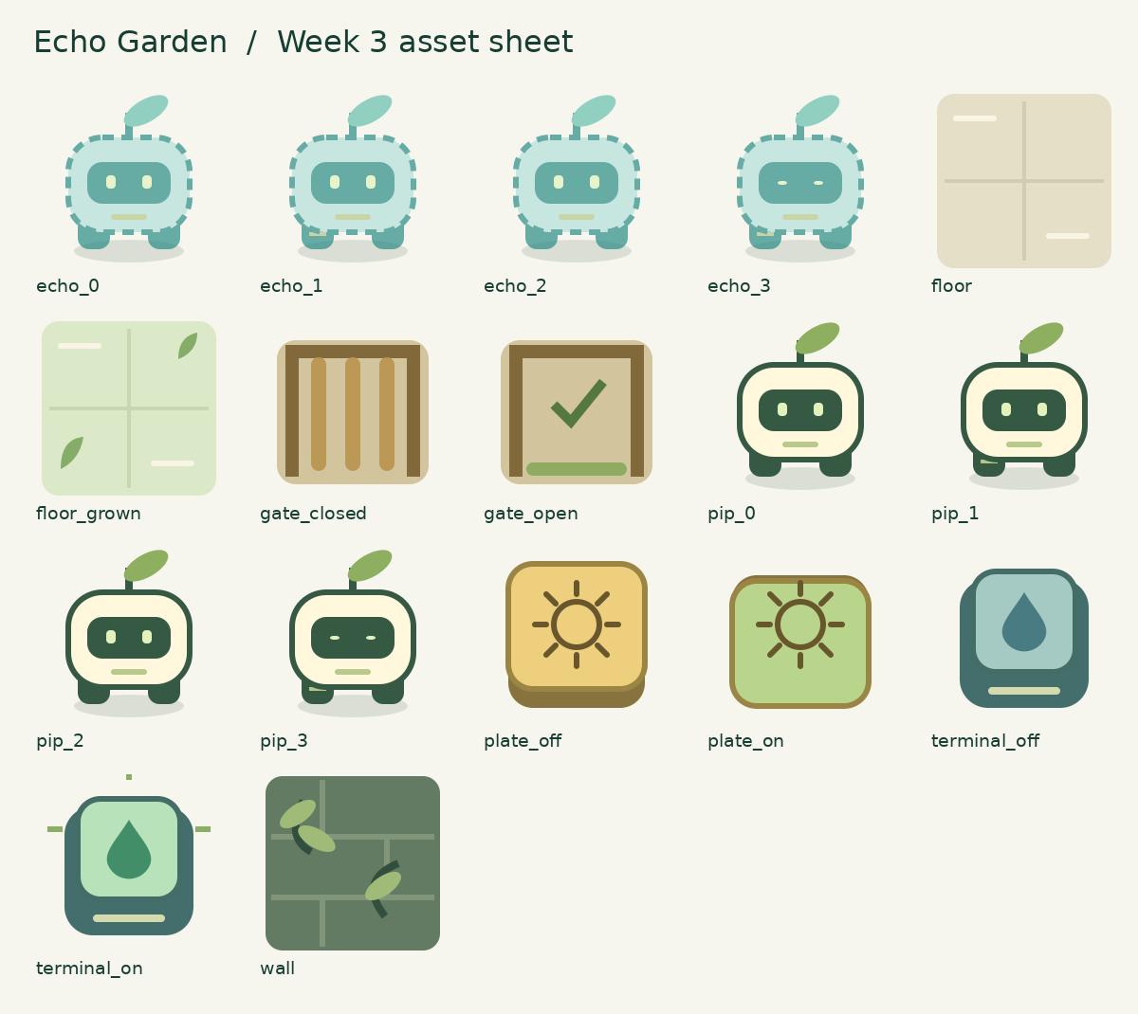
Figure 1. Contact sheet of all 17 SVG assets, rasterized for inspection. This is an asset preview, not a screenshot of the running game.

Asset breakdown
Pip and the Echo each have four frames: three frames used for movement and one blink frame. The environment set includes dry and restored floors, an ivy-covered wall, two plate states, two gate states and two terminal states. All files share a 96 × 96 viewBox and contain their own geometry without external image references.

Animation integration
The renderer cycles movement frames, occasionally selects the blink frame, and interpolates displayed positions over 150 milliseconds. Gates switch artwork and briefly flash on opening. Restoring a room swaps floor and terminal assets and emits a short particle burst. These visual effects never change the integer grid positions or the order in which game rules resolve.

Audio design and asset integration

Audio inventory
WAV file | Duration | Purpose
move.wav | 0.16 s | movement click
record.wav | 0.36 s | record start or rewind
gate.wav | 0.42 s | gate opening chime
reset.wav | 0.4 s | reset descending cue
restore.wav | 1.2 s | restoration arpeggio
garden_loop.wav | 8 s | quiet repeating garden melody

Creation process and technical settings
Each cue combines sine tones with a quieter second harmonic and a short attack/release envelope. Ascending tones indicate recording and restoration; a descending cue indicates reset. The background uses a slow sequence of notes with a quiet transition at the loop boundary. It is not presented as a seamless soundscape. Every WAV is mono, 16-bit PCM at 22,050 Hz. This is sufficient for simple tonal prototype audio while limiting download size.
The 23 runtime assets occupy approximately 465 KiB in their uncompressed source files. The preview sheet and documentation are separate from this figure. SVG images are loaded once and reused by the renderer; the assets do not depend on a network service.

Loading and event feedback
assets.js creates image objects from relative paths and provides a recovery notice if an image fails. Letter fallbacks preserve basic board readability while an asset is unavailable. Audio files connect to movement, recording, gate-opening, reset and restoration events. Effects and music have independent opt-in controls. Playback failures display feedback without blocking the puzzle.

Accessibility and theme consistency
The Echo uses an outline as well as a different colour. Plate, gate and terminal states have distinct artwork. Operating-system reduced-motion preference disables frame cycling, interpolation, flashing and particles while leaving state feedback visible. Audio begins off and is never required to solve a room. The muted palette, plant details and gentle tonal design support the existing garden-restoration theme.

Verification and submission

Completed checks
All 21 automated tests passed: 13 core-rule tests and eight UI/asset-wiring tests. The UI tests use a DOM and Canvas substitute; they verify event wiring and game behavior without a browser. Coverage includes the three room solutions, recording, reset, gate timing, completion, optional sound, music toggling and image-load failure recovery.
A separate Python check validated all 23 runtime files. It parsed the SVGs, checked their viewBox values and inspected the WAV headers and sample data. The audio files are non-silent, remain below full-scale clipping and have quiet endpoints. All 17 SVGs were rasterized and the contact sheet was visually reviewed. The archive includes TEST_RESULTS.txt and ASSET_VALIDATION.txt.

Limits of verification
A real browser executable was unavailable during preparation. Browser rendering, animation timing, audio decoding, listening quality, autoplay behavior and performance on the target device therefore remain manual review items. The automated tests and structural audio checks do not establish those results. No external playtest or subjective audio assessment is claimed.

Manual review before submission
- Extract the full archive and open index.html. Confirm the art, text, controls and all three rooms are visible.
- Enable effects and check movement, recording, gate opening, reset and restoration sounds. Enable music, listen through a loop and turn it off.
- Check character frames, gate feedback and restoration effects. Reload with reduced motion enabled and confirm gameplay remains usable.
- Resize the browser and solve the documented room routes. Confirm the assets folder is uploaded with the project.

Challenges and resolutions
The main integration concern was separating animation from deterministic puzzle rules. The renderer interpolates presentation only, while core.js remains unchanged. Audio is tied to state changes and user actions rather than the rendering loop, avoiding repeated cues on every frame. Relative asset paths support offline use. Fallback images and audio error handling keep missing files from stopping the underlying game.

Submission package
The ZIP contains the integrated project, assets, editable generation script, report and a description longer than 200 words. Upload this DOCX in the form’s Word report field. Publish the extracted Week 3 files to an accessible repository and paste its actual URL. Use a separate Week 3 repository or folder to preserve the submitted Week 2 project. No GitHub repository has been created or updated by this package.

Further improvements
After manual device review, adjust audio balance and animation timing using feedback. Later work could add a longer ambient track, additional floor variants and more puzzles. The current deliverable focuses on a small, consistent asset set integrated into the existing prototype.

