Echo Garden Level Design and Environmental Setup Report
Week 4 • The Rooftop Reservoir • Version 1.0
Prepared for: Sarthak Shelar | Submission date: 03/11/2026
This report accompanies an implemented, connected level for the Echo Garden browser game. The Rooftop Reservoir expands the earlier isolated puzzles into a three-stage rooftop journey with linked switches and gates, two intermediate pumps, session checkpoints and a final reservoir objective. The project also includes the earlier three practice rooms.

Design objective
The level aims to combine spatial planning with visible environmental recovery. The player records a route for an Echo, lets that Echo hold a switch and follows a different route to a pump. Pump activation changes the environment and creates a safe starting point for the next puzzle. The central mechanic remains deterministic and turn-based; no enemies or time limits are introduced.

Scope and implemented features
- One 21 × 11 tile level with an intake yard, pump terrace and reservoir approach.
- Three numbered pressure-plate and gate links, two pumps and one final terminal.
- Pump checkpoints, gates that latch open, stage objectives and a separate whole-level restart.
- Optional story signs, dry and restored planters, floor restoration, character animation and optional audio.
- Annotated coordinate map, interactive-object blueprint, exact walkthroughs and automated validation results.

Technology and project continuity
The level extends the HTML, CSS and JavaScript Canvas prototype used in Weeks 2 and 3. core.js now supports multiple gate links, ordered pumps and checkpoint state. renderer.js displays numbered interactive objects and progressive restoration. The asset set contains 20 editable SVG images and six synthesized WAV files. The source and assets were prepared with AI assistance; no completed human playtest, engine port or logged work-hour record is claimed.

Player journey
The intake yard establishes the split-route puzzle, the middle terrace asks for a longer recording and the final approach consolidates the rule with a shorter finishing sequence. Each pump provides visible progress and limits the cost of retrying the next area. The final terminal can complete the level only after both pumps are restored.

Annotated map and interactive objects
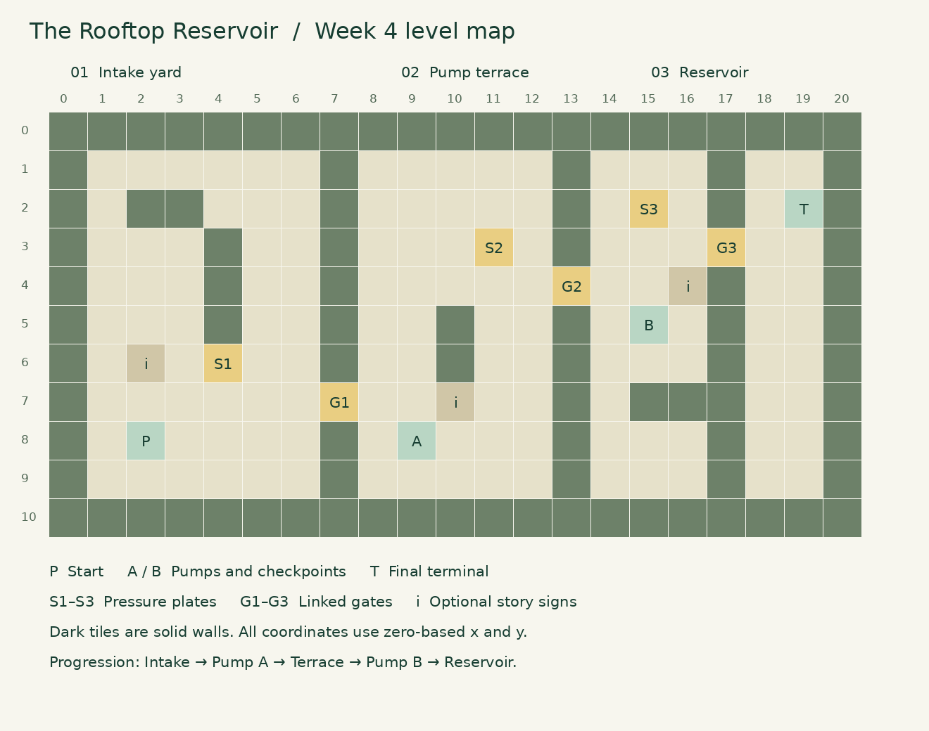
Figure 1. Coordinate map generated from the implemented level. Coordinates are zero-based x and y. Dark cells are walls; numbered plate and gate pairs form the intended bottlenecks. The complete coordinate inventory is in design/LEVEL_BLUEPRINT.md.

Key locations
Start: (2,8). Stage 1 links plate 1 at (4,6) to gate 1 at (7,7), leading to pump A at (9,8). Stage 2 links plate 2 at (11,3) to gate 2 at (13,4), leading to pump B at (15,5). Stage 3 links plate 3 at (15,2) to gate 3 at (17,3), leading to the final terminal at (19,2).

Collision and environmental details
Continuous stone dividers at x = 7, 13 and 17 each have a single gate opening, preventing a route around the intended challenge. Additional wall clusters shape the interior spaces. Signs at (2,6), (10,7) and (16,4) provide optional Enter interactions. Decorative planters at (1,8), (9,2) and (18,7) are nonblocking floor details outside the documented solution path. Walls and closed gates are the solid obstacles.

Stage flow and environmental storytelling

Stage 1 Intake yard
At the start, record Right twice and Up twice, then finish recording. Replay Right four times, Up, Right twice, Down and Right; activate pump A. The four-command Echo reaches its plate before Pip enters gate 1 on replay turn 6. The stage takes nine replay turns. This introduces cooperation across two short, visibly different routes.

Stage 2 Pump terrace
At pump A, record Right twice and Up five times. Replay Up four times, Right six times and Down; activate pump B. The seven-command recording uses most of the eight available slots. Pip enters gate 2 on replay turn 8, after the Echo reaches plate 2 on turn 7. The stage takes eleven additional replay turns and creates the level’s longest planning task.

Stage 3 Reservoir approach
At pump B, record Up three times. Replay Right, Up twice, Right three times and Up; activate the final terminal. The Echo reaches plate 3 on turn 3, and Pip crosses its gate on turn 4. The stage takes seven additional replay turns. The shorter final recording gives the sequence a readable finish rather than introducing another rule at the end.

Checkpoints and recovery
Pump A permanently opens gate 1; pump B permanently opens gate 2. Each pump removes the old Echo and returns the game to planning mode so a new route can be recorded. The checkpoint captures the player coordinate, restored pumps and accumulated replay turns. Reset attempt restores that checkpoint and adds a reset penalty. Restart whole level clears the checkpoints and pump states. Checkpoints last only for the current page session; they are not restored after reloading or switching levels.

Environment connected to progress
The intake sign describes the dry supply and first switch. The middle sign explains how pump A supplies the terrace; the final sign points toward the reservoir. Restoring A changes western and middle floor tiles, restoring B extends the effect into the approach, and final completion restores the remaining area. Dry planters become green as their region is restored. These are visual state changes, not a fluid simulation.

Visual and audio integration
Three new SVG assets add a dry planter, a restored planter and an information sign to the Week 3 set. Number labels identify gates and plates, and A/B labels identify pumps. Existing movement frames, gate flash, restoration effects and audio are retained. Effects and music remain optional; reduced motion disables animated effects while essential state changes stay visible.

Validation balance and submission

Completed automated checks
All 31 automated tests passed with zero failures: 13 earlier game-rule tests, nine new level tests and nine simulated UI/asset-wiring tests. New checks cover the complete three-stage route, checkpoint recovery, whole-level restart, upstream pump requirements, optional signs and closed-gate reachability. TEST_RESULTS.txt contains the captured output. Separate structural checks validated all 26 runtime assets; the updated map and asset contact sheet were visually reviewed.

Solvability and pacing evidence
The documented route uses recordings of four, seven and three commands and takes 27 replay turns without resets. The corresponding score is 730 under the existing scoring formula. This route is verified but not proven globally shortest. Reachability checks show that each closed gate separates the next objective from the preceding checkpoint. These checks establish the intended bottlenecks and a valid solution; they do not establish subjective difficulty or player enjoyment.

Human playtest plan and limits
Real-browser rendering, audio playback and human difficulty assessment remain manual checks. No human playtest results are reported. The proposed next step is to ask three to five players to solve the level without exact solutions initially, recording stage times, resets, hint use and missed pump interactions. Targets are no unrecoverable states, understanding the first stage within two attempts, and finding the longer middle recording with a gentle hint. These are future criteria rather than measured outcomes.
If players repeatedly miss pump activation, strengthen the objective prompt. If the middle route is confusing, adjust its sign or shorten the path. If the challenge is too easy, refine obstacle placement while keeping recordings within eight commands. Checkpoint recovery limits repeated traversal and supports experimentation without time pressure.

Manual review before submission
- Extract the archive, open index.html and confirm the larger map is readable on the target display.
- Complete the three stages; also try a wrong recording, checkpoint reset and whole-level restart.
- Check numbered gate links, pump labels, story signs, restoration states, audio toggles and reduced motion.

Files and submission route
The package contains the updated playable source, assets, report, coordinate map, blueprint, test results and a description longer than 200 words. Upload this DOCX in the Word-report field. Put the extracted Week 4 files in an accessible repository, such as echo-garden-week4, and use its actual URL in the submission form. Paste SUBMISSION_DESCRIPTION.txt into the description field. No remote repository has been created or changed by this package.

