**Title:**

**Flask File Management**

**Introduction**

File management systems are integral to modern web applications, enabling users to upload, store, and access files conveniently. This project involves the development of a Flask-based web application where users can securely log in, upload PDF files with descriptions, and view or download their uploaded files.

**Objectives**

To create a web application that allows secure user registration and login.

To enable users to upload PDF files with descriptions and store these files efficiently.

To allow users to view their uploaded files in a browser tab and download them when needed.

To implement a clean, user-friendly interface using Bootstrap.

To provide secure backend storage using MySQL for user data and file metadata.

**Scope of Work**

**User Authentication:**

* **Implement a registration and login system with password encryption using bcrypt.**
* **Maintain user sessions to ensure secure access to the dashboard.**

**File Management:**

* **Allow users to upload files with descriptions.**
* **Store file metadata (file name, description, and path) in a MySQL database.**
* **Save uploaded files in a dedicated folder structure (documents).**

**File Access:**

* **Provide functionality to view PDF files in a new browser tab.**
* **Enable users to download files directly.**

**Frontend Development:**

* **Design the dashboard with Bootstrap for responsiveness and clarity.**
* **Include logout functionality and a list of uploaded files with action buttons for viewing and downloading.**

**Tools and Technologies**

* Python
* Flask
* Vscode
* Git and Github
* Xampp
* Mysql

**Outcomes**

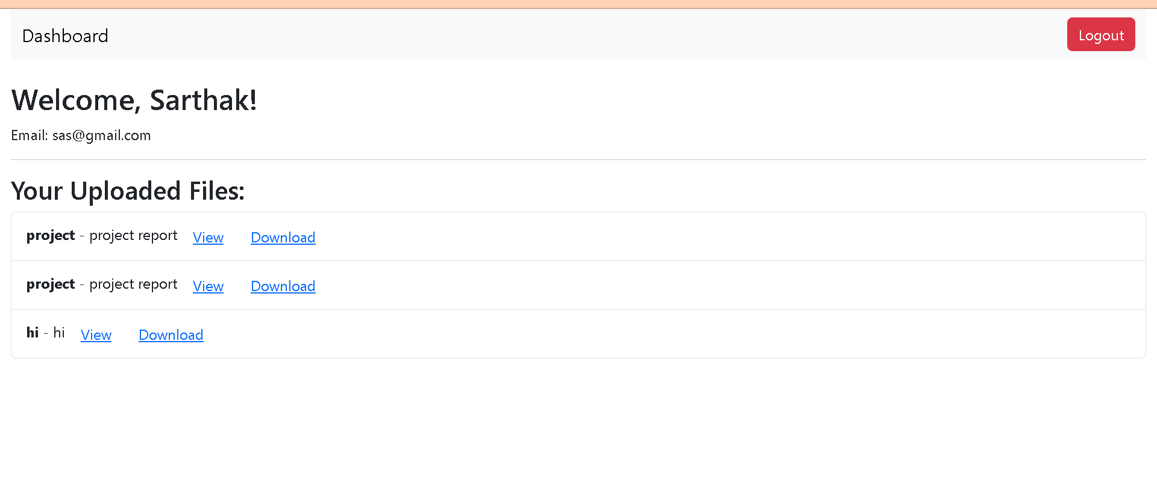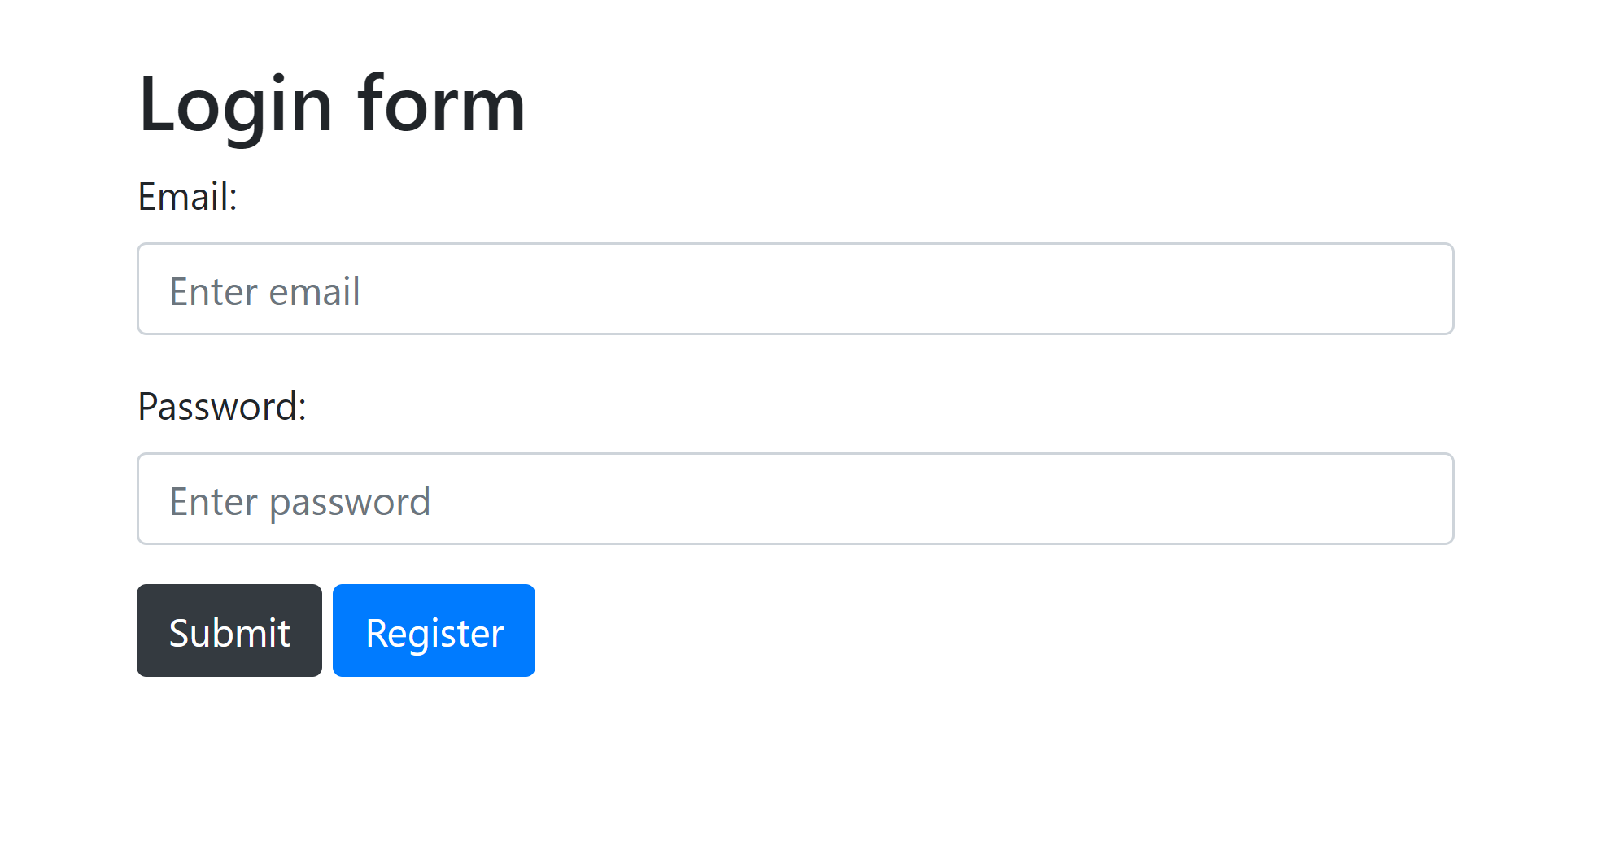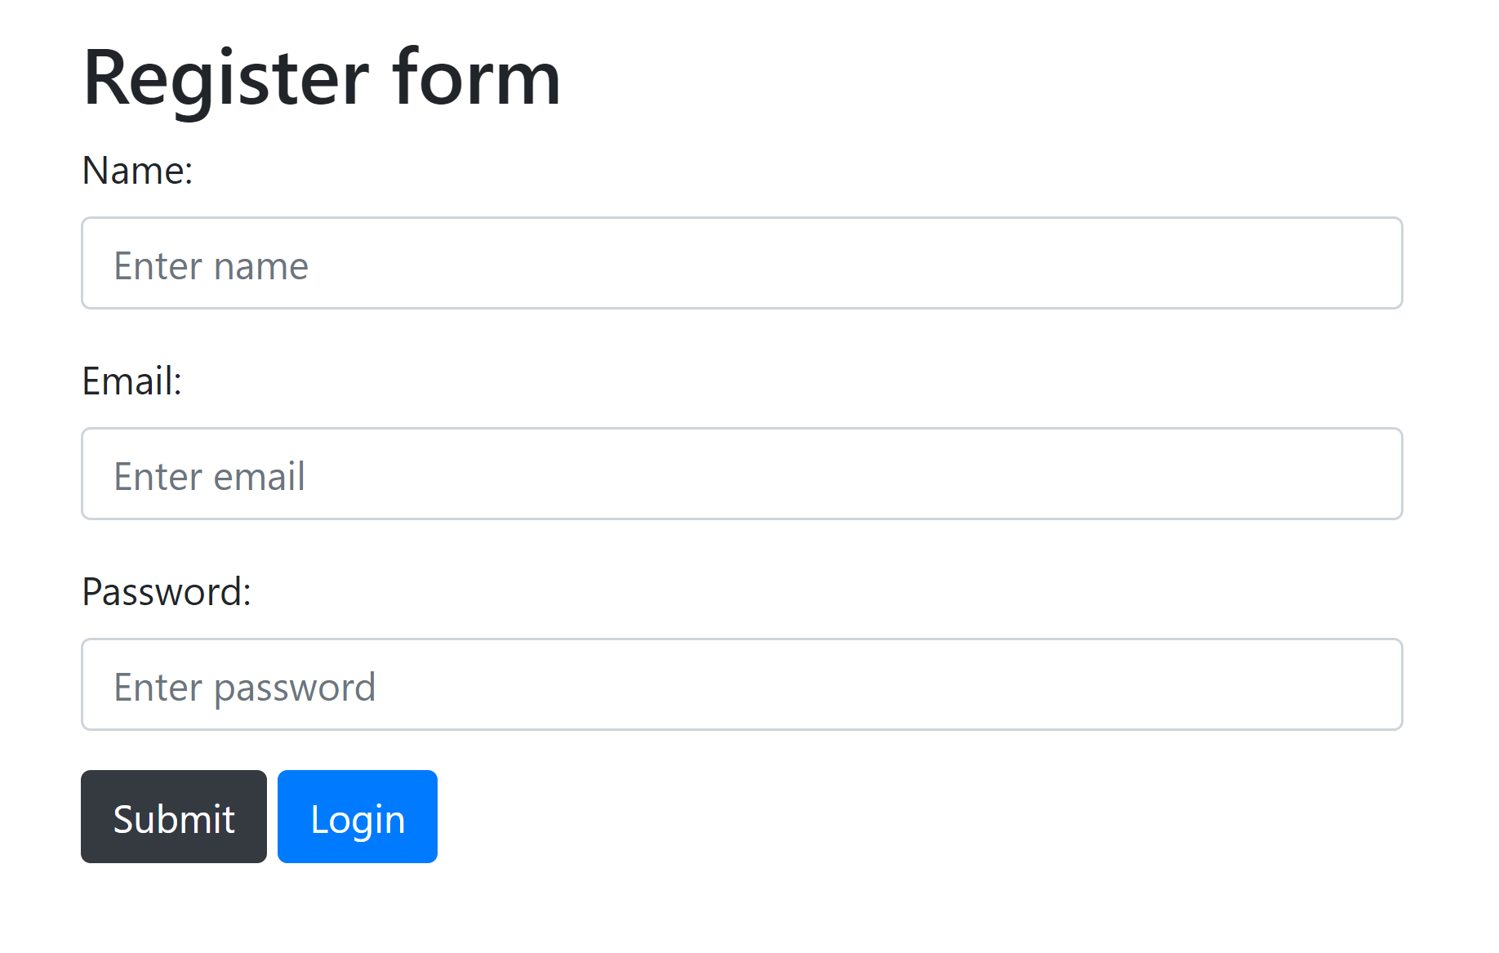

**Conclusion**

I created a project File management systems are integral to modern web applications, enabling users to upload, store, and access files conveniently. This project involves the development of a Flask-based web application where users can securely log in, upload PDF files with descriptions, and view or download their uploaded files.