Yuva Intern - Week 2 Task

Data Visualization and Insight Communication using R
Dataset: Diamonds (ggplot2 built-in)
[Sarthak Shrivastava]
Date: August 8, 2026

1. Data Overview
For this week's visualization task, the 'diamonds' dataset was selected. This dataset is built directly into R's ggplot2 package, making it highly accessible and an industry standard for demonstrating visual analysis. It contains the prices and other attributes of almost 54,000 diamonds, offering an excellent mix of categorical and continuous variables.
Key Variables Defined:
• price: Price in US dollars (Continuous)
• carat: Weight of the diamond (Continuous)
• cut: Quality of the cut (Categorical: Fair, Good, Very Good, Premium, Ideal)
• color: Diamond color, from D (best) to J (worst) (Categorical)

2. Visualization Design, Code, and Interpretation
The visual analysis was conducted using R and the ggplot2 library. The design choices prioritize clarity for a non-technical audience. Below are the visual representations, the R code used to generate them, and the business insights drawn from each.

A. Price Distribution (Histogram)
R Code:
ggplot(diamonds, aes(x = price)) +
geom_histogram(binwidth = 500, fill = 'steelblue', color = 'white') +
labs(title = 'Distribution of Diamond Prices', x = 'Price (USD)', y = 'Count') +
theme_minimal()
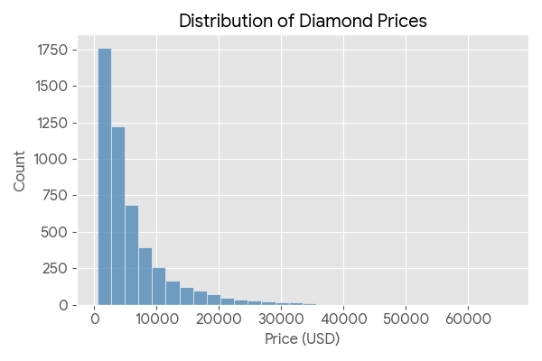
Insight: The histogram reveals a heavily right-skewed distribution. The vast majority of diamonds in the market are priced under $3,000, with a steep drop-off as prices increase. This indicates that while luxury, high-priced diamonds exist, the consumer market is predominantly driven by lower-cost stones.

B. Impact of Carat and Cut on Price (Scatter Plot)
R Code:
ggplot(diamonds, aes(x = carat, y = price, color = cut)) +
geom_point(alpha = 0.5) +
labs(title = 'Carat vs. Price by Cut', x = 'Carat', y = 'Price (USD)') +
scale_color_viridis_d() +
theme_minimal()
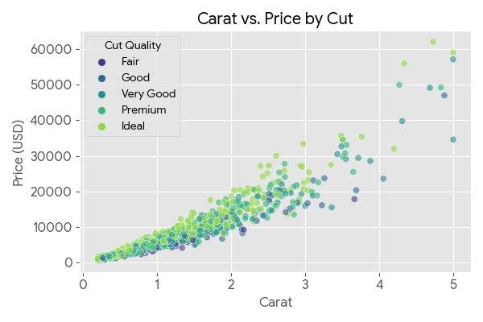
Insight: There is a strong, exponential positive correlation between a diamond's carat (weight) and its price. However, as the carat size increases, the price variance also widens significantly. The color grouping shows that for diamonds of the exact same weight, an 'Ideal' or 'Premium' cut commands a noticeably higher price than a 'Fair' cut.

C. Inventory by Cut Quality (Bar Graph)
R Code:
ggplot(diamonds, aes(x = cut, fill = cut)) +
geom_bar() +
labs(title = 'Count of Diamonds by Cut Quality', x = 'Cut Quality', y = 'Count') +
scale_fill_brewer(palette = 'Set2') +
theme_minimal()
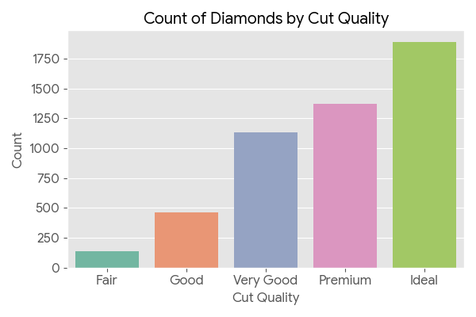
Insight: This bar chart displays the categorical breakdown of the dataset. Counter-intuitively, the highest quality cut ('Ideal') is actually the most common in this inventory, followed by 'Premium'. 'Fair' cuts are exceptionally rare. This suggests the supply chain prioritizes manufacturing high-quality cuts to maximize the stone's final retail value.

D. Price Variance by Color (Box Plot)
R Code:
ggplot(diamonds, aes(x = color, y = price, fill = color)) +
geom_boxplot() +
labs(title = 'Price Distribution by Diamond Color', x = 'Color (D=Best, J=Worst)', y = 'Price (USD)') +
theme_minimal()
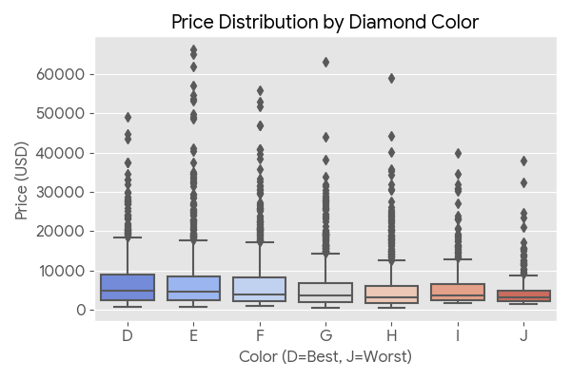
Insight: Box plots effectively show the median and spread of data for anomaly detection. Interestingly, the median price actually remains quite stable or even increases slightly as the color quality worsens (from D to J). This is a hidden pattern where lower-color diamonds tend to be cut significantly larger (higher carat) to make up for their color deficiency, driving the overall price up despite the poorer color grade.

