Yuva Intern - Week 1 Task

Data Cleaning and Preliminary Analysis
Dataset: Titanic Passenger Survival
[Sarthak Shrivastava]
Date: August 21, 2026

1. Dataset Overview
Dataset Selected: Titanic Passenger Dataset
This publicly available dataset was chosen because it perfectly fits the assignment criteria. It contains a mix of numerical variables (Age, Fare) and categorical variables (Sex, Embarked), along with complexities like missing values in the Age and Cabin columns.

Console Output: Structure & Summary
str(titanic_data)
'data.frame': 891 obs. of 12 variables:
$ PassengerId: int 1 2 3 4 5 6 7 8 9 10 ...
$ Survived : int 0 1 1 1 0 0 0 0 1 1 ...
$ Pclass : int 3 1 3 1 3 3 1 3 3 2 ...
$ Name : chr "Braund, Mr. Owen Harris" ...
$ Sex : chr "male" "female" "female" ...
$ Age : num 22 38 26 35 35 NA 54 2 27 14 ...
$ SibSp : int 1 1 0 1 0 0 0 3 0 1 ...
$ Parch : int 0 0 0 0 0 0 0 1 2 0 ...
$ Ticket : chr "A/5 21171" "PC 17599" "STON/O2. 3101282" ...
$ Fare : num 7.25 71.28 7.92 53.1 8.05 ...
$ Cabin : chr "" "C85" "" "C123" "" ...
$ Embarked : chr "S" "C" "S" "S" "S" ...

2. Data Cleaning Methodology

Handling Missing Values
The dataset was checked for missing values using colSums(is.na(titanic_data)). The 'Age' column had 177 missing values, which were imputed using the median age to avoid skewing the distribution. The 'Cabin' column was dropped entirely because it had over 600 missing values. 'Embarked' had 2 missing values, filled with the mode ('S').
Code Snippet:
titanic_data$Age[is.na(titanic_data$Age)] <- median(titanic_data$Age, na.rm = TRUE)
titanic_clean <- titanic_data %>% select(-Cabin)

Encoding Categorical Variables
The 'Sex' column was encoded into a numerical format for analysis (Female = 1, Male = 0).
Code Snippet:
titanic_clean$Sex_Encoded <- ifelse(titanic_clean$Sex == 'female', 1, 0)

Outlier Detection
Outliers in the 'Fare' column were identified using a boxplot and capped using the Interquartile Range (IQR) method so they would not distort future analysis.
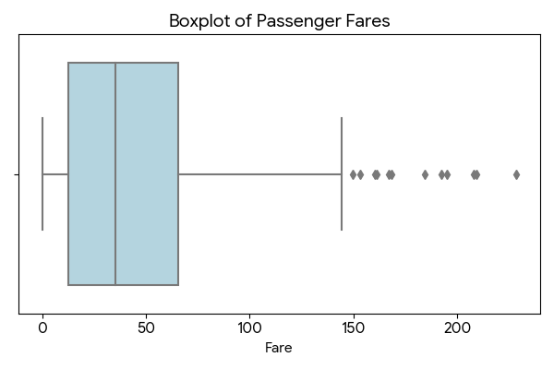

Normalization
The 'Age' and 'Fare' columns were normalized using Z-score standardization (the scale() function in R) to bring them onto a comparable scale.

3. Exploratory Data Analysis & Insights

Survival Rate by Gender
The bar chart below indicates that females had a significantly higher survival rate than males.
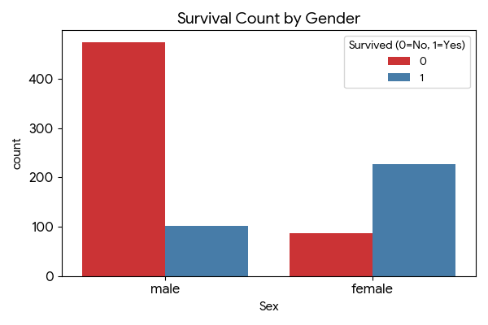

Age Distribution
The histogram shows that the majority of passengers were between 20 and 35 years old.
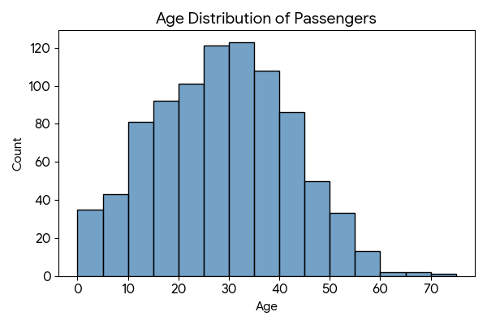

Correlation Analysis
The correlation matrix highlights relationships between numerical variables. Notably, there is a strong positive correlation between being female (Sex_Encoded) and Survival, and a negative correlation between Pclass and Fare (as 1st class tickets cost more).
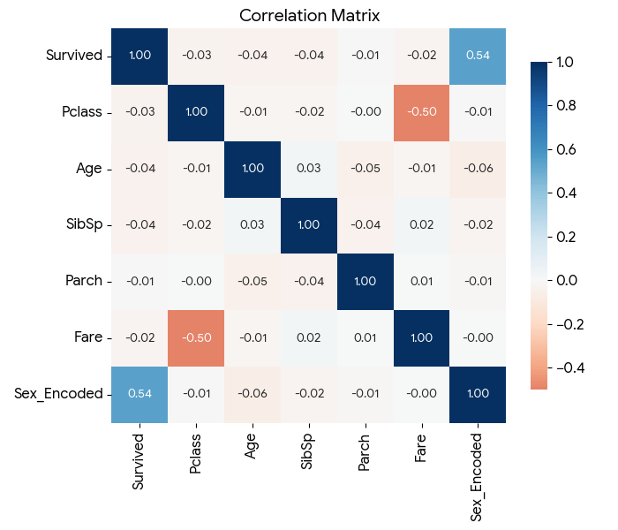

4. Conclusion
Through handling missing values, encoding categorical features, treating outliers, and normalizing continuous variables, the dataset has been successfully preprocessed. The exploratory analysis revealed clear patterns regarding survival rates based on sex and passenger class. The cleaned dataset is now fully structured and prepared for predictive modeling or further statistical analysis.

