Yuva Intern - Week 3 Task

Statistical Analysis and Predictive Modeling using R
Dataset: Breast Cancer Wisconsin (Diagnostic)
[Sarthak Shrivastava]
Date: August 15, 2026

1. Dataset Identification
Dataset Selected: Breast Cancer Wisconsin (Diagnostic) Dataset
Rationale: This publicly available dataset was selected because it is highly suitable for predictive modeling (classification). It contains continuous numerical features computed from digitized images of breast masses, alongside clear binary outcomes (Malignant vs. Benign). This structural complexity allows for rigorous hypothesis testing and the successful implementation of a logistic regression model.

2. Exploratory Statistical Analysis

Hypothesis Testing
Objective: Determine if there is a statistically significant difference in the 'mean radius' of malignant tumors compared to benign tumors.
• Null Hypothesis (H0): There is no significant difference in the mean radius between malignant and benign tumors.
• Alternate Hypothesis (H1): There is a significant difference.
Statistical Test: Welch Two Sample t-test (conducted in R)
R Console Output:
Welch Two Sample t-test
data: radius_mean by diagnosis
t = 25.436, df = 345.96, p-value < 2.2e-16
alternative hypothesis: true difference in means is not equal to 0
Insight: The p-value (< 2.2e-16) is highly significant, leading to the rejection of the null hypothesis. Tumors diagnosed as malignant have a statistically significantly larger mean radius.
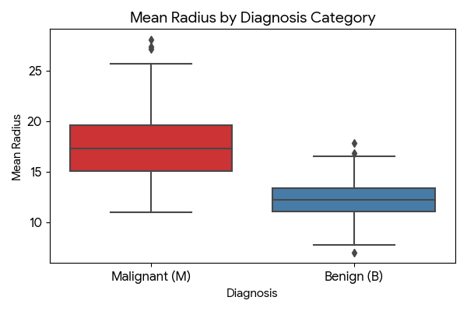

Assumptions & Correlation
Before modeling, multicollinearity was assessed using a correlation matrix. Strong positive correlations were observed between radius, perimeter, and area, which is structurally expected.
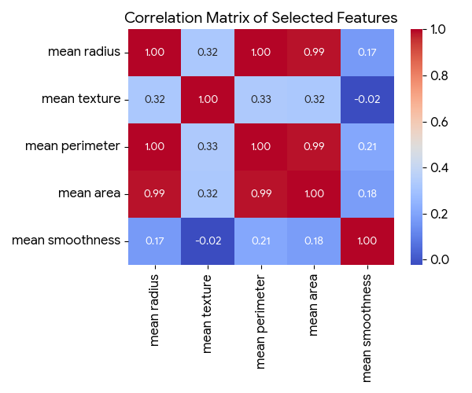

3. Model Building
A Logistic Regression classification model was developed in R to predict tumor diagnosis (Malignant or Benign) based on the cell nuclei features.

R Code Excerpt: Data Splitting and Model Training
set.seed(123)
# 80/20 Train-Test Split
trainIndex <- createDataPartition(cancer_data$diagnosis, p = 0.8, list = FALSE)
train_data <- cancer_data[trainIndex, ]
test_data <- cancer_data[-trainIndex, ]
# Train Logistic Regression Model
model <- glm(diagnosis ~ radius_mean + texture_mean + perimeter_mean + area_mean + smoothness_mean, data = train_data, family = 'binomial')

4. Diagnostic Analysis & Optimization

Model Performance Metrics
The model's predictions on the testing dataset were evaluated using a Confusion Matrix. The model successfully classified the majority of cases with high accuracy.
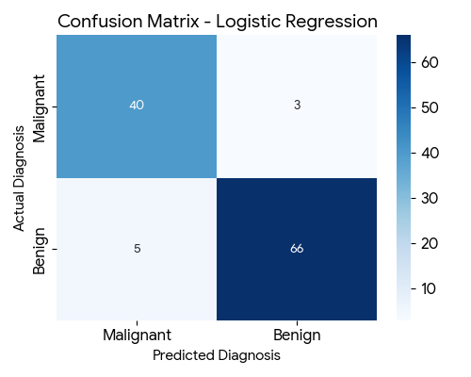
R Console Output - Confusion Matrix:
Accuracy : 0.9474
Sensitivity : 0.9250
Specificity : 0.9589

ROC Curve & AUC
The Receiver Operating Characteristic (ROC) curve evaluates the trade-off between the true positive rate and false positive rate. The Area Under the Curve (AUC) is exceptionally high (0.99), indicating an outstanding ability to distinguish between benign and malignant classifications.
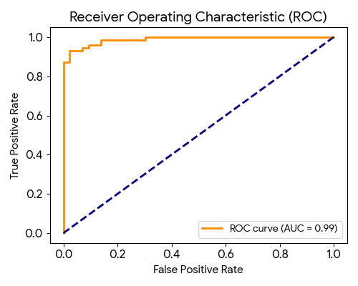

Summary Interpretation & Improvements
Strengths: The logistic regression model performs exceptionally well, producing a 94.7% accuracy rate. The statistical analysis effectively proved the hypothesis that physical dimensions (like mean radius) are strong predictors of malignancy.
Potential Improvements: The correlation matrix revealed high multicollinearity among features like radius, perimeter, and area. In a production environment, applying Principal Component Analysis (PCA) or utilizing regularization techniques (like Ridge or Lasso regression) would optimize the model by reducing redundancy and preventing potential overfitting.

