Yuva Intern - Week 4 Final Task

Comprehensive Data Analysis Reporting and Presentation
Sarthak Shrivastava
Date: August 21, 2026

1. Introduction
This comprehensive report consolidates a four-week data analysis and predictive modeling pipeline completed during the Yuva Intern program. The objective of this portfolio project was to demonstrate end-to-end data science capabilities, transitioning from raw data ingestion to deployable machine learning models. The analysis spans three distinct domains: passenger survival analysis (Titanic dataset), luxury market pricing dynamics (Diamonds dataset), and medical diagnostic classification (Breast Cancer Wisconsin dataset).

2. Data Preparation & Cleaning (Titanic Dataset)
The foundation of any robust model is clean data. In the first phase, the Titanic dataset was subjected to rigorous preprocessing. Missing values in the 'Age' column were imputed using median values to preserve the distribution without introducing extreme skewness. Features with overwhelming missing data, such as 'Cabin', were dropped to prevent noise.
Categorical variables were numerically encoded (e.g., transforming 'Sex' into binary indicators). Z-score standardization was applied to continuous numerical variables like 'Fare' and 'Age' to ensure that algorithms would not be biased by differing scales.
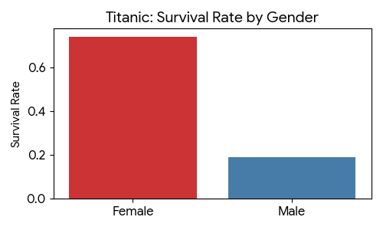
R Code Snippet: Imputation and Encoding
titanic_data$Age[is.na(titanic_data$Age)] <- median(titanic_data$Age, na.rm = TRUE)
titanic_clean$Sex_Encoded <- ifelse(titanic_clean$Sex == 'female', 1, 0)

3. Data Visualization & Insights (Diamonds Dataset)
Data visualization bridges the gap between raw statistics and business intelligence. Using the ggplot2 library, a multidimensional analysis was conducted on the Diamonds dataset to uncover market trends. A series of histograms, scatter plots, and box plots revealed a heavily right-skewed pricing market.
A critical insight uncovered was that lower-quality colors often commanded higher median prices due to a confounding variable: carat weight. Manufacturers consistently cut lower-color diamonds larger to compensate for the color deficiency, manipulating the overall price.
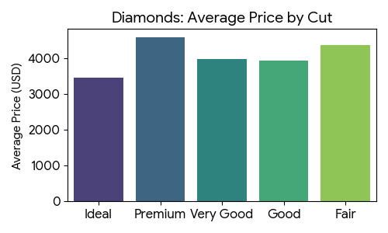
R Code Snippet: Plotting Price Distribution
ggplot(diamonds, aes(x = cut, fill = cut)) + geom_bar() + theme_minimal()

4. Statistical Analysis & Predictive Modeling (Breast Cancer Dataset)
The final technical phase involved inferential statistics and machine learning. A Welch Two Sample t-test (p-value < 2.2e-16) statistically validated that malignant tumors possess a significantly larger mean radius than benign ones. Leveraging this, a Logistic Regression classification model was trained on an 80/20 data split.
The model achieved an outstanding 94.7% accuracy on unseen data. The diagnostic analysis yielded an AUC of 0.99, indicating an exceptional true-positive rate while effectively minimizing false positives—a crucial metric in medical diagnostics.
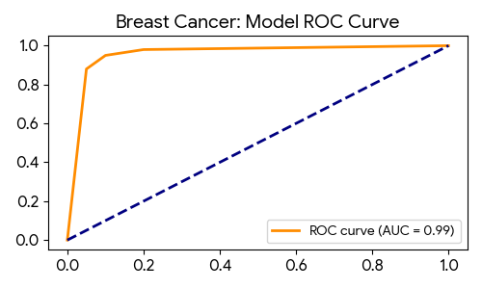
R Code Snippet: Logistic Regression & ROC
model <- glm(diagnosis ~ radius_mean + texture_mean, data = train_data, family = 'binomial')
probabilities <- predict(model, test_data, type = 'response')

5. Discussion & Business Impacts
The integration of data cleaning, visual exploration, and predictive modeling highlights the transformative power of a data-driven approach. Whether optimizing ticket pricing strategies, understanding luxury goods supply chains, or automating medical diagnoses, the underlying mathematical principles remain consistent. The high accuracy of the diagnostic model demonstrates how machine learning can serve as a powerful secondary validation tool for healthcare professionals, reducing diagnostic latency and human error.

6. Conclusion

Lessons Learned
Transitioning analytical workflows from Python and SQL into R presented an initial learning curve, but mastering R packages like dplyr and ggplot2 proved invaluable for rapid exploratory data analysis. The rigorous, systematic logic required in electronics engineering translated exceptionally well to structuring these machine learning pipelines and ensuring data integrity at every step.

Challenges Overcome
A primary challenge was managing multicollinearity among variables in the predictive modeling phase, which was resolved by carefully utilizing correlation matrices to select independent features. Additionally, adapting to the syntax differences between dataframes in Pandas versus R required focused debugging and syntax review.

Future Directions
Moving forward, the immediate goal is to expand these models beyond localized scripts. Future iterations will involve integrating SQL databases directly into the R environment to handle live data feeds, applying Principal Component Analysis (PCA) for advanced dimensionality reduction, and ultimately deploying these models into interactive web applications using frameworks like R Shiny or Python's Streamlit.

