Experiment No. 1.1

Student Name: Sarthak Tyagi UID: 22MCC20079

Branch: MCA - CCD Section/Group: 22MCD-1/ Grp A

Semester: III

Subject Name: Containerization With Docker Subject Code: 22CAH-742

1. Aim/Overview of the practical:
   1. Install Docker on Linux or windows
   2. Using docker CLI with commands.

1. Code for experiment/practical:

Specifications

* + While choosing for windows 10 or 11 with 64 bit, it must be having higher level of translation
  + 4GB RAM or Higher version but not less
  + BIOS settings should have hardware virtualization support enabled.



* + Hyper V feature, WSL 2 feature and Container feature should be enabled in windows.
  + Windows supported by Microsoft need to be updated, if computers have older versions of windows.

Installing Docker on Windows:

* + Go to the website https://docs.docker.com/docker-for-windows/install/ and download the docker file.
  + Note: A 64-bit processor and 4GB system RAM are the hardware prerequisites required to successfully run Docker on Windows 10.
  + Then, double-click on the Docker Desktop Installer.exe to run the installer.
  + Note: Suppose the installer (Docker Desktop Installer.exe) is not downloaded; you can get it from Docker Hub and run it whenever required.
  + Once you start the installation process, always enable Hyper-V Windows Feature on the Configuration page.
  + Then, follow the installation process to allow the installer and wait till the process is done.
  + After completion of the installation process, click Close and restart.

Start Docker Desktop Tool

* + After the installation process is complete, the tool does not start automatically. To start the Docker tool, search for the tool, and select Docker Desktop in your desktop search results.

* + Before starting the application, Docker offers an onboarding tutorial. The tutorial explains how to build a Docker image and run a container.
  + You are now successfully running Docker Desktop on Windows.
  + Next, follow the instruction below to install the Docker engine on your system.
  + Go to Docker CLI and run the Docker version to verify the version of Docker installation on the system.
  + Congratulations, Docker Installation on Windows is now done, and now, you are ready to build and run Docker images and containers on the Docker ecosystem.

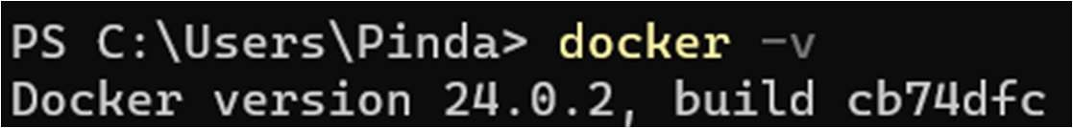

Using docker CLI with commands.

* + docker ps: List all running containers.
  + docker images: List all images. • docker run: Run a container.
  + docker stop: Stop a container.
  + docker rm: Remove a container.
  + docker build: Build an image.
  + docker push: Push an image to a registry.
  + docker pull: Pull an image from a registry.



1. Learning outcomes (What I have learned):
   * 1. To install Docker on Windows.
     2. To install Docker Desktop, WSL on windows.
     3. Understand to use Docker with CLI.