Experiment No. 1.2

Student Name: Sarthak Tyagi UID: 22MCC20079

Branch: MCA - CCD Section/Group: 22MCD-1/ Grp A

Semester: III

Subject Name: Containerization With Docker Subject Code: 22CAH-742

1. Aim/Overview of the practical: Pulling Docker Images from Docker Hub

1. Code for experiment/practical:

Pulling Docker images from Docker Hub is a quick and easy way to get started with Docker. Docker Hub contains a wide variety of pre-built images that you can use to run a variety of applications.

To pull Docker images from Docker Hub, you can use the docker pull command. This command will download the image from Docker Hub and store it on your local machine.

For Example:



To pull a single image, simply specify the image name and tag. For example, to pull the latest version of the Nginx image, you would use the following command: docker pull nginx:latest

To pull all images from a repository, use the -a flag. For example, to pull all images from the nginx repository, you would use the following command:

docker pull nginx:latest -a

Steps to Pull Image from Docker Hub:

• $ docker pull Image_Name

Ex: docker pull nginx

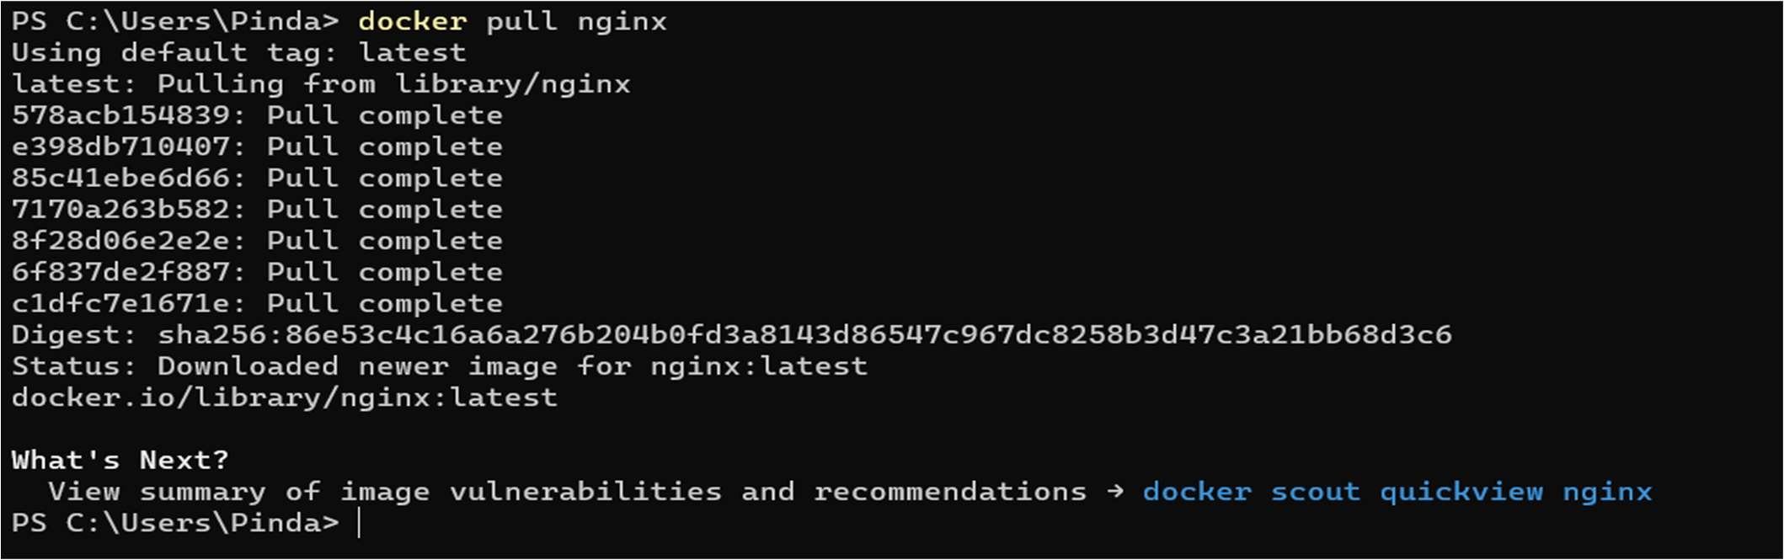

To Check if Image is pulled or not, Run $ docker images

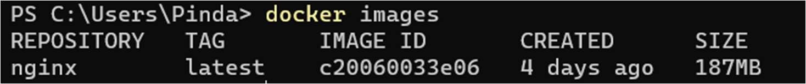

Image is available in docker engine and ready to use.



DockerHub:

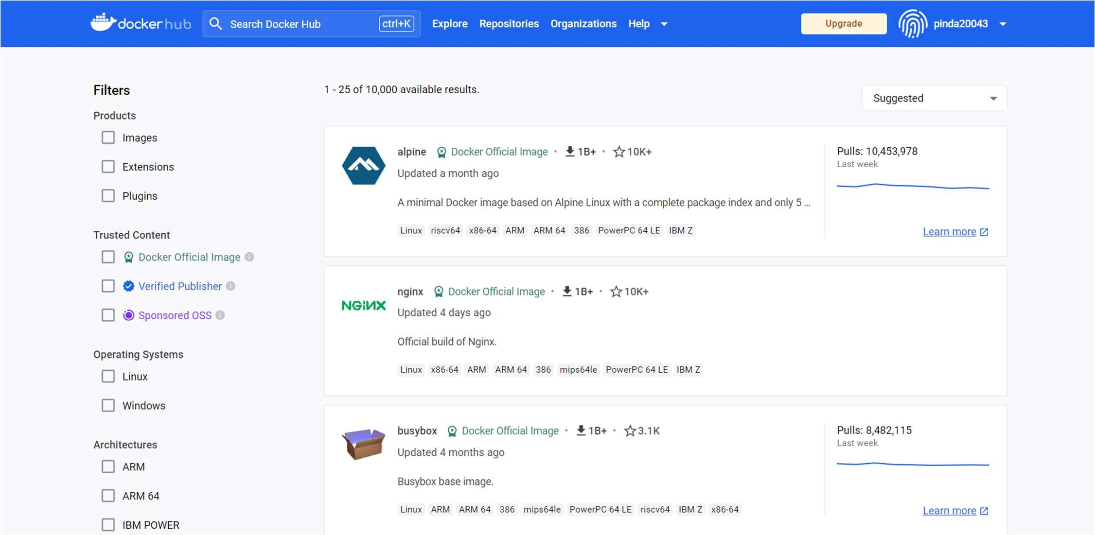

3. Learning outcomes (What I have learned):

1. To Understand the DockerHub.
2. To Pull Images from DockerHub.
3. Understand to use Docker Images commands.