Experiment No. 1.4

Student Name: Sarthak Tyagi UID: 22MCC20079

Branch: MCA - CCD Section/Group: 22MCD-1/ Grp A

Semester: III

Subject Name: Containerization With Docker Subject Code: 22CAH-742

1. Aim/Overview of the practical: Managing Containers with the Docker CLI

1. Task to be done: The Docker CLI is a powerful tool for managing Docker containers. It provides a comprehensive set of commands for performing all aspects of container management, including:
   * Starting, stopping, and restarting containers
   * Viewing container logs
   * Inspecting container status
   * Managing container networks and volumes

1. Code for experiment/practical:



To Create: $ docker run –name python1 python

To List: $ docker container ls -a



To Inspect: $ docker inspect python1

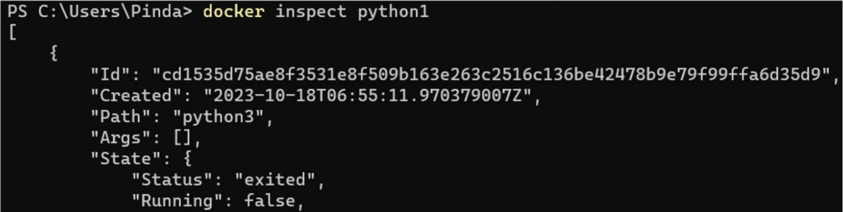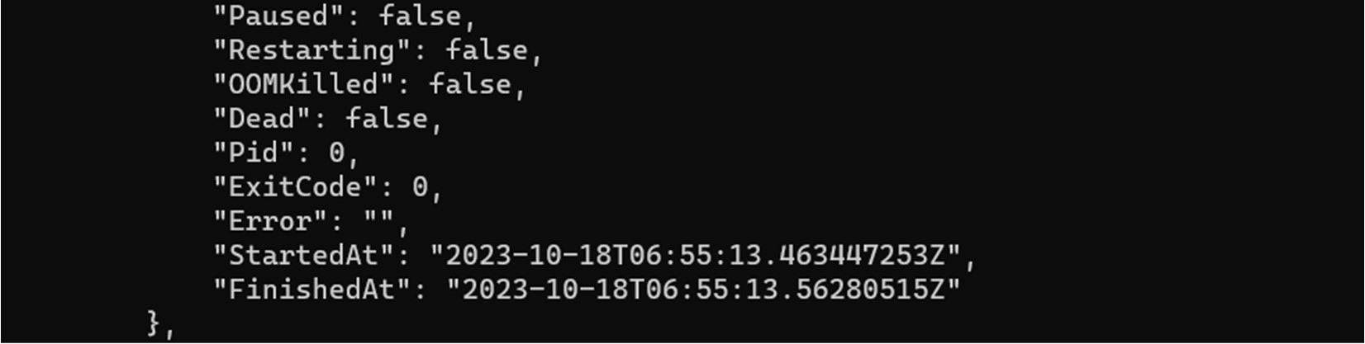

To Run in interactive mode: $ docker run –name ubuntu -it ubuntu

To Stop: $ docker container stop ubuntu1

To Remove: docker container rm ubuntu1

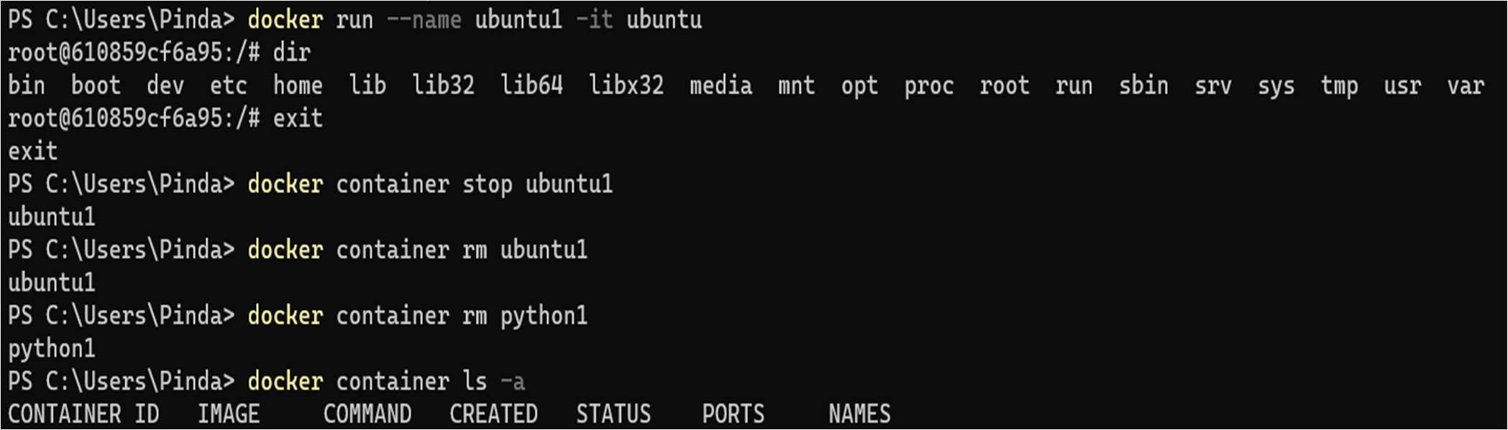

Managing container networks and volumes

To create network: $docker network create my-network

To create volume: $ docker volume create my-volume



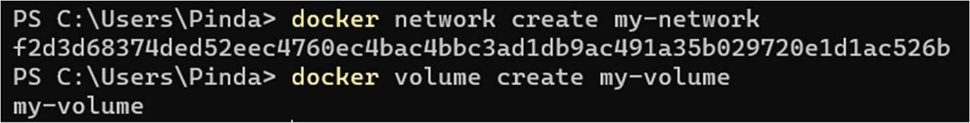

1. Learning outcomes (What I have learned):
   1. To manage container with CLI.
   2. To run, stop, remove Containers.
   3. Manage container networks and volume.