Experiment No. 2.1

Student Name: Sarthak Tyagi UID: 22MCC20079

Branch: MCA - CCD Section/Group: 22MCD-1/ Grp A

Semester: III

Subject Name: Containerization With Docker Subject Code: 22CAH-742

1. Aim/Overview of the practical: Understanding the Docker file for Customizing Images

1. Code for experiment/practical:

A Dockerfile is a text document that contains instructions for building a Docker image. It is a simple way to automate the image building process and ensure that your images are built consistently.

Dockerfiles are made up of a series of instructions, each of which is executed in order. The most common Dockerfile instructions include:



* + FROM: Specifies the base image to use for building the new image.
  + RUN: Executes a command in the image.
  + COPY: Copies files from the host machine to the image.
  + CMD: Specifies the command to run when the container is started.

Here is an example of a simple Dockerfile for customizing an image:

Creating a simple python image

Create Three file:

* + doc.py
  + requirement.txt
  + Dockerfile

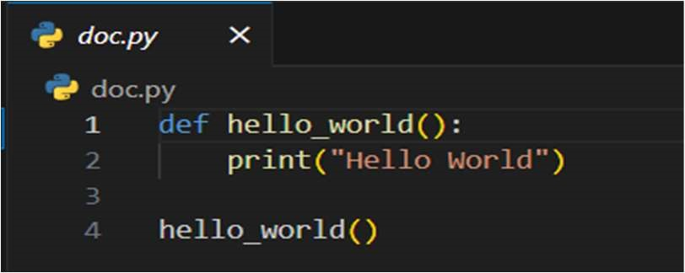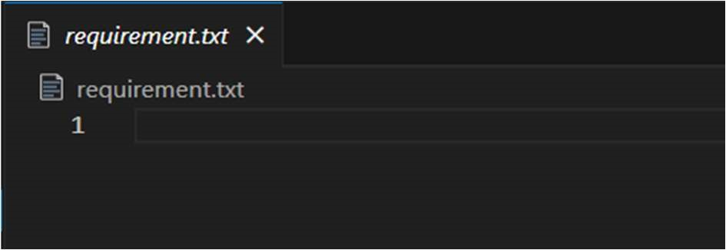

This Dockerfile builds a new image based on the python:3 base image. It then copies the application's . /app file and source code to the image. It then installs the application's dependencies and sets the CMD instruction to start the application when the container is started.

Commands for building an Image: $ docker build -t python-image.

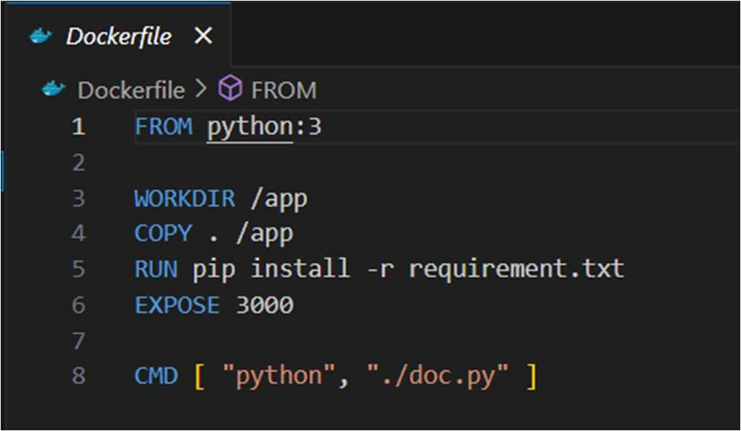

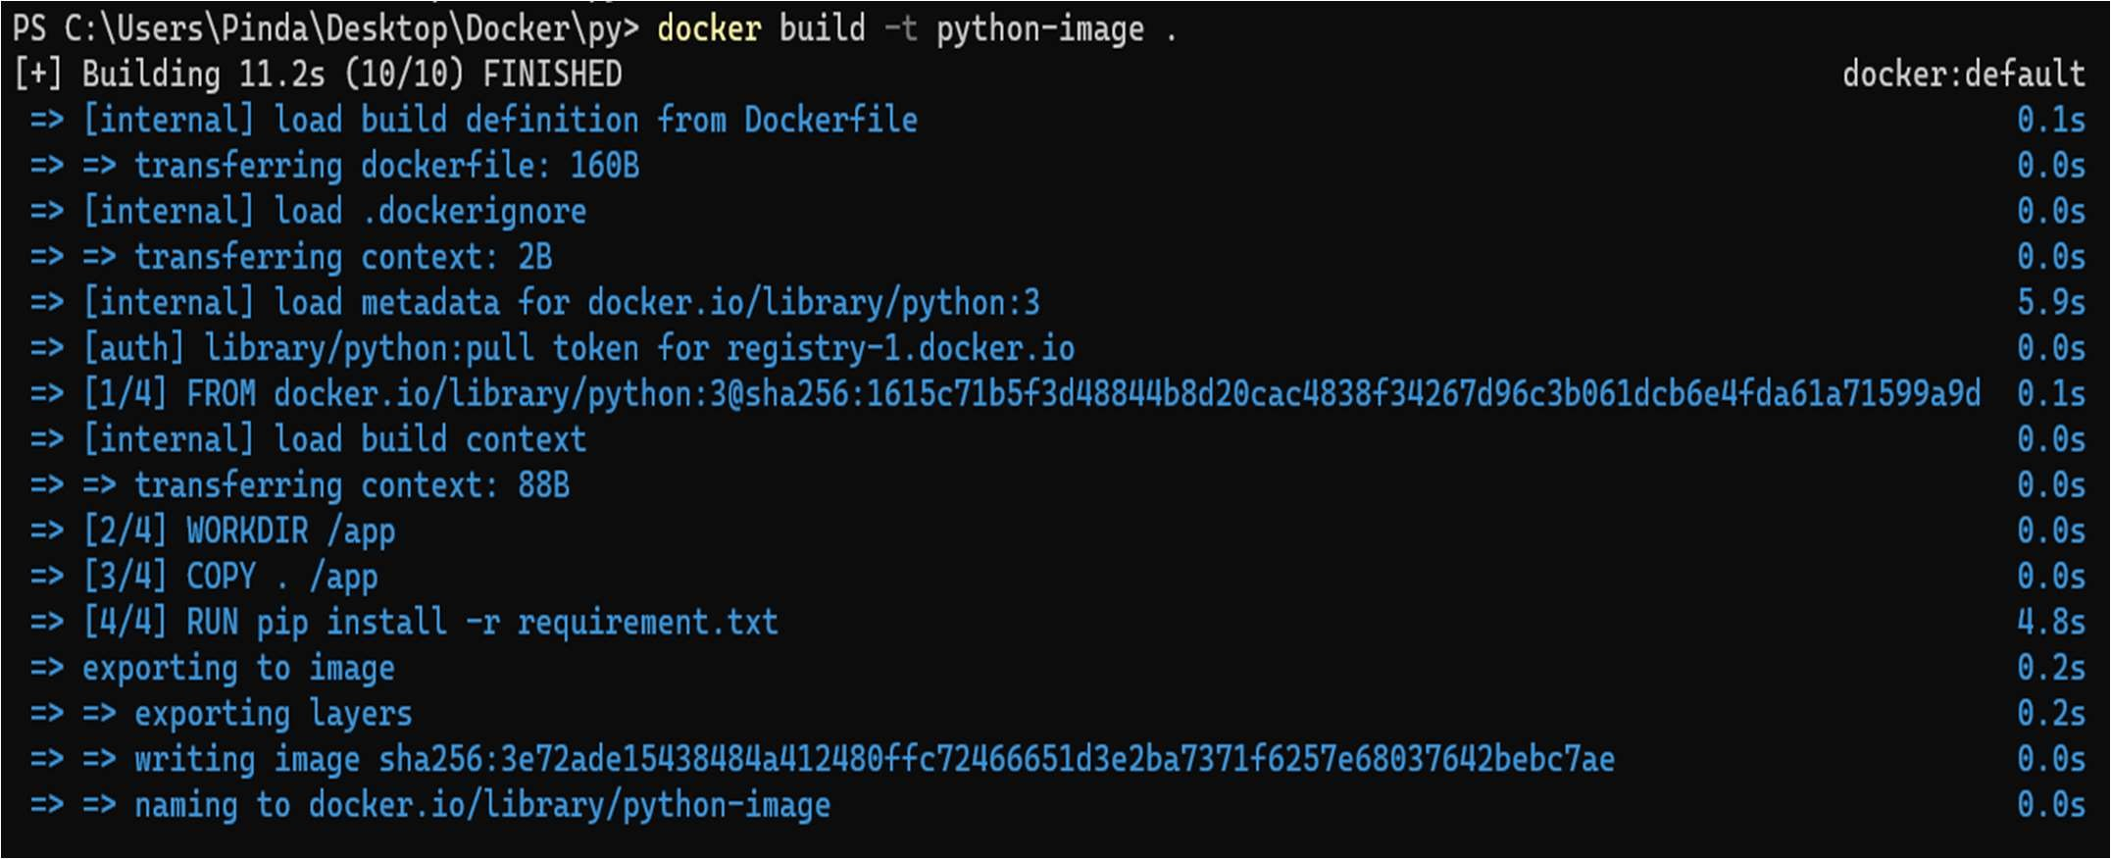

To run Image: $ docker run python-image



1. Learning outcomes (What I have learned):
   1. To understand Dockerfile.
   2. To build Docker Image from Dockerfile.
   3. To run an image that was created using Dockerfile.