Experiment No. 2.2

Student Name: Sarthak Tyagi UID: 22MCC20079

Branch: MCA - CCD Section/Group: 22MCD-1/ Grp A

Semester: III

Subject Name: Containerization With Docker Subject Code: 22CAH-742

1. Aim/Overview of the practical: Building a Custom Docker Image for a Web Application

1. Code for experiment/practical:

To build a custom Docker image for a web application, you will need to create a Dockerfile. The Dockerfile will contain the instructions that Docker needs to build the image.

The first step is to choose a base image. The base image is the image that your custom image will be built on. For a web application, you will typically want to choose a base image that contains a web server, such as Nginx or Apache.



Here, we are creating web application image using nginx base image,. Step1: Create an index.html and Dockerfile.

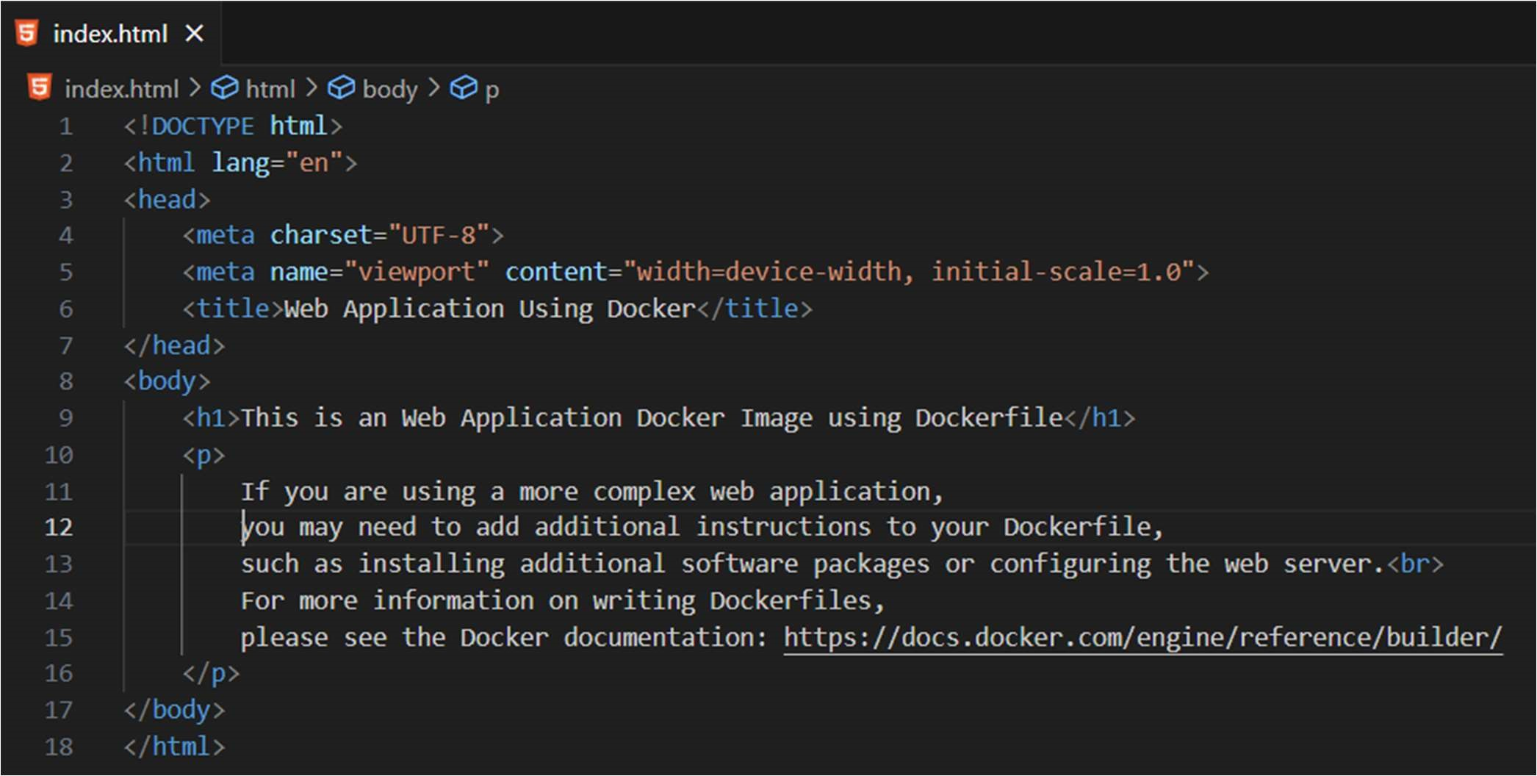

Commands for building an Image: $ docker build -t web-image .

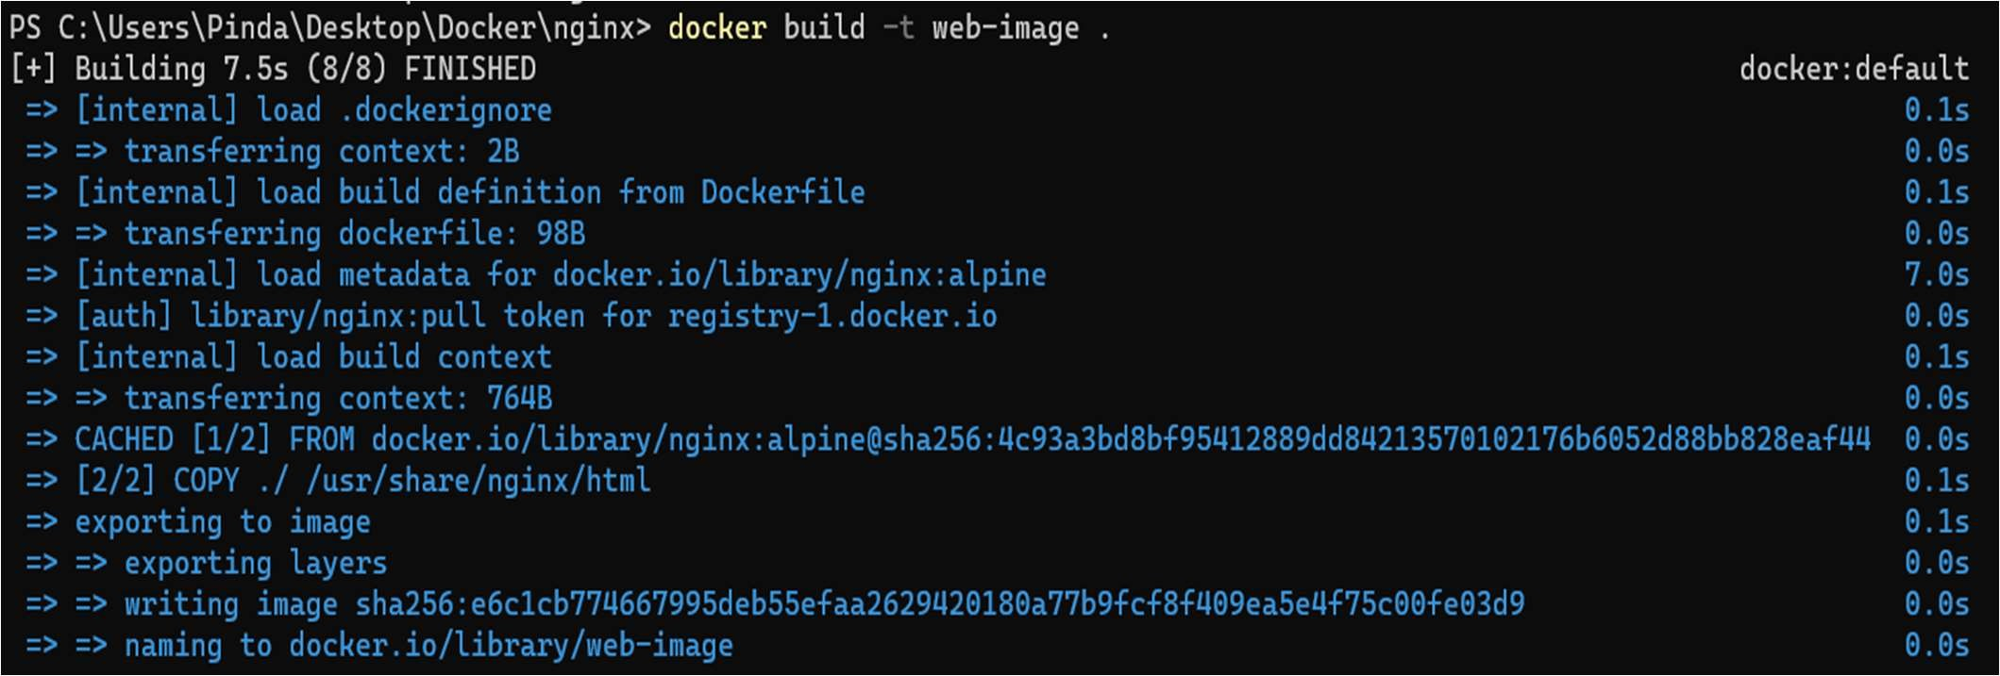

To run Image: $ docker run -it -p 8080:80 web-image

Note: Here we have to specify the port number for running web application.

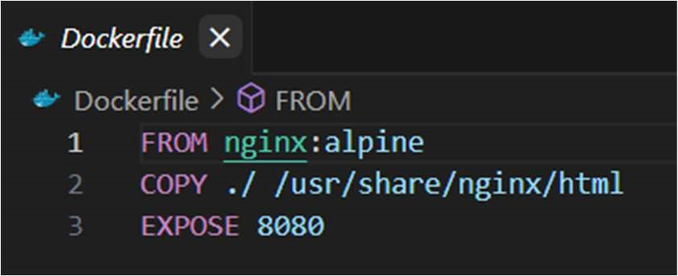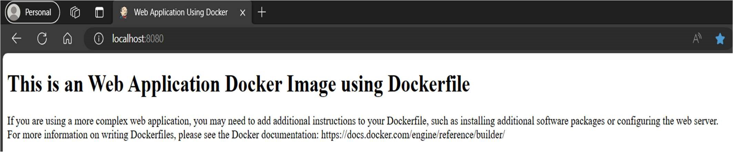

1. Learning outcomes (What I have learned):
   1. To understand Dockerfile.
   2. To build Docker Image from Dockerfile.
   3. To run an image that was created using Dockerfile.