Experiment No. 2.3

Student Name: Sarthak Tyagi UID: 22MCC20079

Branch: MCA - CCD Section/Group: 22MCD-1/ Grp A

Semester: III

Subject Name: Containerization With Docker Subject Code: 22CAH-742

1. Aim/Overview of the practical: Maintaining States with Docker Volumes.

1. Code for experiment/practical:

Maintaining state with Docker volumes means using Docker volumes to store data that needs to be persisted between container restarts or between different containers. This is useful for applications that need to retain their state, such as databases, caching servers, and session state servers.

Two Sates:

* + Stateless containers
  + Stateful containers



To maintain state with Docker volumes, you need to:

* + Create a Docker volume.
  + Mount the Docker volume to the container.
  + Write data to the Docker volume.

Once you have written data to the Docker volume, the data will be persisted even if the container is restarted or deleted.

Steps for Maintaining States with Docker Volumes.

* + First create a volume and inspect.

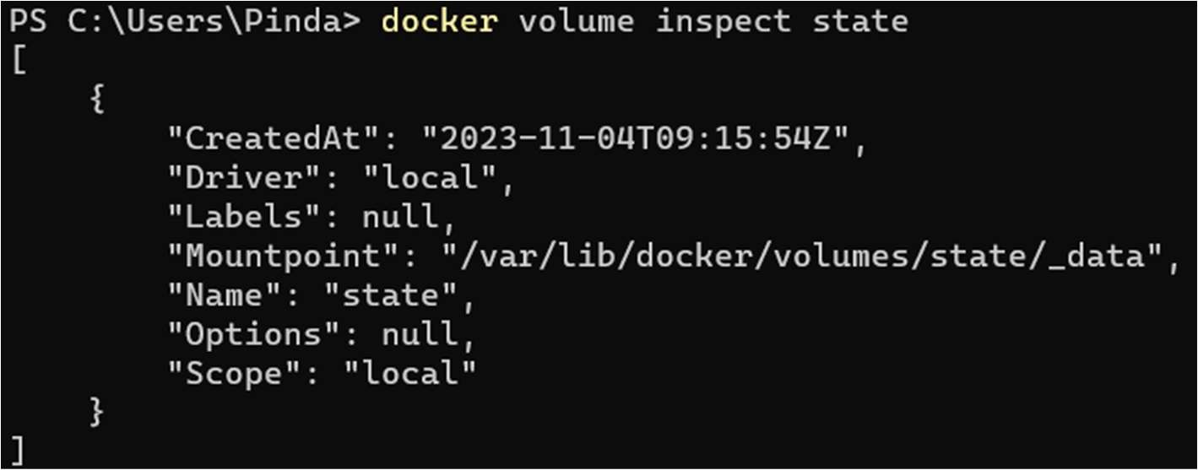

* + Create a container using image with some additional flags:

-v for volume

-it for interaction mode

--name container name



Container is in running state.

o Specify the path o Create some files or data in running container, Then exit and remove the container.

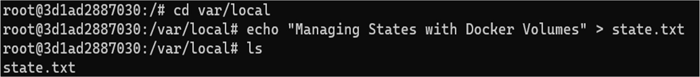

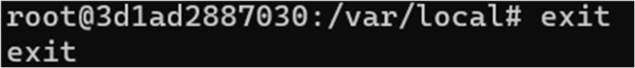

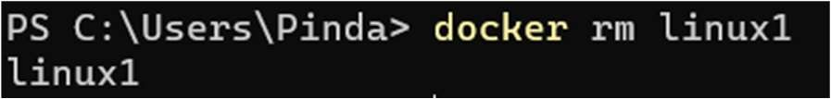

* + After removing the previous container, Now Create another container same with -v -it or –name flag o Specify the path o List the files



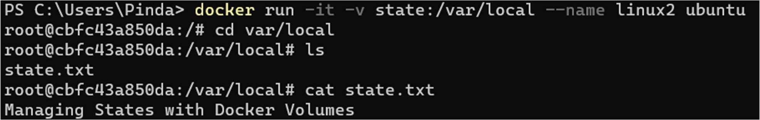

* + Previous generated file is visible that means different container are using the same volume.

1. Learning outcomes (What I have learned):
   * 1. To understand the States
     2. To Manage the States with Docker Volumes.
     3. To Share same Volume with different containers.