Experiment No. 3.1

Student Name: Sarthak Tyagi UID: 22MCC20079

Branch: MCA - CCD Section/Group: 22MCD-1/ Grp A

Semester: III

Subject Name: Containerization With Docker Subject Code: 22CAH-742

1. Aim/Overview of the practical: Working with Docker Compose.

1. Code for experiment/practical:

Compose is a tool for defining and running multi-container Docker applications. With Compose, you use a YAML file to configure your application's services. Then, with a single command, you create and start all the services from your configuration.

Compose works in all environments; production, staging, development, testing, as well as CI workflows. It also has commands for managing the whole lifecycle of your application:

* + Start, stop, and rebuild services



* + View the status of running services
  + Stream the log output of running services • Run a one-off command on a service

Working with Docker Compose:

* + Installation
  + Create Docker Compose File
  + Use Docker Compose file to create services

1. Installation

With Docker-Desktop installation, Docker-Compose is pre-installed

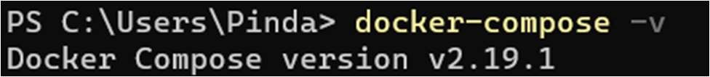

1. Create Docker Compose file
   * Create a directory at a specific location.

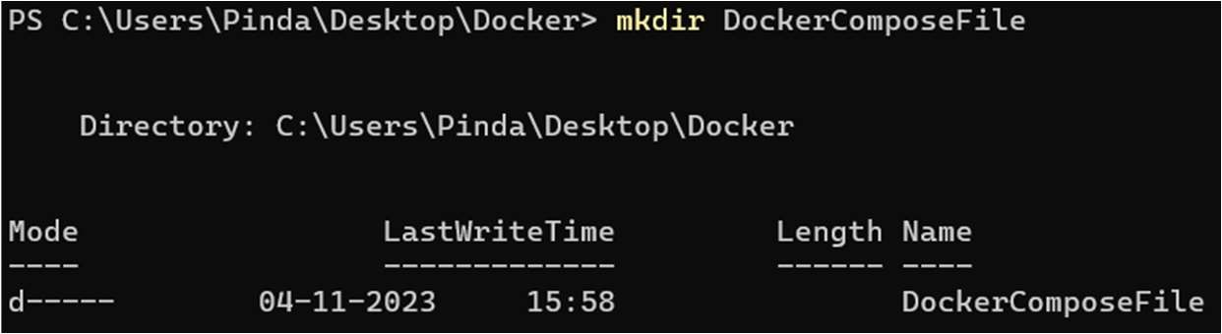

* + Go to that directory and create a file docker-compose.yml.

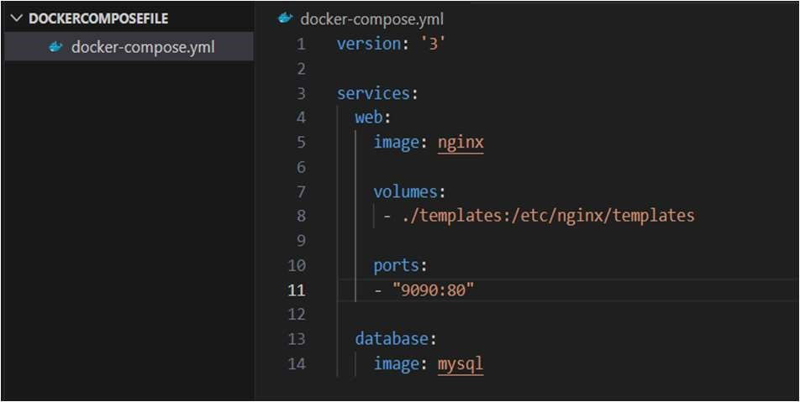

* + Check the validity of docker-compose file.

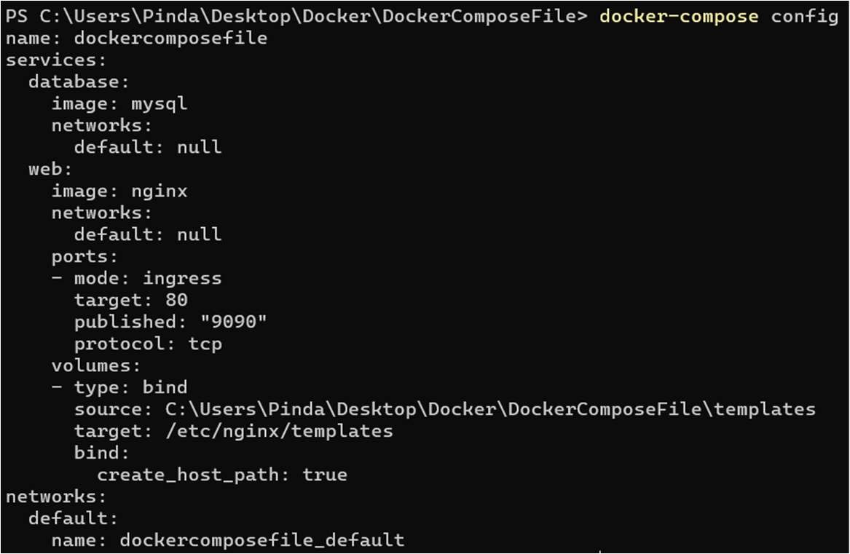



1. Use Docker Compose File to create services • Run docker-compose.yml file.

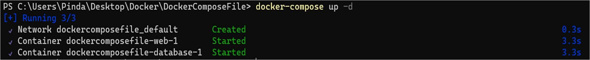

* + To stop docker-compose

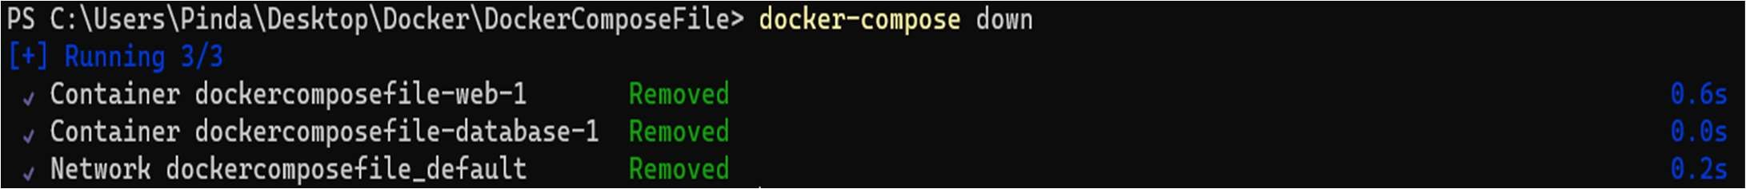

3. Learning outcomes (What I have learned):

1. To understand the Docker Compose.
2. To manage multiple containers using Docker Compose.
3. To create services in Docker Compose.