Experiment No. 3.2

Student Name: Sarthak Tyagi UID: 22MCC20079

Branch: MCA - CCD Section/Group: 22MCD-1/ Grp A

Semester: III

Subject Name: Containerization With Docker Subject Code: 22CAH-742

1. Aim/Overview of the practical: Creating a Private Docker Image Repository.

1. Code for experiment/practical:

A private Docker image repository is a Docker registry that is only accessible to authorized users. This is in contrast to a public Docker registry, such as Docker Hub, which is accessible to anyone.

Private Docker image repositories can be hosted on-premises or in the cloud. There are many benefits to using a private Docker image repository, including:

* Security
* Compliance



* Performance

Creating Private Docker Image Repository :

* Pull the Registry Image from Dockerhub

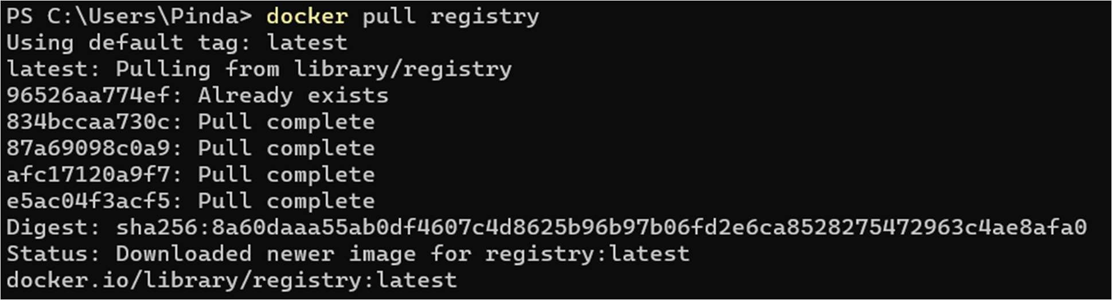

* Run local registry in detached mode

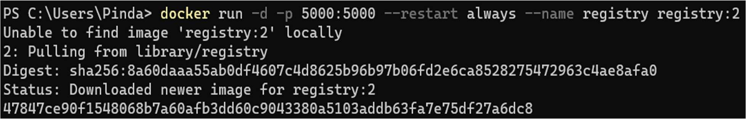

* Now, use it from within Docker:

$ docker pull nginx

* Set tag to ready for push

$ docker tag nginx localhost:5000/nginx1



* Pushing image to Private Docker Image Repository

$ docker push localhost:5000/nginx1

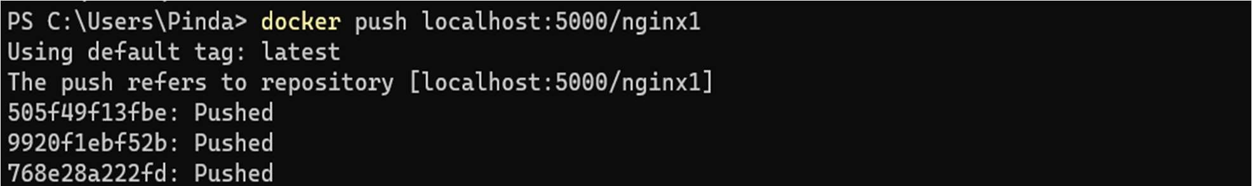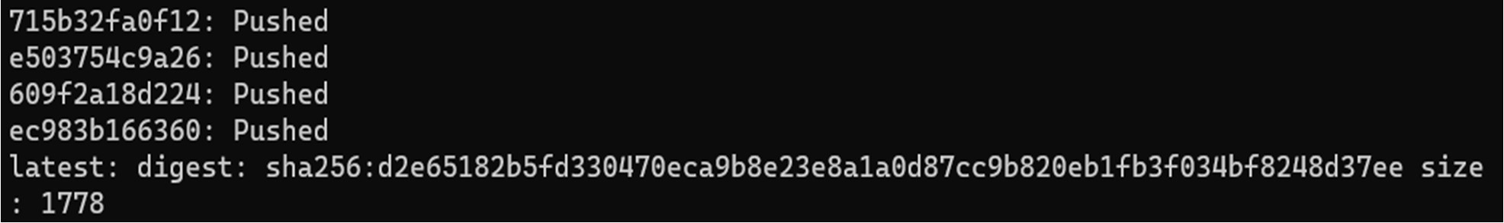

* Check image is pushed or not in private repository curl http://localhost:5000/v2/_catalog

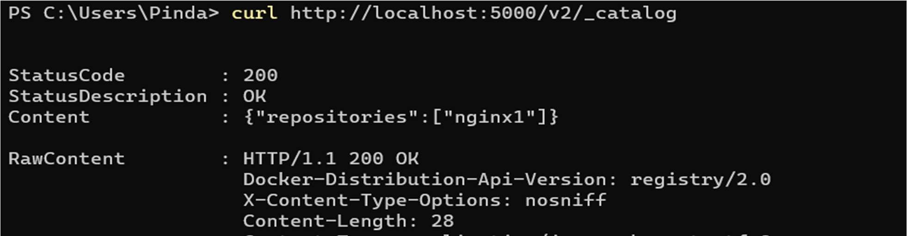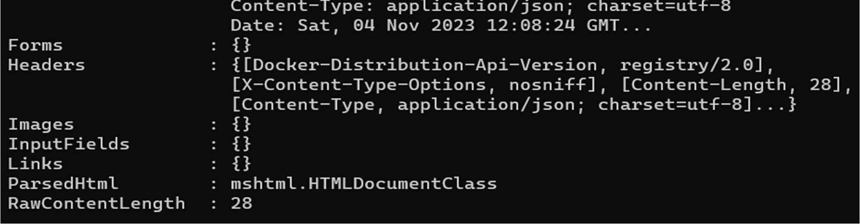

3. Learning outcomes (What I have learned):

1. Understand the Private Docker Image Repository.
2. Understand to run or stop Private Repository.
3. Understand to tag, push Image to Private Repository.