Experiment No. 3.3

Student Name: Sarthak Tyagi UID: 22MCC20079

Branch: MCA - CCD Section/Group: 22MCD-1/ Grp A

Semester: III

Subject Name: Containerization With Docker Subject Code: 22CAH-742

1. Aim/Overview of the practical: Cleaning Up Old Containers and Docker Images.

1. Code for experiment/practical:

To clean up old containers and Docker images, you can use the following commands:

* + docker container prune: Removes all stopped containers.
  + docker image prune: Removes all dangling images.
  + docker system prune: Removes all unused images, containers, volumes, and networks.

Important: Be careful when using the system prune command, as it can remove all unused resources, including volumes. If you are unsure about what will be removed, you can use the -a flag to display all resources that will be removed before confirming the operation.



Cleaning up Old Container:

* + First check container that are available: $docker ps -a



* + Then use docker container prune to clean up old container: $docker container prune o Their will be WARNING that This will remove all stopped containers.

o Are you sure you want to continue? [y/N] o Press Y for yes else N, then Enter.

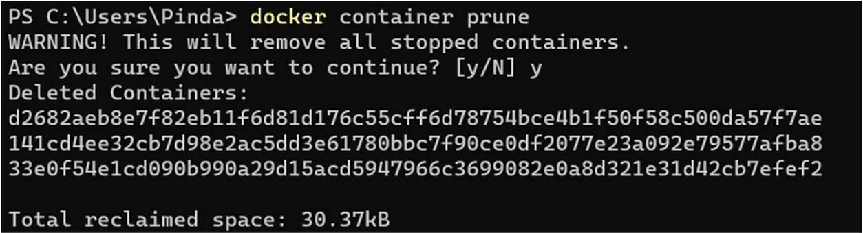

Cleaning up Old Images:

* + First check images that are available: $docker images

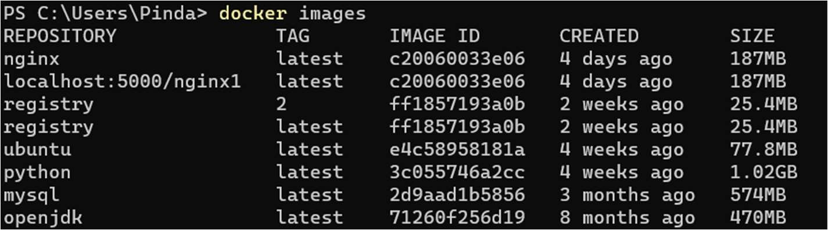

* + Then use docker image prune to clean up old dangling images: $docker image prune o Their will be WARNING that This will remove all dangling images.

o Are you sure you want to continue? [y/N] o Press Y for yes else N, then Enter.

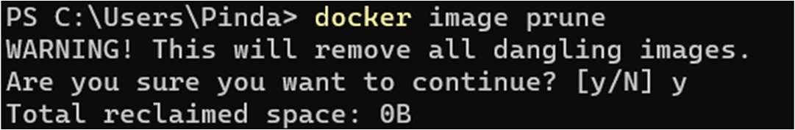

* + Then use docker image prune to clean up all available images: $docker image prune -a o Their will be WARNING that This will remove all images.

o Are you sure you want to continue? [y/N] o Press Y for yes else N, then Enter.



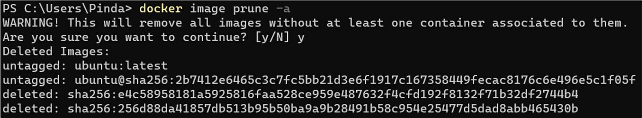

1. Learning outcomes (What I have learned):
   * 1. Understand the Docker Prune command.
     2. Understand to run prune command with images and container.
     3. Understand to free up the space by pruning the unnecessary data or storage.