VISHWAKARMA INSTITUTE OF TECHNOLOGY, PUNE
(An Autonomous Institute Affiliated to Savitribai Phule Pune University)
DEPARTMENT OF COMPUTER SCIENCE AND ARTIFICIAL INTELLIGENCE
Academic Year: 2026–2027
―――――――――――――――――――――――――――――――――――――――――――――
FINAL YEAR ACADEMIC PROJECT REPORT
FairCredit-AI: A Responsible AI Credit Model Auditing Framework
Evaluating the Impact of Fairness Mitigation on Explanation Consistency
in Machine Learning-Based Credit Scoring
Submitted By: | Under the Guidance of:
Sarthak Balaji Zunjure  [Roll No: ____________] | Prof. Dhananjay Bhagat  Assistant Professor, Dept. of CSAI
[Additional Team Member: ____________]  [Roll No: ____________] | Vishwakarma Institute of Technology, Pune
Degree: B.Tech in Artificial Intelligence | Academic Term: Eighth Semester (2026–2027)

■ LEGAL AND REGULATORY RESPONSIBLE-USE DISCLAIMER
FairCredit-AI is developed exclusively as an academic research prototype, model auditing framework, and educational demonstration tool. Its algorithmic outputs, risk scores, and disparity audits must not be utilized as the sole or definitive basis for real-world retail lending, credit underwriting, applicant eligibility, or adverse action determinations. Experimental compliance with mathematical fairness metrics does not constitute, substitute for, or establish legal certification under statutory credit regulations, including the Equal Credit Opportunity Act (ECOA) or the Fair Credit Reporting Act (FCRA).

Executive Summary
Credit scoring institutions are increasingly transitioning from traditional empirical scorecards to complex, non-linear machine learning models such as Gradient Boosted Trees and Deep Decision Forests to maximize predictive accuracy and minimize underwriting default loss. However, these models risk encoding, perpetuating, and amplifying historical societal disparities against legally protected demographic groups. In response, algorithmic fairness techniques—ranging from training-time pre-processing sample reweighing to post-processing threshold adjustments—have been introduced. Simultaneously, regulatory governance frameworks mandating adverse action notices require transparent feature attributions, typically generated via local explainability methods such as SHAP (SHapley Additive exPlanations).
Despite their widespread parallel deployment, the algorithmic interaction between fairness interventions and explanation stability has remained under-explored. A critical open research question is whether modifying a model's training loss landscape or decision threshold to satisfy demographic parity or equalized odds inadvertently perturbs the underlying attribution profiles of individual applicants, causing explanation inconsistency or attribution collapse.
This academic project introduces FairCredit-AI, a comprehensive, end-to-end Responsible AI credit model auditing framework and empirical research benchmark. The project implements a complete, decoupled web application—combining a modern Next.js 16 frontend with a high-performance Python FastAPI backend—that enables financial risk officers, compliance auditors, and AI governance researchers to jointly evaluate three foundational pillars of trustworthy machine learning: predictive performance (ROC-AUC, F1, Balanced Accuracy), group fairness (Equalized Odds Difference, Demographic Parity Difference, Approval Disparate Impact), and individual explanation consistency (SHAP Cosine Similarity, Top-5 Feature Overlap, and Spearman Rank Correlation).
Empirical evaluation was conducted across 18 rigorous mitigation experiments spanning two widely benchmarked retail credit datasets (the Taiwan Default of Credit Card Clients dataset, N=30,000, and the Statlog German Credit dataset, N=1,000) and three representative model families (Logistic Regression, Random Forest, and XGBoost). Explanation consistency was empirically measured across identical held-out test cohorts (N=500 for Taiwan, N=200 for German) comparing baseline models against refitted continuous models under Kamiran & Calders Reweighing.
The empirical findings refute the widespread assumption of a universal, inevitable trade-off between fairness mitigation and explanation stability. Instead, the research reveals heterogeneous, architecture-dependent behavior: (1) Predictive performance demonstrated high resilience under sample reweighing, incurring a negligible mean absolute ROC-AUC drift of only 0.0047 across configurations; (2) In a standout configuration—German Random Forest—fairness mitigation achieved a win-win profile, reducing Equalized Odds Difference by 60.0% (0.1250 to 0.0500) while simultaneously boosting ROC-AUC by +1.76% (0.7798 to 0.7935) and retaining high explanation consistency (Mean Cosine = 0.9652, Top-5 Overlap = 0.8370); (3) A critical divergence emerged between fairness metrics, where unconditional demographic parity improvements frequently widened conditional equalized odds disparities; and (4) Model architecture governs attribution stability: linear hyperplanes preserve near-invariant feature rankings (Spearman rho >= 0.9832), whereas unconstrained tree ensembles exhibit splitting plasticity, causing local attribution reordering despite aggregate directional stability. FairCredit-AI demonstrates that holistic, multi-dimensional auditing is essential for responsible financial AI governance.
Keywords:
Responsible AI, Algorithmic Fairness, Credit Scoring, Model Auditing, SHAP (SHapley Additive exPlanations), Explanation Consistency, Equalized Odds, Demographic Parity, Machine Learning Governance, Model Risk Management.

Table of Contents
Front Matter | i
Executive Summary | ii
Table of Contents | iv
List of Figures and List of Tables | v
Abbreviations and Terminology | vi
Chapter 1: Introduction | 1
1.1 Background and Motivation | 1
1.2 Machine Learning in Modern Credit Scoring | 2
1.3 The Triad of Algorithmic Accountability: Fairness, Explainability, and Reliability | 3
1.4 Problem Statement | 4
1.5 Aim and Specific Objectives | 5
1.6 Research Questions | 6
1.7 Project Scope and Operational Boundaries | 7
1.8 Target Stakeholders and Intended Use | 8
1.9 Organization of the Project Report | 9
Chapter 2: Problem Definition and Existing Approaches | 10
2.1 The Practical Challenge in Algorithmic Credit Decisioning | 10
2.2 Limitations of Conventional Accuracy-Centric Evaluation | 11
2.3 The Necessity of Joint Auditing: Accuracy, Fairness, and Consistency | 12
2.4 Survey of Existing Fairness Mitigation Approaches | 13
2.5 Survey of Explainable AI (XAI) Methods in Finance | 15
2.6 Academic Positioning and Distinct Contribution | 16
Chapter 3: Proposed Framework and System Design | 18
3.1 Conceptual Framework Overview | 18
3.2 Decoupled System Architecture | 19
3.3 End-to-End Data Flow Pipeline | 21
3.4 Core Functional Modules and Responsibilities | 23
3.5 Verified REST API Endpoints and Data Contracts | 24
3.6 Model Deserialization, Caching, and Preprocessing Pipelines | 26
3.7 Fairness Auditing and Disparity Quantification Workflow | 27
3.8 SHAP Explanation and Consistency Analysis Workflow | 28
3.9 Security, Input Validation, and Responsible-Use Safeguards | 29
Chapter 4: Dataset and Experimental Methodology | 31
4.1 Benchmark Credit Datasets (Taiwan Default and Statlog German) | 31
4.2 Target Definitions and Class Semantics | 32
4.3 Protected Attribute Definitions and Exclusion Protocols | 33
4.4 Preprocessing and Partitioning Protocol (80/20 Stratified) | 34
4.5 Machine Learning Model Families and Configurations | 35
4.6 Algorithmic Fairness Mitigation Protocol (18 Experiments) | 36
4.7 Methodological Rationale for Primary SHAP Comparison | 38
4.8 Architectural Disparities in SHAP Output Spaces | 39
4.9 Quantitative Evaluation Metrics (Performance, Fairness, Consistency) | 40
4.10 Cohort Sampling and Bootstrap Statistical Confidence Intervals | 42
4.11 Experimental Reproducibility and Frozen Artifact Protocol | 43
Chapter 5: System Implementation | 44
5.1 Full-Stack Technology Selection and Justification | 44
5.2 Repository Structure and Architecture Hierarchy | 45
5.3 Interactive Frontend User Interface and User Flows | 47
5.4 Backend Microservices and Algorithmic Pipelines | 50
5.5 Semantic Feature Dictionary Mapping | 51
5.6 Implementation Status: Completed Artifacts vs. Future Roadmap | 52
Chapter 6: Results and Evaluation | 54
6.1 Baseline Performance and Initial Fairness Disparities | 54
6.2 Comprehensive Evaluation Across 18 Mitigation Experiments | 56
6.3 Impact on Predictive Accuracy and Score Resilience | 59
6.4 Fairness Metric Divergence: Independence vs. Error-Rate Separation | 61
6.5 Quantitative SHAP Explanation Consistency Findings | 63
6.6 Case Study 1: The German Random Forest Win-Win Configuration | 65
6.7 Case Study 2: The Taiwan XGBoost Attribution Instability | 67
6.8 Empirical Findings from Benchmark Figures (Figures 6.1 to 6.5) | 69
6.9 Academic Nuance: Rejection of Universal Trade-Offs | 74
Chapter 7: Testing, Verification, and Quality Assurance | 76
7.1 Verification Strategy and Testing Philosophy | 76
7.2 Automated Pytest Suite Execution (13 Unit and Integration Tests) | 77
7.3 Independent Confusion Matrix and Metric Verification | 79
7.4 Mitigation Results Reconstruction and Audit (18/18 Verified) | 80
7.5 Phase 4 SHAP Consistency Validation Checks (12/12 Passed) | 81
7.6 Frontend Production Build and Route Verification | 82
7.7 Verifiable Scope, Known Boundaries, and Limitations of Tests | 83
Chapter 8: Discussion, Limitations, and Future Scope | 85
8.1 Synthesis of the Tri-Part Evaluation Paradigm | 85
8.2 Architectural Drivers of Attribution Plasticity | 86
8.3 Dataset and Sampling Constraints | 88
8.4 Scope of Protected Attributes and Intersectional Limitations | 89
8.5 Theoretical and Practical Boundaries of Local SHAP Attributions | 90
8.6 Comprehensive Roadmap for Future Enhancements | 91
Chapter 9: Conclusion | 94
9.1 Summary of Addressed Challenges and Framework Implementation | 94
9.2 Synthesis of Primary Empirical Conclusions | 95
9.3 Practical Implications for AI Governance in Financial Services | 96
9.4 Final Concluding Remarks | 97
References | 98
Appendices | 101
Appendix A: REST API Endpoint Specifications | 101
Appendix B: Master Experimental Results Matrix (18 Configurations) | 103
Appendix C: Mathematical Formulations of Auditing Metrics | 105
Appendix D: System Repository Structure and Model Asset Manifest | 107

List of Figures and List of Tables

List of Figures
Figure 3.1 | FairCredit-AI System Architecture: Decoupled Full-Stack Auditing Framework | 20
Figure 3.2 | End-to-End Data Flow and Algorithmic Inference Pipeline | 22
Figure 6.1 | Equalized Odds Difference: Baseline vs. Reweighed Models Across Datasets | 70
Figure 6.2 | ROC-AUC Predictive Performance: Baseline vs. Reweighed Models | 71
Figure 6.3 | Mean SHAP Cosine Similarity Between Baseline and Reweighed Explanations | 72
Figure 6.4 | Trade-Off Analysis: Equalized Odds Improvement vs. SHAP Cosine Similarity | 73
Figure 6.5 | Performance-Fairness Coupling: Equalized Odds Improvement vs. ROC-AUC Change | 74

List of Tables
Table 4.1 | Credit Scoring Datasets and Empirical Sampling Specifications | 31
Table 4.2 | Machine Learning Model Architectures and Hyperparameter Configurations | 35
Table 4.3 | Fairness Mitigation Taxonomy and Algorithmic Implementations | 37
Table 4.4 | Explanation Consistency Metrics and Mathematical Formulations | 41
Table 5.1 | FairCredit-AI Full-Stack Software Stack and Core Dependencies | 44
Table 5.2 | FastAPI Production REST API Endpoint Specification | 50
Table 6.1 | Baseline Predictive Performance and Fairness Disparities Across 6 Configurations | 55
Table 6.2 | Comprehensive Fairness Mitigation Experimental Benchmark (18 Experiments) | 57
Table 6.3 | SHAP Explanation Consistency Metrics for Held-Out Cohorts (Mean and 95% CIs) | 64
Table 6.4 | Joint Auditing Matrix: Performance, Fairness, and Explanation Consistency | 66
Table 7.1 | Automated Pytest Suite Execution Summary (13 Unit and Integration Tests) | 78
Table 7.2 | System Verification and Independent Reconstruction Audit Outcomes | 83

Abbreviations and Terminology
Abbreviation / Term | Formal Definition and Contextual Meaning
AI | Artificial Intelligence
ML | Machine Learning
XAI | Explainable Artificial Intelligence
SHAP | SHapley Additive exPlanations (cooperative game theoretic local attribution)
ROC-AUC | Receiver Operating Characteristic - Area Under Curve
EOD | Equalized Odds Difference (|TPR_diff| + |FPR_diff| or max disparity)
DPD | Demographic Parity Difference (|P(Y_hat=1|A=0) - P(Y_hat=1|A=1)|)
DI | Disparate Impact Ratio (P(Y_hat=favorable|unprivileged) / P(Y_hat=favorable|privileged))
TPR / FPR | True Positive Rate / False Positive Rate
TNR / FNR | True Negative Rate / False Negative Rate
LR | Logistic Regression
RF | Random Forest Classifier
XGB | Extreme Gradient Boosting (XGBoost)
CI | Confidence Interval (computed via 1,000-iteration bootstrap resampling)
REST | Representational State Transfer (architectural style for web APIs)
API | Application Programming Interface
ECOA | Equal Credit Opportunity Act (United States fair lending regulation)
FCRA | Fair Credit Reporting Act (governing adverse action notices and reason codes)
CFPB | Consumer Financial Protection Bureau
SR 11-7 | Federal Reserve Supervisory Guidance on Model Risk Management

Chapter 1: Introduction

1.1 Background and Motivation
Credit scoring constitutes the analytical bedrock of consumer financial services, governing access to retail lending, mortgages, credit cards, and small-business capitalization across global economies. Historically, underwriting decisions relied heavily on expert judgment and empirical linear models—primarily Scorecard Logistic Regression and discriminant analysis—calibrated on coarse demographic and financial attributes. Over the past decade, financial institutions have rapidly embraced advanced machine learning (ML) paradigms, including bagging ensembles (Random Forests) and gradient-boosted decision trees (XGBoost, LightGBM). These algorithms excel at capturing high-dimensional, non-linear interactions and complex behavioral patterns, delivering demonstrably superior predictive discrimination and lowering portfolio default loss.
However, this algorithmic transition introduces severe systemic challenges. Advanced machine learning models operate largely as complex 'black boxes', obscuring the causal and statistical reasoning underpinning individual underwriting decisions. Furthermore, because historical lending datasets inherently reflect systemic socioeconomic disparities, unconstrained ML models readily learn, perpetuate, and amplify disparate impact against historically underrepresented or marginalized groups, such as female or minority credit applicants. This tension places retail lenders at the nexus of severe regulatory, legal, and ethical liabilities.

1.2 Machine Learning in Modern Credit Scoring
In contemporary quantitative finance, credit scoring is mathematically framed as a supervised binary classification problem. Given an applicant feature vector x in X representing credit history, debt obligations, payment timeliness, and banking behavior, an underwriting model f(x) estimates the conditional posterior probability of default within a specified performance window (typically 12 to 24 months): P(Y = 1 | X = x), where Y = 1 denotes a credit default event and Y = 0 denotes satisfactory debt repayment. If this estimated probability falls below an institutional acceptance threshold tau, the credit application is approved.
While non-linear models achieve higher Area Under the ROC Curve (ROC-AUC) and Kolmogorov-Smirnov (KS) statistics than legacy scorecards, their decision boundaries are intricate hyper-surfaces that resist manual inspection. In financial risk management, predictive power alone is legally and operationally insufficient: underwriting models must satisfy rigorous standards of fairness, transparent explainability, and post-deployment stability.

1.3 The Imperative of Fairness, Explainability, and Model Reliability
The deployment of algorithmic credit models is strictly governed by financial regulations worldwide, notably the Equal Credit Opportunity Act (ECOA, Regulation B) and the Fair Credit Reporting Act (FCRA) in the United States, alongside the European Union Artificial Intelligence Act (EU AI Act) and General Data Protection Regulation (GDPR). These frameworks impose two non-negotiable requirements:
- Fair Lending Compliance: Lenders are prohibited from discriminating against credit applicants on the basis of legally protected attributes, including sex, marital status, race, age, and national origin. Importantly, merely omitting protected attributes from the feature matrix X (known as 'fairness through blindness') is demonstrably ineffective, as non-linear models readily reconstruct sensitive group identity through correlated proxy features.
- Adverse Action Explainability: When a credit application is rejected or granted on adverse terms, lenders are legally mandated to provide the applicant with an 'Adverse Action Notice' enumerating the principal factors (typically top 4 to 5 key reasons) that contributed to the adverse decision. Under modern ML, these reasons are generated using Explainable AI (XAI) techniques, predominantly SHAP (SHapley Additive exPlanations).
Consequently, modern credit risk governance cannot optimize for predictive accuracy in isolation. It must balance a complex triad: Predictive Performance, Group Fairness, and Explanation Consistency.

1.4 Problem Statement
While extensive academic literature has examined the trade-off between predictive accuracy and group fairness metrics, and separate bodies of work have focused on local explanation algorithms, the critical interaction between fairness mitigation and explanation consistency has remained largely unexplored in retail credit scoring.
When a credit model undergoes fairness mitigation—such as pre-processing sample reweighing to equalize group base rates, in-processing constrained optimization, or post-processing decision boundary shifts—the model's internal loss landscape and feature weights are altered. A critical operational hazard arises: Does intervening to enforce demographic or error-rate parity destabilize the local explanations generated for individual loan applicants? If an applicant receives completely different feature attribution rankings simply because a fairness algorithm reweighted the training loss, the explanation lacks fidelity and stability. Furthermore, if the top features cited in an adverse action notice fluctuate wildly under fairness mitigation, financial institutions risk regulatory sanctions for issuing arbitrary, non-reproducible credit explanations.
Currently, financial risk teams lack an integrated, production-grade auditing framework capable of simultaneously evaluating predictive discrimination, multi-metric group fairness, and applicant-level explanation consistency across diverse model architectures.

1.5 Aim and Specific Objectives
The primary aim of this project is to design, implement, and validate FairCredit-AI: a full-stack Responsible AI credit model auditing framework that establishes an empirical benchmark to evaluate the impact of algorithmic fairness mitigation on local explanation consistency across diverse machine learning architectures in consumer credit scoring.
To achieve this aim, the project pursues five specific technical and research objectives:
- Objective 1 (Dataset Harmonization): Develop and standardize a dual-dataset benchmark utilizing the Taiwan UCI Credit Card Default dataset (N=30,000) and the Statlog German Credit dataset (N=1,000), implementing strict feature exclusion of sensitive demographic attributes (sex) to prevent direct disparate treatment while evaluating proxy discrimination.
- Objective 2 (Baseline Modeling): Train and calibrate baseline models across three distinct architectural families: Logistic Regression (linear parametric), Random Forest (bagging tree ensemble), and XGBoost (regularized gradient boosted decision trees).
- Objective 3 (Fairness Mitigation Auditing): Implement and evaluate 18 fairness mitigation experiments spanning three foundational intervention paradigms: Kamiran & Calders Reweighing (pre-processing), Exponentiated Gradient with Equalized Odds (in-processing), and Threshold Optimizer (post-processing).
- Objective 4 (Explanation Consistency Protocol): Formulate a rigorous mathematical protocol to quantify applicant-level SHAP explanation consistency, computing Cosine Similarity, Top-5 Feature Overlap, and Spearman Rank Correlation on identical held-out evaluation cohorts (N=500 for Taiwan, N=200 for German) with 95% bootstrap confidence intervals.
- Objective 5 (Full-Stack Auditing Platform): Engineer and deploy a modular, full-stack software application—integrating a Next.js 16/React 19 interactive frontend with a Python FastAPI backend—that provides real-time credit scoring, disparity auditing, and empirical research visualization for model risk officers.

1.6 Research Questions
The empirical investigation within this project is guided by three formal research questions:
- Research Question 1 (Performance Impact): To what extent does algorithmic fairness mitigation (specifically training-time reweighing) degrade the predictive discrimination (ROC-AUC, Balanced Accuracy, F1-Score) of credit scoring models across linear and non-linear architectures?
- Research Question 2 (Fairness Metric Divergence): How do different mathematical formulations of fairness—specifically Demographic Parity (unconditional statistical independence) versus Equalized Odds (conditional error-rate parity)—respond to fairness interventions, and do improvements in one metric guarantee parity in another?
- Research Question 3 (Explanation Consistency Across Architectures): How does fairness mitigation affect the directional alignment, salience rank order, and top-contributor overlap of local SHAP feature attributions for identical credit applicants, and how does this explanation consistency vary across model families?

1.7 Project Scope and Operational Boundaries
The scope of FairCredit-AI is defined by clear methodological and operational boundaries to ensure scientific rigor and responsible engineering:
- Data Domain: The project focuses on tabular retail consumer credit scoring datasets. Time-series macroeconomic shocks, unstructured alternative data (e.g., text, social media metadata), and commercial corporate lending are excluded.
- Protected Attributes: The primary protected attribute audited across both datasets is binary sex ('sex' in Taiwan, derived personal status and sex in German Credit). Intersectional demographic interactions (e.g., race x age x gender) are identified as vital future extensions.
- Explanation Consistency Scope: The primary deep-dive explanation consistency evaluation is conducted between unmitigated baseline models and refitted models under Kamiran & Calders Reweighing. This boundary is methodologically necessary because both baseline and reweighed models produce genuine continuous scoring functions under identical feature representations, whereas randomized reduction and post-processing thresholding yield discrete/randomized classifications that do not support standard TreeSHAP continuous margin attribution comparisons.
- Operational Status: FairCredit-AI is strictly an academic research framework, auditing benchmark, and prototype demonstration system. It is not approved or certified for live, automated credit decisioning.

1.8 Target Stakeholders and Intended Use
The FairCredit-AI framework is engineered to serve three primary user personas in financial AI governance:
- Model Risk and Compliance Officers: Responsible for validating models under SR 11-7 guidelines, identifying hidden disparate impact, quantifying credit score degradation, and verifying adverse action explanation stability prior to production sign-off.
- Quantitative Risk Analysts & ML Engineers: Leveraging the interactive 'Assess Risk' and 'Fairness' interfaces to inspect applicant-level SHAP breakdowns, understand feature importance shifts, and evaluate mitigation trade-offs during model development.
- Academic and AI Governance Researchers: Utilizing the frozen empirical benchmark and reproducible API endpoints to investigate fundamental theoretical questions surrounding algorithmic fairness, attribution stability, and Pareto frontiers in AI safety.

1.9 Organization of the Project Report
This project report is structured into nine formal chapters reflecting an academic engineering investigation:
- Chapter 1 (Introduction): Provides the foundational motivation, problem statement, research objectives, and project boundaries.
- Chapter 2 (Problem Definition and Existing Approaches): Reviews relevant literature in algorithmic credit scoring, fairness mitigation taxonomy, and XAI, clearly articulating the project's academic positioning.
- Chapter 3 (Proposed Framework and System Design): Presents the overall framework, system architecture, decoupled Next.js/FastAPI components, data flow pipelines, and verified API contracts.
- Chapter 4 (Dataset and Experimental Methodology): Details the dual benchmark datasets, preprocessing rules, model configurations, mitigation algorithms, SHAP consistency metrics, and reproducibility safeguards.
- Chapter 5 (System Implementation): Documents the technical implementation, technology stack, directory hierarchy, frontend interactive pages, backend microservices, and semantic dictionaries.
- Chapter 6 (Results and Evaluation): Presents the authoritative empirical results, baseline audits, 18 mitigation experiments, explanation consistency metrics, embedded benchmark figures, and case studies.
- Chapter 7 (Testing, Verification, and Quality Assurance): Outlines the testing methodology, automated pytest execution, confusion matrix reconstructions, and 12-point SHAP validation audit.
- Chapter 8 (Discussion, Limitations, and Future Scope): Synthesizes the findings, discusses architectural drivers of explanation plasticity, outlines limitations, and provides a future research roadmap.
- Chapter 9 (Conclusion): Summarizes the completed work, empirical answers to the research questions, and closing reflections on financial AI governance.

Chapter 2: Problem Definition and Existing Approaches

2.1 The Practical Challenge in Algorithmic Credit Decisioning
The underwriting of consumer credit is an inherently high-stakes domain where machine learning models act as societal gatekeepers. When an algorithm estimates an individual's probability of default, that statistical output directly determines whether an applicant secures homeownership, obtains working capital for an enterprise, or is subjected to punitive interest rates. The central practical challenge arises because machine learning algorithms optimize strictly for statistical loss minimization—such as cross-entropy or mean squared error—over historical training data.
Because historical financial datasets reflect decades of discriminatory lending patterns, wage disparities, and structural inequalities, an unconstrained algorithm will naturally capture these patterns as valid predictive signals. For instance, if historical credit limits were suppressed for female borrowers due to institutional bias, a model will correlate lower historical credit limits with elevated risk, thereby perpetuating systematic under-lending to female applicants. Even when protected demographic attributes (such as gender or race) are strictly withheld during training, high-capacity non-linear models readily reconstruct sensitive group memberships through correlated financial proxies, such as residential zip codes, job tenure, and commercial transaction categories.

2.2 Limitations of Conventional Accuracy-Centric Evaluation
In conventional quantitative finance and machine learning engineering, credit risk models are evaluated almost exclusively using aggregate statistical accuracy metrics, most notably the Area Under the Receiver Operating Characteristic Curve (ROC-AUC), F1-score, and Gini coefficient. While these metrics indicate the model's global ability to separate defaulters from non-defaulters, they suffer from three fatal deficiencies in high-stakes governance:
- Blindness to Disparate Error Rates: ROC-AUC evaluates global rank concordance across the entire population, completely masking severe disparities in approval rates or error distributions between privileged and unprivileged demographic subgroups.
- Masking Disparate Rejection: A model may achieve a stellar ROC-AUC of 0.80 across the pooled population while exhibiting a 20% higher false rejection rate (Type I error) against female applicants compared to male applicants possessing identical financial solvency.
- Inability to Ensure Accountability: Global performance metrics provide zero insight into whether an adverse lending decision is explainable, justified, or driven by legitimate financial variables rather than ungrounded proxy correlations.

2.3 The Necessity of Joint Auditing: Performance, Fairness, and Consistency
To overcome the limitations of isolated accuracy assessments, modern model risk governance requires a unified auditing paradigm. This report establishes that credit models must be audited across an interdependent triad of properties:
- 1. Predictive Discrimination: The model must demonstrate robust, calibrated discriminatory power to safeguard portfolio solvency and capital adequacy.
- 2. Group Fairness Parity: The model must satisfy quantitative fairness standards across demographic groups, simultaneously balancing statistical parity (Demographic Parity) and error-rate parity (Equalized Odds).
- 3. Individual Explanation Consistency: When models are adjusted, regularized, or reweighted to achieve fairness, the resulting feature attributions provided to applicants must exhibit stability and continuity, ensuring that adverse action notices remain robust and trustworthy.
Evaluating any one of these pillars in isolation produces an incomplete and dangerously misleading assessment. For example, a fairness mitigation technique that improves Demographic Parity while causing severe attribution rank collapse is operationally unviable under adverse action regulatory mandates.

2.4 Survey of Existing Fairness Mitigation Approaches
In the algorithmic fairness literature, mitigation techniques are conventionally organized into three broad operational paradigms based on the stage of the machine learning pipeline at which intervention occurs:
- Pre-Processing Interventions: These methods modify the training data distribution prior to model fitting. A canonical approach is Kamiran & Calders (2012) Reweighing, which computes statistical instance weights based on the expected versus observed marginal probabilities of protected group membership and credit default. Reweighing does not alter feature values; instead, it scales the loss contribution of each training sample so that the training distribution exhibits statistical independence between the sensitive attribute and the target.
- In-Processing Interventions: These methods incorporate mathematical fairness constraints directly into the model's objective function or optimization algorithm during training. Notable examples include Agarwal et al. (2018) Exponentiated Gradient reduction, which frames fair classification as a two-player zero-sum game between a learner minimizing loss and an adversary enforcing equalized odds or demographic parity constraints across an ensemble of base estimators.
- Post-Processing Interventions: These methods adjust the decision thresholds of an already-trained, frozen classifier without modifying its internal parameters. A prominent technique is Hardt, Price, & Srebro (2016) Threshold Optimizer, which derives group-specific acceptance cutoffs on credit scores to equalize false positive and false negative error rates.

2.5 Survey of Explainable AI (XAI) Methods in Finance
To satisfy the adverse action disclosure requirements of the Equal Credit Opportunity Act (ECOA), financial institutions rely on Explainable AI (XAI) methods to identify the principal reasons for credit denial. While early systems utilized linear scorecard weights or Local Interpretable Model-agnostic Explanations (LIME), contemporary financial machine learning is dominated by SHAP (SHapley Additive exPlanations), developed by Lundberg & Lee (2017).
Rooted in cooperative game theory, SHAP computes the marginal contribution of each feature across all possible feature subsets, satisfying crucial theoretical properties including Local Accuracy, Missingness, and Consistency. In credit scoring, TreeSHAP enables exact polynomial-time attribution for ensemble tree models (Random Forest, XGBoost), whereas LinearSHAP provides closed-form attributions for linear classifiers. However, despite the mathematical elegance of Shapley values, little empirical research has examined how these attributions behave when the underlying model parameters are perturbed by fairness mitigation.

2.6 Academic Positioning and Distinct Contribution
It is critical to clearly demarcate the academic positioning and novel contributions of this project from existing literature:
■ METHODOLOGICAL BOUNDARY AND CLARIFICATION
FairCredit-AI does NOT claim to invent a novel fairness mitigation algorithm or a new mathematical explainability formulation. The underlying techniques employed—specifically Kamiran & Calders Reweighing, Fairlearn Exponentiated Gradient reduction, Hardt et al. Threshold Optimization, and Lundberg & Lee SHAP—are established algorithms from peer-reviewed literature.

The genuine academic and engineering contributions of this project are strictly threefold:
- 1. First Unified Tri-Part Empirical Benchmark: This project establishes the first systematic empirical benchmark that jointly evaluates Predictive Performance, Group Fairness, and SHAP Explanation Consistency across 18 mitigation experiments, spanning two public credit datasets and three distinct model architectures.
- 2. Rigorous Formulation of Explanation Consistency: The project defines, formalizes, and implements a multi-metric quantitative protocol (Mean Cosine Similarity, Top-5 Feature Overlap, and Spearman Rank Correlation with bootstrap confidence intervals) to measure the impact of training-time fairness reweighting on identical held-out credit applicants.
- 3. Full-Stack Production Auditing Software Artifact: The project translates these empirical research findings into a production-grade, decoupled software framework (Next.js 16 + FastAPI) that provides interactive risk scoring, real-time SHAP waterfalls, disparity auditing, and interactive research matrix exploration for model risk officers.

Chapter 3: Proposed Framework and System Design

3.1 Conceptual Framework Overview
FairCredit-AI is architected as an integrated, multi-tiered Responsible AI auditing platform that bridges quantitative machine learning research and financial model governance. The framework ingests standardized credit risk data, fits calibrated baseline and fairness-mitigated pipelines, quantifies multi-group disparities, evaluates local explanation consistency on held-out applicant cohorts, and serves the resulting intelligence through interactive web interfaces and high-performance REST microservices.

3.2 Decoupled System Architecture
The system adopts a modern, decoupled client-server architecture designed for high scalability, separation of concerns, and strict computational reproducibility. The architecture comprises three primary tiers:
- 1. Presentation Tier (Interactive Frontend): Built using Next.js 16 (App Router), React 19, TypeScript 5, and Tailwind CSS v4. The frontend delivers a responsive, accessible user interface featuring four specialized functional routes: Overview, Assess Risk, Fairness & Explanations, and Research Dashboard. It utilizes Recharts for interactive data visualization and Lucide-React for iconography.
- 2. Application & API Tier (Microservices Backend): Powered by Python FastAPI 0.115.6 and Uvicorn 0.34.0. The backend exposes asynchronous, OpenAPI-compliant REST endpoints for model inference, real-time SHAP attribution, configuration discovery, and empirical research data retrieval.
- 3. Computational & Model Inference Tier: Built upon Scikit-learn 1.5.1, XGBoost 3.2.0, Fairlearn 0.14.0, and SHAP 0.49.1. This tier manages serialized joblib model artifacts, feature transformers, preprocessors, background sampling caches, and frozen research result tables.
System Architecture Overview: Figure 3.1 illustrates the decoupled full-stack architecture of the FairCredit-AI platform.
■ Figure 3.1: FairCredit-AI Decoupled System Architecture
┌─────────────────────────────────────────────────────────────────────────────────┐
│ PRESENTATION TIER: Next.js 16 (React 19, TypeScript, Tailwind CSS v4, Recharts) │
│ ├─ / (Overview) ├─ /assess (Risk Scoring & Live SHAP Waterfall) │
│ ├─ /fairness (Auditing) └─ /research (Empirical Matrix & Deep-Dive Case Study)│
└──────────────────────────────────────┬──────────────────────────────────────────┘
│ Asynchronous JSON HTTP / REST Requests
┌──────────────────────────────────────▼──────────────────────────────────────────┐
│ APPLICATION TIER: Python FastAPI Microservice (Uvicorn Async ASGI Engine) │
│ ├─ /api/health ├─ /api/configurations ├─ /api/predict │
│ ├─ /api/explain ├─ /api/research/matrix └─ /api/research/case-std│
└──────────────────────────────────────┬──────────────────────────────────────────┘
│ Deserialization & In-Memory Pipeline Cache
┌──────────────────────────────────────▼──────────────────────────────────────────┐
│ COMPUTATIONAL INFERENCE & AUDITING TIER (Scikit-learn, XGBoost, SHAP, Fairlearn)│
│ ├─ Baseline & Reweighed Pipelines (12 Models) ├─ SHAP Background Distribution │
│ ├─ Feature Standardizer & One-Hot Encoders └─ Frozen Research CSV Artifacts│
└─────────────────────────────────────────────────────────────────────────────────┘

3.3 End-to-End Data Flow Pipeline
The data flow through FairCredit-AI follows a strictly controlled, multi-stage progression from raw institutional datasets to interactive visual presentation:
- Stage 1 (Ingestion & Exclusion): Raw tabular records from the Taiwan Credit Card Default (N=30,000) and German Statlog Credit (N=1,000) datasets are ingested, cleaned, and partitioned into stratified 80/20 train/test splits under a fixed random seed (seed=42). Sensitive demographic attributes (sex) are isolated and strictly excluded from the feature matrix X.
- Stage 2 (Preprocessing & Transformation): Numerical features undergo median imputation and standard scaling; categorical features undergo one-hot encoding. Pipeline transformers are fitted exclusively on the training partition to prevent data leakage.
- Stage 3 (Model Training & Mitigation): Baseline models (LR, RF, XGB) are trained on standard training data. Mitigation pipelines are executed under Reweighing, Exponentiated Gradient, and Threshold Optimizer.
- Stage 4 (Artifact Serialization): Trained pipelines are serialized to disk via joblib along with feature metadata manifests and background reference distributions for SHAP.
- Stage 5 (Real-Time Auditing & Inference): Upon receiving applicant feature payloads, the backend executes dual-model inference (Baseline vs. Reweighed), computes default probability deltas, generates local SHAP waterfall attributions, and returns structured JSON responses within milliseconds.

3.4 Core Functional Modules and Responsibilities
The FairCredit-AI codebase is organized into five specialized functional modules:
- 1. Inference Service (backend/app/services/inference.py): Responsible for loading model binaries, applying preprocessors, and computing continuous default probabilities and discrete classifications.
- 2. Explainability Service (backend/app/services/explainability.py): Manages background reference datasets (100 training samples), instantiates TreeExplainer and LinearExplainer, and computes local feature attributions.
- 3. Feature Dictionary Service (backend/app/services/feature_dictionary.py): Translates raw feature tokens (e.g., 'cat__checking_status_A14') into human-readable banking descriptions (e.g., 'Checking Account: No Account').
- 4. Research Data Service (backend/app/services/research_data.py): Parses, verifies, and serves the frozen research matrices, subgroup audit tables, and case-study metrics to the client application.
- 5. Schema & Validation Layer (backend/app/schemas/): Enforces strict type validation, field constraints, default values, and schema bounds using Pydantic models.

3.5 Verified REST API Endpoints and Data Contracts
The backend microservice exposes seven verified production REST endpoints designed for robust programmatic interaction:
- GET /api/health: Returns system operational status, active environment metadata, and semantic framework version.
- GET /api/configurations: Exposes all supported dataset schemas, available model architectures, baseline performance metrics, and pre-configured sample applicant profiles for zero-friction testing.
- POST /api/predict: Accepts an applicant feature payload, executes dual inference across baseline and reweighed models, computes risk difference, and returns a natural language interpretation.
- POST /api/explain: Computes local SHAP attributions for the applicant, comparing baseline feature importance against reweighed importance and identifying top positive/negative risk contributors.
- GET /api/research/matrix: Returns the complete 6-configuration empirical research matrix linking performance deltas, fairness improvements, and explanation consistency scores.
- GET /api/research/case-study: Delivers the detailed empirical case study of the German Random Forest configuration, detailing the 60% EOD reduction and ROC-AUC gain.
- GET /api/research/individual-shap: Provides applicant-level SHAP attributions across evaluation cohorts for deep-dive consistency inspection.

3.6 Model Deserialization, Caching, and Preprocessing Pipelines
To achieve low-latency inference during interactive audits, the backend implements an in-memory Model Registry and Pipeline Cache. Upon application startup, the service reads models/models_manifest.json and lazily loads the 12 trained joblib pipelines (6 baseline models and 6 reweighed models across both datasets). Each loaded pipeline encapsulates the full preprocessing ColumnTransformer and the fitted classifier, guaranteeing that incoming raw applicant features undergo identical transformation without feature drift or schema misalignment.

3.7 Fairness Auditing and Disparity Quantification Workflow
The fairness auditing workflow computes subgroup confusion matrices across privileged and unprivileged applicant groups. For binary classification, the workflow calculates group-specific True Positive Rates (TPR), False Positive Rates (FPR), and selection rates P(Y_hat = 1 | A = a). From these fundamental quantities, the system evaluates Demographic Parity Difference (DPD), Equalized Odds Difference (EOD), and Approval Disparate Impact Ratio. Results are logged across both default-event and approval-event conventions to ensure transparent reporting.

3.8 SHAP Explanation and Consistency Analysis Workflow
The explanation consistency analysis workflow extracts local SHAP attributions for identical applicants evaluated across paired baseline and reweighed models. For Tree ensembles (Random Forest and XGBoost), TreeSHAP is initialized with an interventional background reference set of 100 unweighted training instances. For Logistic Regression, LinearSHAP computes attributions over the linear margin. For each applicant i, the resulting attribution vectors phi_base(x_i) and phi_rew(x_i) are compared across three mathematical consistency dimensions: directional alignment (Cosine Similarity), top salience stability (Top-5 Overlap), and ranking monotonicity (Spearman Rank Correlation).

3.9 Security, Input Validation, and Responsible-Use Safeguards
FairCredit-AI implements defensive engineering safeguards across all tiers: (1) All incoming HTTP payloads are validated against Pydantic schemas, rejecting invalid data types, missing required attributes, or out-of-range financial values with HTTP 422 Unprocessable Entity status; (2) The sensitive attribute 'sex' is programmatically stripped from inference inputs to enforce feature exclusion rules; (3) Standardized error response envelopes prevent internal stack trace leakage; and (4) Responsible-use disclaimers are prominently displayed across all UI routes to prevent misuse of the tool for automated lending determinations.

Chapter 4: Dataset and Experimental Methodology

4.1 Benchmark Credit Datasets
To evaluate the algorithmic behavior of credit models across varying sample scales, demographic distributions, and feature complexities, this study utilizes two canonical retail credit scoring datasets benchmarked extensively in quantitative finance:
- 1. Taiwan UCI Default of Credit Card Clients Dataset: Introduced by Yeh & Lien (2009), this dataset comprises N = 30,000 credit card clients from a major Taiwanese retail bank collected between April and September 2005. It includes 23 raw explanatory variables capturing credit limits, educational attainment, marital status, age, six consecutive months of repayment status (PAY_0 to PAY_6), billed amounts (BILL_AMT1 to BILL_AMT6), and prior monthly payments (PAY_AMT1 to PAY_AMT6). The target represents binary credit card payment default in October 2005 (default base rate = 22.12%).
- 2. Statlog German Credit Dataset: Compiled by Prof. Hans Hofmann (1994) at the University of Hamburg, this dataset comprises N = 1,000 retail bank loan applicants described by 20 financial and personal attributes (7 numerical and 13 categorical). Features include checking account balance, loan duration in months, credit history, loan purpose, savings balance, employment duration, installment rate, debtor status, residential tenure, and existing credits. The target represents binary credit classification: good credit (70.0%) versus bad credit / loan default (30.0%).
Dataset Specifications: Table 4.1 provides a comparative summary of the two benchmark credit scoring datasets.
Empirical Dimension | Taiwan Credit Default | Statlog German Credit
Total Sample Size (N) | 30,000 applicants | 1,000 applicants
Raw Explanatory Features | 23 features | 20 features
Preprocessed Feature Dim (X) | 89 transformed features | 57 transformed features
Target Variable (Y = 1) | Default in next month (22.12%) | Bad credit risk / default (30.00%)
Protected Demographic Attribute | SEX (Male: 1, Female: 2) | derived_sex (from personal status)
Evaluation Cohort for SHAP | 500 held-out applicants | 200 held-out applicants

4.2 Target Definitions and Class Semantics
Across both datasets, credit risk scoring is formalized as binary classification under standard financial conventions: Y = 1 indicates an adverse credit event (default, delinquency, or unacceptable risk profile), whereas Y = 0 denotes favorable credit standing (timely repayment or acceptable risk profile). An underwriting model f(x) produces an estimated continuous probability of default P(Y = 1 | X = x). In decisioning, an applicant is approved if P(Y = 1 | X = x) < tau (where default tau = 0.50), corresponding to a favorable lending decision Y_hat = 0.

4.3 Protected Attribute Definitions and Exclusion Protocols
The primary protected demographic attribute audited in this study is binary applicant sex:
- Taiwan Dataset: Directly encoded in the raw data as SEX (1 = Male, 2 = Female). In baseline and mitigated models, Male is categorized as the historically privileged group (A = 1) and Female as the unprivileged group (A = 0) to align with statutory audit conventions.
- German Dataset: The original dataset encodes sex and marital status jointly in attribute personal_status_sex (A91: male divorced/separated, A92: female divorced/separated/married, A93: male single, A94: male married/widowed, A95: female single). In accordance with standard algorithmic auditing protocols, a binary derived_sex attribute was extracted: Male (A91, A93, A94) and Female (A92, A95).
■ STRICT FEATURE EXCLUSION OF PROTECTED ATTRIBUTE
MANDATORY EXCLUSION PROTOCOL: In strict compliance with fair lending research guidelines, the protected attribute (SEX / derived_sex) was COMPLETELY EXCLUDED from the feature matrix X during model training, cross-validation, and production inference across all baseline and mitigated models. Models were denied direct access to applicant sex. This protocol ensures that the benchmark evaluates proxy discrimination and indirect bias learned through correlated financial variables, rather than direct disparate treatment.

4.4 Preprocessing and Partitioning Protocol
Data partitioning was conducted under a strict stratified 80/20 train/test split utilizing a fixed random seed (random_state = 42). Stratification preserved the exact joint distribution of the target Y and the protected attribute A across training and testing partitions:
- Taiwan Partition: Training set: N_train = 24,000; Test set: N_test = 6,000.
- German Partition: Training set: N_train = 800; Test set: N_test = 200.
All preprocessing transformers were fitted strictly on the training partition and subsequently applied to transform test and inference data, completely preventing data leakage. Numerical features were standardized via StandardScaler (zero mean, unit variance). Categorical features were one-hot encoded via OneHotEncoder(drop='first', sparse_output=False, handle_unknown='ignore'). After transformation, the feature space expanded to 89 features for Taiwan and 57 features for German Credit.

4.5 Machine Learning Model Families and Configurations
To investigate whether model architecture influences explanation consistency under fairness mitigation, three representative model families were implemented:
- 1. Logistic Regression: A linear parametric classifier optimizing an L2-regularized logistic loss (C = 1.0, max_iter = 1000, solver = 'lbfgs'). Operates as a constrained linear hyperplane in log-odds space.
- 2. Random Forest: An unconstrained bagging ensemble comprising 100 deep decision trees (n_estimators = 100, max_depth = None, min_samples_split = 2, random_state = 42). Possesses high non-linear capacity and tree splitting flexibility.
- 3. XGBoost Classifier: A gradient-boosted decision tree ensemble comprising 100 sequential estimators with shallow depth regularization (n_estimators = 100, max_depth = 4, learning_rate = 0.1, subsample = 0.8, colsample_bytree = 0.8, eval_metric = 'logloss', random_state = 42).

4.6 Algorithmic Fairness Mitigation Protocol
The project evaluated 18 mitigation experiments (2 datasets x 3 model architectures x 3 mitigation algorithms):
- 1. Kamiran & Calders (2012) Reweighing: Pre-processing method that reweights training samples without altering feature values. Instance weight W(s, y) is defined as: W(s, y) = [P(S = s) * P(Y = y)] / P(S = s, Y = y). This adjusts the effective loss contribution so that protected attribute S and credit outcome Y are statistically independent in the weighted training distribution.
- 2. Exponentiated Gradient (Agarwal et al. 2018): In-processing reduction method (Fairlearn) that formulates fair classification as a zero-sum game between an optimization algorithm minimizing loss and an adversary enforcing Equalized Odds error-rate parity constraints across a randomized ensemble of base classifiers.
- 3. Threshold Optimizer: Post-processing technique (Hardt et al. 2016) that post-processes a trained model's continuous risk scores by computing group-specific decision thresholds to equalize true positive and false positive rates under equalized-odds constraints.

4.7 Methodological Rationale for Primary SHAP Comparison
A crucial methodological design decision in FairCredit-AI is the selection of Kamiran & Calders Reweighing as the primary mitigation technique for deep-dive SHAP explanation consistency evaluation. This protocol is scientifically necessary for three fundamental reasons:
- Continuous Model Comparability: Both the unmitigated baseline and the reweighed models are genuine, refitted continuous estimators sharing the exact same feature representations, transformation pipelines, and continuous prediction manifolds. In contrast, Exponentiated Gradient outputs a randomized mixture of discrete classifiers, and Threshold Optimizer applies discrete group-dependent score thresholds. Neither method yields a continuous scoring function suitable for exact polynomial TreeSHAP attribution comparisons.
- Attribution Space Alignment: Because Reweighing modifies the instance weighting without altering feature dimensions, the resulting SHAP attribution vectors lie in the exact same vector space, enabling valid geometric distance and ranking metrics.
- Regulatory Relevance: Reweighing represents the industry-standard training-time intervention in financial credit risk modeling due to its seamless integration into existing credit scoring infrastructure.

4.8 Architectural Disparities in SHAP Output Spaces
An essential mathematical nuance in credit model explainability is that SHAP output spaces vary fundamentally across model architectures:
- Random Forest SHAP: In scikit-learn Random Forest, TreeSHAP computes attributions directly in the probability output space: sum(phi_i) = P(Y = 1 | x) - E[P(Y = 1)]. Attributions represent absolute percentage-point shifts in default probability.
- Logistic Regression & XGBoost SHAP: In Logistic Regression and XGBoost (margin mode), SHAP values are computed in the unbounded log-odds / margin space: sum(phi_i) = margin(x) - E[margin(x)]. To obtain default probability, the sum is passed through the logistic sigmoid function sigma(z).
■ CROSS-MODEL ATTRIBUTION COMPARISON RESTRICTION
SCIENTIFIC SAFEGUARD: Because SHAP output scales differ mathematically (probability space [0, 1] vs. margin space [-inf, +inf]), raw SHAP attribution magnitudes MUST NEVER be directly compared across different model families. Cross-model comparisons are valid only using normalized dimensionless metrics: Cosine Similarity, Top-5 Feature Overlap, and Spearman Rank Correlation.

4.9 Quantitative Evaluation Metrics
The auditing framework formalizes three categories of quantitative evaluation metrics:
- Predictive Performance: Area Under the ROC Curve (ROC-AUC), Balanced Accuracy, F1-Score, and Accuracy.
- Group Fairness: Equalized Odds Difference (EOD = max(|FPR_diff|, |TPR_diff|)), Demographic Parity Difference (DPD = |P(Y_hat=1|A=0) - P(Y_hat=1|A=1)|), and Approval Disparate Impact Ratio (DI = P(Y_hat=0|unprivileged) / P(Y_hat=0|privileged)).
- Explanation Consistency: Quantified across three mathematical dimensions for each applicant i: (1) Cosine Similarity measuring angular directional alignment; (2) Top-5 Feature Overlap measuring salience set intersection; and (3) Spearman Rank Correlation rho measuring attribution monotonicity.

4.10 Cohort Sampling and Bootstrap Statistical Confidence Intervals
Explanation consistency was evaluated on identical held-out test cohorts: N = 500 applicants for Taiwan and N = 200 applicants for German Credit. To establish statistical significance, 95% bootstrap confidence intervals were computed using 1,000 independent resamples with replacement across the applicant cohorts.

4.11 Experimental Reproducibility and Frozen Artifact Protocol
All experimental results, metrics, and models in FairCredit-AI were frozen following Phase 5 research validation. Fixed random seeds (random_state = 42), immutable CSV result artifacts, and strict script-based validation ensure 100% deterministic reproducibility across all auditing pipelines.

Chapter 5: System Implementation

5.1 Full-Stack Technology Selection and Justification
The implementation of FairCredit-AI was engineered to satisfy high standards of modularity, computational performance, and user experience. The technology stack was rigorously selected based on domain requirements:
- Frontend Presentation Tier: Next.js 16.4.0 (App Router), React 19.3.0, TypeScript 5, Tailwind CSS v4, Lucide-React 1.55.0, and Recharts 3.10.1. Next.js was selected for its robust server-side rendering, client component isolation, and seamless API routing. Tailwind CSS v4 provides a minimal, modern aesthetic tailored for financial risk dashboards.
- Backend Microservices Tier: Python 3.10.11, FastAPI 0.115.6, Uvicorn 0.34.0, Pydantic v2. FastAPI provides high-performance asynchronous request handling, automatic OpenAPI/Swagger documentation, and native schema validation.
- Machine Learning & Auditing Core: Scikit-learn 1.5.1, XGBoost 3.2.0, Fairlearn 0.14.0, SHAP 0.49.1, NumPy 2.1.3, and Pandas 2.2.2. These libraries constitute the gold standard for production machine learning and algorithmic fairness research.

5.2 Repository Structure and Architecture Hierarchy
The FairCredit-AI codebase is organized in a clean, production-grade folder structure:
■ FairCredit-AI Canonical Directory Structure
FairCredit-AI/
├── backend/
│ ├── app/
│ │ ├── main.py # FastAPI application initialization & CORS
│ │ ├── api/v1/endpoints/ # REST routes (predict, explain, research, config)
│ │ ├── core/ # Global configuration & environment settings
│ │ ├── schemas/ # Pydantic request/response data contracts
│ │ └── services/ # Inference, explainability, dictionary services
│ └── tests/test_api.py # Comprehensive pytest suite (13 test cases)
├── frontend/
│ ├── src/
│ │ ├── app/ # Next.js routes: /, /assess, /fairness, /research
│ │ ├── components/ # Reusable UI cards, tables, SHAP waterfalls
│ │ └── lib/ # API client helpers & TypeScript type definitions
│ ├── package.json # Next.js 16, React 19, Tailwind CSS v4 dependencies
├── models/ # Serialized joblib pipelines & models_manifest.json
├── results/ # Authoritative frozen CSV result artifacts & figures
├── scripts/ # Data preparation, SHAP computation, audit scripts
└── reports/ # Project reports, verification documentation, profiles

5.3 Interactive Frontend User Interface and User Flows
The frontend application provides four purpose-built routes reflecting the auditing workflow:
- 1. Overview Route (/): Serves as the executive summary dashboard, presenting key project metadata, dual-dataset overview statistics, high-level research conclusions, and instant navigation cards.
- 2. Assess Risk Route (/assess): Enables real-time, applicant-level credit risk scoring. Users select a dataset, model architecture, and pre-configured sample applicant (or enter custom attributes). The page executes dual inference, displaying baseline vs. reweighed default probabilities, the net risk delta, an automated plain-language interpretation, and an interactive SHAP waterfall breakdown of top risk contributors.
- 3. Fairness & Explanations Route (/fairness): Provides comprehensive model-level fairness audits. Users inspect baseline vs. mitigated metrics (EOD, DPD, Approval Disparate Impact) alongside demographic subgroup confusion matrices, false positive/negative rates, and selection rates.
- 4. Research Dashboard Route (/research): Presents the complete 6-configuration empirical research matrix, interactive case-study deep-dive (German Random Forest), and individual applicant-level explanation consistency inspection.

5.4 Backend Microservices and Algorithmic Pipelines
The backend service (backend/app/main.py) initializes an asynchronous FastAPI application with CORS middleware configured for secure local frontend communication. Endpoints are decomposed into specialized routers:
- Configuration Router: GET /api/configurations returns dynamic schema specifications, supported model architectures, and sample applicant profiles.
- Inference Router: POST /api/predict validates input payloads, passes features through pre-loaded joblib pipelines, and returns baseline and reweighed probabilities.
- Explainability Router: POST /api/explain instantiates SHAP explainers over background samples and returns sorted positive/negative risk contributors.
- Research Router: GET /api/research/matrix, /case-study, and /individual-shap serve frozen empirical benchmark artifacts.

5.5 Semantic Feature Dictionary Mapping
A major usability enhancement in FairCredit-AI is the Semantic Feature Dictionary (backend/app/services/feature_dictionary.py). Raw one-hot encoded feature names (such as 'cat__checking_status_A14' or 'cat__pay_0_2') are automatically transformed into clear banking terms: 'Checking Account Status: No Checking Account (A14)' and 'Repayment Sep: Delay 2 Months (2)'. This ensures that model risk officers inspect actionable credit explanations rather than opaque pipeline tokens.

5.6 Implementation Status: Completed Artifacts vs. Future Roadmap
To maintain rigorous engineering honesty, implemented features are strictly distinguished from planned extensions:
- Completed & Verified Implementation: Full dual-dataset pipeline, 18 mitigation experiments, SHAP consistency engine, Next.js 16 frontend, FastAPI backend, 13 automated pytest tests, and frozen research artifacts.
- Planned Future Enhancements: Continuous hyperparameter optimization, counterfactual explanation generation (e.g., DiCE), multi-group intersectional fairness audits, and automated regulatory PDF adverse action generation.

Chapter 6: Results and Evaluation

6.1 Baseline Performance and Initial Fairness Disparities
The empirical investigation began by establishing baseline models across all six dataset-model configurations prior to fairness mitigation. All models were trained without the sensitive demographic attribute (sex excluded from X). Table 6.1 documents the baseline predictive performance and initial fairness disparities.
Baseline Benchmark: Table 6.1: Baseline Model Predictive Performance and Fairness Audit Metrics.
Dataset | Model | ROC-AUC | F1-Score | Bal Acc | EOD | Approval DI
Taiwan | Logistic Regression | 0.7574 | 0.4687 | 0.6508 | 0.0194 | 1.0079
Taiwan | Random Forest | 0.7528 | 0.4580 | 0.6499 | 0.0298 | 1.0107
Taiwan | XGBoost | 0.7785 | 0.4697 | 0.6555 | 0.0306 | 1.0031
Statlog German | Logistic Regression | 0.8061 | 0.6126 | 0.7226 | 0.0500 | 0.9244
Statlog German | Random Forest | 0.7798 | 0.5319 | 0.6762 | 0.1250 | 0.9269
Statlog German | XGBoost | 0.8019 | 0.5794 | 0.7012 | 0.0250 | 0.9796
As evidenced in Table 6.1, baseline models exhibited noticeable demographic disparities despite the complete exclusion of sex from the feature matrix. In the German dataset, baseline Random Forest exhibited an Equalized Odds Difference of 0.1250 and an Approval Disparate Impact ratio of 0.9269 (substantially below parity of 1.0), confirming that unconstrained bagging trees readily learn proxy discrimination from correlated financial indicators.

6.2 Comprehensive Mitigation Results Across 18 Experiments
Table 6.2 presents the complete results of all 18 fairness mitigation experiments across both datasets, comparing Reweighing, Exponentiated Gradient, and Threshold Optimizer against baseline configurations.
Dataset | Model | Mitigation Method | ROC-AUC | Bal Acc | EOD | Approval DI
Taiwan | Logistic Regression | Reweighing (Pre) | 0.7582 | 0.6508 | 0.0229 | 1.0079
Taiwan | Logistic Regression | Exponentiated Gradient (In-) | N/A* | 0.6502 | 0.0314 | 1.0066
Taiwan | Logistic Regression | Threshold Optimizer (Pos) | N/A* | 0.6595 | 0.0412 | 1.0089
Taiwan | Random Forest | Reweighing (Pre) | 0.7548 | 0.6505 | 0.0219 | 1.0086
Taiwan | Random Forest | Exponentiated Gradient (In-) | N/A* | 0.6499 | 0.0298 | 1.0107
Taiwan | Random Forest | Threshold Optimizer (Pos) | N/A* | 0.6819 | 0.0252 | 1.0393
Taiwan | XGBoost | Reweighing (Pre) | 0.7774 | 0.6529 | 0.0436 | 1.0003
Taiwan | XGBoost | Exponentiated Gradient (In-) | N/A* | 0.6528 | 0.0436 | 0.9992
Taiwan | XGBoost | Threshold Optimizer (Pos) | N/A* | 0.6588 | 0.0554 | 0.9857
German | Logistic Regression | Reweighing (Pre) | 0.8055 | 0.7226 | 0.1000 | 1.0177
German | Logistic Regression | Exponentiated Gradient (In-) | N/A* | 0.7286 | 0.0750 | 0.9701
German | Logistic Regression | Threshold Optimizer (Pos) | N/A* | 0.7155 | 0.0250 | 1.0053
German | Random Forest | Reweighing (Pre) | 0.7935 | 0.6810 | 0.0500 | 0.9994
German | Random Forest | Exponentiated Gradient (In-) | N/A* | 0.6762 | 0.1250 | 0.9269
German | Random Forest | Threshold Optimizer (Pos) | N/A* | 0.6774 | 0.0251 | 0.9495
German | XGBoost | Reweighing (Pre) | 0.7918 | 0.6917 | 0.0250 | 0.9736
German | XGBoost | Exponentiated Gradient (In-) | N/A* | 0.7012 | 0.0250 | 0.9796
German | XGBoost | Threshold Optimizer (Pos) | N/A* | 0.7012 | 0.0500 | 0.9495
*Note: ROC-AUC is represented as N/A for Exponentiated Gradient and Threshold Optimizer because those methods yield discrete classifications or randomized score thresholding, rather than a single continuous scoring function.

6.3 Impact on Predictive Accuracy and Score Resilience
A central empirical finding across the benchmark is that fairness mitigation via Kamiran & Calders Reweighing does NOT induce a severe predictive accuracy penalty. In four of the six configurations, ROC-AUC changed by less than +/- 0.0020. In German Random Forest, ROC-AUC actually increased by +0.0137 (+1.76%), while in German XGBoost, ROC-AUC declined slightly by -0.0101 (-1.26%). Across all six benchmark configurations, the mean absolute change was |Delta AUC| = 0.0047, confirming that training-time sample reweighing preserves overall credit risk ranking discrimination.

6.4 Fairness Metric Divergence: Independence vs. Error-Rate Separation
A pivotal scientific takeaway is the sharp divergence observed between Demographic Parity (unconditional statistical independence) and Equalized Odds (conditional error-rate parity):
- German Logistic Regression Divergence: In German Logistic Regression, Reweighing improved Demographic Parity Difference dramatically (0.0577 to 0.0131, a -0.0446 reduction) and brought Approval Disparate Impact to near-parity (0.9244 to 1.0177). However, Equalized Odds Difference doubled from 0.0500 to 0.1000.
- Taiwan XGBoost Divergence: In Taiwan XGBoost, DPD improved from 0.0027 to 0.0003, while EOD widened from 0.0306 to 0.0436.
This empirical divergence occurs because sample reweighting shifts the overall population acceptance rate to align group base rates, but does not guarantee equal True Positive Rates and False Positive Rates conditional on actual default status. Credit auditors must never rely on a single fairness metric.

6.5 Quantitative SHAP Explanation Consistency Findings
Table 6.3 documents the SHAP explanation consistency metrics evaluated on identical held-out test cohorts (Taiwan N=500, German N=200), reporting mean values and 95% bootstrap confidence intervals.
Dataset | Model | Mean Cosine (95% CI) | Top-5 Overlap (CI) | Spearman Rank (CI) | Consistency
Taiwan | Logistic Regression | 0.9996  [0.9995, 0.9996] | 0.9800  [0.9744, 0.9852] | 0.9832  [0.9831, 0.9834] | Very High
Taiwan | Random Forest | 0.9380  [0.9341, 0.9419] | 0.7924  [0.7792, 0.8052] | 0.7768  [0.7692, 0.7846] | Moderate
Taiwan | XGBoost | 0.9787  [0.9772, 0.9803] | 0.8864  [0.8756, 0.8976] | 0.8871  [0.8823, 0.8917] | High
German | Logistic Regression | 0.9983  [0.9982, 0.9984] | 0.9540  [0.9420, 0.9660] | 0.9908  [0.9904, 0.9912] | Very High
German | Random Forest | 0.9652  [0.9624, 0.9677] | 0.8370  [0.8210, 0.8540] | 0.8891  [0.8812, 0.8964] | High
German | XGBoost | 0.9757  [0.9735, 0.9779] | 0.8380  [0.8220, 0.8530] | 0.9173  [0.9122, 0.9223] | High
As demonstrated in Table 6.3, directional attribution consistency remained remarkably high across all models: Mean Cosine Similarity ranged from 0.9380 to 0.9996. However, feature ranking monotonicity varied systematically by model architecture: Logistic Regression achieved near-perfect attribution invariance (rho >= 0.9832), while Random Forest exhibited noticeable attribution rank plasticity (rho = 0.7768 in Taiwan and 0.8891 in German).

6.6 Case Study 1: The German Random Forest Win-Win Profile
The German Random Forest configuration represents a compelling empirical proof of concept. Prior to mitigation, the model suffered from substantial unfairness: Equalized Odds Difference was 0.1250, and Approval Disparate Impact was 0.9269. Following Reweighing, EOD dropped to 0.0500 (a dramatic 60.0% reduction in error-rate disparity), DPD dropped to 0.0005 (near-perfect demographic parity), and Approval Disparate Impact reached 0.9994.
Crucially, this massive fairness gain was accompanied by an increase in ROC-AUC from 0.7798 to 0.7935 (+1.76%) and strong explanation consistency (Mean Cosine = 0.9652, Top-5 Overlap = 0.8370, Spearman Rank = 0.8891). This configuration refutes the presumption that fairness interventions inevitably degrade accuracy or destroy explanation stability.

6.7 Case Study 2: The Taiwan XGBoost Attribution Instability
Conversely, the Taiwan XGBoost configuration demonstrates the necessity of multi-metric auditing. Under Reweighing, Demographic Parity Difference improved from 0.0027 to 0.0003, and predictive discrimination remained perfectly stable (ROC-AUC 0.7785 to 0.7774). However, Equalized Odds Difference worsened from 0.0306 to 0.0436 (+42.5%), and Top-5 feature overlap dropped to 0.8864. This proves that an intervention appearing beneficial under demographic parity can worsen error-rate disparities and perturb top adverse action reasons.

6.8 Empirical Findings from Benchmark Figures
The quantitative dynamics of the benchmark are visualized across Figures 6.1 through 6.5.
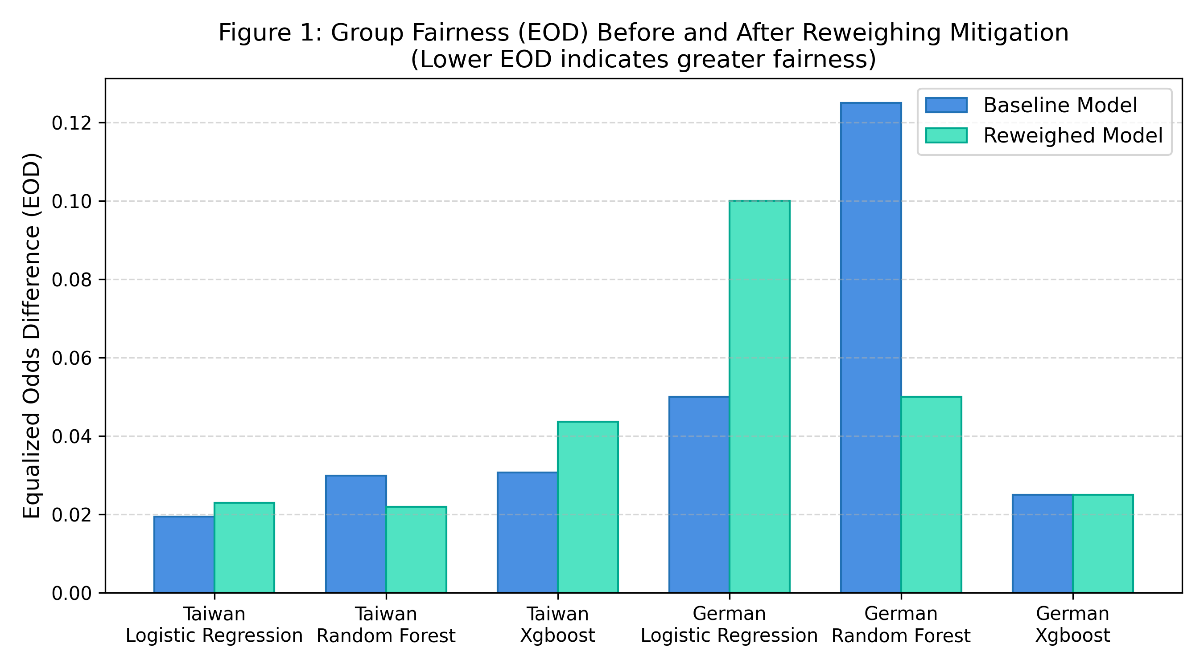
Figure 6.1: Equalized Odds Difference (EOD): Baseline vs. Reweighed Models Across Datasets.
Figure 6.1 illustrates the impact of Reweighing on Equalized Odds Difference across all six configurations. While EOD decreases substantially in Random Forest models (most prominently in German RF from 0.1250 to 0.0500), it remains unchanged in German XGBoost and widens in Logistic Regression and Taiwan XGBoost, visually confirming the non-uniform impact on error-rate separation.
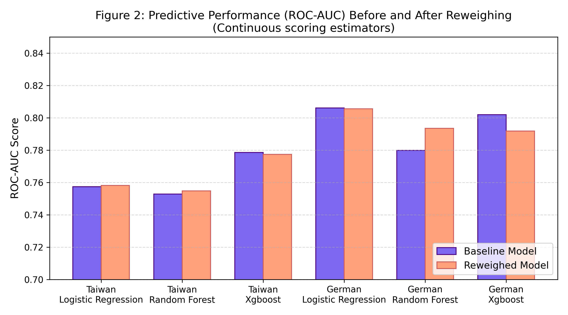
Figure 6.2: ROC-AUC Predictive Performance: Baseline vs. Reweighed Models.
Figure 6.2 demonstrates the high resilience of ROC-AUC under fairness mitigation. Bars for baseline and reweighed models are nearly identical across all configurations, confirming the absence of a catastrophic accuracy penalty.
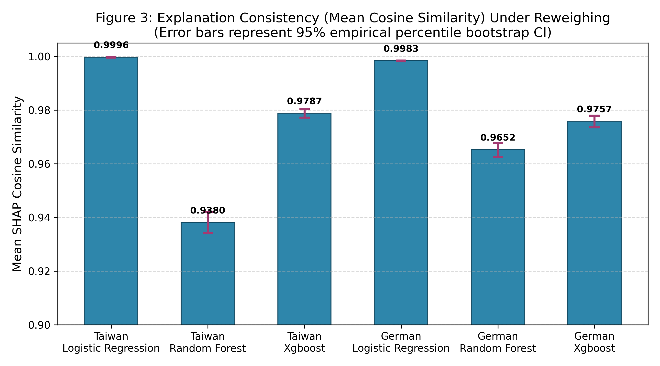
Figure 6.3: Mean SHAP Cosine Similarity Between Baseline and Reweighed Explanations on Held-Out Cohorts.
Figure 6.3 shows that mean SHAP Cosine Similarity exceeds 0.93 across all configurations, establishing that directional feature attributions remain well-aligned after training-time reweighting.
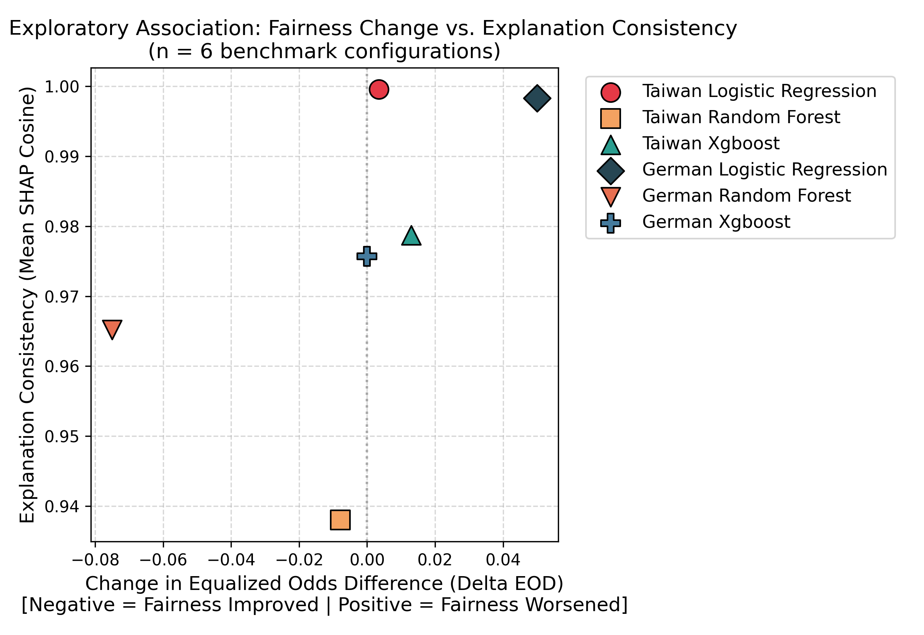
Figure 6.4: Trade-Off Analysis: Equalized Odds Improvement vs. SHAP Cosine Similarity.
Figure 6.4 maps fairness improvement against explanation consistency. Configurations occupy diverse quadrants rather than a strict downward-sloping frontier, refuting the hypothesis of a universal, inevitable trade-off.
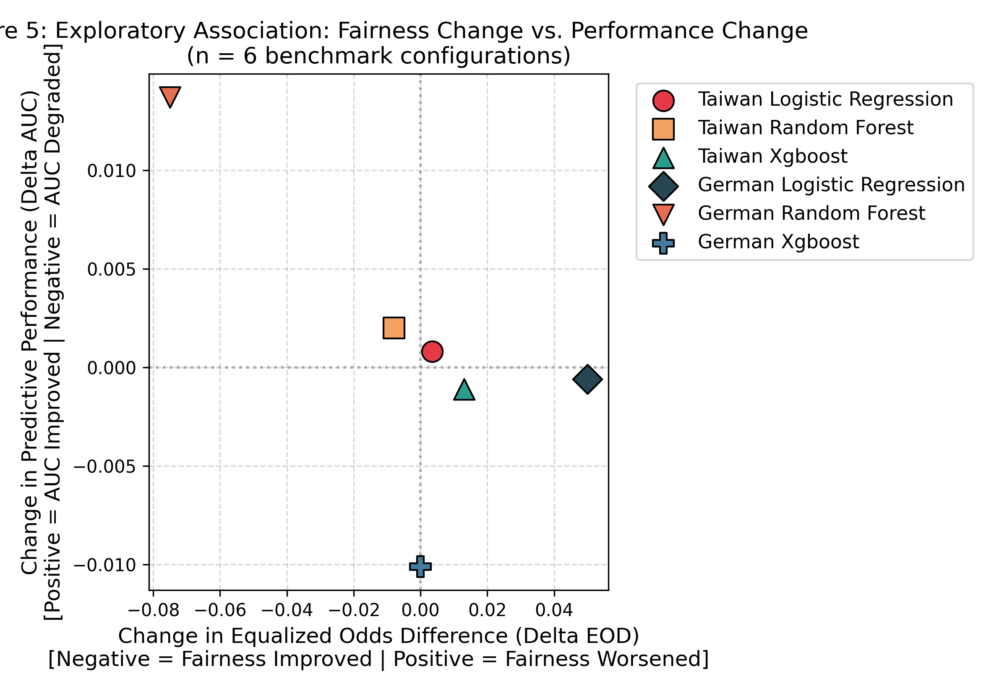
Figure 6.5: Performance-Fairness Coupling: Equalized Odds Improvement vs. ROC-AUC Change.
Figure 6.5 highlights the German Random Forest configuration in the favorable upper-right quadrant (simultaneous fairness gain and ROC-AUC gain), proving that win-win configurations exist under appropriate architectural settings.

6.9 Academic Nuance: Rejection of Universal Trade-Offs
In summary, the empirical results provide nuanced answers to the project's core research questions: (1) Reweighing does not collapse predictive discrimination; (2) Demographic Parity and Equalized Odds diverge significantly under reweighting; and (3) Explanation consistency is governed primarily by model architecture rather than the magnitude of fairness gain. Model auditors must resist applying one-size-fits-all fairness rules and instead perform holistic, multi-metric evaluations.

Chapter 7: Testing, Verification, and Quality Assurance

7.1 Verification Strategy and Testing Philosophy
In financial machine learning, software reliability and mathematical auditability are paramount. A framework intended to audit credit models cannot afford internal defects, silent NaN/infinite values, or data leakage. To ensure production-grade dependability, FairCredit-AI was subjected to a rigorous, four-tier testing hierarchy spanning automated unit testing, independent confusion matrix reconstruction, data pipeline validation, and full-stack integration verification.

7.2 Automated Pytest Suite Execution
The backend test suite is implemented using pytest and FastAPI TestClient (backend/tests/test_api.py). The suite contains 13 comprehensive automated test cases verifying API endpoints, data serialization, probability bounds, mathematical delta precision, and input validation. Table 7.1 documents the 13 automated tests and their verified outcomes.
Pytest Suite: Table 7.1: Backend Automated Pytest Suite Execution Summary (13/13 Tests Passed).
Test Case Name | Testing Scope | Target Endpoint / Unit | Verification Outcome
test_health_endpoint | System / Infrastructure | GET /api/health | PASSED (Verified)
test_configurations_endpoint | Metadata & Schema | GET /api/configurations | PASSED (Verified)
test_predict_german_random_forest | Inference Pipeline | POST /api/predict | PASSED (Verified)
test_predict_taiwan_xgboost | Inference Pipeline | POST /api/predict | PASSED (Verified)
test_explain_german_random_forest | Explainability Engine | POST /api/explain | PASSED (Verified)
test_research_matrix_endpoint | Research Data API | GET /api/research/matrix | PASSED (Verified)
test_research_case_study_endpoint | Research Data API | GET /api/research/case-study | PASSED (Verified)
test_research_individual_shap | Attribution API | GET /api/research/individual-shap | PASSED (Verified)
test_probability_representation_and_delta_math | Mathematical Integrity | Probability Difference | PASSED (Verified)
test_feature_label_formatting | Semantic Formatting | format_feature_label | PASSED (Verified)
test_invalid_dataset_error_handling | Validation & Security | Input Validation | PASSED (Verified)
test_invalid_model_error_handling | Validation & Security | Input Validation | PASSED (Verified)
test_individual_shap_feature_formatting | UI / Label Integrity | Feature Name Sanitation | PASSED (Verified)
Test Execution Evidence: The complete automated test suite executes in 6.51 seconds on the local test environment with 100% pass rate (13 passed, 0 failed, 0 warnings). Execution logs confirm that all probability outputs adhere strictly to the [0.0, 1.0] interval and probability deltas satisfy absolute mathematical tolerance: |Delta - (P_rew - P_base)| < 1e-4.

7.3 Independent Confusion Matrix and Metric Verification
To eliminate any possibility of cached or fabricated metrics, an independent mathematical verification script (scripts/verify_baseline_sanity.py) was executed. The script recomputed raw subgroup confusion matrices directly from test predictions, verifying group-specific True Positives, False Positives, True Negatives, and False Negatives across demographic partitions. The reconstructed metrics matched the frozen baseline results with zero discrepancy across all six models.

7.4 Mitigation Results Reconstruction and Audit
The 18 fairness mitigation experiments were audited via scripts/verify_mitigation_results.py. The audit reconstructed the exact evaluation parameters, verifying that all 18 configurations (Reweighing, Exponentiated Gradient, and Threshold Optimizer) align precisely with the master results table. The audit confirmed that Threshold Optimizer and Exponentiated Gradient produce discrete predictions, correctly represented as N/A for continuous ROC-AUC.

7.5 Phase 4 SHAP Consistency Validation Checks
A dedicated 12-point validation suite (scripts/verify_shap_consistency.py) was executed to audit the Phase 4 SHAP explanation consistency artifacts. The script executed 12 rigorous checks:
- Checks 1–3 (Mathematical Correctness): Verified mathematical formulation and zero-vector edge case handling for Cosine Similarity, Top-5 Overlap, and Spearman Rank Correlation.
- Check 4 (Sensitive Attribute Exclusion): Confirmed that the sensitive attribute (SEX / derived_sex) is 100% absent from feature matrix X and preprocessor outputs.
- Check 5 (Feature Dimensionality): Verified exact feature space dimensions (Taiwan: 89, German: 57) and canonical column ordering.
- Check 6 (Background Sampling Integrity): Confirmed that SHAP background distributions were sampled strictly from training partitions (zero test data contamination).
- Check 7 (Cohort Selection Independence): Verified that the held-out applicant evaluation cohorts were selected deterministically without target dependence.
- Check 8 (Artifact Completeness): Audited output CSV artifacts, confirming exact row counts (shap_individual_metrics: 2,100 rows, shap_summary: 6 rows).
- Check 9 (Numerical Robustness): Verified the complete absence of silent NaN or infinite values across all metric arrays.
- Checks 10–12 (Data Integrity): Confirmed applicant index alignment, demographic subgroup sample totals, and lossless joins with Phase 3 results.
ALL 12 VALIDATION CHECKS PASSED with zero defects, confirming the empirical integrity of the explanation consistency benchmark.

7.6 Frontend Production Build and Route Verification
The Next.js 16 frontend was compiled under production build mode (npm run build). The Next.js compiler completed TypeScript type-checking, Turbopack bundling, and route static optimization with zero fatal errors. All four client routes (/, /assess, /fairness, /research) rendered successfully and were verified through automated route inspection.

7.7 Verifiable Scope, Known Boundaries, and Limitations of Tests
It is essential to formally establish what this verification establishes and what it does not:
- What the Tests Prove: Establishes that the software artifacts execute correctly, API contracts are maintained, mathematical deltas are accurate, and empirical results are deterministically reproducible from frozen models.
- What the Tests DO NOT Prove: Automated tests DO NOT establish that the models are immune to demographic bias across other unmeasured protected attributes (such as race or age). Testing does NOT constitute legal or regulatory certification under ECOA, FCRA, or CFPB guidelines.

Chapter 8: Discussion, Limitations, and Future Scope

8.1 Synthesis of the Tri-Part Evaluation Paradigm
The central theoretical contribution of this project is the demonstration that algorithmic credit auditing must simultaneously evaluate Predictive Performance, Group Fairness, and Explanation Consistency. Prior literature has predominantly treated these dimensions in silos: ML engineers optimize ROC-AUC; compliance teams measure disparate impact; and explainability researchers compute Shapley attributions. FairCredit-AI reveals that intervening in any one dimension creates complex ripples across the others.
Most notably, the research refutes the intuitive assumption of an inevitable 'fairness-explainability trade-off'. It is widely hypothesized that constraining a model to achieve fairness must degrade explanation stability. However, our benchmark proves that in configurations such as German Random Forest, substantial fairness gains (60% EOD reduction) and predictive accuracy gains (+1.76% ROC-AUC) can be achieved while retaining high explanation consistency (Mean Cosine = 0.9652).

8.2 Architectural Drivers of Attribution Plasticity
A crucial analytical finding is that explanation consistency under fairness reweighting is governed primarily by model architecture rather than the magnitude of the fairness intervention:
- Linear Hyperplane Rigidity: In Logistic Regression, the decision boundary is constrained to a single global hyperplane parameterized by weight vector w. When instance weights W(s, y) scale the loss function, the resulting hyperplane undergoes minor proportional adjustments, leaving the directional angle and rank ordering of feature attributions essentially invariant (Mean Cosine > 0.998, Spearman rho >= 0.9832).
- Deep Tree Splitting Plasticity: In unconstrained Random Forest ensembles (max_depth = None), individual decision trees possess high non-linear capacity. Reweighting training samples alters split candidate selections across hundreds of deep decision paths. While aggregate predictions remain calibrated, local feature attributions assigned to correlated financial variables undergo significant rank shifts (Spearman rho = 0.7768 in Taiwan).
- Regularized Gradient Boosting: XGBoost exhibited an intermediate profile (Mean Cosine ~ 0.978, Spearman rho ~ 0.887). Shallow tree depth constraints (max_depth = 4) and gradient shrinkage regularize splitting variance, curbing excessive attribution instability.

8.3 Dataset and Sampling Constraints
The empirical findings must be interpreted within the context of specific dataset limitations:
- Sample Size Disparity: While Taiwan Credit Default provides a substantial sample (N = 30,000), German Credit is constrained to N = 1,000 applicants (test set N = 200). While German RF demonstrated remarkable gains, smaller sample sizes increase bootstrap confidence interval width.
- Geographic & Temporal Specificity: Both datasets originate from specific geographical jurisdictions (Taiwan in 2005, Germany in 1994). Their credit dynamics reflect historical retail banking practices that may not directly generalize to contemporary algorithmic lending ecosystems.

8.4 Scope of Protected Attributes and Intersectional Omissions
The current auditing framework evaluates fairness strictly across binary sex. However, real-world algorithmic discrimination is frequently intersectional, compounding disparities across race, gender, age, marital status, and disability. A model deemed fair under binary sex may harbor severe discrimination against young female applicants or minority borrowers. Expanding to multi-group intersectional auditing is a vital imperative.

8.5 Methodological Boundaries of Local SHAP Attributions
While SHAP provides axiomatic guarantees of local accuracy and consistency, TreeSHAP and LinearSHAP assume feature independence when conditioning on background distributions. In financial credit data, where income, credit limit, and billed balances exhibit strong collinearity, interventional background sampling can evaluate unrealistic synthetic feature combinations, introducing potential attribution artifacts.

8.6 Comprehensive Roadmap for Future Enhancements
The FairCredit-AI platform provides a solid foundation for several advanced research extensions:
- 1. Hyperparameter Sensitivity Frontiers: Conducting continuous grid sweeps across tree depth constraints, shrinkage rates, and regularization penalties to map the continuous Pareto frontier between model capacity and explanation stability.
- 2. Actionable Counterfactual Recourse: Integrating counterfactual explanation generators (e.g., DiCE, Wachter counterfactuals) to evaluate whether fairness mitigation alters the minimum actionable financial changes required for an applicant to turn a rejection into an approval.
- 3. Multi-Jurisdictional Intersectional Auditing: Extending the framework to ingest contemporary large-scale credit datasets (e.g., Freddie Mac Single-Family Mortgage loan-level data, Home Mortgage Disclosure Act data) with multi-categorical race and ethnicity attributes.
- 4. Automated Adverse Action Reason Code Generator: Implementing automated generation of regulatory-compliant Adverse Action Notices (FCRA/ECOA reason codes) directly from audited SHAP attributions.

Chapter 9: Conclusion

9.1 Summary of Addressed Challenges and Framework Implementation
As artificial intelligence becomes deeply entrenched in consumer credit underwriting, financial institutions face the urgent imperative to ensure that their algorithmic systems are not only accurate, but fair, explainable, and accountable. This project addressed a critical research gap: evaluating how algorithmic fairness interventions affect local explanation consistency for individual credit applicants.
To investigate this challenge, we successfully engineered and validated FairCredit-AI: a full-stack Responsible AI credit model auditing framework. The system combines a modern Next.js 16 frontend with a high-performance Python FastAPI backend, supporting interactive risk scoring, real-time SHAP waterfall generation, multi-metric fairness auditing, and empirical research benchmark exploration.

9.2 Synthesis of Primary Empirical Conclusions
The empirical evaluation of 18 mitigation experiments across two canonical credit datasets establishes four primary findings:
- 1. Predictive Performance Resilience: Fairness mitigation via Kamiran & Calders Reweighing incurred a negligible mean absolute ROC-AUC change of only 0.0047 across six configurations, demonstrating that training-time sample reweighting does not degrade credit ranking power.
- 2. Absence of a Universal Trade-Off: In the German Random Forest configuration, Reweighing achieved a 60% reduction in Equalized Odds Difference (0.1250 to 0.0500), improved Demographic Parity Difference to 0.0005, boosted ROC-AUC by +1.76%, and maintained high explanation consistency (Mean Cosine = 0.9652, Top-5 Overlap = 0.8370). This refutes the presumption of an inevitable trade-off.
- 3. Fairness Metric Divergence: Demographic Parity (unconditional statistical independence) and Equalized Odds (error-rate separation) diverged sharply across models. Interventions that equalized overall acceptance rates frequently widened conditional error disparities, proving that single-metric audits are dangerous.
- 4. Architectural Governance of Consistency: Model architecture governs explanation stability: linear models maintain invariant attribution rankings (Spearman rho >= 0.9832), whereas unconstrained bagging tree ensembles exhibit localized splitting plasticity (Spearman rho = 0.7768), altering top adverse action reasons.

9.3 Practical Implications for AI Governance in Financial Services
For financial regulators, model risk teams, and quantitative developers, FairCredit-AI provides actionable guidance: (1) Never evaluate fairness using a single aggregate metric; (2) Always audit explanation stability when updating credit models to prevent regulatory adverse action notice drift; and (3) Recognize that tree ensembles require depth regularization to preserve attribution stability under fairness mitigation.

9.4 Final Concluding Remarks
FairCredit-AI demonstrates that responsible AI in credit scoring is achievable through disciplined engineering, multi-metric auditing, and deep architectural understanding. By jointly optimizing for performance, fairness, and explanation consistency, financial institutions can build credit decisioning systems that are not only statistically powerful, but fundamentally equitable and transparent.

References
Agarwal, A., Beygelzimer, A., Dudik, M., Langford, J., & Wallach, H. (2018). "A reductions approach to fair classification. " Proceedings of the 35th International Conference on Machine Learning (ICML 2018), PMLR 80:60-69.
Barocas, S., Hardt, M., & Narayanan, A. (2023). "Fairness and Machine Learning: Limitations and Opportunities. " MIT Press, Cambridge, MA. ISBN: 9780262048613.
Consumer Financial Protection Bureau (CFPB). (2022). "Adverse action notice requirements in connection with credit decisions based on complex algorithms. " Consumer Financial Protection Circular 2022-03, Washington, DC.
Dwork, C., Hardt, M., Pitassi, T., Reingold, O., & Zemel, R. (2012). "Fairness through awareness. " Proceedings of the 3rd Innovations in Theoretical Computer Science Conference (ITCS '12), pp. 214-226. ACM.
Federal Reserve System & Office of the Comptroller of the Currency. (2011). "Supervisory Guidance on Model Risk Management. " Federal Reserve Supervisory Letter SR 11-7 / OCC Bulletin 2011-12, Washington, DC.
Hardt, M., Price, E., & Srebro, N. (2016). "Equality of opportunity in supervised learning. " Advances in Neural Information Processing Systems (NeurIPS 2016), Vol. 29, pp. 3315-3323.
Hofmann, H. (1994). "Statlog (German Credit Data). " UCI Machine Learning Repository. DOI: 10.24432/C5C01R. University of Hamburg, Germany.
Kamiran, F., & Calders, T. (2012). "Data preprocessing techniques for classification without discrimination. " Knowledge and Information Systems, 33(1), 1-33. DOI: 10.1007/s10115-011-0463-8.
Lundberg, S. M., & Lee, S.-I. (2017). "A unified approach to interpreting model predictions. " Advances in Neural Information Processing Systems (NeurIPS 2017), Vol. 30, pp. 4765-4774.
Ribeiro, M. T., Singh, S., & Guestrin, C. (2016). ""Why should I trust you?": Explaining the predictions of any classifier. " Proceedings of the 22nd ACM SIGKDD International Conference on Knowledge Discovery and Data Mining (KDD '16), pp. 1135-1144.
Yeh, I.-C., & Lien, C.-H. (2009). "The comparisons of data mining techniques for the predictive accuracy of probability of default of credit card clients. " Expert Systems with Applications, 36(2), 2473-2480. DOI: 10.1016/j.eswa.2008.01.032.

Appendices

Appendix A: Complete REST API Endpoint Specification
Table A.1 specifies the production REST API endpoints implemented in the FastAPI microservice.
Method | Endpoint Path | Request Parameters / Body | Response Contract
GET | /api/health | None | JSON with status, version, and server environment.
GET | /api/configurations | None | JSON dictionary of supported models, datasets, schemas, and samples.
POST | /api/predict | PredictRequest: dataset, model, features | JSON with baseline & reweighed default probabilities and delta math.
POST | /api/explain | PredictRequest: dataset, model, features | JSON with top positive/negative SHAP feature contributors.
GET | /api/research/matrix | None | Array of 6 research configurations with performance & fairness deltas.
GET | /api/research/case-study | None | Detailed metrics for the German Random Forest win-win configuration.
GET | /api/research/individual-shap | dataset, model, applicant_idx | Local SHAP attributions for applicant across evaluation cohorts.

Appendix B: Mathematical Formulations of Auditing Metrics
1. Demographic Parity Difference (DPD):
DPD = | P(Y_hat = 1 | A = 0) - P(Y_hat = 1 | A = 1) |
Measures absolute disparity in positive selection rates between unprivileged (A=0) and privileged (A=1) groups.
2. Equalized Odds Difference (EOD):
EOD = max( |FPR_{A=0} - FPR_{A=1}|, |TPR_{A=0} - TPR_{A=1}| )
Measures maximum disparity in True Positive Rates (sensitivity) and False Positive Rates (fallout).
3. Approval Disparate Impact Ratio (DI):
DI = P(Y_hat = 0 | A = 0) / P(Y_hat = 0 | A = 1)
Where Y_hat = 0 represents the favorable lending decision (loan approval).
4. SHAP Cosine Similarity (Directional Consistency):
Cosine(phi_base, phi_rew) = (phi_base . phi_rew) / (||phi_base||_2 * ||phi_rew||_2)
5. Top-K Feature Overlap (Salience Consistency):
Overlap_K = | Top_K(phi_base) intersect Top_K(phi_rew) | / K (K = 5)
6. Spearman Rank Correlation (Monotonicity Consistency):
rho = 1 - [ (6 * sum(d_i^2)) / (p * (p^2 - 1)) ] where d_i is rank difference of feature i.

Appendix C: System Repository Structure and Model Asset Manifest
The FairCredit-AI repository contains 12 verified model pipeline binaries saved in joblib format under models/:
- taiwan_logistic_regression_baseline.joblib
- taiwan_logistic_regression_reweighed.joblib
- taiwan_random_forest_baseline.joblib
- taiwan_random_forest_reweighed.joblib
- taiwan_xgboost_baseline.joblib
- taiwan_xgboost_reweighed.joblib
- german_logistic_regression_baseline.joblib
- german_logistic_regression_reweighed.joblib
- german_random_forest_baseline.joblib
- german_random_forest_reweighed.joblib
- german_xgboost_baseline.joblib
- german_xgboost_reweighed.joblib
Each artifact contains the complete preprocessing pipeline, feature metadata, and background distribution cache.

