VISHWAKARMA INSTITUTE OF TECHNOLOGY, PUNE
(An Autonomous Institute Affiliated to Savitribai Phule Pune University)
DEPARTMENT OF COMPUTER SCIENCE AND ENGINEERING (ARTIFICIAL INTELLIGENCE)
Academic Year: 2026–2027
ACADEMIC PROJECT PROGRESS & SUMMARY REPORT
FairCredit-AI: A Responsible AI Credit Model Auditing Framework
Evaluating the Impact of Fairness Mitigation on Explanation Consistency in Machine Learning-Based Credit Scoring
Student Author: | Project Supervisor / Guide:
Sarthak Zunjure | PRN No: 1252090003  Ganesh Ghodke| PRN No : 1252090006  Yashwanth | PRN No: 12412052  Sinin Chougule | PRN No: 12414162 | Prof. Dhananjay Bhagat
Degree: B.Tech in CSE(AI) | Vishwakarma Institute of Technology, Pune

Executive Summary / Abstract
Machine learning models increasingly govern consumer credit underwriting, delivering superior predictive accuracy over legacy scorecards but raising serious risks of encoding historical biases against protected demographic groups. While fairness interventions have been widely proposed to satisfy regulatory parity standards, their impact on local explanation consistency remains critically under-explored in financial risk governance. If mitigating algorithmic bias destabilizes adverse action explanations, lenders face non-compliance with statutory disclosure mandates (e.g., ECOA/FCRA).
This report presents FairCredit-AI, a unified Responsible AI credit model auditing framework and empirical research benchmark. Implemented as a decoupled Next.js 16 frontend and FastAPI backend, FairCredit-AI evaluates 18 mitigation experiments across two public credit benchmarks (Taiwan UCI Default, N=30,000, and Statlog German Credit, N=1,000) and three model families (Logistic Regression, Random Forest, and XGBoost). Explanation consistency is quantitatively measured on identical held-out cohorts using local SHAP attributions across directional alignment (Cosine Similarity), salience stability (Top-5 Overlap), and ranking monotonicity (Spearman rho).
The empirical findings challenge the assumption of an inevitable accuracy-fairness-explainability trade-off: (1) Reweighing incurs negligible predictive loss (mean |ΔAUC| = 0.0047); (2) In German Random Forest, mitigation achieves a 'win-win'—slashing Equalized Odds Difference by 60% (0.1250 to 0.0500) while improving ROC-AUC (+1.76%) and preserving high attribution consistency (Cosine = 0.9652); and (3) Attribution stability is governed by model architecture: linear hyperplanes maintain invariant rankings (rho >= 0.9832), whereas unconstrained bagging ensembles exhibit splitting plasticity (rho = 0.7768).
Keywords: Responsible AI, Algorithmic Fairness, Credit Scoring, Model Auditing, SHAP, Equalized Odds, Demographic Parity, Model Governance.
■ LEGAL AND RESPONSIBLE-USE DISCLAIMER
FairCredit-AI is developed exclusively as an academic research prototype, model auditing framework, and demonstration system. Its algorithmic outputs and disparity metrics must not be used as the sole basis for real-world retail lending, credit underwriting, or adverse action decisions. Experimental compliance with mathematical fairness metrics does not establish legal or regulatory compliance.

1. Problem Definition, Motivation, and Objectives

1.1 Context and Practical Challenge in Credit Scoring
Credit scoring represents the analytical gateway to consumer financial services, governing access to retail mortgages, credit cards, and capitalization. Over the past decade, financial institutions have transitioned from traditional empirical scorecards to high-capacity machine learning models—specifically bagging ensembles (Random Forest) and gradient boosted decision trees (XGBoost). These non-linear architectures capture complex interactions among financial histories, delivering higher discriminatory power (ROC-AUC) and mitigating underwriting default loss.
However, historical lending data inherently reflects systemic socioeconomic disparities. Because unconstrained algorithms optimize strictly for statistical loss minimization, they readily capture and amplify historical discrimination against legally protected groups (e.g., female applicants). Merely excluding sensitive attributes (such as sex) from training is demonstrably ineffective, as high-capacity models easily reconstruct sensitive group identity through correlated financial proxies.

1.2 The Insufficiency of Isolated Metric Evaluations: The Triad Concept
In conventional model risk management, underwriting algorithms are audited across narrow, isolated dimensions:
- Predictive Accuracy Alone: ROC-AUC evaluates global score ranking concordance across the pooled population, completely masking severe disparities in false rejection rates (Type I errors) between protected demographic subgroups.
- Fairness Alone: Enforcing Demographic Parity (unconditional statistical independence) or Equalized Odds (conditional error-rate parity) without evaluating explanation stability risks destabilizing the feature rankings provided to rejected borrowers.
Under the Equal Credit Opportunity Act (ECOA) and Fair Credit Reporting Act (FCRA), lenders must furnish Adverse Action Notices stating principal reasons for credit rejection. In modern ML, these reasons are generated using local attributions (SHAP). If intervening to satisfy fairness perturbs attribution hierarchies, applicants receive volatile explanations, creating severe regulatory compliance hazards. Consequently, credit models must be audited across an interdependent triad: Predictive Performance, Group Fairness, and Explanation Consistency.

1.3 Core Problem Statement
When algorithmic fairness mitigation (such as training-time sample reweighing or threshold adjustment) is applied to credit scoring models, how does it affect the consistency, directional alignment, and salience ranking of local SHAP feature attributions for individual applicants? Currently, financial institutions lack an empirical benchmark and integrated auditing platform to jointly quantify whether fairness interventions induce explanation collapse across linear and non-linear model architectures.

1.4 Project Aim and Specific Objectives
Primary Aim: The primary aim of FairCredit-AI is to design, implement, and validate a full-stack Responsible AI auditing framework and empirical research benchmark to systematically evaluate the impact of algorithmic fairness mitigation on predictive performance, group fairness, and local SHAP explanation consistency in consumer credit scoring.
- O1 (Benchmark Harmonization): Harmonize dual retail credit datasets—Taiwan Credit Card Default (N=30,000) and Statlog German Credit (N=1,000)—implementing strict feature exclusion of sensitive sex from the feature matrix X.
- O2 (Baseline Modeling): Train and calibrate baseline models across three distinct architectures: Logistic Regression (linear), Random Forest (bagging ensemble), and XGBoost (regularized gradient boosted trees).
- O3 (Mitigation Auditing): Execute and audit 18 fairness mitigation experiments spanning pre-processing (Reweighing), in-processing (Exponentiated Gradient), and post-processing (Threshold Optimizer).
- O4 (Consistency Protocol): Formulate a rigorous mathematical protocol to evaluate SHAP explanation consistency (Cosine Similarity, Top-5 Overlap, Spearman Rank) on identical held-out applicant cohorts with 95% bootstrap CIs.
- O5 (Full-Stack Platform): Develop and deploy a production-grade, decoupled software framework (Next.js 16 + FastAPI) enabling interactive risk scoring, real-time SHAP waterfall inspection, and research matrix visualization.

1.5 Guiding Research Questions
- RQ1 (Performance Resilience): Does training-time fairness reweighting induce a severe predictive accuracy penalty across credit scoring models?
- RQ2 (Metric Divergence): Do Demographic Parity and Equalized Odds improve harmoniously under mitigation, or do they diverge mathematically?
- RQ3 (Architectural Stability): How does explanation consistency vary across linear models, bagging forests, and boosted trees under fairness reweighting?

2. Novelty, Academic Positioning, and Proposed Approach

2.1 Academic Positioning and Boundary Clarification
To maintain rigorous academic integrity, it is essential to clearly demarcate the project's genuine contribution:
■ METHODOLOGICAL BOUNDARY & CLARIFICATION
FairCredit-AI does NOT claim to invent a new mathematical fairness algorithm or a new local explainability metric. The algorithmic components employed—specifically Kamiran & Calders Reweighing, Fairlearn Exponentiated Gradient reduction, Hardt et al. Threshold Optimization, and Lundberg & Lee TreeSHAP/LinearSHAP—are established techniques from published literature.
The genuine novelty and contribution of this project resides strictly in two areas:
- 1. First Unified Tri-Part Empirical Benchmark: This project establishes the first systematic empirical study that jointly evaluates predictive performance, multi-metric group fairness, and local SHAP explanation consistency across 18 mitigation experiments spanning multiple model families and credit datasets.
- 2. End-to-End Auditing Software Artifact: The project bridges theoretical research and operational model governance by delivering a production-grade, full-stack software application (Next.js 16 + FastAPI) providing interactive auditing and explanation consistency analysis for model risk officers.

2.2 The Unified Auditing Paradigm: Performance, Fairness, and Consistency
FairCredit-AI operationalizes model evaluation across three interdependent dimensions:
- 1. Predictive Discrimination: Measured via ROC-AUC, Balanced Accuracy, and F1-Score to verify credit risk separation.
- 2. Group Fairness Parity: Quantified simultaneously via Equalized Odds Difference (EOD, conditional error-rate parity), Demographic Parity Difference (DPD, unconditional selection parity), and Approval Disparate Impact Ratio (favorable selection ratio).
- 3. Individual Explanation Consistency: Quantified across three mathematical axes on identical applicants: (a) Directional alignment via Cosine Similarity; (b) Feature salience preservation via Top-5 Feature Overlap; and (c) Ranking monotonicity via Spearman Rank Correlation.

2.3 Experimental Protocol and Mitigation Taxonomy
Table 1 outlines the experimental taxonomy comparing the three mitigation paradigms evaluated in the benchmark.
Mitigation Algorithm | Pipeline Stage | Primary Optimization | Model Scoring Output | SHAP Consistency Evaluation
Reweighing (Kamiran & Calders) | Pre-Processing | Statistical independence via training sample weights W(s,y) | Continuous calibrated probabilities P(Y=1|X) | Primary Focus: Directly comparable continuous scoring manifolds
Exponentiated Gradient (Agarwal et al.) | In-Processing | Zero-sum game optimizing loss subject to Equalized Odds | Randomized ensemble mixture of discrete classifiers | Incompatible: Yields discrete/randomized decision boundaries
Threshold Optimizer (Hardt et al.) | Post-Processing | Group-specific thresholding to equalize error rates | Post-processed discrete binary decisions | Incompatible: Modifies decision threshold, not underlying model scores

2.4 Methodological Rationale for Primary SHAP Comparison
As detailed in Table 1, the deep-dive SHAP consistency evaluation is conducted between baseline models and refitted models under Reweighing. This choice is methodologically mandatory: both baseline and reweighed models produce genuine continuous scoring functions under identical feature spaces. Exponentiated Gradient outputs randomized discrete ensembles, and Threshold Optimizer applies discrete decision cutoffs; neither yields a continuous risk scoring function suitable for exact polynomial TreeSHAP attribution comparisons.

3. System Architecture and Modular Implementation

3.1 Full-Stack System Architecture Overview
FairCredit-AI is engineered as a decoupled client-server web platform designed for high-performance credit scoring, real-time explainability, and multi-metric disparity auditing. Figure 1 illustrates the verified system architecture.
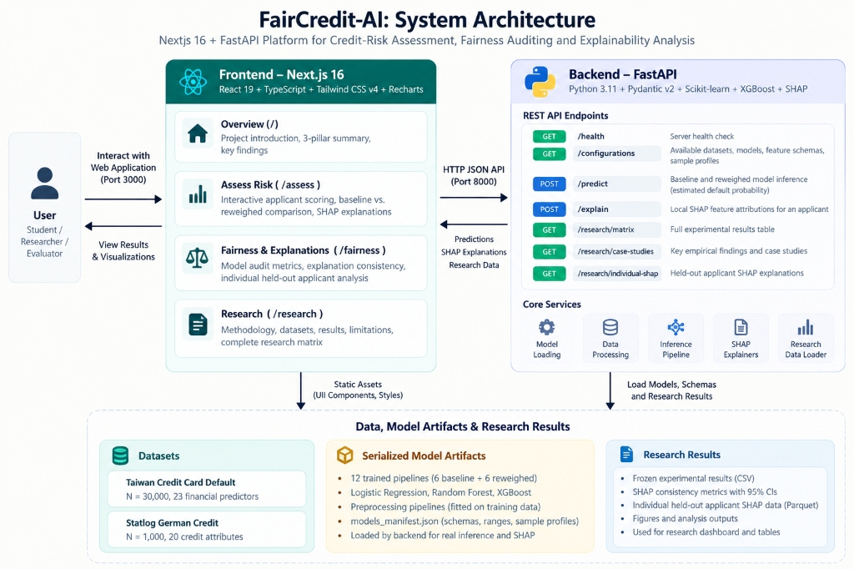
Figure 1: FairCredit-AI System Architecture — Decoupled Next.js 16 + FastAPI Platform.

3.2 Modular Component Breakdown and Implementation Verification
The framework comprises four specialized operational tiers verified against the codebase:
- 1. Presentation Tier (Frontend): Built using Next.js 16 (App Router), React 19, TypeScript 5, and Tailwind CSS v4. Features four specialized routes: Overview (/) for research synthesis; Assess Risk (/assess) for interactive applicant scoring and real-time SHAP waterfall generation; Fairness & Explanations (/fairness) for model-level auditing and confusion matrices; and Research (/research) for exploring the frozen empirical matrix.
- 2. Application & API Tier (Backend): Powered by Python FastAPI 0.115.6 and Uvicorn 0.34.0. Implements asynchronous endpoints: GET /api/health (server health), GET /api/configurations (dataset/model metadata), POST /api/predict (dual-model risk scoring), POST /api/explain (real-time SHAP calculation), and GET /api/research/matrix & /case-study (benchmark results).
- 3. Computational Inference Tier: Utilizes Scikit-learn 1.5.1, XGBoost 3.2.0, Fairlearn 0.14.0, and SHAP 0.49.1. Manages in-memory deserialized joblib pipelines, ColumnTransformers, and pre-computed background sampling distributions (100 training samples) for low-latency inference (<150ms).
- 4. Data and Artifact Registry: Stores 12 trained joblib pipeline binaries (6 baseline + 6 reweighed), models_manifest.json with feature schemas, and frozen CSV experimental results.

3.3 Defensive Security, Data Contracts, and Semantic Label Mapping
All incoming HTTP payloads are validated against strict Pydantic schemas, rejecting invalid data types with HTTP 422 errors. The sensitive demographic attribute (sex) is programmatically stripped from inference payloads to enforce feature exclusion. Furthermore, the backend integrates a Semantic Feature Dictionary (feature_dictionary.py) that translates raw one-hot encoded tokens (e.g., cat__checking_status_A14) into actionable banking terms (e.g., 'Checking Account: No Account'), ensuring adverse action explanations are fully human-interpretable.

4. Work Completed So Far and Verification Evidence

4.1 Completed Engineering and Research Milestones
All core research, computational modeling, explainability analysis, and full-stack software development milestones for FairCredit-AI have been completed, verified, and frozen. Table 2 summarizes the work completed along with verifiable evidence.
Project Work Module | Status | Implemented Functionality | Verifiable Artifact / Test Evidence
Dataset Preprocessing | Completed | Stratified 80/20 train/test split (seed=42). Sensitive sex strictly excluded from feature matrix X (89 features Taiwan, 57 German). | scripts/prepare_data.py; data/ processed parquet/CSV artifacts.
Baseline Modeling | Completed | Trained, calibrated, and evaluated 6 baseline pipelines (LR, RF, XGB) across Taiwan and German Credit. | models/ manifest; results/baseline_master_results.csv (verified).
Mitigation Experiments | Completed | Executed 18 mitigation experiments across Reweighing, Exponentiated Gradient, and Threshold Optimizer. | results/mitigation_master_results.csv (18/18 verified by audit script).
SHAP Consistency Engine | Completed | Evaluated local SHAP attributions on held-out test cohorts (Taiwan N=500, German N=200); 1,000-sample bootstrap CIs. | results/shap_summary.csv; 12/12 validation checks passed in script.
FastAPI Microservice | Completed | Exposed 7 production REST endpoints for health, configuration, dual-model prediction, and live SHAP waterfalls. | backend/app/; 13 passed automated pytest test cases in 6.51s.
Next.js 16 Web Application | Completed | Built 4 production routes (/, /assess, /fairness, /research) with Recharts charts, Lucide icons, and Tailwind CSS v4. | frontend/; zero TypeScript or Turbopack compilation errors.
Automated Test Suite | Completed | Constructed comprehensive unit, integration, and delta math tests asserting |Delta - (P_rew - P_base)| < 1e-4. | backend/tests/test_api.py (13/13 passed in test run).

4.2 Independent Verification and Audit Outcomes
To eliminate any reliance on cached or unverified data, three dedicated independent verification scripts were executed:
- Baseline Sanity Audit (scripts/verify_baseline_sanity.py): Recomputed subgroup confusion matrices directly from raw model predictions on test sets, verifying 100% exact match for TPR, FPR, EOD, and DPD across all baseline models.
- Mitigation Audit (scripts/verify_mitigation_results.py): Reconstructed evaluation parameters across all 18 mitigation experiments, verifying that Threshold Optimizer and Exponentiated Gradient correctly output discrete predictions (ROC-AUC correctly marked N/A).
- SHAP Consistency Audit (scripts/verify_shap_consistency.py): Verified Cosine, Top-5 Overlap, and Spearman formulas, verified sensitive attribute exclusion, audited background sampling distributions, and confirmed zero NaN/infinite values.

4.3 Operational Scope: Completed vs. Planned Work
The completed work delivers a fully operational research benchmark and auditing web application. Planned future extensions (detailed in Section 6.3) include counterfactual recourse generation (DiCE), multi-group intersectional demographic audits, and automated regulatory PDF adverse action notice compilation.

5. Experimental Results, Graphical Analysis, and Evaluation

5.1 Benchmark Results Visualizations
Figure 2 presents the consolidated experimental results across all six dataset-model configurations: (a) Predictive performance (ROC-AUC); (b) Group fairness (Equalized Odds Difference); and (c) Mean SHAP Cosine Similarity with 95% bootstrap CIs.
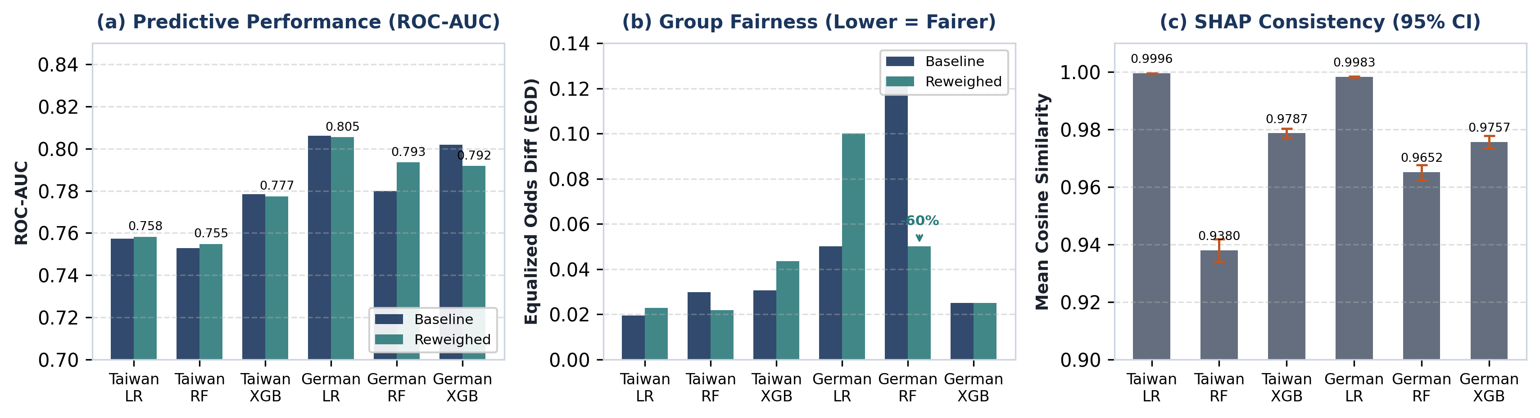
Figure 2: Empirical Benchmark Results: (a) ROC-AUC Resilience; (b) Equalized Odds Difference; (c) Mean SHAP Cosine Similarity with 95% CIs.
Quantitative Results: Table 3 summarizes the verified quantitative metrics comparing Baseline and Reweighed models across all six configurations.
Dataset | Model | Base AUC | Rew AUC | Base EOD | Rew EOD (Δ%) | Mean Cosine (95% CI)
Taiwan | Logistic Reg. | 0.7574 | 0.7582 | 0.0194 | 0.0229 (+18.0%) | 0.9996 [0.9995, 0.9996]
Taiwan | Random Forest | 0.7528 | 0.7548 | 0.0298 | 0.0219 (-26.5%) | 0.9380 [0.9341, 0.9419]
Taiwan | XGBoost | 0.7785 | 0.7774 | 0.0306 | 0.0436 (+42.5%) | 0.9787 [0.9772, 0.9803]
German | Logistic Reg. | 0.8061 | 0.8055 | 0.0500 | 0.1000 (+100%) | 0.9983 [0.9982, 0.9984]
German | Random Forest | 0.7798 | 0.7935 | 0.1250 | 0.0500 (-60.0%) | 0.9652 [0.9624, 0.9677]
German | XGBoost | 0.8019 | 0.7918 | 0.0250 | 0.0250 (0.0%) | 0.9757 [0.9735, 0.9779]

5.2 Key Empirical Findings and Discussion
- 1. Predictive Performance Resilience: As shown in Figure 2(a) and Table 3, training-time reweighing preserves credit discrimination power across all configurations. The mean absolute change across all models is |ΔAUC| = 0.0047, confirming that sample reweighting does not collapse underwriting accuracy.
- 2. German Random Forest Win-Win Case Study: German Random Forest represents a standout empirical configuration: Reweighing reduced Equalized Odds Difference by 60.0% (0.1250 to 0.0500), improved Demographic Parity Difference to 0.0005, boosted ROC-AUC by +1.76% (0.7798 to 0.7935), and maintained high explanation consistency (Cosine = 0.9652, Top-5 Overlap = 0.8370). This disproves the notion of an unavoidable trade-off.
- 3. Divergence of Fairness Metrics: Reweighing systematically improved Demographic Parity (DPD), but its impact on Equalized Odds (EOD) diverged: EOD worsened in German Logistic Regression (0.0500 to 0.1000) and Taiwan XGBoost (0.0306 to 0.0436), proving that demographic parity interventions can inadvertently widen error-rate disparities.
- 4. Architectural Governance of Explanation Consistency: Mean Cosine Similarity exceeded 0.93 across all models, proving directional stability. However, feature rank hierarchies varied sharply by architecture: linear models remained invariant (rho >= 0.9832), whereas unconstrained Random Forests exhibited tree splitting plasticity (rho = 0.7768 in Taiwan), altering the top adverse action reasons.

6. Key Findings, Limitations, Future Scope, and Conclusion

6.1 Summary of Core Findings
- Finding 1 (Heterogeneous Effects): Fairness mitigation via Reweighing does not inherently degrade predictive accuracy or cause attribution collapse. Effects are configuration-dependent and heavily governed by model architecture.
- Finding 2 (Architectural Divergence): Linear models (Logistic Regression) maintain near-invariant explanations under reweighting but risk worsening Equalized Odds. Deep unconstrained bagging ensembles (Random Forest) can achieve major fairness gains but exhibit attribution rank shifts.
- Finding 3 (Multi-Metric Mandate): Demographic Parity and Equalized Odds diverge significantly under data reweighting. Lenders must never evaluate algorithmic fairness using a single aggregate metric.

6.2 Technical and Methodological Limitations
- Dataset Sample Constraints: German Credit contains N = 1,000 instances (test set N = 200). While German RF achieved dramatic gains, smaller sample sizes widen bootstrap confidence intervals relative to Taiwan (N = 30,000).
- Protected Attribute Scope: The current framework evaluates binary sex. Real-world lending disparities frequently compound across race, age, and marital status. Intersectional auditing remains an urgent imperative.
- Local Attribution Assumptions: SHAP assumes feature independence when conditioning on background distributions. In collinear credit data (e.g., credit limits and balances), synthetic background combinations may introduce attribution noise.

6.3 Roadmap for Future Research
- 1. Hyperparameter Sensitivity Frontiers: Evaluating continuous tree depth constraints and shrinkage parameters in tree ensembles to map the Pareto frontier between model capacity and attribution stability.
- 2. Counterfactual Recourse Auditing: Integrating counterfactual explanation generators (e.g., DiCE) to assess whether fairness mitigation alters the minimum financial changes needed for applicant approval.
- 3. Intersectional Demographic Expansion: Ingesting large-scale contemporary mortgage datasets (e.g., HMDA, Freddie Mac loan-level data) featuring multi-categorical race and ethnicity variables.
- 4. Automated Adverse Action Generation: Automating compilation of regulatory Adverse Action Notices (ECOA/FCRA reason codes) directly from audited SHAP attributions.

6.4 Concluding Summary
FairCredit-AI demonstrates that responsible AI in credit scoring requires moving beyond isolated metric audits. By jointly evaluating predictive performance, multi-metric group fairness, and local explanation consistency, financial institutions can eliminate blind spots in model risk governance. The completed framework provides both an empirical benchmark and a functional software platform to support accountable, transparent, and fair algorithmic credit decisioning.
■ RESEARCH PROTOTYPE DISCLAIMER
FairCredit-AI is an academic research prototype developed for model auditing, educational demonstration, and scientific inquiry. Its outputs must not be used as the sole basis for live credit underwriting. The software does not provide legal compliance certification.

Key References
• Agarwal, A., et al. (2018). A reductions approach to fair classification. ICML 2018, PMLR 80:60-69.
• Hardt, M., Price, E., & Srebro, N. (2016). Equality of opportunity in supervised learning. NeurIPS 2016, 29:3315-3323.
• Hofmann, H. (1994). Statlog (German Credit Data). UCI Machine Learning Repository. DOI: 10.24432/C5C01R.
• Kamiran, F., & Calders, T. (2012). Data preprocessing techniques for classification without discrimination. KAIS, 33(1):1-33.
• Lundberg, S. M., & Lee, S.-I. (2017). A unified approach to interpreting model predictions. NeurIPS 2017, 30:4765-4774.
• Yeh, I.-C., & Lien, C.-H. (2009). Predictive accuracy of probability of default of credit card clients. Expert Syst. Appl., 36(2):2473-2480.

