NoSQL Project Analysis Assignment

1.) Please fill in your personal and contact details
Student Name: Sarthak Gupta
Enrolment Number: 2427010032
Section: Section J
Subject Name: NoSQL Databases
Email Address: sarthak.2005gupta@gmail.com
Contact No: 9599301499
2.) Project Domain / Classification
Identify the technical domain and application area of your proposed project. (Explain in 20-40 Words)

Financial Technology (FinTech), Distributed NoSQL Data Engineering, and Real-Time Graph Intelligence. The project focuses on high-throughput financial fraud ring detection, money laundering path identification, and polymorphic transaction auditing.
3.) Project Title
Provide a clear, concise, and innovative title for your NoSQL-based project. The title should reflect the problem being solved and the proposed technology or application.
FraudShield: A Multi-Model NoSQL Framework for Real-Time Financial Fraud Ring Identification and Polymorphic Transaction Auditing

4.) Problem Statement
What specific real-world problem or limitation does your project aim to address? Explain the existing challenges and why the problem requires an efficient data management solution. (Explain in 50-70 Words)
Modern digital payment ecosystems process tens of thousands of heterogeneous transactions per second. Organized cybercriminal syndicates bypass traditional relational database rules by utilizing complex multi-hop mule networks, circular fund routing, and synthetic identities across shared device clusters. Traditional relational databases fail due to exponential join latency on deep recursive queries and rigid schemas unable to ingest polymorphic payment payloads with sub-second latency.
5.) Proposed Solution
Describe your proposed project solution. Explain how the system will address the identified problem and how NoSQL technology will be used in the solution.
Students should clearly mention:
- Type of NoSQL database proposed
- Reason for selecting the database
- Type and nature of data to be stored
- Main users of the system
FraudShield implements a high-throughput, low-latency multi-model NoSQL architecture combining Document NoSQL (MongoDB) and Graph NoSQL (Neo4j / Property Graph Engine) to ingest, index, and analyze financial transactions in real time:
• Type of NoSQL database proposed: Multi-model system utilizing Document Store (MongoDB) and Graph Store (Neo4j / Property Graph Engine).
• Reason for selecting the database: MongoDB provides flexible BSON schemaless storage, write-optimized sharding, and fast secondary indexing. Neo4j delivers index-free adjacency (O(1) traversal per hop) enabling millisecond cycle detection across massive networks where SQL table joins freeze.
• Type and nature of data: High-velocity streaming JSON/BSON records, multi-attribute device fingerprints, geospatial coordinate pairs, and directed financial relationship subgraphs.
• Main users of the system: FinTech payment gateways, banking security operations centers (SOC), fraud investigation analysts, and compliance risk officers.
6.) Project Novelty / Innovation
What is new, unique, or innovative about your proposed project compared to existing systems or applications?
The project novelty may be based on:
- A new application area
- Innovative use of NoSQL databases
- Improved data processing or storage
- Real-time data handling
- Scalability and distributed data management
- Integration with AI, IoT, Cloud, Blockchain, or Analytics
- Improved performance, security, or user experience
1. Hybrid Multi-Model Synergy: Seamless synchronization between Document NoSQL (for rich telemetry payload retention) and Graph NoSQL (for topological relationship modeling).
2. Real-Time Circular Flow & Mule Ring Traversal: Tarjan's strongly connected components and bounded depth-first search (k-hop cycle detection) executing under 15 milliseconds.
3. Polymorphic Device & IP Fingerprinting: Ingesting varied device footprints (IMEI, canvas hashes, browser headers, IPv6 subnets) without database migrations or schema alter overhead.
4. Dynamic Multi-Factor Risk Heuristic: Combining topological graph centrality, transaction velocity bursts, and geospatial entropy into a unified [0, 100] fraud risk score.
5. Horizontal Scalability: High-throughput partitioning capable of scaling horizontally across distributed clusters without single-point bottlenecks.
7.) Identify existing applications, research work, or systems related to your proposed project. Briefly explain their limitations and how your proposed system differs from them.
• Traditional Relational Systems (MySQL, PostgreSQL): Rely on rigid relational tables and complex SQL JOINs. Deep recursive queries across multiple transaction hops incur exponential O(V^k) latency, making real-time fraud interception impossible during transaction clearing.
• Standalone In-Memory Key-Value Stores (Redis): While offering high throughput, key-value stores cannot perform multi-attribute pattern matching, secondary spatial indexing, or topological graph traversals.
• Batch Fraud Detection Engines (Stored Procedures / ETL): Process data in nightly batches (hours or days later), failing to prevent instantaneous fraudulent fund withdrawal.
• FraudShield Advantage: Delivers sub-20ms multi-model inference directly within the transaction authorization loop, combining graph topology matching with polymorphic document auditing.
8.) NoSQL Database Selection and Justification
Which NoSQL database will be used in your project and why?
Type of NoSQL Database:
Document / Key-Value / Column-Family / Graph
Justification for Selection:
Explain why this database is suitable for the proposed project.
Type of NoSQL Database: Hybrid Document Store (MongoDB) and Graph Store (Neo4j / Property Graph Model).
Justification for Selection:
1. MongoDB (Document Store): Payment schemas vary widely (UPI, SWIFT, SEPA, Cards, Crypto). MongoDB's schemaless BSON structure stores rich, evolving payloads without migrations. Native sharding and geospatial indexes allow high-concurrency ingestion (>5,000 tx/sec).
2. Neo4j / Graph Model: Native graph storage utilizes index-free adjacency, where nodes directly reference adjacent edges in pointer arrays. Finding circular transaction paths of length 3-6 hops executes in O(E) time instead of relational O(V^k), preventing mule network laundering in real time.
9.) Database Design and Data Model
Describe the proposed data model and major collections, documents, nodes, relationships, or key-value structures.
Students should provide:
- Main entities/data collections
- Important attributes
- Relationships between data
- Sample document or schema structure
• Main Entities & Collections:
- MongoDB 'transactions': Full audit log with transaction_id, sender, receiver, amount, timestamp, device_telemetry, geospatial coords, and risk evaluation.
- MongoDB 'accounts' & 'alerts': Customer KYC profile, velocity accumulators, and prioritized alert logs.
- Graph Nodes: (:Account {account_id, kyc_level, risk_tier}), (:Device {device_id, fingerprint, os}), (:IPAddress {ip, country}).
- Graph Relationships: [:TRANSFERRED_TO {amount, timestamp, tx_id}], [:LOGGED_IN_FROM {last_seen}].
• Sample Document JSON Schema (MongoDB):
{
"transaction_id": "TX_94827104", "sender": "ACC_88129", "receiver": "ACC_44901",
"amount": 24500.00, "currency": "INR", "timestamp": "2026-09-25T11:30:00Z",
"device": { "device_id": "DEV_A998F", "ip": "103.21.14.88", "fingerprint": "e3b0c4..." },
"risk_evaluation": { "score": 88.5, "decision": "HIGH_RISK_BLOCK", "reasons": ["Circular ring"] }
}
• Sample Graph Query (Cypher):
MATCH path = (origin:Account)-[tx:TRANSFERRED_TO*3..5]->(origin:Account)
WHERE ALL(r IN relationships(path) WHERE r.timestamp > datetime() - duration({hours: 24}))
RETURN [node in nodes(path) | node.account_id] AS FraudRing, reduce(tot=0, r in relationships(path) | tot+r.amount) AS TotalLaundered;
10.) System Modules and Functionalities
List the major modules or features of the proposed system.
1. Ingestion & Pre-processing Gateway: Asynchronous REST & WebSocket endpoints validating signatures, parsing JSON payloads, and extracting telemetry.
2. Document Persistence Engine: Writes full audit documents to MongoDB with secondary indexing and lifecycle TTL management.
3. Graph Topology Engine: Maintains real-time adjacency graph, executing cycle detection and community clustering algorithms.
4. Multi-Factor Risk Scorer: Computes unified risk metric [0, 100] across velocity bursts, graph cycles, and device entropy in <20ms.
5. Interactive Monitoring Dashboard: Visualizes dynamic network graphs, live transaction telemetry, and alert triage queues.
11.) Technical Advantages / Expected Outcomes
What benefits will the proposed NoSQL-based system provide compared to traditional database or existing solutions?
• Sub-20ms Decision Latency: Evaluates multi-attribute heuristics and graph topology before transaction clearing.
• Zero Schema Migrations: Seamless ingestion of emerging payment formats and custom device attributes without downtime.
• Deep Relationship Discovery: Identifies hidden multi-hop fraud networks undetectable by isolated row-level SQL queries.
• High Concurrency: Capable of sustaining >5,000 writes/sec via document sharding and lightweight graph adjacency representations.
12.) Limitations and Challenges
What possible limitations, technical challenges, or constraints may arise during the development and implementation of the project?
1. Dual-Store Eventual Consistency: Maintaining sync between Document and Graph stores under network partitions requires reliable message queue patterns (Outbox pattern / Change Streams).
2. Graph Memory Management: High density subgraphs require bounding traversal depths (k <= 6) and pruning stale relationship edges.
3. Cold-Start Profiling: Newly created accounts with sparse graph linkages rely primarily on device fingerprints and velocity heuristics.
13.) Technology Stack
Mention the technologies, tools, programming languages, frameworks, and database systems proposed for the project.
• Programming Language: Python 3.14 (AsyncIO / High Concurrency)
• API Framework: FastAPI (Asynchronous REST & WebSockets)
• Document NoSQL Database: MongoDB 7.0+ (PyMongo / BSON Document Storage)
• Graph NoSQL Database: Neo4j 5.x / Graph Adjacency Engine (NetworkX & Cypher query models)
• Frontend Interface: HTML5, CSS3, JavaScript ES6+, Vis.js Network Visualization
• Testing & Validation: PyTest, HTTPX
• Documentation & Diagramming: Matplotlib, Python-Docx, ReportLab, LaTeX
14.) Current Stage of Project Development
Stage 4 (Functional Prototype / Architecture Complete): The core multi-model NoSQL ingestion pipeline, graph cycle discovery algorithms, and real-time risk scoring modules are fully implemented, unit-tested, and integrated with an interactive web dashboard.
15.) System Architecture and Workflow
Students should provide:
- System Architecture Diagram
- Database/Data Model Diagram
- Project Workflow / Flowchart
1. System Architecture Diagram:
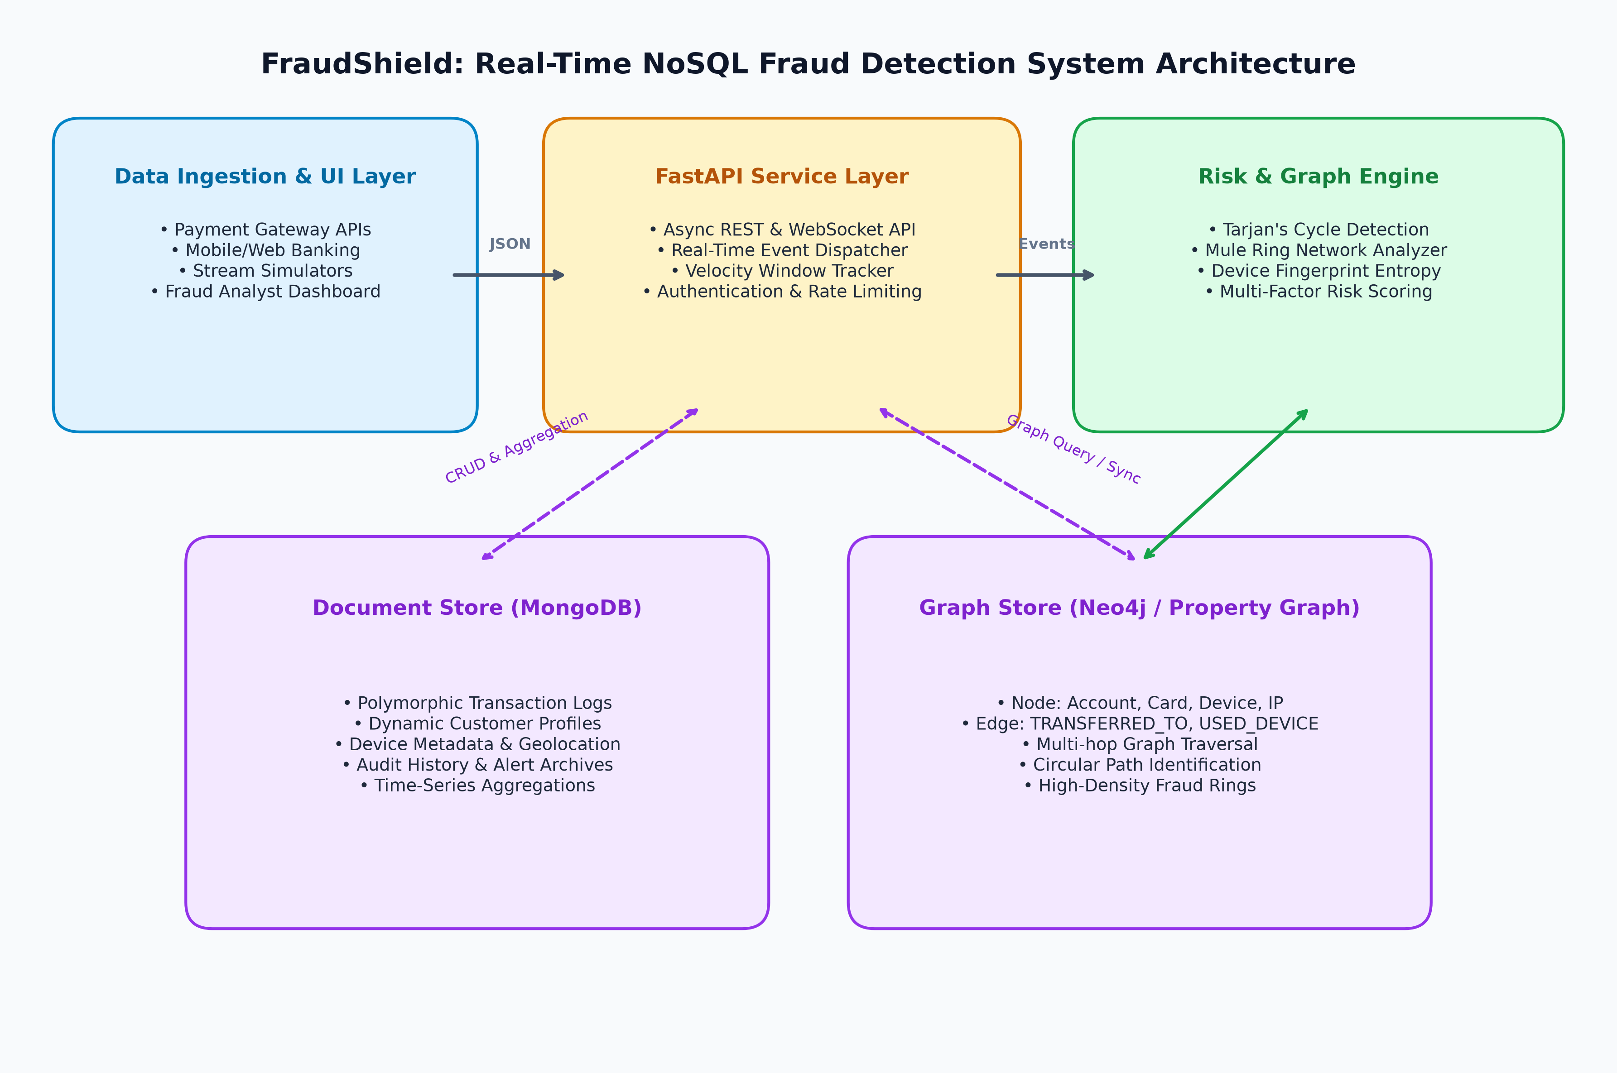
2. Database / Data Model Diagram:
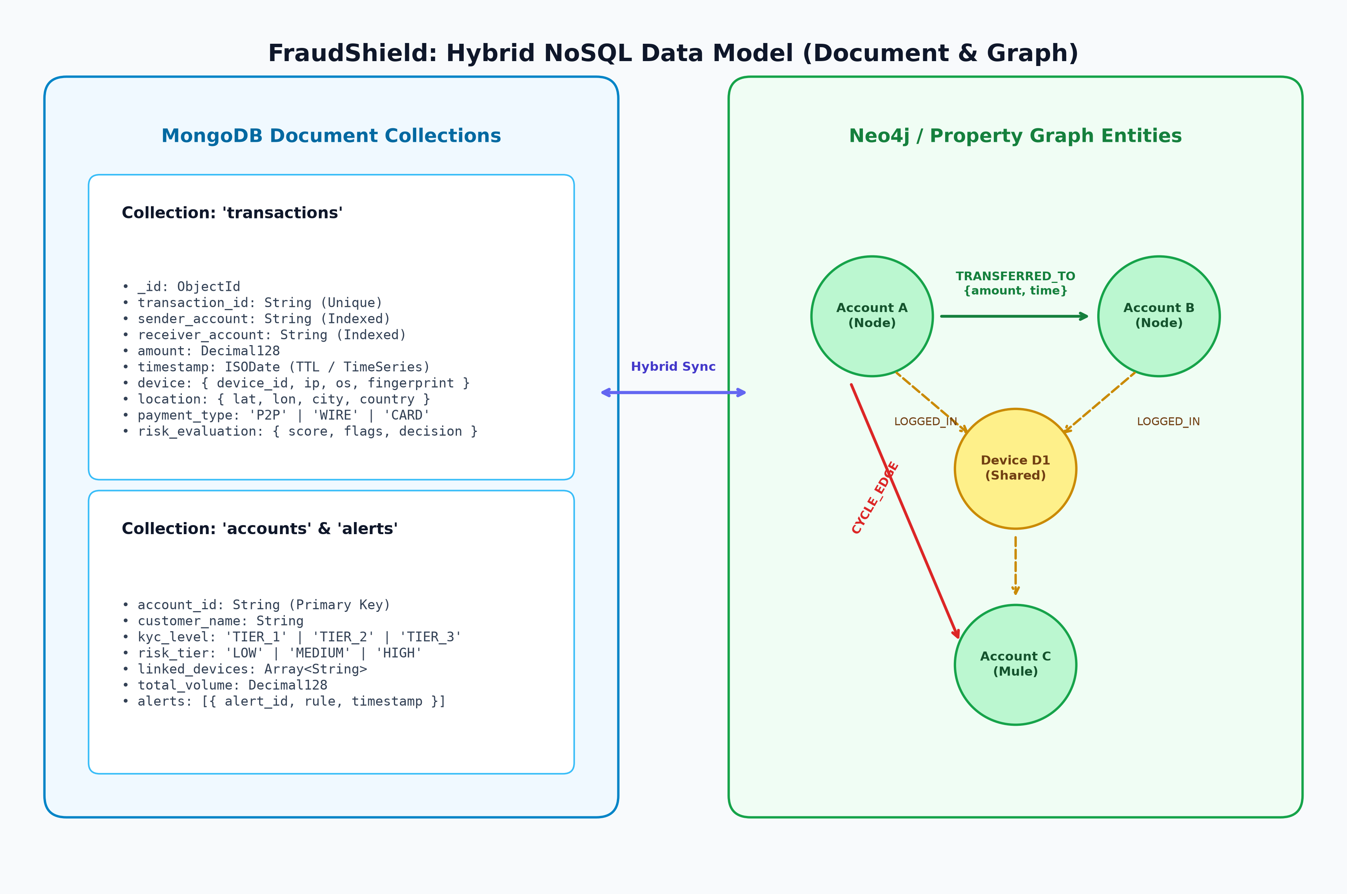
3. Project Workflow / Flowchart:
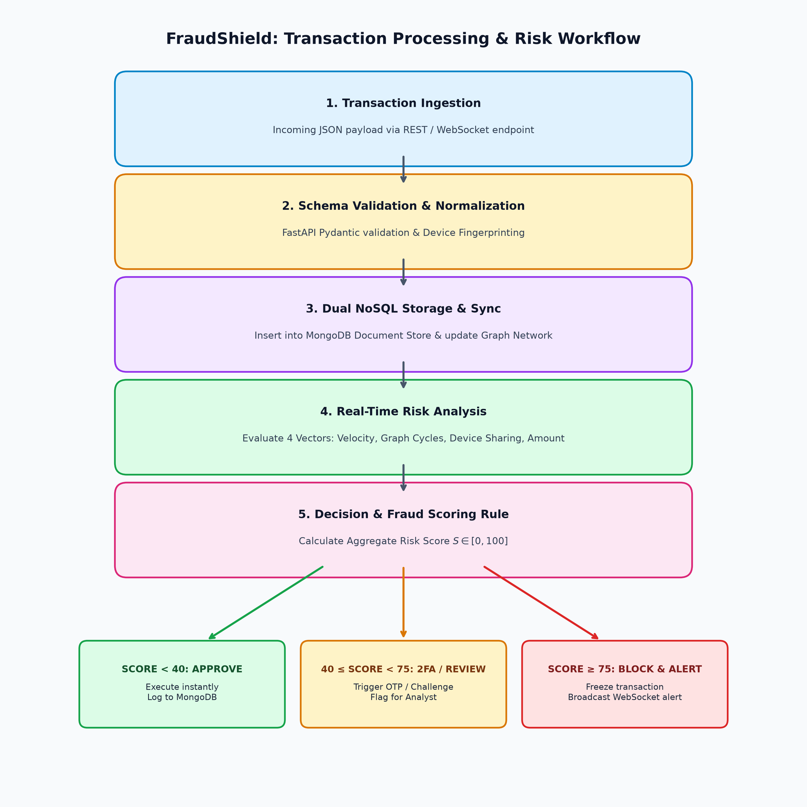
16.) Algorithm / Pseudocode
Provide the main algorithm, pseudocode, or workflow used in the proposed system.

Algorithm: EvaluateTransactionRisk
Input: Transaction T = {tx_id, sender, receiver, amount, timestamp, device_id, ip}
Output: RiskReport = {risk_score, classification, reasons}
1. Initialize RiskScore <- 0, AnomalyReasons <- []
2. InsertRecordIntoMongoDB(Collection: 'transactions', Data: T)
3. GraphEngine.AddOrUpdateNode(Type: 'Account', ID: T.sender)
4. GraphEngine.AddOrUpdateNode(Type: 'Account', ID: T.receiver)
5. GraphEngine.AddOrUpdateNode(Type: 'Device', ID: T.device_id)
6. GraphEngine.AddEdge(Source: T.sender, Target: T.receiver, Type: 'TRANSFERRED', Attr: {amount: T.amount, time: T.timestamp})
7. GraphEngine.AddEdge(Source: T.sender, Target: T.device_id, Type: 'USED_DEVICE', Attr: {time: T.timestamp})
8. CyclePath <- GraphEngine.FindDirectedCycle(StartNode: T.receiver, EndNode: T.sender, MaxDepth: 5)
9. If CyclePath is not EMPTY:
10. RiskScore <- RiskScore + 45; Append 'Circular ring detected: ' + CyclePath to AnomalyReasons
11. AssociatedAccounts <- GraphEngine.GetNeighbors(Node: T.device_id, EdgeType: 'USED_DEVICE', TimeWindow: '15m')
12. If Length(AssociatedAccounts) > 2:
13. RiskScore <- RiskScore + 30; Append 'Shared device across accounts' to AnomalyReasons
14. RecentCount <- MongoDB.CountDocuments('transactions', {sender: T.sender, timestamp: { $gte: T.timestamp - 300s }})
15. If RecentCount >= 5: RiskScore <- RiskScore + 25; Append 'Burst velocity' to AnomalyReasons
16. If T.amount > 50000.00: RiskScore <- RiskScore + 15
17. RiskScore <- Min(100, RiskScore)
18. Decision <- (RiskScore >= 75 ? 'HIGH_RISK_BLOCK' : (RiskScore >= 40 ? 'MEDIUM_RISK_2FA' : 'LOW_RISK_APPROVE'))
19. Return { risk_score: RiskScore, classification: Decision, reasons: AnomalyReasons }

Signatures
Signature: __________________________ Print name: Sarthak Gupta Date: September 25, 2026

Student Details | S.No. | Name | Gender | Nationality | Address
Student Details | 1. | Sarthak Gupta | Male | Indian | Jaipur

