**“DBMS LAB FILES”**

SUBMITTED BY:

**Sarthak Arun Jadhav**

**( 2124UCEM1073)**

**SUBJECT:**

**“Data Base Management System”**

Under the Guidance of :

**MR. Utkarsh Varshney Sir**



**Department of Computer Science and Engineering**

**Sanjivani Rural Education Society’s**

# SANJIVANI UNIVERSITY

**KOPARGAON – 423603, DIST : AHMEDNAGAR**

**2024-2025**

**INDEX**

| **Sr. No.** | **Practical Title** | **Date** | **Signature** | **Page No.** |
| --- | --- | --- | --- | --- |
| **1** | **Install and Set Up MySQL. Create Database and Table for Employee Details. Perform INSERT & DELETE.** |  |  |  |
| **2** | **Create Student Table. Perform INSERT, UPDATE, DELETE, and SELECT Operations.** |  |  |  |
| **3** | **Create Employee Table with Data Types. Insert Data and Perform Queries.** |  |  |  |
| **4** | **Create Employee Table with Constraints (Primary Key, Foreign Key, Unique). Test with Valid/Invalid Data.** |  |  |  |
| **5** | **Create Customer Table with NOT NULL, CHECK, DEFAULT Constraints. Test with Valid/Invalid Data.** |  |  |  |
| **6** | **Use DDL and DML Commands. Perform Insert, Update, Delete, and Data Retrieval Using SELECT Queries.** |  |  |  |
| **7** | **Create Sales Table. Use Aggregate Functions: COUNT, SUM, AVG, MIN, MAX.** |  |  |  |
| **8** | **Use INNER JOIN, LEFT JOIN, and RIGHT JOIN on Customers and Orders Tables.** |  |  |  |

**Practical :- 1**

**AIM :-** Install and set up MySQL. Create a database and a table to store employee details.

* **CODE FOR INSERTION :-**

CREATE DATABASE PRACTICAL1;

USE PRACTICAL1;

CREATE TABLE EMPLOYEE(  
id int auto_increment primary key,  
name varchar(50) not null,  
departement varchar(50) not null,  
position varchar(50) not null,  
salary decimal(10,2),  
joindate date not null);

select * from EMPLOYEE;

insert into EMPLOYEE (name, departement, position, salary, joindate)

VALUES  
('Sarthak ', 'COMPUTER', 'MANAGER', '10000.00', '2020-03-04'),  
('ALEX', 'CYBER', 'MANAGER', '10000.00', '2020-03-04'),  
('ROBIN', 'COMPUTER', 'EMPLOYEE', '1000.00', '2024-01-12'),  
('WEDNESDAY', 'COMPUTER', 'EMPLOYEE', '1000.00', '2023-06-14'),  
('KAILY', 'CYBER', 'EMPLOYEE', '1000.00', '2020-03-04');

select * from EMPLOYEE;

* **OUTPUT :-**
* 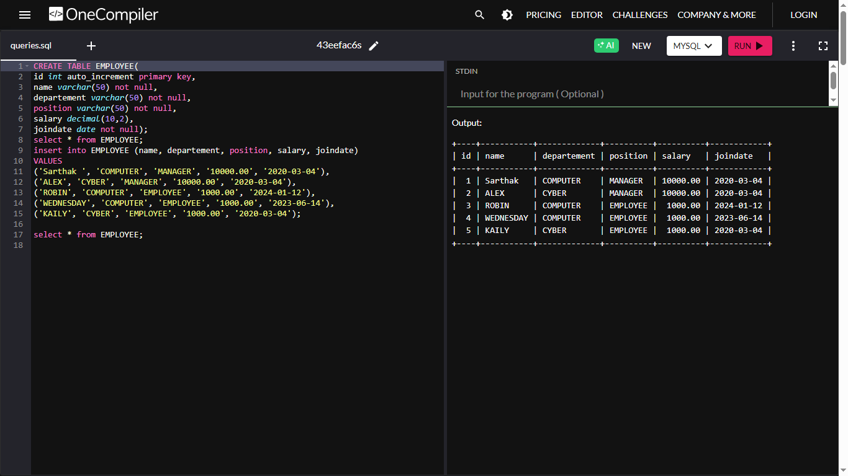
* **CODE FOR DELETION :-**

CREATE DATABASE PRACTICAL1;

USE PRACTICAL1;

CREATE TABLE EMPLOYEE(  
id int auto_increment primary key,  
name varchar(50) not null,  
departement varchar(50) not null,  
position varchar(50) not null,  
salary decimal(10,2),  
joindate date not null);  
select * from EMPLOYEE;  
insert into EMPLOYEE (name, departement, position, salary, joindate)

VALUES

('Sarthak', 'COMPUTER', 'MANAGER', '10000.00', '2020-03-04'),  
('ALEX', 'CYBER', 'MANAGER', '10000.00', '2020-03-04'),  
('ROBIN', 'COMPUTER', 'EMPLOYEE', '1000.00', '2024-01-12'),  
('WEDNESDAY', 'COMPUTER', 'EMPLOYEE', '1000.00', '2023-06-14'),  
('KAILY', 'CYBER', 'EMPLOYEE', '1000.00', '2020-03-04');

DELETE FROM EMPLOYEE  
WHERE id = 4;

select * from EMPLOYEE;

**OUTPUT :-**

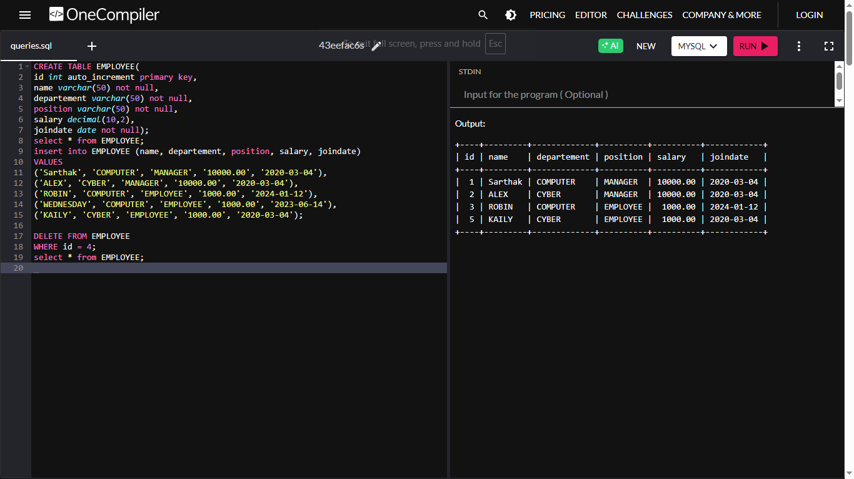

**Practical :- 2**

**Aim:** Create a table for storing student information. Insert sample data and perform basic Operations: INSERT, UPDATE, DELETE, and SELECT.

* **CODE FOR TABLE CREATION :-**

CREATE DATABASE PRACTICAL2;

USE PRACTICAL2;

CREATE TABLE STUDENTS_INFO(  
STUDENT_ID int auto_increment primary key,  
STUDENT_NAME varchar(50) not null,  
STUDENT_MAIL_ID varchar(50) not null,  
DEPARTMANT varchar(50) not null,  
JOIN_DATE date not null);

SELECT * FROM STUDENTS_INFO

* **OUTPUT :-**

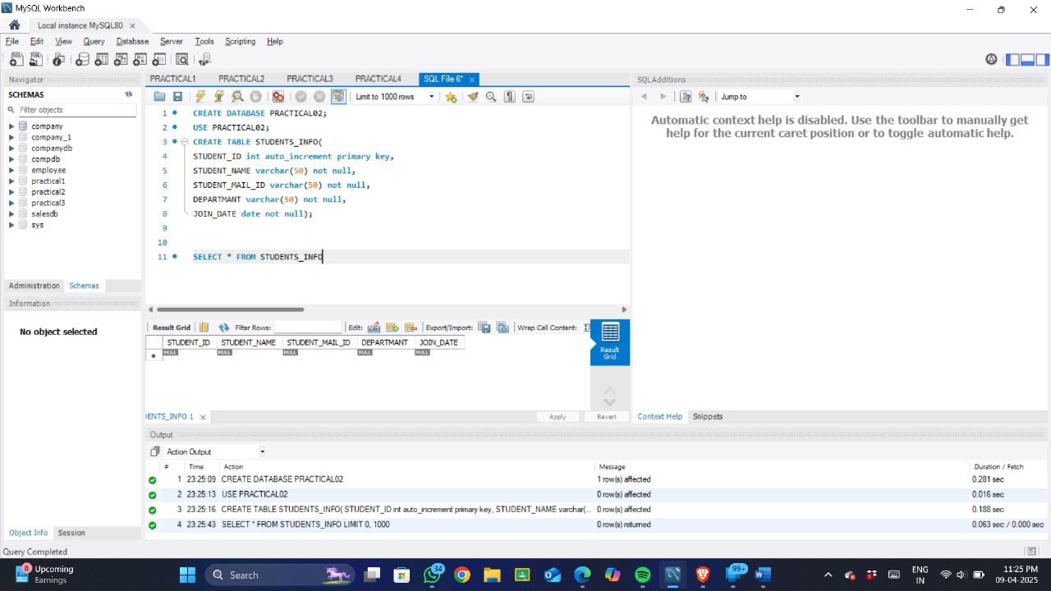

* **CODE FOR SOME SAMPLE DATA :-**

CREATE DATABASE PRACTICAL2;

USE PRACTICAL2;

CREATE TABLE STUDENTS_INFO(  
STUDENT_ID int auto_increment primary key,  
STUDENT_NAME varchar(50) not null,  
STUDENT_MAIL_ID varchar(50) not null,  
DEPARTMANT varchar(50) not null,  
JOIN_DATE date not null);

-- SELECT * FROM STUDENTS_INFO

INSERT into STUDENTS_INFO (STUDENT_NAME, STUDENT_MAIL_ID, DEPARTMANT, JOIN_DATE)

VALUES

('SARVESH NIRHALI', 'sarvesh.nirhali_24uce@sanjivani.edu.in', 'CSE', '2024-09-13'),  
('ALEX ROY', 'alexroy@yahoo.com', 'CY', '2020-03-04'),  
('ROBIN HOOD', 'robhood@google.com', 'AIML', '2024-01-12'),  
('WEDNESDAY ADAM', 'wedadam@hotmail.com', 'AIDS', '2023-06-14'),  
('KAILY SWIFT', 'kailyswift@example.com', 'CY', '2020-03-04');

SELECT * FROM STUDENTS_INFO

* **OUTPUT:-**

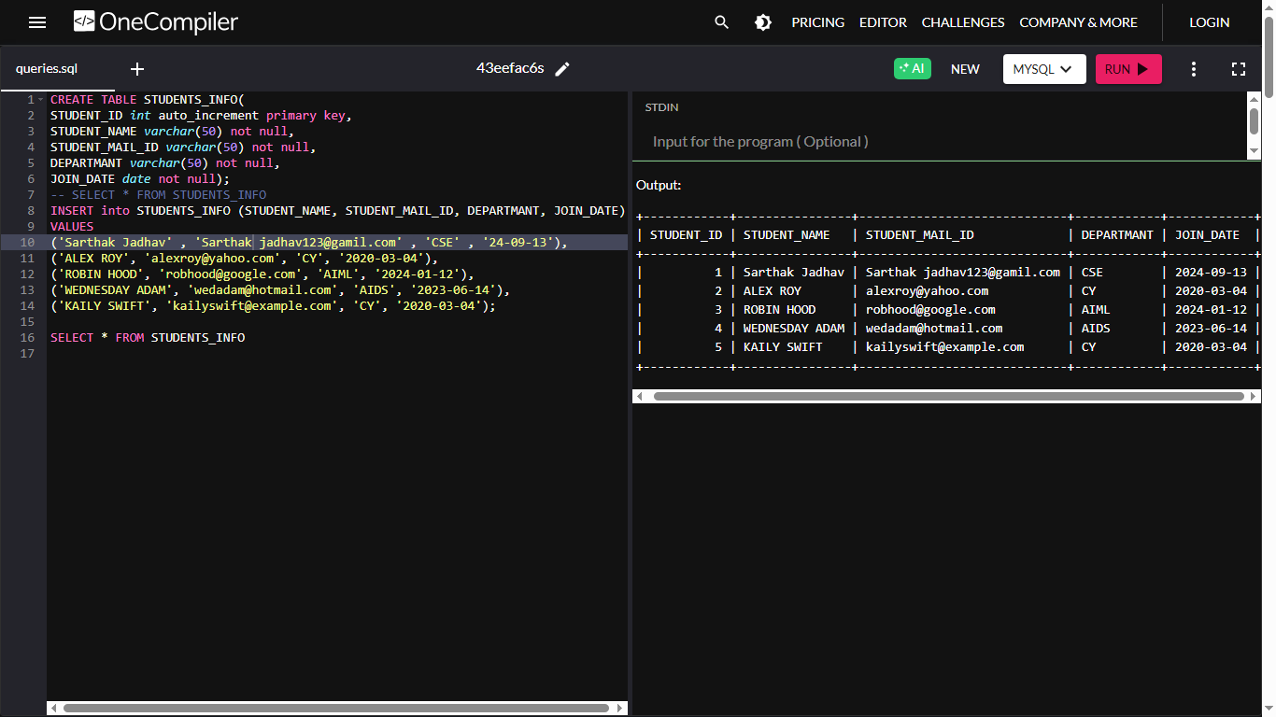

* **CODE FOR UPDATE THE TABLE :-**

UPDATE STUDENTS_INFO  
SET DEPARTMANT = 'BBA'  
WHERE STUDENT_ID = 5;

SELECT * FROM STUDENTS_INFO

* **OUTPUT :-**

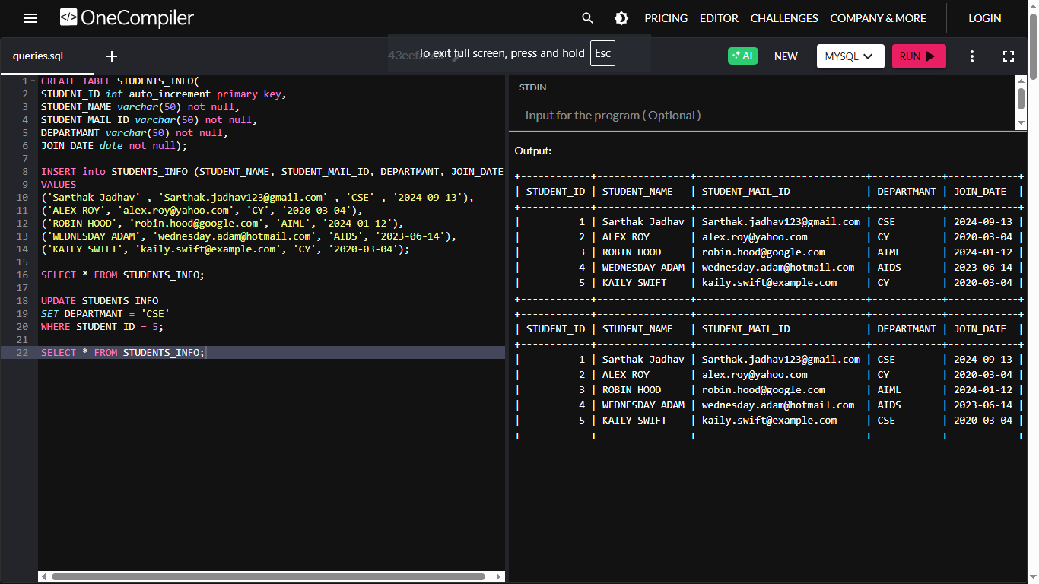

* **CODE FOR DELETE THE RECORD FROM THE TABLE :-**

DELETE FROM STUDENTS_INFO  
WHERE STUDENT_ID = 3;  
SELECT * FROM STUDENTS_INFO

* **OUTPUT :-**

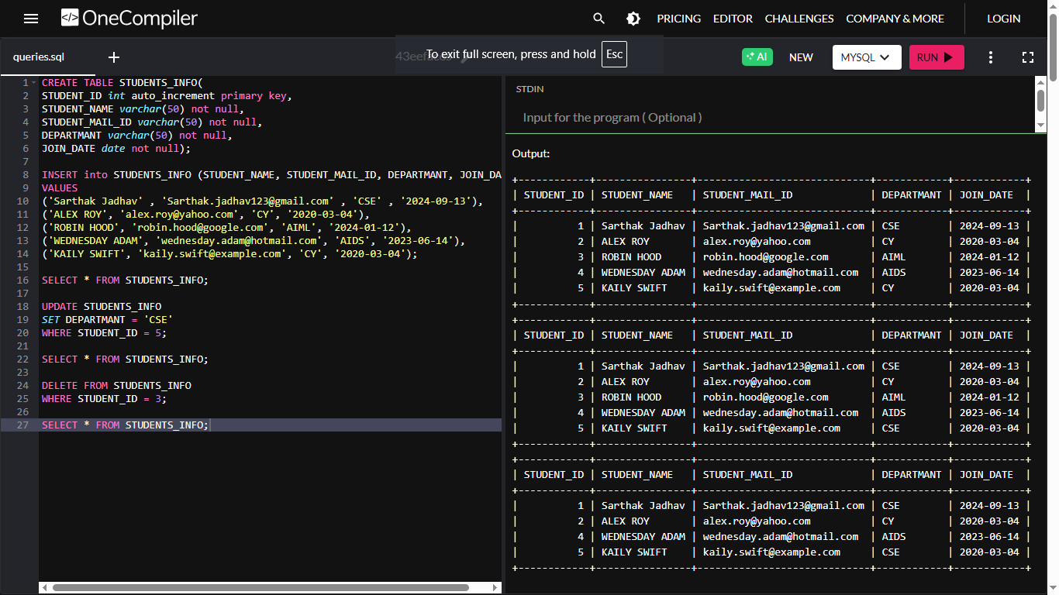

* **CODE FOR INSERT A RECORD INTO THE EXESTING TABLE :-**

INSERT INTO STUDENTS_INFO (STUDENT_ID, STUDENT_NAME, STUDENT_MAIL_ID, DEPARTMANT, JOIN_DATE)

VALUE

('3', 'SURAT ADAM', 'broosuratdumb@example.com', 'AIML', '2024-12-28');

SELECT * FROM STUDENTS_INFO

* **OUTPUT :-**

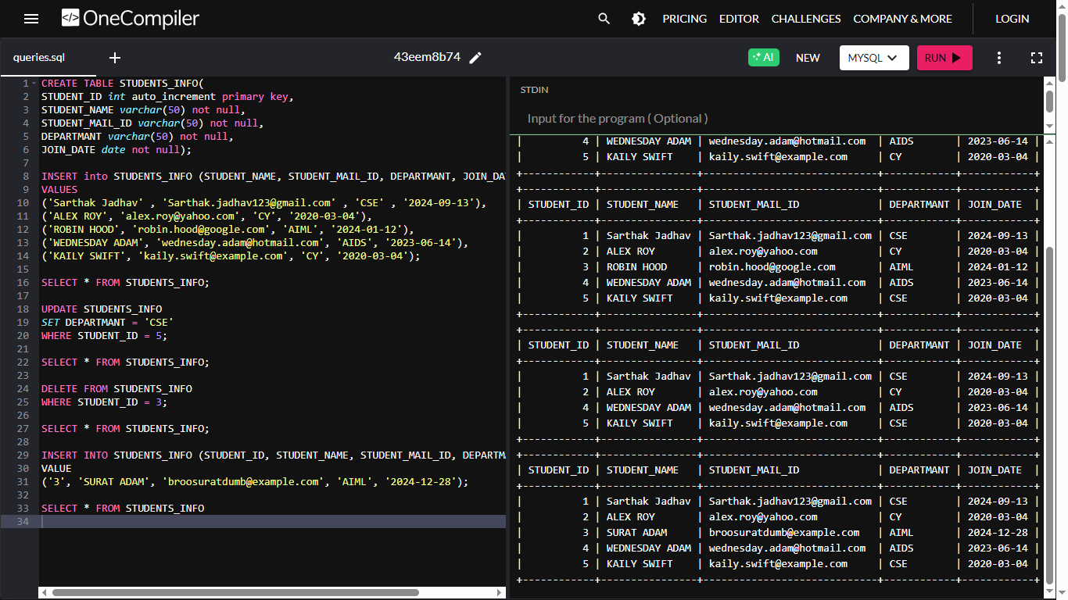

**Practical :- 3**

**AIM :-** Create a table with columns for EmployeeID, Name, Salary, JoiningDate, and ActiveStatus using different data types. Insert sample data and perform queries to manipulate and retrieve data.

* **CODE FOR CREATION OF TABLE :-**

CREATE DATABASE PRACTICAll3;

USE PRACTICAll3;

CREATE TABLE Employees (

EmployeeID INT PRIMARY KEY,

Name VARCHAR(100),

Salary DECIMAL(10, 2),

JoiningDate DATE,

ActiveStatus BOOLEAN);

select*FROM Employees

* 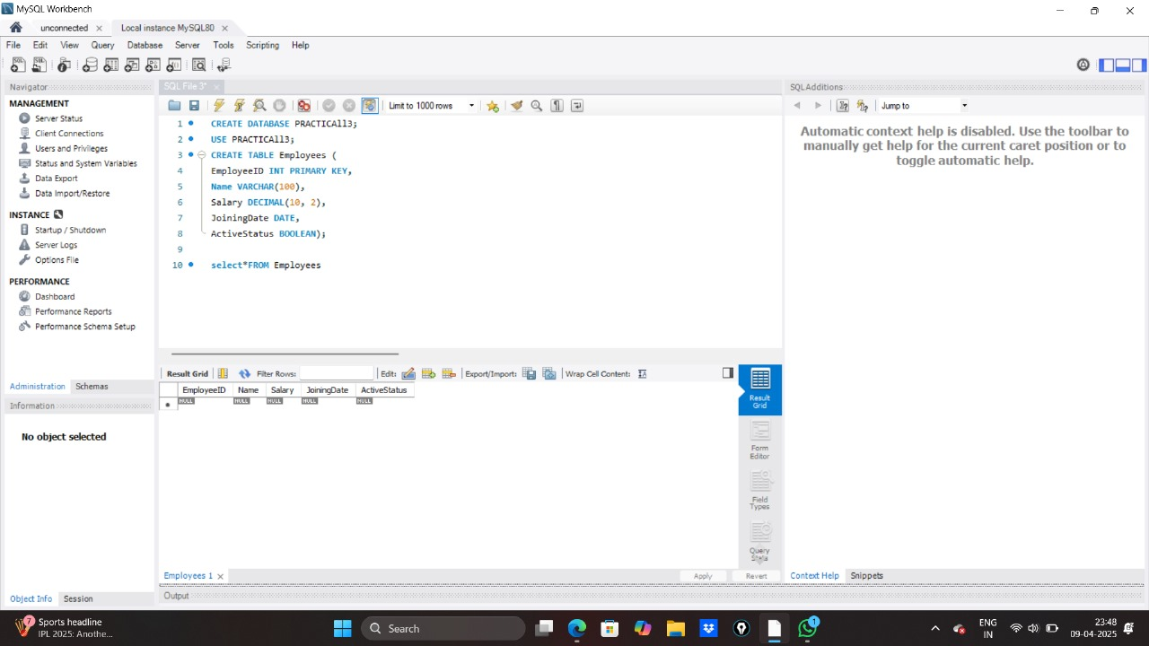**OUTPUT :-**
* **CODE FOR INSERTION OF SAMPLE DATA :-**

INSERT INTO Employees (EmployeeID, Name, Salary, JoiningDate, ActiveStatus)

VALUES

(101, 'Sarthak Jadhav', '85000.00', '2023-02-18', TRUE),  
(102, 'Avery Knight', 55000.00, '2020-06-15', FALSE),  
(103, 'Lena Brooks', 62000.50, '2019-03-10', TRUE),  
(104, 'Kai Thornton', 48000.75, '2021-01-25', FALSE),  
(105, 'Zane Holloway', 75000.00, '2018-11-01', TRUE),  
(106, 'Nova Chandler', 51000.00, '2022-08-20', FALSE);

SELECT * FROM Employees

* **OUTPUT :-**

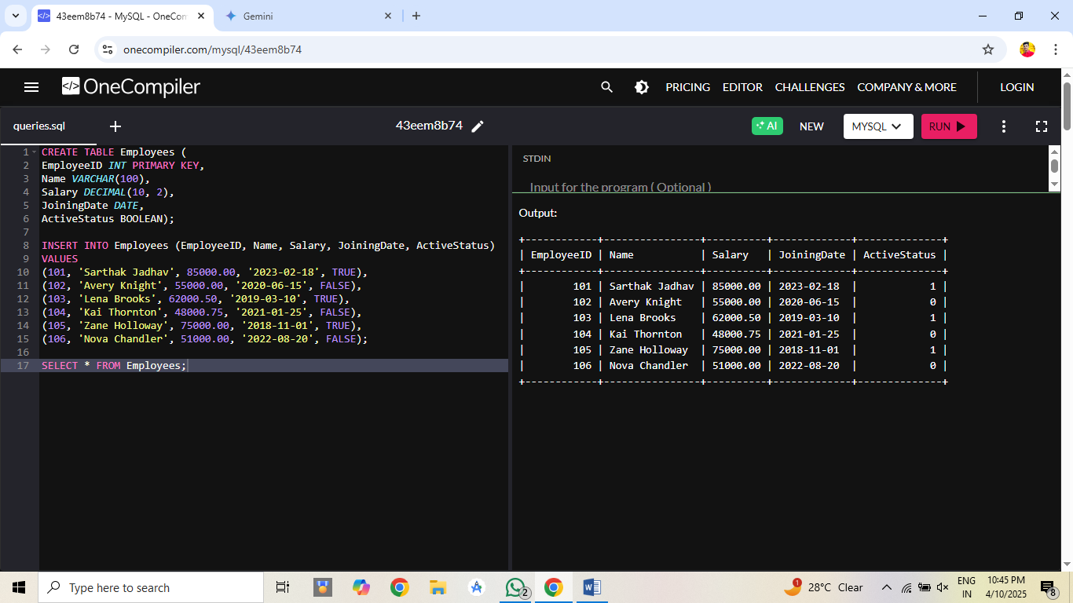

* **CODE FOR PERFORMING QUERIES TO MANIPULATE AND RETRIEVE DATA :-**

1. SELECT * FROM Employees

* **OUTPUT :-**
* 

1. SELECT * FROM Employees WHERE Salary > 60000 ;

**OUTPUT :-**

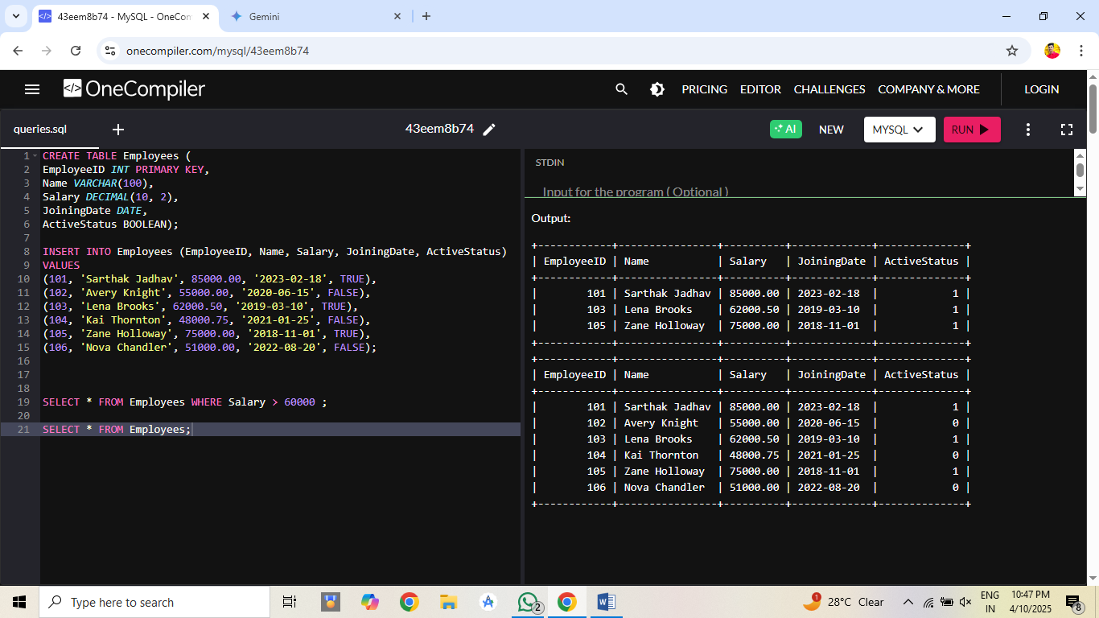

**3.**SELECT * FROM Employees WHERE JoiningDate < '2022-08-20';

* **OUTPUT :-**

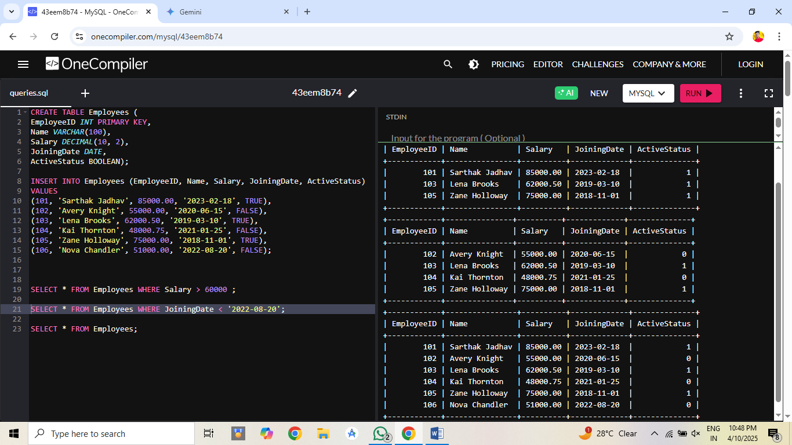

**4.UPDATE Employees**

SET Salary = 58000.00

WHERE EmployeeID = 104;

SELECT Name, Salary

FROM EMPLOYEES

WHERE EmployeeID = 104;

* **OUTPUT :-**

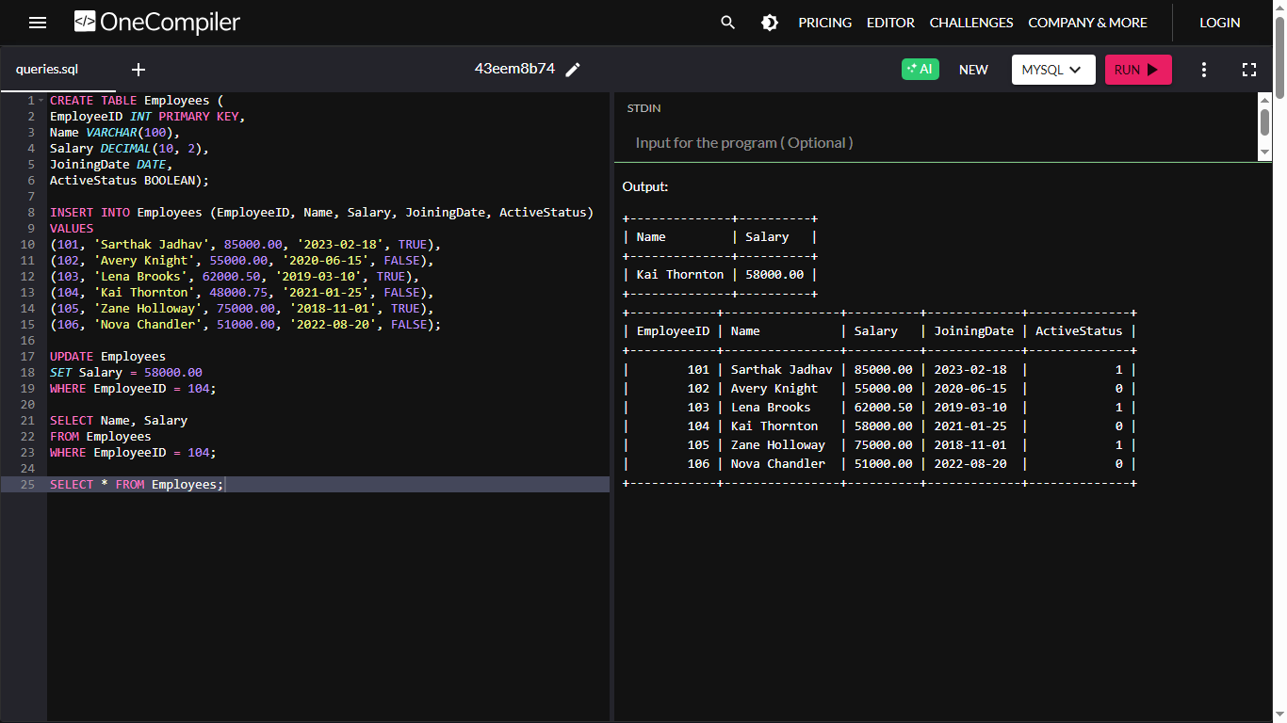

**5.UPDATE Employees**

SET ActiveStatus = TRUE

WHERE EmployeeID = 106;

SELECT Name, ActiveStatus

FROM EMPLOYEES

WHERE EmployeeID = 106;

* **OUTPUT :-**

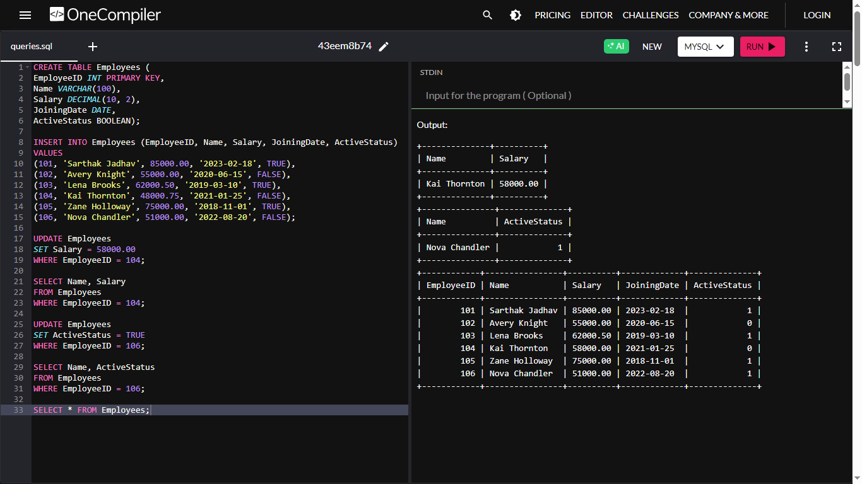

**Practical :- 4**

**Aim:** Create a table to store employee information with constraints like Primary Key,Foreign Key, and Unique.

**Code** :

CREATE TABLE Department (

DeptID INT PRIMARY KEY,

DeptName VARCHAR(50) UNIQUE

);

CREATE TABLE Employee (

EmpID INT PRIMARY KEY,

Name VARCHAR(100) NOT NULL,

Email VARCHAR(100) UNIQUE,

Salary DECIMAL(10,2) CHECK (Salary > 0),

DeptID INT,

FOREIGN KEY (DeptID) REFERENCES Department(DeptID)

);

INSERT INTO Department (DeptID, DeptName) VALUES (1, 'HR');

INSERT INTO Department (DeptID, DeptName) VALUES (2, 'IT');

INSERT INTO Employee (EmpID, Name, Email, Salary, DeptID)

VALUES (101, 'Sarthak ', 'alice@example.com', 50000.00, 1);

INSERT INTO Employee (EmpID, Name, Email, Salary, DeptID)

VALUES (102, 'Aditya', 'bob@example.com', 60000.00, 2);

INSERT INTO Employee (EmpID, Name, Email, Salary, DeptID)

VALUES (103, 'Charlie', 'charlie@example.com', 55000.00, 1);

INSERT INTO Employee (EmpID, Name, Email, Salary, DeptID)

VALUES (104, 'David', 'david@example.com', 45000.00, 2);

INSERT INTO Employee (EmpID, Name, Email, Salary, DeptID)

VALUES (105, 'Frank', 'frank@example.com', 40000.00, 1);

SELECT * FROM Employee;

SELECT * FROM Department;

**Output :**

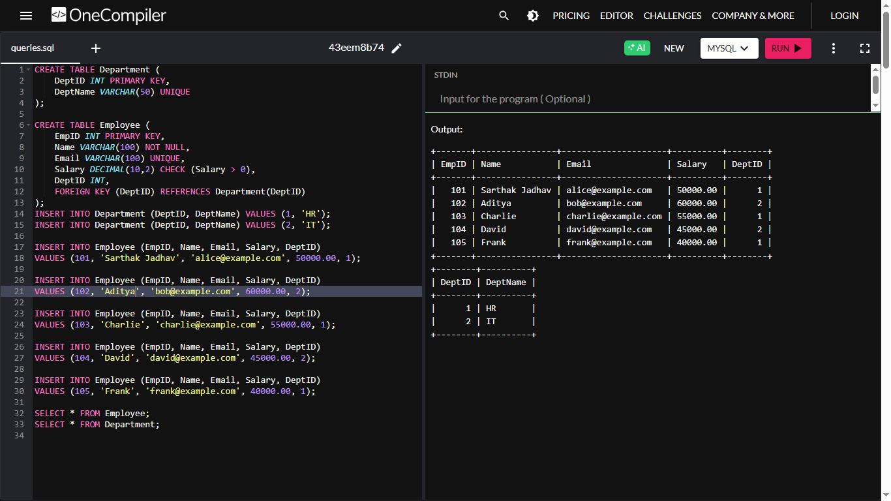

**Practical :- 5**

**Aim:** Create a table for Customer details with various integrity constraints like NOT NULL, CHECK, and DEFAULT. Insert valid and invalid data to test these constraints and ensure data integrity.

**Code :**

CREATE TABLE Customer (

CustomerID INT PRIMARY KEY,

FirstName VARCHAR(100) NOT NULL,

LastName VARCHAR(100) NOT NULL,

Email VARCHAR(100) UNIQUE,

Phone VARCHAR(15),

Age INT CHECK (Age >= 18),

IsActive BOOLEAN DEFAULT TRUE

);

INSERT INTO Customer (CustomerID, FirstName, LastName, Email, Phone, Age, IsActive)

VALUES (1, 'Sarthak', 'Jadhav', 'SJ.Jadhav@example.com', '1234567890', 25, TRUE);

INSERT INTO Customer (CustomerID, FirstName, LastName, Email, Phone, Age)

VALUES (2, 'Jane', 'Smith', 'jane.smith@example.com', '0987654321', 30);

INSERT INTO Customer (CustomerID, FirstName, LastName, Email, Phone, Age)

VALUES (3, 'Taylor', 'Taylor', 'taylor@example.com', '5551234567', 20);

INSERT INTO Customer (CustomerID, FirstName, LastName, Email, Phone, Age)

VALUES (4, 'Alice', 'Johnson', 'alice.johnson@example.com', '6669876543', 20);

INSERT INTO Customer (CustomerID, FirstName, LastName, Email, Phone, Age)

VALUES (5, 'Bob', 'Brown', 'bob.brown@example.com', '7771234567', 28);

SELECT * FROM Customer;

**Output :**

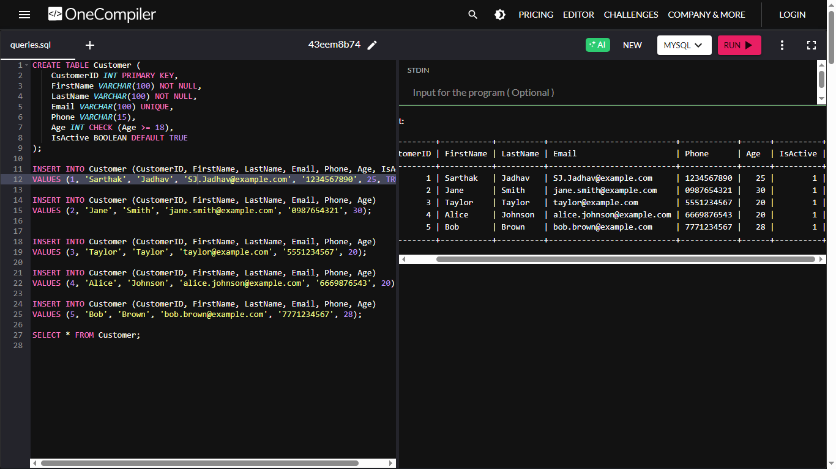

**Practical :- 6**

**Aim:** Use DDL commands to create tables and DML commands to insert, update, and delete data. Write SELECT queries to retrieve and verify data changes.

**Code :**

CREATE TABLE Employees (

EmployeeID INT PRIMARY KEY,

FirstName VARCHAR(50),

LastName VARCHAR(50),

Age INT,

Department VARCHAR(50),

Salary DECIMAL(10, 2)

);

INSERT INTO Employees (EmployeeID, FirstName, LastName, Age, Department, Salary)

VALUES (1, 'Sarthak', 'Jadhav', 28, 'HR', 50000.00);

INSERT INTO Employees (EmployeeID, FirstName, LastName, Age, Department, Salary)

VALUES (2, 'Jane', 'Smith', 35, 'IT', 65000.00);

INSERT INTO Employees (EmployeeID, FirstName, LastName, Age, Department, Salary)

VALUES (3, 'Michael', 'Johnson', 40, 'Finance', 75000.00);

UPDATE Employees

SET Salary = 70000.00

WHERE EmployeeID = 2;

UPDATE Employees

SET FirstName = 'Sarthak', LastName = 'Jadhav', Salary = 75000.00

WHERE EmployeeID = 2;

UPDATE Employees

SET FirstName = 'Michael', LastName = 'Brown', Age = 45, Department = 'Management', Salary = 80000.00

WHERE EmployeeID = 3;

UPDATE Employees

SET Salary = Salary * 1.10

WHERE Department = 'HR';

UPDATE Employees

SET Salary = Salary + 5000

WHERE Salary = (

SELECT max_sal FROM (

SELECT MAX(Salary) AS max_sal FROM Employees

) AS temp

);

UPDATE Employees

SET Salary = CASE

WHEN Department = 'HR' THEN Salary * 1.05

WHEN Department = 'IT' THEN Salary * 1.08

WHEN Department = 'Finance' THEN Salary * 1.10

ELSE Salary

END;

DELETE FROM Employees

WHERE EmployeeID = 1;

SELECT * FROM Employees;

SELECT * FROM Employees

WHERE EmployeeID = 2;

SELECT * FROM Employees

WHERE EmployeeID = 1;

**Output :**

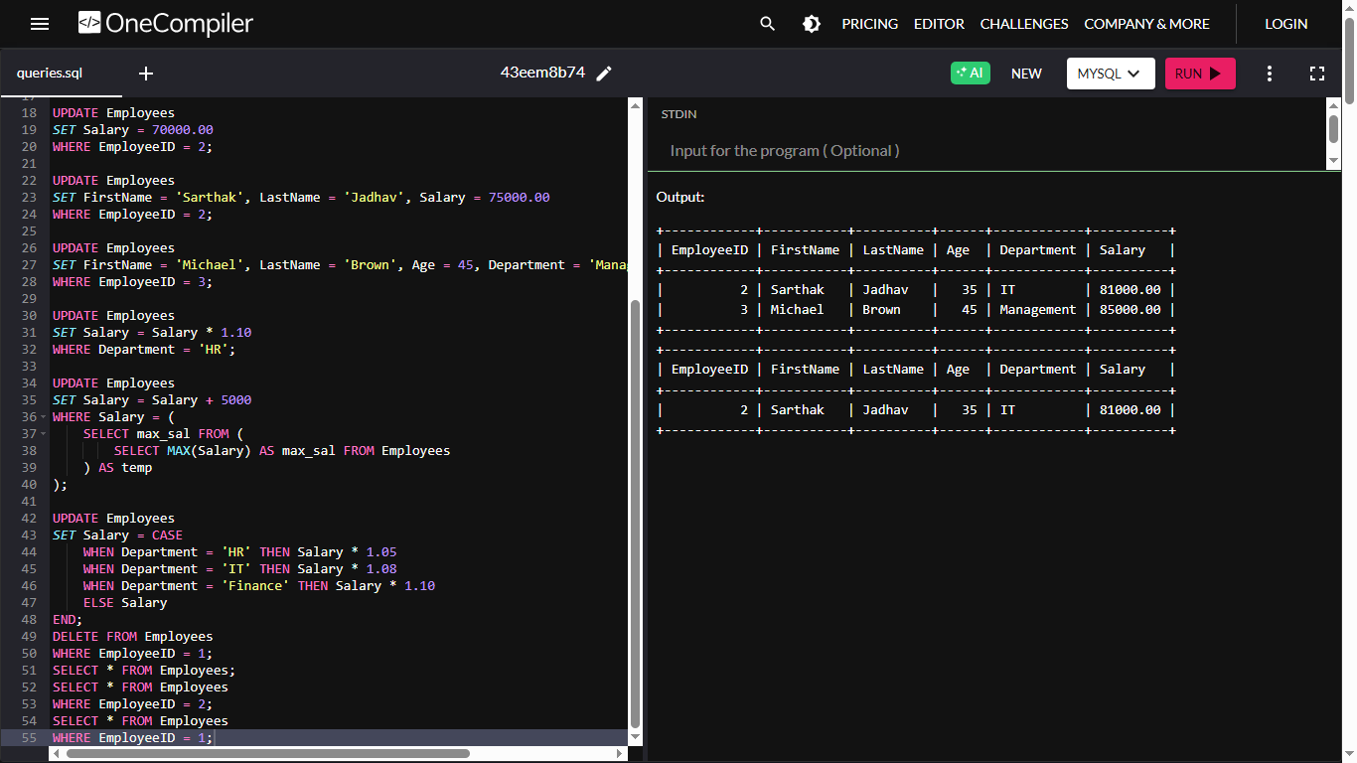

**Practical :- 7**

**Aim :** Create a Sales table and use aggregate functions like COUNT,SUM, AVG, MIN, and MAX to summarize sales data and calculate statistics.

**Code :**

CREATE TABLE Sales (

SaleID INT PRIMARY KEY AUTO_INCREMENT,

Product VARCHAR(50),

Quantity INT,

Price DECIMAL(10,2),

SaleDate DATE

);

INSERT INTO Sales (Product, Quantity, Price, SaleDate) VALUES

('Laptop', 2, 75000.00, '2025-02-01'),

('Mobile', 5, 20000.00, '2025-02-02'),

('Tablet', 3, 30000.00, '2025-02-03'),

('Laptop', 1, 78000.00, '2025-02-04'),

('Mobile', 4, 22000.00, '2025-02-05'),

('Tablet', 2, 32000.00, '2025-02-06');

SELECT COUNT(*) AS Total_Sales FROM Sales;

SELECT COUNT(DISTINCT Product) AS Unique_Products FROM Sales;

SELECT Product, COUNT(*) AS Sales_Count FROM Sales GROUP BY Product;

SELECT SaleDate, COUNT(*) AS Sales_Per_Day FROM Sales GROUP BY SaleDate;

SELECT COUNT(*) AS High_Quantity_Sales FROM Sales WHERE Quantity > 2;

SELECT COUNT(*) AS Sales_This_Month FROM Sales WHERE MONTH(SaleDate) = MONTH(CURRENT_DATE) AND YEAR(SaleDate) = YEAR(CURRENT_DATE);

SELECT COUNT(*) AS High_Value_Sales FROM Sales WHERE (Quantity * Price) > 50000;

SELECT Product, COUNT(*) AS High_Value_Transactions FROM Sales WHERE (Quantity * Price) > 40000 GROUP BY Product;

SELECT COUNT(*) AS Sales_After_Date FROM Sales WHERE SaleDate > '2025-02-03';

SELECT SUM(Quantity * Price) AS Total_Revenue FROM Sales;

SELECT SUM(Quantity) AS Total_Quantity_Sold FROM Sales;

SELECT Product, SUM(Quantity * Price) AS Revenue_Per_Product FROM Sales GROUP BY Product;

SELECT SaleDate, SUM(Quantity * Price) AS Revenue_Per_Day FROM Sales GROUP BY SaleDate;

SELECT SUM(Quantity * Price) AS Revenue_This_Month FROM Sales WHERE MONTH(SaleDate) = MONTH(CURRENT_DATE) AND YEAR(SaleDate) = YEAR(CURRENT_DATE);

SELECT SUM(Quantity * Price) AS High_Quantity_Revenue FROM Sales WHERE Quantity > 2;

SELECT SUM(Quantity * Price) AS Revenue_After_Date FROM Sales WHERE SaleDate > '2025-02-03';

SELECT Product, SUM(Quantity * Price) AS High_Value_Revenue FROM Sales WHERE (Quantity * Price) > 40000 GROUP BY Product;

SELECT AVG(Price) AS Average_Price FROM Sales;

SELECT AVG(Quantity) AS Average_Quantity_Sold FROM Sales;

SELECT AVG(Quantity * Price) AS Average_Revenue_Per_Transaction FROM Sales;

SELECT Product, AVG(Price) AS Average_Price_Per_Product FROM Sales GROUP BY Product;

SELECT Product, AVG(Quantity * Price) AS Average_Revenue_Per_Product FROM Sales GROUP BY Product;

SELECT Product, AVG(Quantity) AS Average_Quantity_Per_Product FROM Sales GROUP BY Product;

SELECT SaleDate, AVG(Quantity * Price) AS Average_Revenue_Per_Day FROM Sales GROUP BY SaleDate;

SELECT AVG(Quantity * Price) AS Average_Revenue_This_Month FROM Sales WHERE MONTH(SaleDate) = MONTH(CURRENT_DATE) AND YEAR(SaleDate) = YEAR(CURRENT_DATE);

SELECT AVG(Price) AS Avg_Price_High_Quantity_Sales FROM Sales WHERE Quantity > 2;

SELECT AVG(Quantity * Price) AS Average_Revenue_After_Date FROM Sales WHERE SaleDate > '2025-02-03';

SELECT MIN(Price) AS Min_Price, MAX(Price) AS Max_Price FROM Sales;

SELECT MIN(Quantity) AS Min_Quantity_Sold, MAX(Quantity) AS Max_Quantity_Sold FROM Sales;

SELECT MIN(Quantity * Price) AS Min_Revenue, MAX(Quantity * Price) AS Max_Revenue FROM Sales;

SELECT Product, MIN(Price) AS Min_Price_Per_Product, MAX(Price) AS Max_Price_Per_Product FROM Sales GROUP BY Product;

SELECT Product, MIN(Quantity * Price) AS Min_Revenue_Per_Product, MAX(Quantity * Price) AS Max_Revenue_Per_Product FROM Sales GROUP BY Product;

SELECT Product, MIN(Quantity) AS Min_Quantity_Per_Product, MAX(Quantity) AS Max_Quantity_Per_Product FROM Sales GROUP BY Product;

SELECT SaleDate, MIN(Quantity * Price) AS Min_Revenue_Per_Day, MAX(Quantity * Price) AS Max_Revenue_Per_Day FROM Sales GROUP BY SaleDate;

SELECT MIN(Quantity * Price) AS Min_Revenue_This_Month, MAX(Quantity * Price) AS Max_Revenue_This_Month FROM Sales WHERE MONTH(SaleDate) = MONTH(CURRENT_DATE) AND YEAR(SaleDate) = YEAR(CURRENT_DATE);

SELECT MIN(Price) AS Min_Price_High_Quantity_Sales, MAX(Price) AS Max_Price_High_Quantity_Sales FROM Sales WHERE Quantity > 2;

SELECT MIN(Quantity * Price) AS Min_Revenue_After_Date, MAX(Quantity * Price) AS Max_Revenue_After_Date FROM Sales WHERE SaleDate > '2025-02-03';

**Output :**

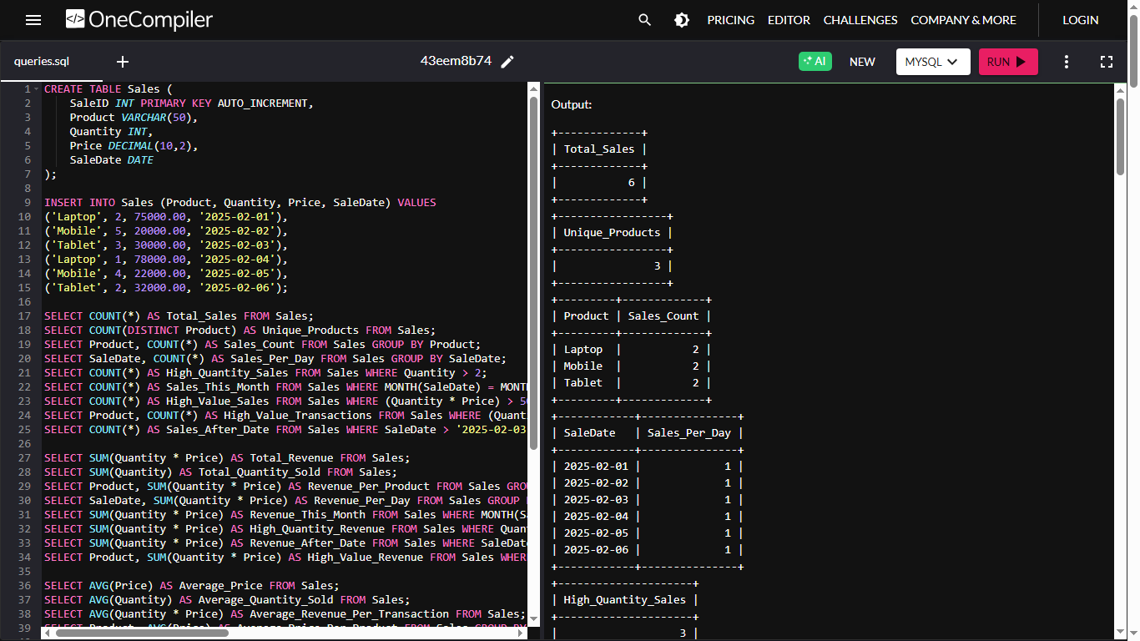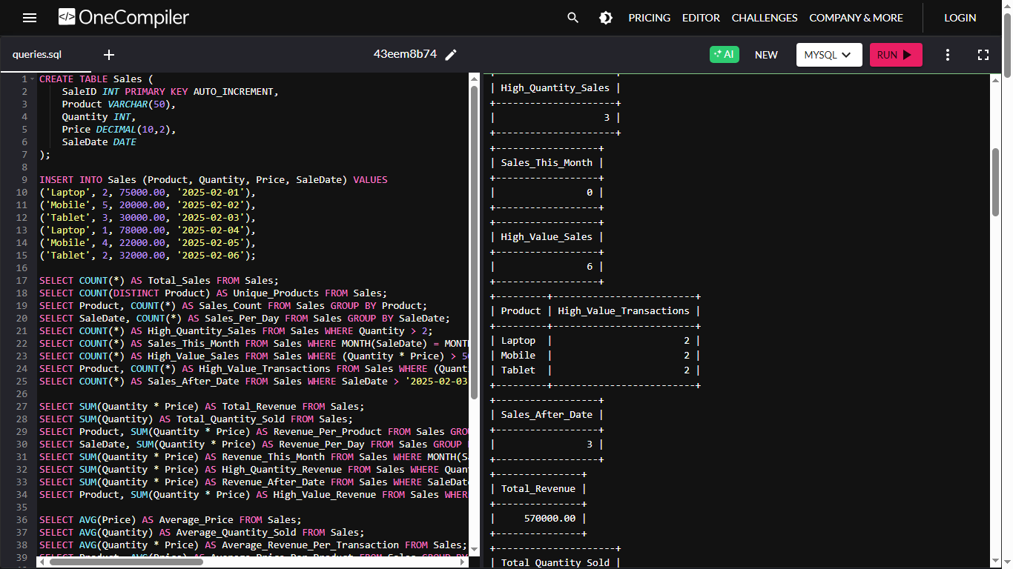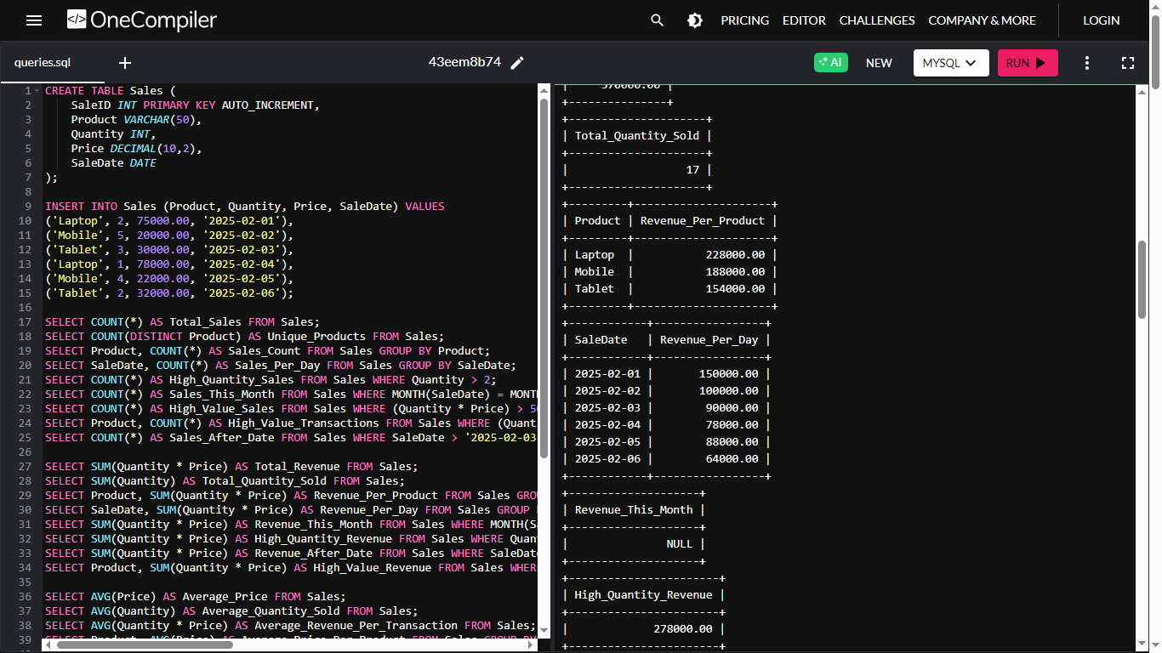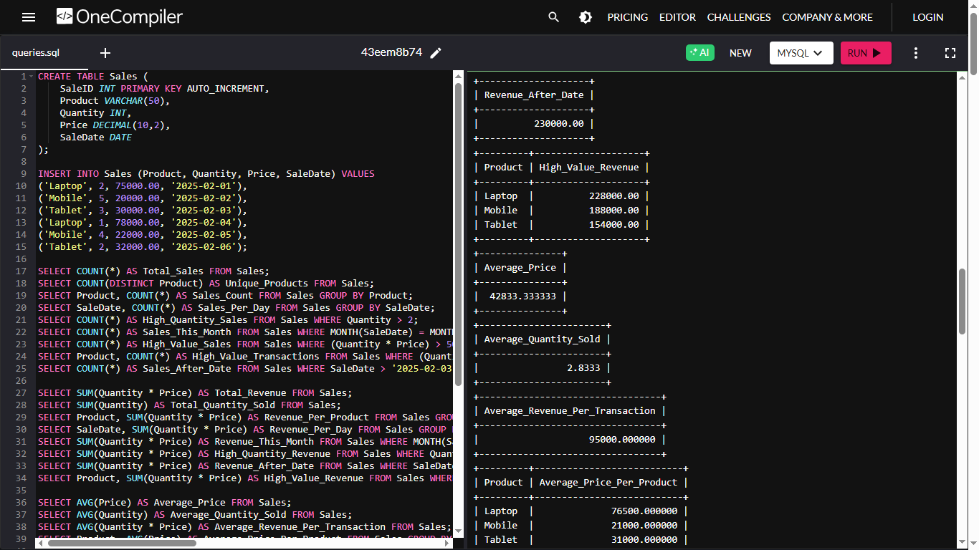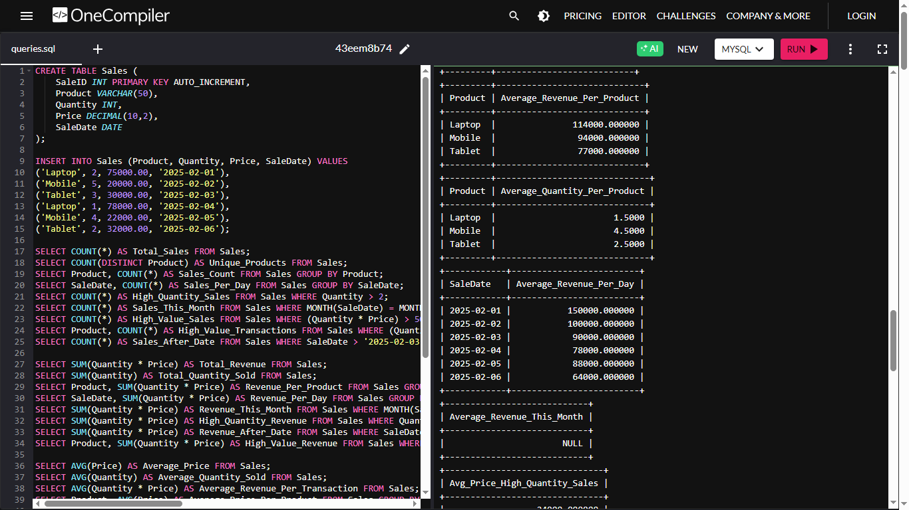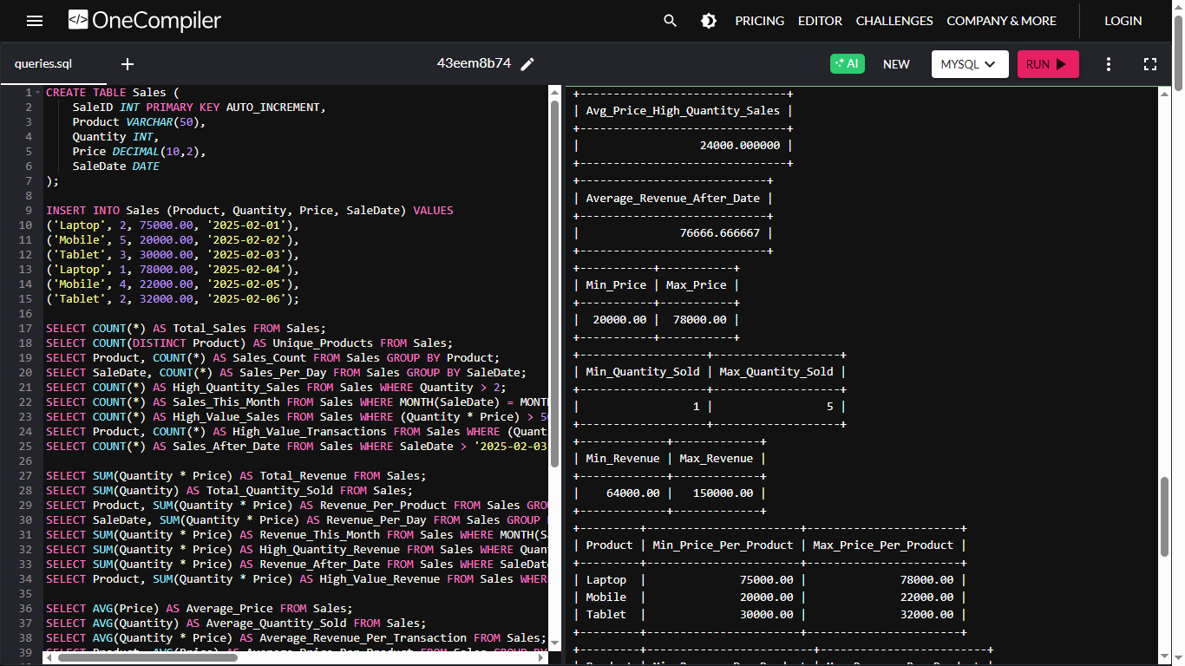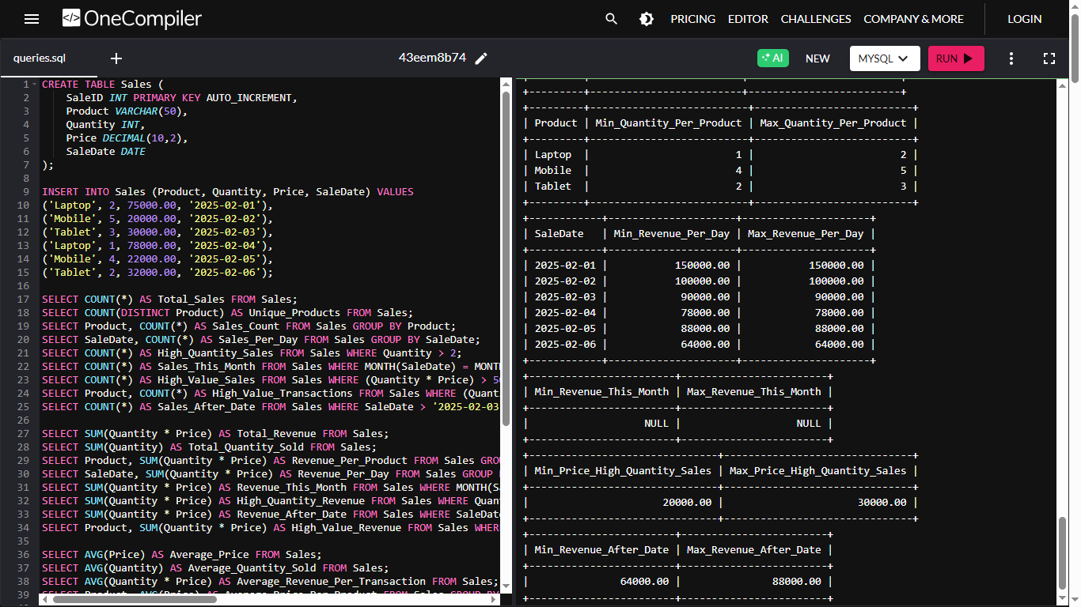

**Practical :- 8**

**Aim :** Given Customers and Orders tables, write SQL queries to perform INNER JOIN, LEFT JOIN, and RIGHT JOIN to retrieve combined data for customer orders.

**Code :**

CREATE TABLE Customers (

customer_id INT PRIMARY KEY,

customer_name VARCHAR(100) NOT NULL

);

CREATE TABLE Orders (

order_id INT PRIMARY KEY,

order_date DATE NOT NULL,

customer_id INT,

FOREIGN KEY (customer_id) REFERENCES Customers(customer_id)

);

INSERT INTO Customers (customer_id, customer_name) VALUES

(1, 'Alice'),

(2, 'Bob'),

(3, 'Charlie'),

(4, 'David');

INSERT INTO Orders (order_id, order_date, customer_id) VALUES

(101, '2024-01-01', 1),

(102, '2024-01-02', 2),

(103, '2024-01-03', 4);

SELECT * FROM Customers;

SELECT * FROM Orders;

SELECT

c.customer_id,

c.customer_name,

o.order_id,

o.order_date

FROM

Customers c

INNER JOIN

Orders o

ON

c.customer_id = o.customer_id;

SELECT

c.customer_id,

c.customer_name,

o.order_id,

o.order_date

FROM

Customers c

LEFT JOIN

Orders o

ON

c.customer_id = o.customer_id;

SELECT

c.customer_id,

c.customer_name,

o.order_id,

o.order_date

FROM

Customers c

RIGHT JOIN

Orders o

ON

c.customer_id = o.customer_id;

**output :**

