Task-1

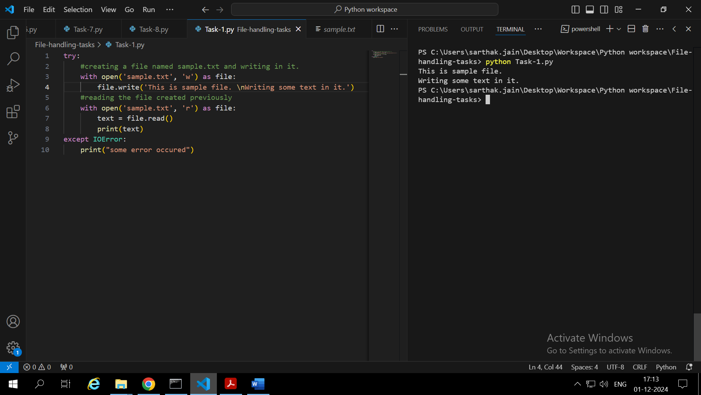

1. **open**(‘filename’, **‘w’**) is used to open a file in python ‘w’ -> specifies the mode (write(‘w’)/read(‘r’)/append(‘a’))
2. read() method is used to read the contents of a file
3. If a file doesn’t exists then FileNotFoundError is generated which can be handled in except FileNotFoundError block

Task-2:

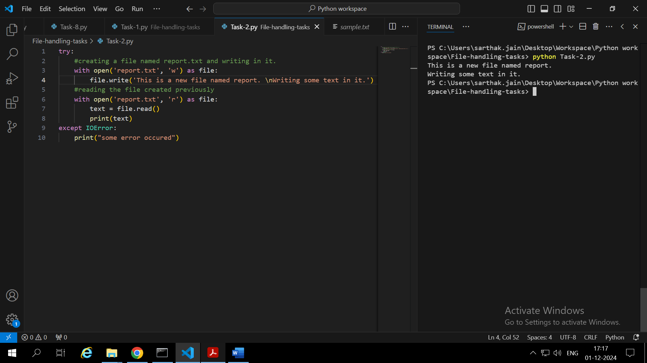

1. ‘w’ -> (write mode) If the file already contains some data, then it will be overridden but if the file is not present then it creates the file and writes in it.

‘a’-> (append mode) For writing something in already created file. If file does not exist it creates a new file and writes in it. It file exists then it does not overrides the present data just adds new data to it.

1. By reading and printing the file after writing to it we can check whether the file has been written correctly.

Task-3:

1. If we try to open a file in ‘w’ mode and it already exists then it will overwrite the existing content of that file with the new data provided.
2. **os.path.exists(‘filepath’)** can be used to check if the file exists.

Task 4

1. When we read a file line by line then memory is not used to store the whole file at once. Thus in case of large files looping on lines is good to save memory.
2. Implemented in code

Task 5:

1. replace() method returns the string after replacement. It does not modifies the original string.

Task 6:

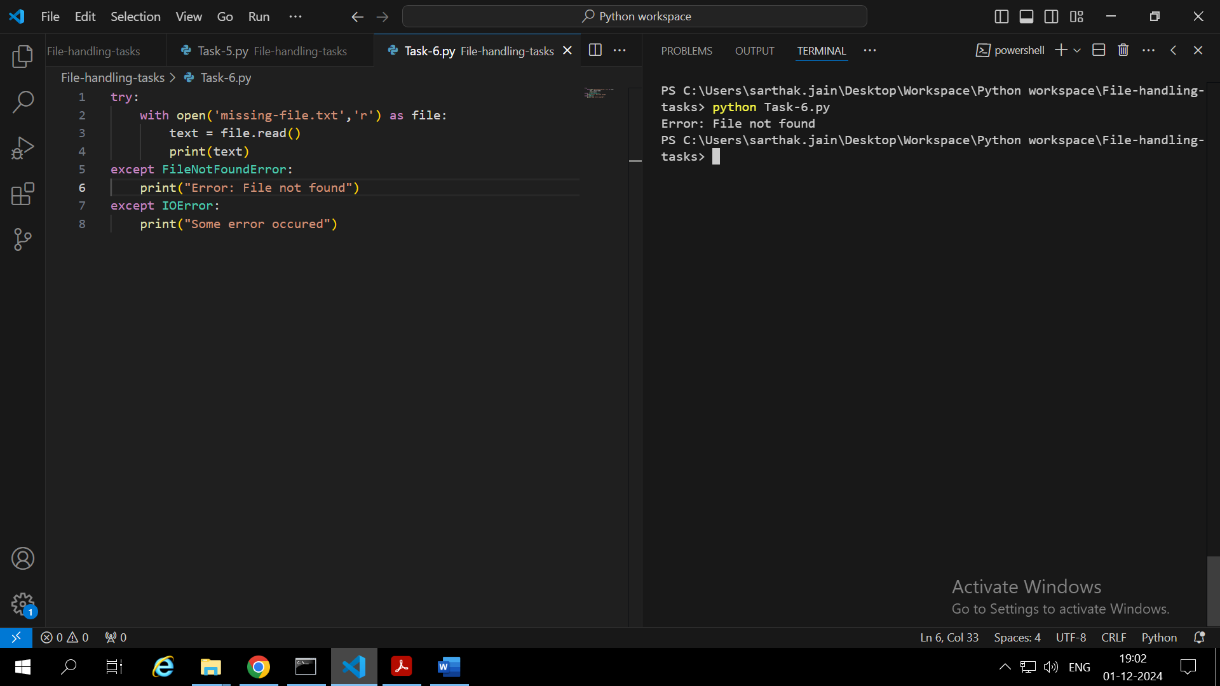

1. FileNotFoundError is raised when we try to read a missing file.
2. We can use try except block to handle this error smoothly without leading to program termination.

Task 7:

1. File.read() is used to read content of file in python.
2. If the destination file already exists, we can use append ‘a’ mode to add the new content without disturbing the original one.

Task 8

1. We should include **microsecond** also in timestamp as execution is very fast. So to keep track we will need it.

Task 9

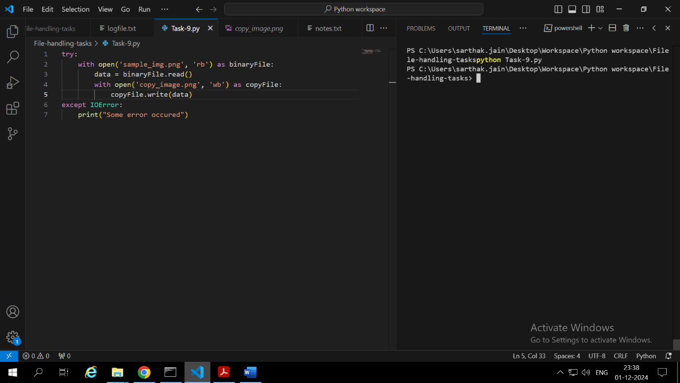

**Code**

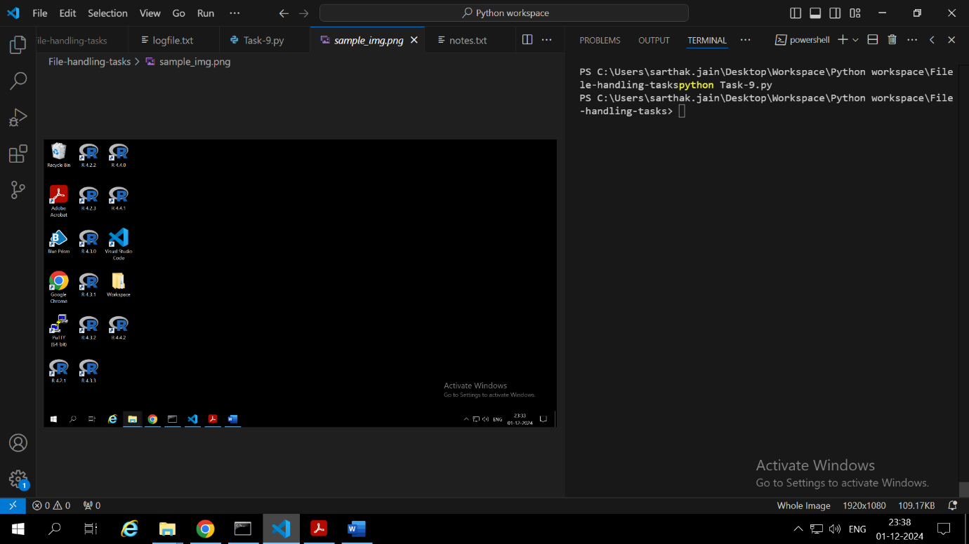

**Original image file**

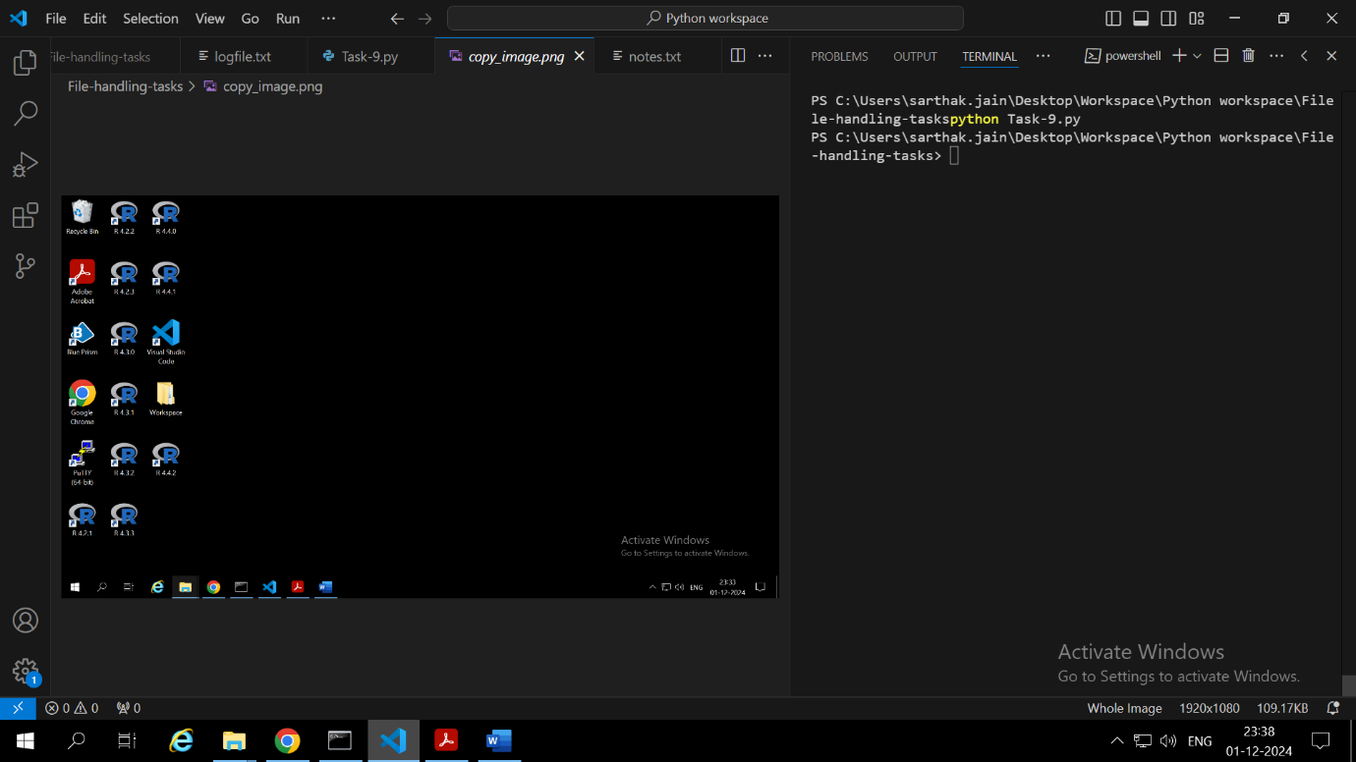

**New copied image file**

‘rb’ -> read binary mode, ‘wb’ -> write binary mode

Task 10

**with** statement automatically closes the file after performing the operation even if exception was raised.