Task-1:

If we try to access the balance from outside the class “AttributeError” will occur. It is helpful to protect the private members from being modified from outside the class.

Modified the withdraw code to generate exception when insufficient balance:

Task-2

Inheritance helps to remove the redundancy. If there are some common attributes and methods in animal and cat,dog. Then no need to define them separately in all 3. Just inherit the animal class so that all the attributes and methods of animal can be used in dog and cat.

Calling eat() method on cat object will execute the eat method from animal class. Since there is no eat() method in cat class and cat is inheriting from animal class.

Task 5

The relationship between shopping cart and product is “Has a” relationship.

Inheritance -> “Is a” relationship

Composition -> “has a” relationship

Example: An employee is a person ->Inheritance

Employee has salary -> composition

Inheritance means inheriting all the properties and methods of a parent class. That means child is a form of parent only.

Whereas composition means one class consists of other class. That is one class has object of another class in it.

Adding same product multiple times:

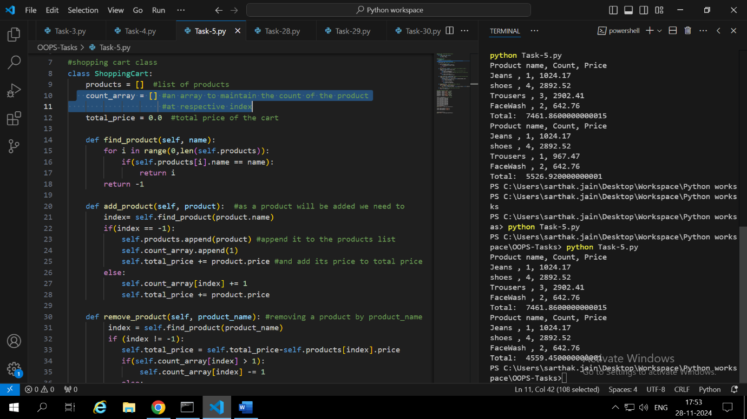

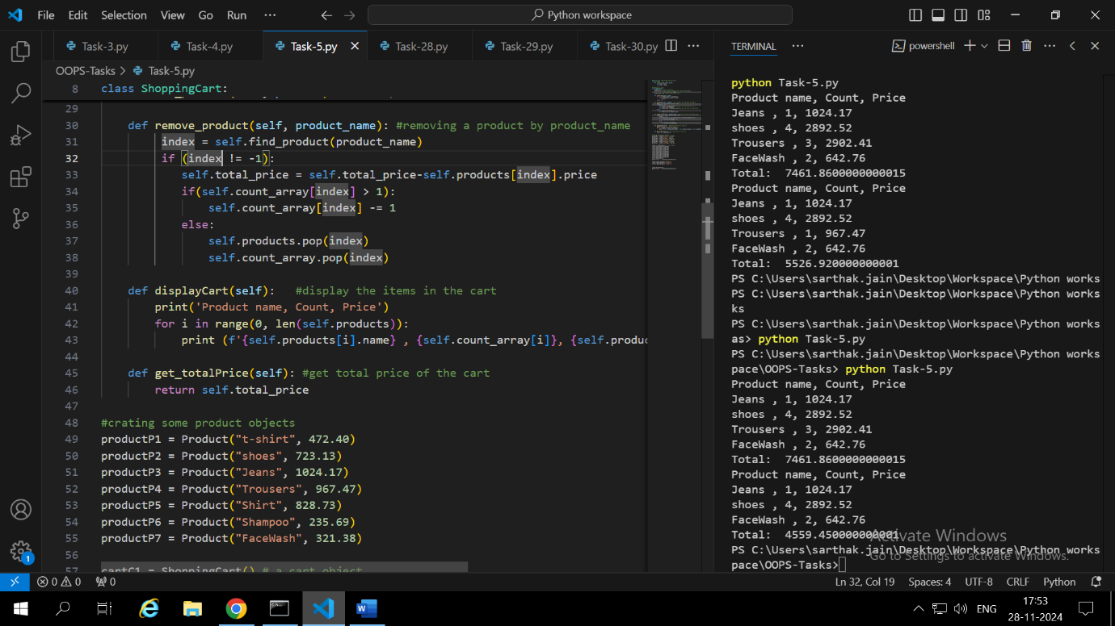

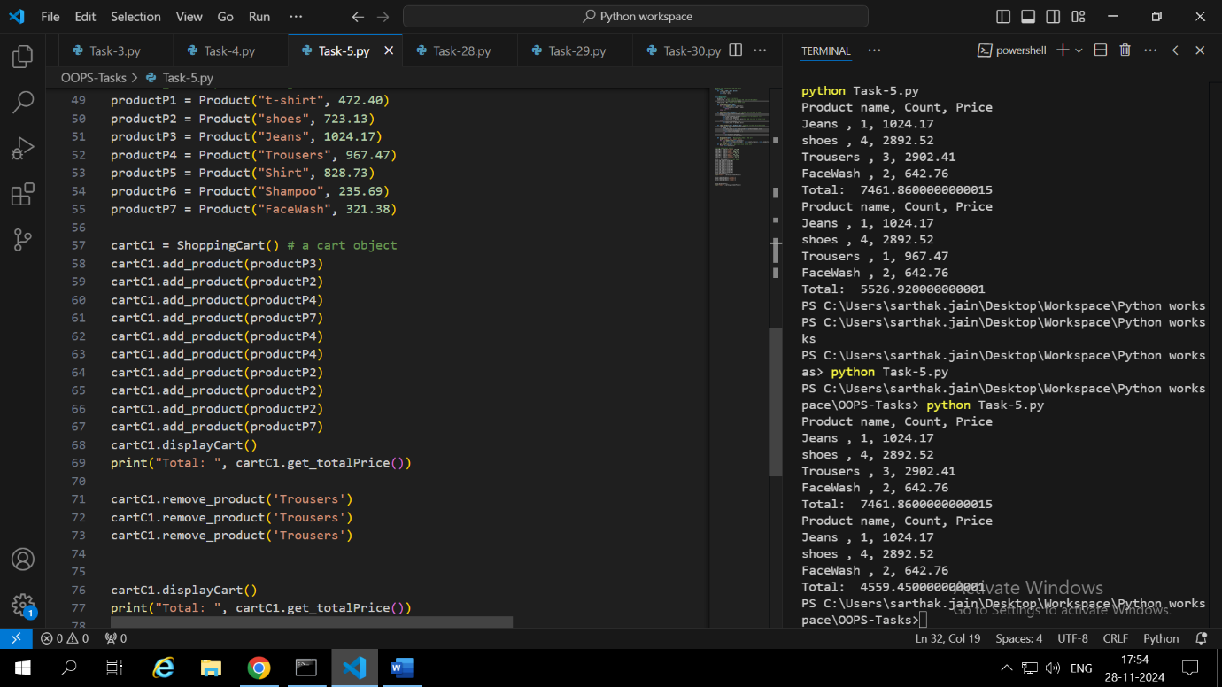

Added a count_array[] to shopping cart class to maintain the count of the products at respective index.

Task-6:

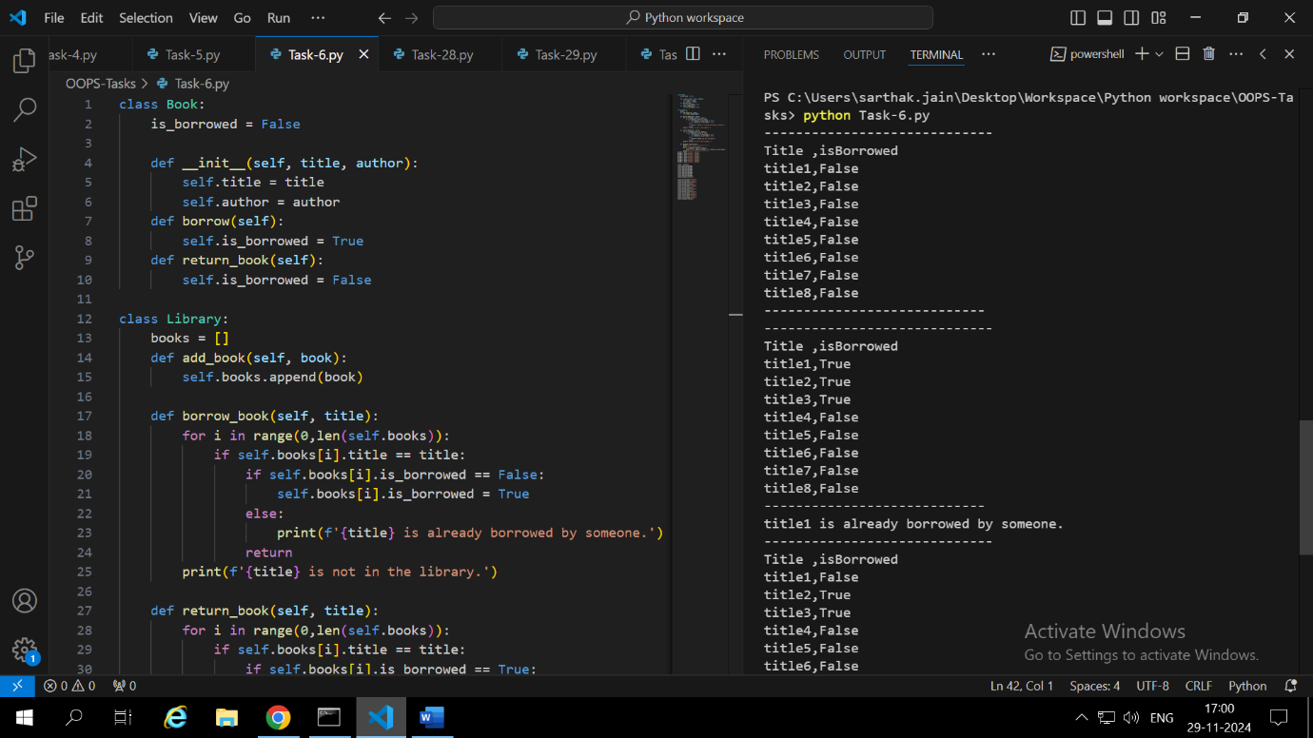

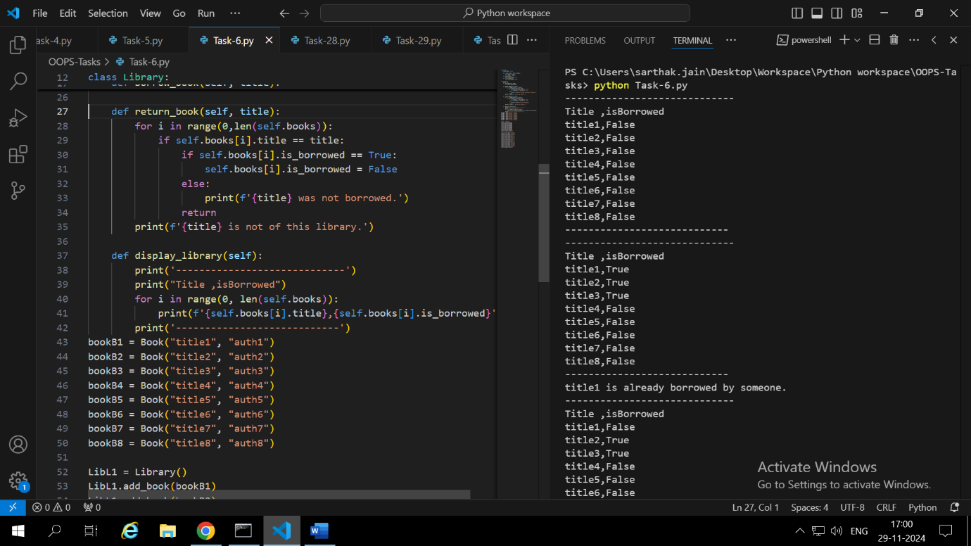

Library and books have ‘Has-a’ relationship. i.e Library has books. Although both can exist without each other that’s why we passed objects of book class in library class.

Encapsulation helps to keep all the properties and methods of book inside book class and of library inside library class.

We can use print statement to display that this book is already borrowed.

Task-7:

Inheritance helps to reduce the redundancy like we don’t have to again write the code for initializing the name and price of the electronics and clothing.

Polymorphism means having the same method do different functions in different classes. If the object calling the method has that function defined in its class then it will execute else it will execute from the parent class.