11.

12.

When we try to access an index that is not present in the list:

We get an “**IndexError**” saying that **the index is out of range**

13.

When we try to change an item in tuple we get “TypeError” stating that “tuple doesn’t support item assignment”

Since tuples are immutable we can’t change any item in tuple.

14.

Trying to access a key which does not exists we get “KeyError”

15.

When we try adding a duplicate element in the set nothing happens. Since set does not allow duplicates.

16.

When we use an index which is out of range in slicing nothing happens. It just stops at the last available index.

17.

Just replace max by min to return the minimum from the list.

18.

19.

Overriding the speak method of parent class in child class:

20.

21.

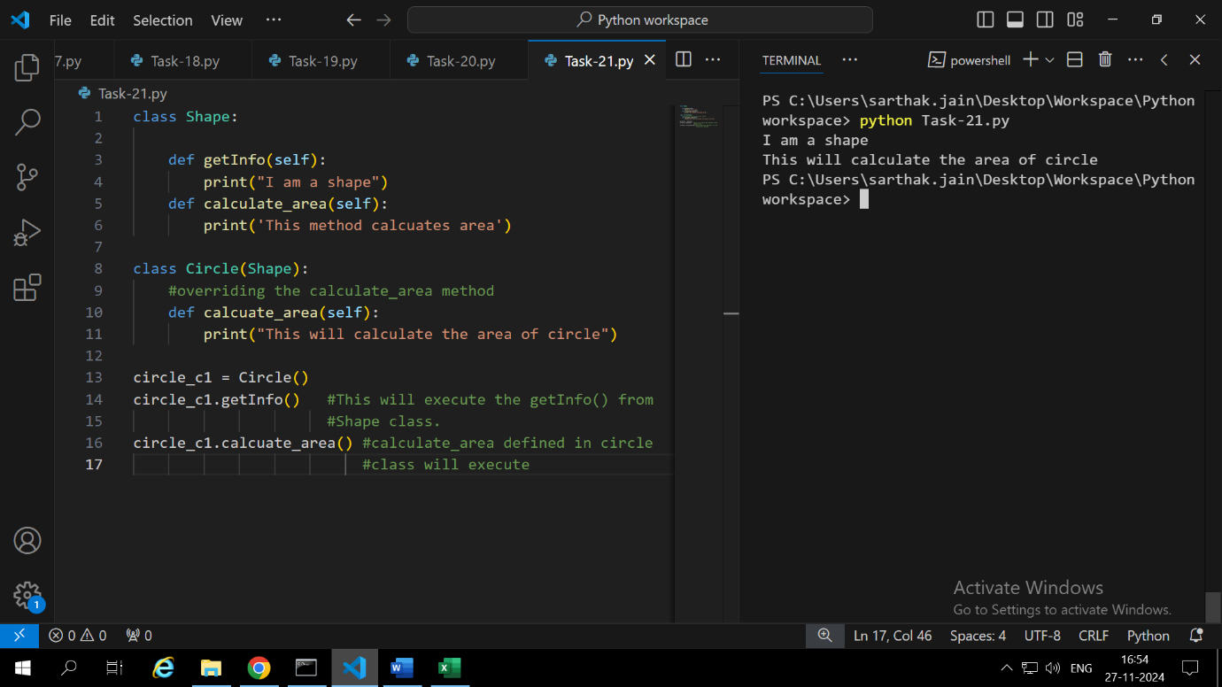

22.

For accessing the static method we don’t need to create an object(instance) of the class. Whereas for accessing the instance method we need to create an object.

23.

String formatting allows us to insert dynamic values into string not decided during writing the code. We can also insert mathematical expression.

24.

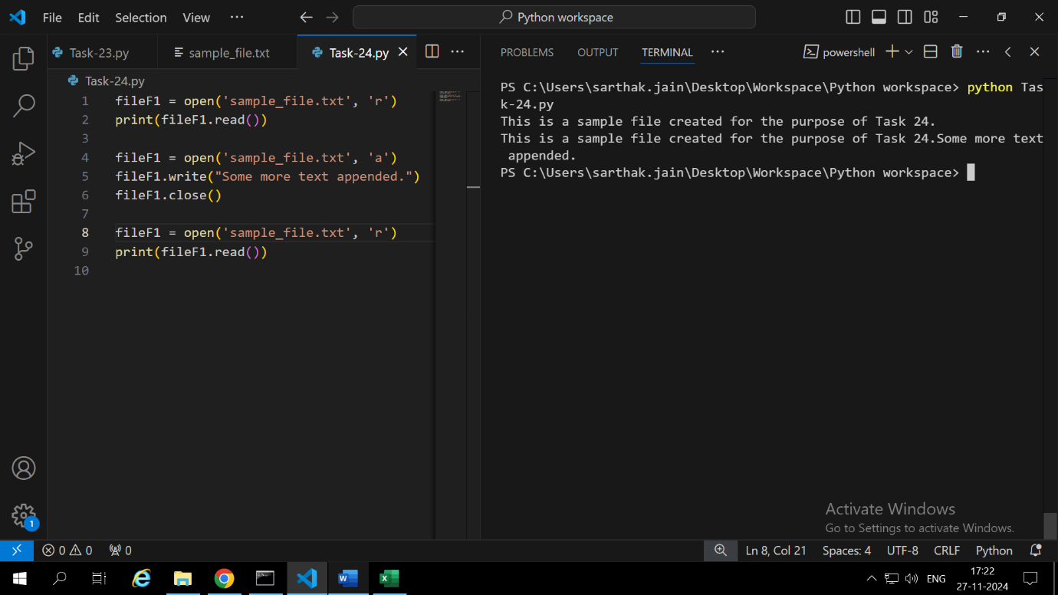

We get “FileNotFoundError” when we try to open a file which does not exists.

25.

26.

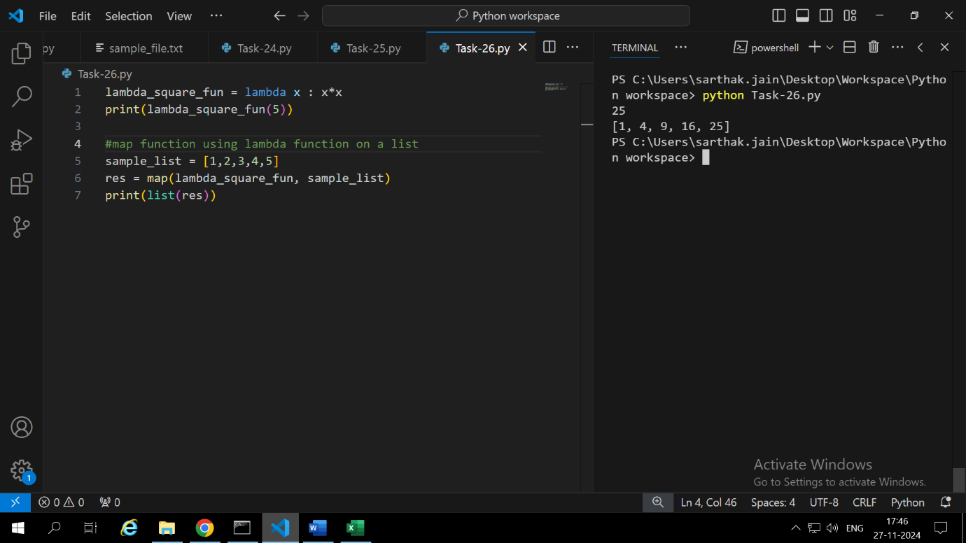

Lambda function differs from the normal function which uses dif in terms of syntax. Lambda function is easy to create, has a concise syntax. Can be used to create anonymous functions.

27.

28.

29.

If we miss the base condition in the recursive function the recursion will never stop and will go on infinitely leading to error.

30.

Except blocks are executed in order. If more general error is written before the specific error then that general error except block will execute