# Scenario 1: Game does not payout at correct level

## Scenario Description

When player wins on consecutive matches, but balance does not increase.

## Version Control

|  |  |  |  |
| --- | --- | --- | --- |
| Version # | Date | Author | Description |
| 0.1 | 13/10/2016 | Sarthak Joshi | Initial Version |
| 0.2 | 22/10/2017 | Sarthak Joshi | Final Version |

## Test Scripts

* Normal Play

## Use Case

Player wins in consecutive matches

## Test Components/Requirements

Dice

Game

Player

## Script 1: Normal Play – Player Wins

### Script Description

Player plays one match and wins consecutive turns, but his balance doesn’t increase which means game does not payout correctly.

### Testing Requirements

Play with three identical dice with the faces of each dice marked with the symbols of a crown, anchor, heart, diamond, club and spade.

### Script Steps

| **Step #** | **Test Action** | **Expected Results** | **Pass/ Fail** |
| --- | --- | --- | --- |
| 1 | Dealer throws the dice |  |  |
| 2 | symbol appears on one or more of the uppermost face of the three dice |  |  |
| 3 | Player wins in consecutive turns | Balance should add | FAIL |

### Output from the Automated Test

Figure 1 shows that Player won in turn 22,23, and 24 but balance didn’t increase.

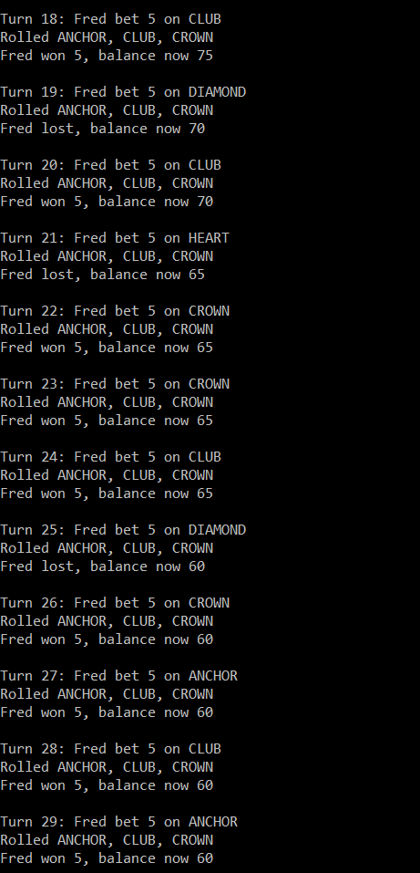

Figure 1 - Bug1