# Scenario 2: Player cannot reach betting limit

## Scenario Description

Limit set to 0, but game ends with player still with 5 (dollars) remaining.

## Version Control

|  |  |  |  |
| --- | --- | --- | --- |
| Version # | Date | Author | Description |
| 0.1 | 13/10/2017 | Sarthak Joshi | Initial Version |
| 0.2 | 21/10/2017 | Upama Aryal | Final Version |

## Test Scripts

* Player cannot reach betting limit

## Use Case

Player loses

## Test Components/Requirements

Dice

Game

Player

## Script 1: Normal Play – Player cannot reach betting limit

### Script Description

Player plays one match and loses it but game ends, limit is set to 0 and player still has a balance of $5.

### Testing Requirements

Play with three identical dice with the faces of each dice marked with the symbols of a crown, anchor, heart, diamond, club and spade.

### Script Steps

| **Step #** | **Test Action** | **Expected Results** | **Pass/ Fail** |
| --- | --- | --- | --- |
| 1 | Dealer throws the dice |  |  |
| 2 | Symbol doesn’t appear on one or more of the uppermost face of the three dice |  |  |
| 3 | Player loses in consecutive turns | Player balance is $5 and should be allowed another turn | Fail |

### Output from the Automated Test

Figure 2 shows that Player still has a balance of $5 after 40 turns but game ends.

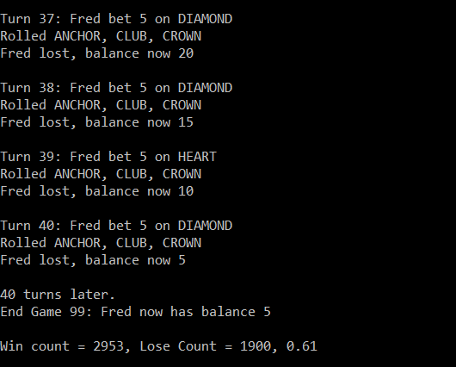

Figure 2 - Bug2