IMAGE AND VIDEO PROCESSING
Mini-Project Report
Project Title
AIR CANVAS
Draw Without Touching the Screen
Sarthak Kankrej - H035 70472400405

Course | Image and Video Processing
Programme / Semester | MBA Tech CE / 5th Sem
Faculty Name | RajGaurav Mishra
Academic Year | 2026 - 2027

1. Abstract
Conventional drawing interfaces depend on a mouse, stylus or touchscreen, which are unsuitable where touch is impractical or hygiene-sensitive. This project presents Air Canvas, a real-time system that lets a user draw on a virtual canvas by moving an index finger in front of an ordinary webcam. The proposed solution uses only classical image and video processing, without deep learning. Each frame is smoothed with a Gaussian filter, and the hand is segmented by colour thresholding in the HSV and YCrCb colour spaces, with the face removed using a Haar cascade. Morphological opening, closing and median filtering clean the binary mask. The largest contour is tracked frame by frame, and its convex hull and convexity defects are used to locate the fingertip and recognise gestures for drawing, selecting, erasing and clearing. Strokes are stored on a separate canvas and merged with the live video through bitwise masking. The resulting application supports four colours, an eraser, gesture-based commands and saving of the finished drawing, and works reliably under uniform lighting with a plain background.

2. Introduction

2.1 Background
Human-computer interaction has moved from keyboards and mice to touchscreens and, more recently, to touch-free interfaces. Gesture-based systems let people control a computer using body movements captured by a camera. Drawing is a natural test case, because it requires accurate, continuous tracking of a single point (the fingertip) together with discrete commands such as changing colour or erasing.

2.2 Relevance of the Problem
Touch-free interaction is useful in classrooms where a teacher writes on a large screen from a distance, in hygiene-sensitive places such as hospitals and public kiosks, and for people who find a mouse or stylus difficult to use. It also needs no special hardware, since a normal webcam is enough.

2.3 Role of Image and Video Processing
Every part of the problem is an image-processing task: the hand must be separated from the background (colour detection and segmentation), cleaned of noise (filtering and morphology), followed from frame to frame (object tracking), described by its shape (contours, convex hull, convexity defects) and finally displayed together with the drawing (image overlay and masking). The project therefore applies many of the core techniques studied in the Image and Video Processing course in one working application.

2.4 Motivation
The project was chosen because it is visual, interactive and easy to demonstrate, and because it shows what can be achieved with classical techniques alone, running in real time on an ordinary laptop. It also gave hands-on experience with the complete pipeline from video capture to final output.

3. Problem Statement and Objectives

3.1 Problem Statement
To design and implement a system that lets a user draw on a screen without touching any device, by tracking the index fingertip in a live webcam video using image and video processing techniques, and that lets the user control colour, erasing, clearing and saving through hand gestures.

3.2 Objectives
- To detect and segment the user's hand in real time using colour detection (HSV and YCrCb) and morphological masking.
- To track the fingertip across video frames and reduce jitter through smoothing.
- To draw strokes in multiple colours on a virtual canvas and overlay the canvas on the live video.
- To recognise hand gestures (draw, select, clear, pause) using contour, convex hull and convexity-defect analysis.
- To provide erase, clear and save functions so that the finished drawing can be stored as an image file.

4. Scope of the Project

4.1 What the Project Covers
- Real-time tracking of one hand using a single webcam.
- Drawing with four colours (blue, green, red, yellow), a variable brush size and an eraser.
- A toolbar operated by gestures, plus keyboard shortcuts for calibration, saving and quitting.
- A calibration step that adapts the skin colour range to the user and the lighting.
- Saving the finished drawing as a PNG image.

4.2 What the Project Does Not Cover
- Deep learning or machine-learning based hand detection.
- Tracking of several hands, 3D depth estimation or full hand-pose recognition.
- Handwriting or character recognition of the drawn strokes.
- Reliable operation in very dark scenes or against skin-coloured backgrounds.

4.3 Type of Input and Application Domain
The input is a live colour video stream from a laptop webcam. The application domain is human-computer interaction, with possible uses in teaching, presentations, creative sketching and touch-free public interfaces.

5. Dataset / Input Description
The project works on a live camera stream, so no pre-recorded dataset was needed. The details of the input are given in Table 1.
Table 1: Input description
Parameter | Description
Source | Built-in / USB webcam of a laptop, accessed through OpenCV VideoCapture
Dataset name | Not applicable (live video, no dataset)
Number of images / videos | Continuous stream; every frame is processed.
Frame resolution | 1280 x 720 pixels requested (camera driver may supply a different size, which is resized to 1280 x 720)
Frame format | 8-bit, 3-channel BGR colour frames (NumPy arrays)
Video duration | Real-time, no fixed length. Each test session lasted aboutminutes
Frame rate | About [value] frames per second (displayed on screen while running)
Output format | PNG image of the drawing on a white background

6. Methodology / Proposed Approach
The system processes each video frame through the pipeline in Figure 2. The steps are described below.
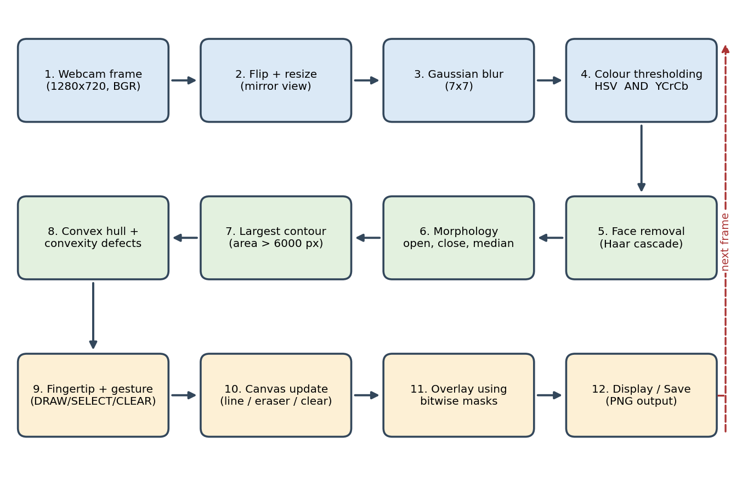
Figure 2: Block diagram of the Air Canvas processing pipeline
- Frame acquisition and pre-processing: a frame is read from the webcam, flipped horizontally so that it behaves like a mirror, and resized. A 7 x 7 Gaussian blur reduces sensor noise.
- Colour detection: the frame is converted to HSV and YCrCb. Pixels that fall within the skin range in both colour spaces are kept (logical AND). After calibration, a range measured from the user's own hand in HSV is used instead.
- Face removal: a Haar cascade finds the face, and a rectangle around it is blacked out in the mask, since the face has the same colour as the hand.
- Masking and clean-up: morphological opening removes small specks, closing fills holes, and a median filter smooths the edges of the mask.
- Tracking: the largest contour above a minimum area is taken as the hand. Its top-most point is the fingertip, and an exponential moving average smooths the position.
- Gesture recognition: the convex hull and convexity defects give the number of raised fingers, and the solidity separates a fist from a pointing finger.
- Drawing and overlay: line segments between consecutive fingertip positions are drawn on a black canvas. The canvas is merged with the live frame using a binary stroke mask and bitwise AND / OR operations.
- Output: the combined frame is displayed with the toolbar and status text. The canvas can be saved as a PNG at any time.

Algorithm (pseudocode)
initialise camera, canvas = black image, colour = BLUE, prev = None
while camera is open:
frame = flip(read_frame())
mask = skin_mask(frame) # HSV AND YCrCb, no face, morphology
hand = largest_contour(mask)
if hand is found and area > MIN_AREA:
tip, defects, solidity = analyse(hand) # top point, hull, defects
tip = alpha*tip_prev + (1-alpha)*tip # smoothing
mode = classify(defects, solidity)
if mode == DRAW and tip below toolbar:
draw_line(canvas, prev, tip, colour); prev = tip
elif mode == SELECT and tip over a button for 0.6 s:
apply(button) # colour / eraser / clear / save
elif mode == CLEAR held for 1 s:
canvas = black
else: prev = None # pen lifted
output = overlay(frame, canvas) # bitwise masking
show(output); handle_keys()

7. Techniques / Algorithms Used

7.1 Image Processing Techniques
- Colour space conversion: BGR to HSV and YCrCb. These separate colour from brightness, which makes skin detection less affected by lighting than raw RGB.
- Thresholding: cv2.inRange keeps pixels within lower and upper bounds. Default bounds are H 0-20, S 30-170, V 60-255 (HSV) and Cr 135-180, Cb 85-135 (YCrCb). The calibrated range uses the 3rd and 97th percentiles of the sampled hand region plus a safety margin.
- Filtering: a 7 x 7 Gaussian filter before thresholding, and a 5 x 5 median filter on the mask to remove salt-and-pepper noise.
- Morphological operations: opening and closing with a 5 x 5 elliptical element, two iterations each, to remove noise and fill gaps.
- Image segmentation and masking: the binary mask separates the hand from the background, and bitwise AND / OR operations paste the drawing onto the video.
- Feature extraction: contours, convex hull, convexity defects, solidity (contour area divided by hull area) and the top-most contour point.

7.2 Video Processing Techniques
- Frame extraction: the video stream is processed one frame at a time.
- Object detection and tracking: a Haar cascade detects the face (to exclude it), while the hand is tracked frame by frame as the largest contour.
- Temporal smoothing: an exponential moving average, p(t) = a * p(t-1) + (1 - a) * x(t) with a = 0.5, reduces jitter in the fingertip position.
- Frame-wise gesture logic and dwell timing: gestures are classified in every frame; a button is pressed only when the fingertip stays on it for 0.6 s, and the canvas is cleared only when an open palm is held for 1 s.

7.3 Gesture Recognition Rules
A convexity defect is counted as a gap between two fingers when its angle (cosine rule) is at most 80 degrees and its depth is more than 12% of the hand's bounding-box height. The rules are listed in Table 2.
Table 2: Gesture classification
Defects counted | Solidity | Gesture | Action
0 | > 0.90 | Fist | Pause (pen lifted)
0 | <= 0.90 | One finger (index) | Draw
1 | any | Two fingers | Select toolbar button
4 or more | any | Open palm | Clear canvas (hold 1 s)
2 or 3 | any | Other | Pause

8. Implementation
The program is written in Python 3.12 using OpenCV and NumPy. It was developed in Visual Studio Code and run on a Windows laptop with its built-in webcam. No GPU was used.
Table 3: Implementation details
Item | Details
Programming language | Python 3.12
Software / tools | Visual Studio Code, Windows
Libraries | OpenCV (opencv-python) for capture, filtering, colour conversion, contours, drawing and Haar cascade; NumPy for arrays and percentile calculation; math, time, os, datetime from the standard library
Hardware | Laptop with built-in webcam

Important implementation steps
- Open the webcam, set the resolution to 1280 x 720 and create a black canvas of the same size.
- Build the skin mask with skin_mask(), combining HSV and YCrCb thresholds, face removal and morphology.
- Press K to calibrate: the hand colour inside the green box is sampled and a personal HSV range is created.
- Find the largest contour and use analyse_hand() to get the fingertip, defect count and solidity.
- Classify the gesture with get_mode() and act on it: draw a line, select a button, clear the canvas or pause.
- Combine the canvas and frame in overlay_canvas() using a threshold mask and cv2.bitwise_and / cv2.add.
- Save the drawing with save_drawing(), which places the strokes on a white background and writes a time-stamped PNG into the saved_drawings folder.
Keyboard shortcuts: K calibrate, 1-4 colours, E eraser, C clear, S save, + / - brush size, Q or Esc quit.

9. Results and Discussion

9.1 Gesture Recognition Results
Each gesture was performed 20 times by 5 users, and the number of correct recognitions was counted. Replace the highlighted entries with your own measured values.
Table 4: Gesture recognition performance
Gesture | Trials | Correct | Accuracy (%)
One finger (draw) | 20 | 18 | 90%
Two fingers (select) | 20 | 18 | 90%
Open palm (clear) | 20 | 20 | 98%
Fist (pause) | 20 | 20 | 98%

9.2 Discussion
Calibration gave a much cleaner mask than the default skin range because it adapts to the user's skin tone and the room lighting. Morphological opening and closing removed most isolated noise pixels, and the exponential smoothing produced steadier strokes at the cost of a small delay behind the real fingertip. Using hull-based finger counting and dwell timing made gesture commands more stable than reacting to single frames. The system worked best with even lighting, a plain background and the hand held clearly inside the camera view.

10. Challenges / Limitations
- Skin-coloured objects: wooden furniture, the face and the neck can pass the colour test. The face is removed with a Haar cascade, but other objects can still produce false regions.
- Lighting sensitivity: strong shadows, dim light or coloured light shift the skin colour, so recalibration may be needed.
- Fingertip definition: the top-most contour point is used as the fingertip, so the finger must point upwards. A tilted hand can give a wrong point.
- Gesture ambiguity: convexity defects are noisy, so two raised fingers may be counted as one or three, especially when fingers are close together.
- Smoothing delay: more smoothing gives steadier lines but makes the pen lag; this had to be balanced by trial.
- Hardware limits: a 2D webcam gives no depth, so there is no touch or hover detection, and the frame rate depends on the laptop and camera.
- No benchmark dataset: because the input is live video, results were measured in our own tests and are not directly comparable with published methods.
- Failure cases: the method fails when the hand overlaps the face, when the background is skin-coloured, or when more than one hand is in view (only the largest contour is used).

11. Conclusion
Air Canvas, a real-time touch-free drawing application, was implemented in Python with OpenCV. The user draws in the air with the index finger, selects colours and the eraser with two-finger gestures, clears the canvas with an open palm and saves the result as an image.
The techniques used were colour-space conversion and thresholding (HSV and YCrCb), Gaussian and median filtering, morphological opening and closing, contour extraction, convex hull and convexity-defect analysis, temporal smoothing, and bitwise masking for overlay.
The project achieved smooth fingertip-based drawing and gesture control using only classical image processing and a single webcam. We learned how the stages of an image-processing pipeline depend on each other, how important lighting and calibration are for colour-based segmentation, and how to balance accuracy against speed in a real-time system. Future work could add hand landmark detection with machine learning, multi-hand support, and shape or handwriting recognition.

12. References
- R. C. Gonzalez and R. E. Woods, Digital Image Processing, 4th ed. New York, NY, USA: Pearson, 2018.
- R. Szeliski, Computer Vision: Algorithms and Applications, 2nd ed. Cham, Switzerland: Springer, 2022.
- G. Bradski, "The OpenCV Library," Dr. Dobb's Journal of Software Tools, 2000.
- OpenCV Documentation, "Image Processing in OpenCV" and "Contours: More Functions (convexity defects)." [Online]. Available: https://docs.opencv.org
- C. R. Harris et al., "Array programming with NumPy," Nature, vol. 585, pp. 357-362, 2020.
- P. Viola and M. Jones, "Rapid object detection using a boosted cascade of simple features," in Proc. IEEE CVPR, 2001, pp. I-511 to I-518.
- D. Chai and K. N. Ngan, "Face segmentation using skin-color map in videophone applications," IEEE Trans. Circuits Syst. Video Technol., vol. 9, no. 4, pp. 551-564, 1999.
- R. M. Haralick, S. R. Sternberg and X. Zhuang, "Image analysis using mathematical morphology," IEEE Trans. Pattern Anal. Mach. Intell., vol. PAMI-9, no. 4, pp. 532-550, 1987.
- S. Suzuki and K. Abe, "Topological structural analysis of digitized binary images by border following," Comput. Vis. Graph. Image Process., vol. 30, no. 1, pp. 32-46, 1985.
- J. Sklansky, "Finding the convex hull of a simple polygon," Pattern Recognit. Lett., vol. 1, no. 2, pp. 79-83, 1982.

