MS-SQL Case Study 3 (Burger Bash)

-Sarthak Niranjan Kulkarni (Maverick)

- [sarthakkul2311@gmail.com](mailto:sarthakkul2311@gmail.com) - (+91) 93256 02791

**Day 4 – 7/11/2024 (Thursday)**

1. **How many burgers were ordered?**

🡪 SELECT COUNT(*) AS total_burgers_ordered

FROM customer_orders;

1. **How many unique customer orders were made?**

🡪 SELECT COUNT(DISTINCT order_id) AS unique_customer_orders

FROM customer_orders;

1. **How many successful orders were delivered by each runner?**

🡪 SELECT runner_id, COUNT(*) AS successful_orders

FROM runner_orders

WHERE cancellation IS NULL

GROUP BY runner_id;

1. **How many of each type of burger was delivered?**

🡪 SELECT b.burger_name, COUNT(co.order_id) AS burger_count

FROM customer_orders co

JOIN burger_names b ON co.burger_id = b.burger_id

GROUP BY b.burger_name;

1. **How many Vegetarian and Meatlovers were ordered by each customer?**

🡪 SELECT co.customer_id, b.burger_name, COUNT(co.order_id) AS burger_count

FROM customer_orders co

JOIN burger_names b ON co.burger_id = b.burger_id

GROUP BY co.customer_id, b.burger_name

ORDER BY co.customer_id, b.burger_name;

1. **What was the maximum number of burgers delivered in a single order?**

🡪 SELECT MAX(order_count) AS max_burgers_in_single_order

FROM (SELECT order_id, COUNT(burger_id) AS order_count

FROM customer_orders

GROUP BY order_id) AS burger_counts;

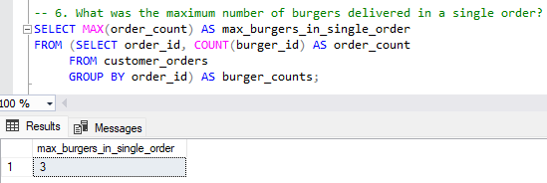

1. **What was the total volume of burgers ordered for each hour of the day?**

🡪

SELECT DATEPART(hour, order_time) AS order_hour, COUNT(order_id) AS total_burgers_ordered

FROM customer_orders

GROUP BY DATEPART(hour, order_time)

ORDER BY order_hour;

