PySpark Coding Challenge

-Sarthak Niranjan Kulkarni (Maverick)

- [sarthakkul2311@gmail.com](mailto:sarthakkul2311@gmail.com) - (+91) 93256 02791

**26/11/2024 (Tuesday)**

**1) Explain ETL (Extract, Transform, Load) with PySpark(in your own words):**

🡪 **ETL:** ETL with PySpark means using Python and Apache Spark to extract data from different sources, clean or transform it as needed, and load it into a storage system like a database or data warehouse. It’s a fast and efficient way to handle large datasets for analysis or reporting. It helps automate and streamline data workflows, making it easier to manage and process big data in real-time or batches.

**Extract:** Retrieve data from various sources like databases, files or APIs.

**Transform:** Clean, aggregate and manipulate data to fit your analysis needs.

**Load:** Store the transformed data into a database or data warehouse for analysis.

**Advantages of ETL: -**

* Data Centralization: Brings scattered data into a single, unified location.
* Improved Data Quality: Cleans and standardizes data, ensuring accuracy and consistency.
* Faster Decision-Making: Prepares data for quick analysis and insights.
* Time and Cost Efficiency: Automates repetitive data processing tasks, saving resources.
* Flexibility: Handles various data types and formats from multiple sources.
* Scalability: Easily adapts to growing data volumes.

**Example:** Extracting sales data from multiple CSV files, cleaning it to remove duplicates, and loading it into a database for reporting using PySpark.

**2) Using Spark SQL - Transformations such as Filter, Join, Simple Aggregations, GroupBy on the case study dataset: -**

**1. Filter: -**

🡪 # Filter customers older than 40

from pyspark.sql import SparkSession

spark = SparkSession.builder.appName("LoanData").getOrCreate()

filtered_df = df.filter(df['Age'] > 40)

filtered_df.show()

🡪 # Filter married customers with Expenditure greater than 20,000

married_high_expenditure_sql_df = spark.sql("SELECT * FROM loan WHERE `Marital Status` = 'MARRIED' AND Expenditure > 20000")

married_high_expenditure_sql_df.show()

**2. Joins: -** (Performed with Case study Datasets (Loan and Credit_card))

🡪 **Types Of Joins: -**

* **Inner Join:**

**#** Load the loan and credit tables as DataFrames

loan_df = spark.table("loan")

credit_df = spark.table("credit")

# Inner join between loan and credit tables on Customer_ID

inner_join_df = loan_df.join(credit_df, loan_df.Customer_ID == credit_df.CustomerId, 'inner')

inner_join_df.show()

* **Left Join: -**

# Left join between loan and credit tables on Customer_ID

left_join_df = loan_df.join(credit_df, loan_df.Customer_ID == credit_df.CustomerId, 'left')

left_join_df.show()

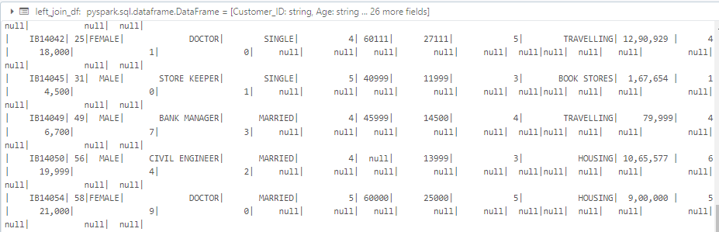

* **Right Join: -**

# Right join between loan and credit tables on Customer_ID

right_join_df = loan_df.join(credit_df, loan_df.Customer_ID == credit_df.CustomerId, 'right')

right_join_df.show()

* **Outer Join: -**

# Outer join between loan and credit tables on Customer_ID

outer_join_df = loan_df.join(credit_df, loan_df.Customer_ID == credit_df.CustomerId, 'outer')

outer_join_df.show()

**3. Simple Aggregate Functions: -**

🡪 # Count the number of records in the loan table using PySpark

count_records = spark.sql("SELECT COUNT(*) AS total_records FROM loan")

count_records.show()

# Average Income Amount in the loan table using PySpark

average_income = spark.sql("""

SELECT AVG(`Income`) AS avg_income

FROM loan

""")

average_income.show()

**4. Group By: -**

🡪 # Group by Marital Status and calculate the total Expenditure using PySpark

group_by_marital_status = spark.sql("""

SELECT `Marital Status`, SUM(Expenditure) AS total_expenditure

FROM loan

GROUP BY `Marital Status`

""")

group_by_marital_status.show()

# Group by Loan Category and calculate the average Expenditure using PySpark

group_by_loan_category = spark.sql("""

SELECT `Loan Category`, AVG(Expenditure) AS avg_expenditure

FROM loan

GROUP BY `Loan Category`

""")

group_by_loan_category.show()

