ENTRESKILL HUB
Technical Report
Architecture, Database Design & Engineering Decisions
Document Version: 1.0
Status: Final — Submission Ready

Table of Contents
1. Introduction
2. Technology Stack
3. System Architecture
4. Database Design
5. The Recommendation Engine
6. Security Measures
7. Testing Strategy
8. Deployment Topology
9. Known Limitations & Future Work

1. Introduction
This Technical Report documents the architecture, technology choices, database design, and key algorithms implemented in EntreSkill Hub. It is intended to give a reviewer or future maintainer a complete picture of how the system is built and why specific decisions were made.

2. Technology Stack
Layer | Technology | Rationale
Frontend Framework | Next.js 14 (App Router) + React 18 | File-based routing, server/client component split, strong Vercel deployment story.
Styling | Tailwind CSS | Utility-first styling enables a fast, consistent, and distinctive design system without a heavy CSS pipeline.
Backend Framework | Node.js 18 + Express.js 4 | Mature, well-understood, minimal-overhead framework matching the specified stack exactly.
Database | PostgreSQL | Strong relational guarantees for a schema with many interlinked entities (users, ideas, roadmaps, mentorship).
ORM | Prisma 5 | Type-safe query building, declarative schema, and built-in migration tooling.
Authentication | JWT (access + refresh tokens) | Stateless access tokens scale horizontally; refresh tokens are revocable and stored server-side for control.
Validation | Zod | Schema-first request validation shared conceptually between the API contract and the OpenAPI docs.
API Documentation | OpenAPI 3.0 (swagger-ui-express) | Interactive, browsable contract for frontend integration and graders alike.
Testing | Jest + Supertest | Standard Node testing stack; Supertest exercises the real Express app for integration coverage.

3. System Architecture
EntreSkill Hub follows a classic three-tier architecture: a Next.js frontend, an Express.js REST API, and a PostgreSQL database, with cloud object storage for binary assets. The frontend never talks to the database directly — every read or write passes through the versioned API, which enforces authentication, authorization, and validation centrally.
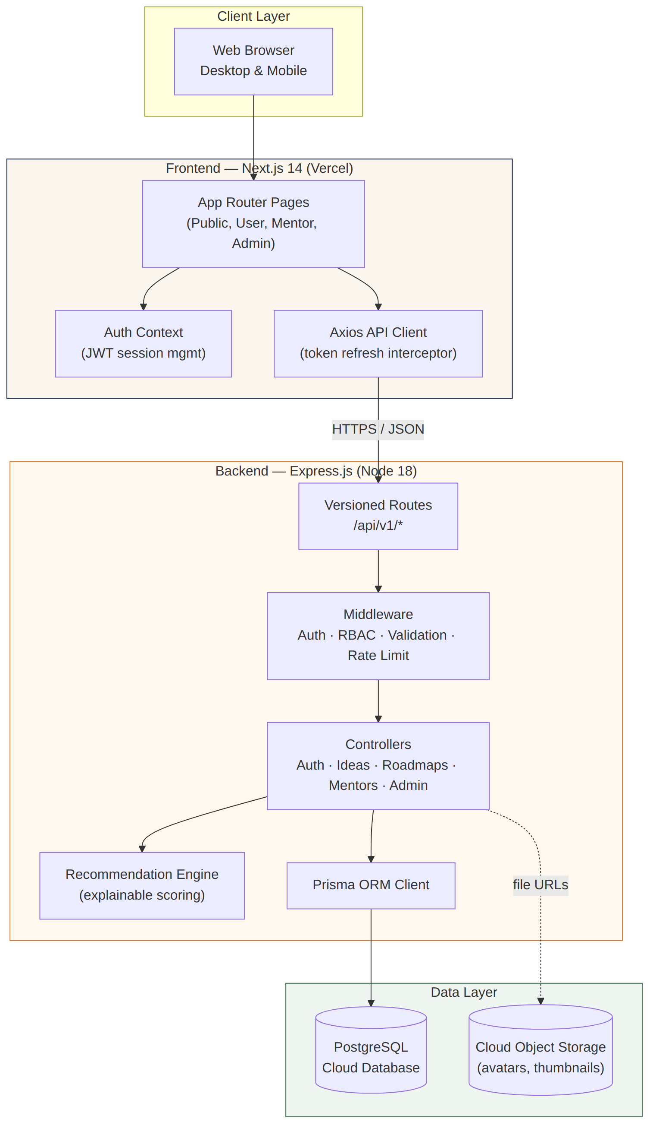

3.1 Request Lifecycle
- The browser sends a request via the Axios API client, which attaches the current JWT access token.
- Express middleware runs in order: security headers (Helmet) → CORS → body parsing → rate limiting → route-specific auth/RBAC/validation.
- The matched controller executes business logic, calling Prisma for data access and the recommendation engine where relevant.
- A consistent JSON envelope is returned; errors are normalized by a single central error handler.
- If the access token has expired, the Axios interceptor transparently calls /auth/refresh and retries the original request once.

4. Database Design
The schema is implemented in Prisma and contains 25 models. It is fully normalized: many-to-many relationships (e.g. business ideas to skills, mentors to expertise) are modeled through explicit join tables carrying additional metadata such as relevance weight or proficiency, rather than implicit Prisma many-to-many fields, so that the recommendation engine has weighted data to work with.
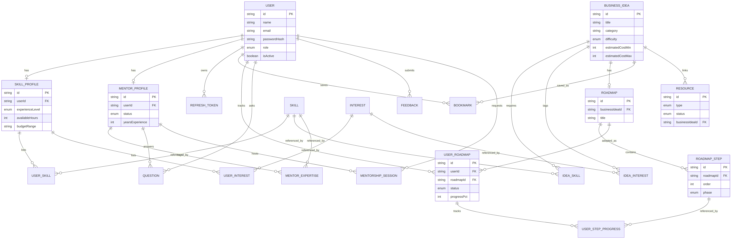

4.1 Notable Design Decisions
- UUIDs are used as primary keys throughout, avoiding sequential ID enumeration and simplifying future sharding.
- Soft state is preferred over hard deletes for Users (isActive flag) to preserve referential integrity in audit logs and historical roadmaps.
- RoadmapStep stores an explicit `phase` enum (Validation, Skills & Tools, Legal, Cost, Marketing, Launch) so the frontend can render phase-specific iconography without string matching on free text.
- UserStepProgress is a separate table from RoadmapStep so the same roadmap template can be reused by many users, each with independent progress.

5. The Recommendation Engine
The recommendation engine deliberately avoids being a black-box machine learning model. For a platform whose users are first-time, often non-technical entrepreneurs, an explainable scoring formula builds far more trust than a model that cannot justify its suggestions. The engine lives in a single pure-function module independent of the database layer, which made it straightforward to unit test in isolation.

5.1 Scoring Formula
matchScore = (skillMatch × 0.60) + (interestOverlap × 0.25) + (feasibilityFit × 0.15)

Skill Match (60% weight)
For each skill an idea requires, the engine compares the idea's relevance weight (1–5) against the user's self-rated proficiency (1–5) in that same skill. The ratio of earned-to-possible weighted proficiency across all of the idea's required skills produces a 0–1 score.

Interest Overlap (25% weight)
The fraction of an idea's tagged interests that intersect with the user's selected interests.

Feasibility Fit (15% weight)
Rewards ideas whose difficulty level is close to the user's stated experience level, and whose estimated cost range overlaps the user's stated budget band.

5.2 Why This Approach
- Every score component can be shown to the user as a breakdown, supporting trust and actionable feedback (e.g. "raise your tailoring proficiency to improve this match").
- No training data or model hosting is required, keeping the system simple to deploy and maintain for a v1.0 release.
- The formula is easily tunable — weights are named constants, not learned parameters buried in a model file.

6. Security Measures
- Passwords are hashed with bcrypt at a cost factor of 12 before storage; plaintext passwords are never logged.
- Access tokens are short-lived (15 minutes); refresh tokens are stored server-side and rotated on every use, so a stolen refresh token can be invalidated.
- All privileged routes are protected by role-based middleware (requireRole) checked after authentication succeeds.
- Helmet sets standard security headers; CORS is restricted to configured frontend origins; express-rate-limit throttles both general API traffic and auth endpoints specifically.
- All request bodies are validated against Zod schemas before reaching controller logic, rejecting malformed or unexpected input early.

7. Testing Strategy
The backend test suite (Jest + Supertest) covers three levels, matching the project's autonomous execution requirements:
Level | Coverage | Example
Unit | Pure logic in isolation (mocked Prisma client) | Recommendation engine scoring, JWT sign/verify round-trips
Integration | Real Express app + real test database via Supertest | Auth endpoints, business idea CRUD + RBAC enforcement
End-to-End | Full user journey across multiple endpoints in sequence | Register → profile → recommend → bookmark → start roadmap → complete step → dashboard reflects progress
See the Test Report document for detailed results and the QA/Testing Guide in the repository README for run instructions.

8. Deployment Topology
- Frontend: deployed to Vercel directly from the Next.js project (zero-config for the App Router).
- Backend: containerized with the included Dockerfile and deployable to any Node host (Render, Railway, Fly.io); a render.yaml blueprint is included for one-click Render deployment.
- Database: any managed PostgreSQL provider (Neon, Supabase, Render Postgres) — connection string supplied via DATABASE_URL.
- CI: GitHub Actions workflow lints, type-checks, and runs the full test suite against a disposable Postgres service container on every push.

9. Known Limitations & Future Work
- The recommendation engine does not yet incorporate collaborative signals (e.g. "users like you also chose..."); this is a natural v2 enhancement once usage data exists.
- Mentorship session scheduling does not currently integrate with external calendars (Google Calendar, etc.).
- Payment processing for paid mentorship or premium content is explicitly out of scope per the original problem statement.

