Case Study :

Inventory Management System for B2B SaaS

Part 1: Code Review & Debugging

@app.route('/api/products', methods=['POST'])
def create_product():
data = request.json

# Create new product
product = Product(
name=data['name'],
sku=data['sku'],
price=data['price'],
warehouse_id=data['warehouse_id']
)

db.session.add(product)
db.session.commit()

# Update inventory count
inventory = Inventory(
product_id=product.id,
warehouse_id=data['warehouse_id'],
quantity=data['initial_quantity']
)

db.session.add(inventory)
db.session.commit()

return {"message": "Product created", "product_id": product.id}

Issues and Impact

API/ Input Error
- Issue: Missing or invalid request data. Impact: The API may throw KeyError/TypeError causing server crashes. fixes:
# Type Error
if not request.is_json:
return {"error": "Invalid, Missing"}, 400
data = request.get_json()
# key Error
required_fields = ["name", "sku", "price", "warehouse_id", "initial_quantity"]
for field in required_fields:
if field not in data:
return {"error": f"Missing required field: {field}"}, 400

- Issue: Required input fields are not validated using patterns or regular expressions. Impact: invalid fields will get accepted by the API. fixes:
# Type Validation
# for product name
if not isinstance(data.get("name"), str) or not data["name"].strip():
return {"error": "Invalid product name"}, 400
# for product id
if not isinstance(data.get("warehouse_id"), int) or data["warehouse_id"] <= 0:
return {"error": "Invalid warehouse_id"}, 400
# regex (pattern validation)
if not re.match(r"^[A-Z0-9_-]+$", data["sku"]):
return {"error": "Invalid SKU format"}, 400

Database & Transaction Errors
- Issue: Product and inventory creation are committed in separate transactions. Impact: If one operation succeeds and the other fails, incomplete or inconsistent data may be stored
fixes : Use a single atomic transaction
try:
product = Product(
name=data["name"],
sku=data["sku"],
# remove warehouse id to normalize the data
price=data["price"]
)
db.session.add(product)
db.session.flush() # without commit get product id preferred
inventory = Inventory(
product_id=product.id,
warehouse_id=data["warehouse_id"],
quantity=data["initial_quantity"]
)
db.session.add(inventory)
# single atomic commit
db.session.commit()

- Issue: No database error handling such as abort, rollback, or transaction management.
Impact: ACID properties are not preserved, leading to data inconsistency.
fixes : added rollback for failures
except Exception:
db.session.rollback()
return {"error": "Database operation failed"}, 500

- Issue: Database constraints such as UNIQUE and NOT NULL are not enforced.
Impact: Duplicate or null values can be written to the database.
Fixes: use unique nullable
# Example Unique constraint
class Product(db.Model):
id = db.Column(db.Integer, primary_key=True)
name = db.Column(db.String, nullable=False)
sku = db.Column(db.String, unique=True, nullable=False)

- Issue :Quantity constraints are not checked
Impact: Invalid inventory quantities can be stored in the database

Integrity Issues

- Issue: Product is directly associated with a single warehouse impact:The same product cannot exist in multiple warehouses, violating normalization principles.
Fixes : use 3NF to normalize the database model
# product
class Product(db.Model):
id = db.Column(db.Integer, primary_key=True)
name = db.Column(db.String, nullable=False)
sku = db.Column(db.String, unique=True, nullable=False)
# inventory
class Inventory(db.Model):
id = db.Column(db.Integer, primary_key=True)
product_id = db.Column(db.Integer, db.ForeignKey("product.id"), nullable=False)
warehouse_id = db.Column(db.Integer, db.ForeignKey("warehouse.id"), nullable=False)
quantity = db.Column(db.Integer, nullable=False)

- Issue: Inventory quantity values are not validated.
Impact: Can store negative values
Fixes: give condition quantity >= 0
- Issue: Foreign key references are not validated
Impact: Inventory records may reference non-existent warehouse or product records.
fixes : validate foreign key references
warehouse = Warehouse.query.get(data["warehouse_id"])
if not warehouse:
return {"error": "Warehouse not found"}, 404

Part 2: Database Design
Given Requirements:
- Companies can have multiple warehouses
- Products can be stored in multiple warehouses with different quantities
- Track when inventory levels change
- Suppliers provide products to companies
- Some products might be "bundles" containing other products
Tasks:
- Design Schema: Create tables with columns, data types, and relationships
- Identify Gaps: List questions you'd ask the product team about missing requirements
- Explain Decisions: Justify your design choices (indexes, constraints, etc.)

DESIGN SCHEMA:

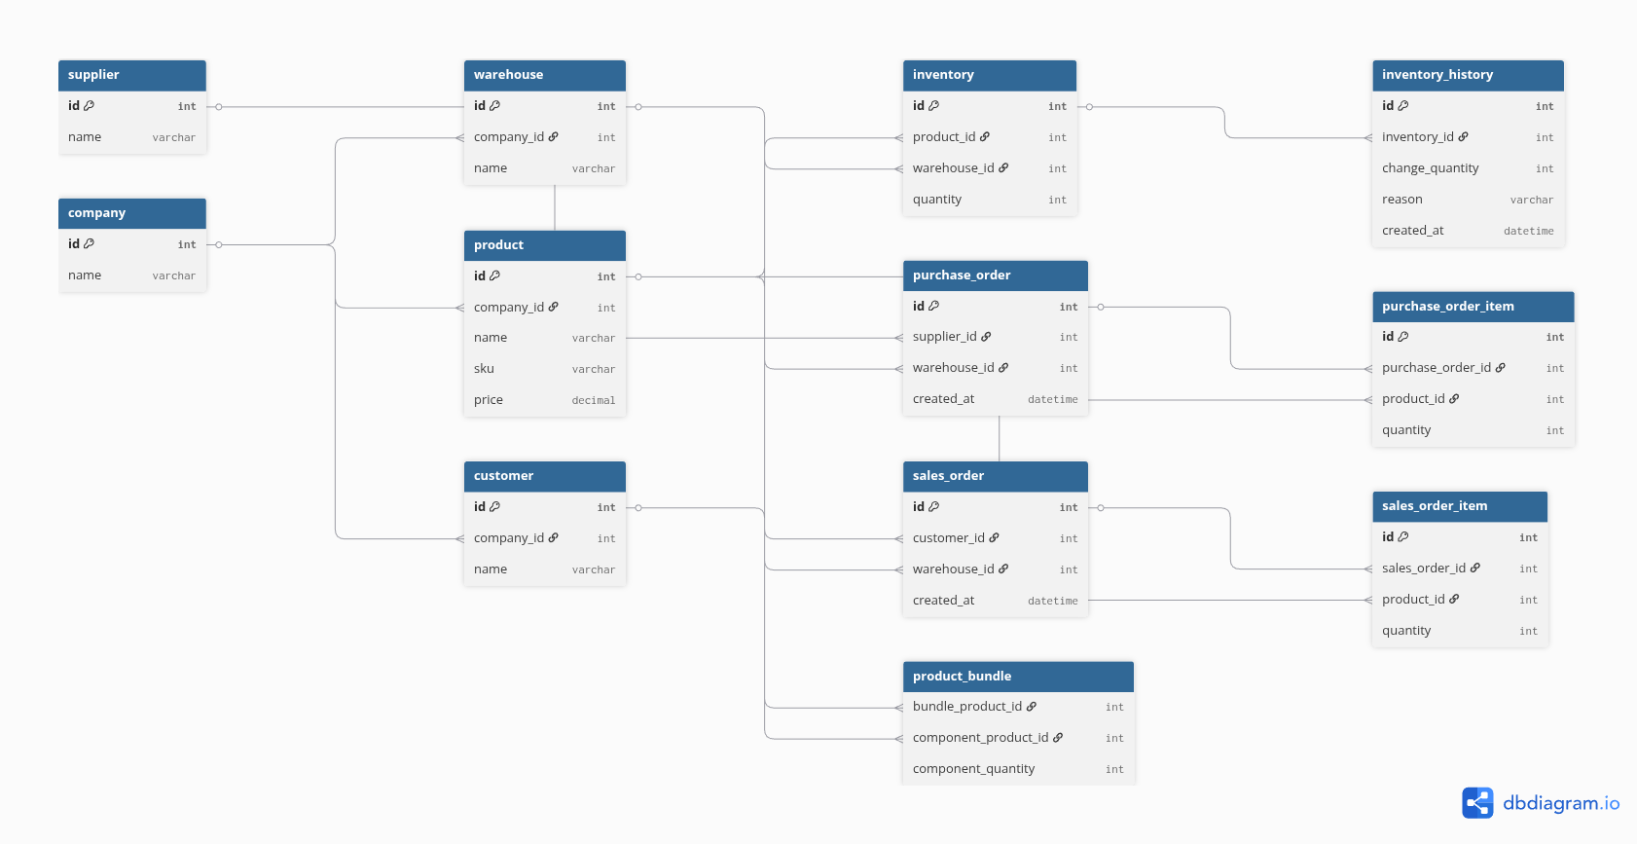

Relationships
- Suppliers deliver products to warehouses through purchase orders (inbound).
- Customers receive products from warehouses through sales orders (outbound).
- Inventory tracks product quantities for each warehouse.
- Inventory history records all inventory level changes.
- Product bundles contain multiple products.

Gaps In the Requirements
- SKU uniqueness is not clearly defined (whether it should be global or per company).
- It is not specified whether a company can work with multiple suppliers.
- The inventory lifecycle is unclear (RAW, WIP, FOR_SALE states are not defined).
- The inventory flow between supplier → company and company → customer is not specified.
- Inventory reservation rules and how inventory levels should be managed are not defined.
- The location of products and how product bundles are stored or handled in inventory is not specified.
- It is unclear whether product bundles consist of the same product or different products.

Design Decisions for gaps:
- Enforced SKU uniqueness per company to handle unclear global uniqueness requirements.
- Added supplier and purchase order tables to support multiple suppliers.
- Introduced inventory lifecycle states (RAW, WIP, FOR_SALE).
- Used purchase orders for supplier-to-company flow and sales orders for company-to-customer flow.
- Added inventory history and reservations to track and control inventory levels.
- Represented product bundles using relationships between products (product-to-product foreign keys).
- Added indexes to improve query performance.

