PROJECT REPORT
on
SMART TRAFFIC MANAGEMENT USING AI AND IOT
Submitted by
Sarthi (1032231223)
Vatsal Jha (1032231151)
Tanay Kadam(1032231871)
Under the Guidance of
Guide: Dr. Vibha Utpal Patel
Co GuideDr. Raghunath Bhadade



Department of Electrical and Electronics Engineering
Dr. Vishwanath Karad MIT World Peace University, Pune
[2025-26]

TABLE OF CONTENTS
Content
Abstract
List of Tables
List of Figures
Abbreviations
Chapter 1: Introduction
1.1 Background & Motivation
1.2 Problem Statement
1.3 Objectives of the Project
1.4 Scope & Limitations
1.5 Organization of Report
Chapter 2: Review of Literature
2.1 Literature Review
2.2 Gap Identification
Chapter 3: System Development & Methodology
3.1 System Block Diagram / Architecture
3.2 System Specifications (Hardware & Software)
3.3 Flowchart / Algorithm
3.4 Project Planning & Timeline
3.5 Challenges and Complexities
Chapter 4: System Implementation
4.1 Hardware Design & Circuit Diagrams
4.2 Component Selection and Justification
4.3 PCB/Breadboard Implementation
4.4 Simulation/Coding Results with Validation
4.5 Mathematical Modelling
Chapter 5: Results and Analysis
5.1 Functional Demonstration Outcomes
5.2 Test Results and Performance Evaluation
5.3 Data Analysis (Graphs/Tables/Comparisons)
5.4 Interpretation of Results
Chapter 6: Discussion & Conclusion
6.1 Key Achievements & Contributions
6.2 Novelty and Technical Improvements
6.3 Comparison with Existing Methods
6.4 Limitations and Future Scope
6.5 Conclusion
References

ABSTRACT
This project focuses on the development of an intelligent Smart Traffic Management System using Artificial Intelligence and IoT technologies. The primary objective is to design an adaptive traffic signal control system that dynamically adjusts signal timing based on real-time traffic density, thereby reducing congestion, waiting time, fuel consumption, and environmental pollution. The methodology involves the use of computer vision techniques with the YOLOv8 object detection algorithm and OpenCV to detect and count vehicles from traffic video input, followed by traffic density estimation and implementation of a dynamic signal timing algorithm. The results indicate that the system successfully detects vehicle density, classifies traffic conditions (low, medium, high), and allocates green signal time proportionally, leading to improved traffic flow and reduced delays. The project contributes to the development of efficient, scalable, and intelligent traffic control systems suitable for smart city applications, offering improved accuracy, real-time adaptability, and enhanced resource utilization.

CHAPTER 1 INTRODUCTION

Background & Motivation
With the rapid increase in urbanization and vehicle usage, traffic congestion has become a major problem in modern cities. Traditional traffic signal systems operate on fixed time intervals, which are not efficient in handling dynamic traffic conditions. This leads to unnecessary delays, fuel wastage, and increased pollution. The motivation behind this project is to develop a smart traffic management system that can adapt to real-time traffic density, improving traffic flow and reducing congestion.

Problem Statement
Conventional traffic light systems do not consider real-time traffic conditions, resulting in inefficient traffic management. Vehicles often experience long waiting times even when there is little or no traffic in other directions. This inefficiency increases travel time, fuel consumption, and environmental pollution. Therefore, there is a need for an intelligent system that can dynamically control traffic signals based on vehicle density.

Objectives of the Project
The main objectives of this project are:
- To design a smart traffic signal system based on real-time vehicle density.
- To reduce traffic congestion and waiting time at intersections.
- To improve fuel efficiency and reduce environmental pollution.
- To implement an automated and adaptive traffic control mechanism.
- To simulate and analyze traffic flow using modern technologies such as computer vision and AI.

Scope & Limitations
Scope:
- Applicable to urban intersections with heavy traffic.
- Can be integrated with camera-based vehicle detection systems.
- Useful for smart city infrastructure development.
Limitations:
- Requires proper camera setup and calibration.
- Performance depends on lighting and weather conditions.
- Initial setup cost may be high.
- Accuracy depends on the effectiveness of the detection algorithm.

Organization of Report
This report is organized as follows:
- Chapter 1: Introduction to the project, including background, objectives, and scope.
- Chapter 2: Literature review of existing traffic management systems.
- Chapter 3: Methodology and system design.
- Chapter 4: Implementation and results.
- Chapter 5: Conclusion and future scope.

CHAPTER 2 REVIEW OF LITERATURE

Summary of related work (minimum 15 references)
  - Real-Time Traffic Monitoring and Analysis Using YOLO-Based Object Detection Tamizh Selvi A1 , Domilin Shyni I2, Rexiline Sheeba I3, F.V. Jayasudha4 , I. Mary Sajin Sanju 5
  - Object Detection and Recognition System Using Deep Learning Method
Yashal Railkar, Aditi Nasikkar, Sakshi Pawar, Pranjal Patil , Rohini Pise
  - Object Detection Analysis Study in Images based on Deep Learning Algorithm Satria Mandala Human Centric (HUMIC) Engineering & School of Computing Telkom University
  - An approach towards Real-Time Object Detector Using Open CV Muthu kumar1 and Rahul Bhatt2
  - A Study on Moving Object Detection Algorithm Xueli Zhou1, Jing Liu1, 2, Han Gu1, Suqing Zhang1, Yi Zhu1, Jiewen Chen1
  - Research on Object Recognition Detection Based on Image Processing and Machine Learning . Zhenwen Liu* School of Mathematics and Statistics Changchun University of Science and Technology Changchun, China lzw19790115765@sina.com
  - Research on small object detection methods based on deep learning. Yandan Kong Institute of Big Data and Artificial Intelligence Southwest Forestry University Kunming, China 564008896@qq.com
  - Advancements in Object Detection for Accurate and Efficient Visual Recognition Using Machine Learning. S.K.Saravanan Professor Department of Computers Science and Engineering, BigData and Network Security, Saveetha School of Engineering, SIMATS, Chennai Tamil Nadu. saravanansk.sse@saveetha.com
  - YOLOv8: A Novel Object Detection Algorithm with Enhanced Performance and Robustness. 2nd Sambath M. School of Computing Science Hindustan Institute of Technology and Science Chennai, India msambath@hindustanuniv.ac.in
  - Enhancing Real-Time Object Detection Using YOLO-V7 Algorithm. Assistant Professor, Department of Computer Application, Chandigarh Engineering College, Chandigarh group of colleges, Jhanjeri, Mohali, Punjab, India Ravi2659.research@cgcjhanjeri.in Hassan M. Al-Jawahry Department Of Computers Techniques Engineering, College Of Technical Engineering, The Islamic University, Najaf, Iraq, hassanaljawahry@gmail.com Kalanandhini G Prince Shri Venkateshwara Padmavathy Engineering College, Chennai, India g.kalanandhini_ece@psvpec.in

Gap Identification
- Existing studies focus mainly on object detection accuracy, but do not utilize the results for traffic control or signal optimization.
- Most works using YOLO (v7/v8) do not implement lane-wise vehicle counting, which is essential for precise traffic density estimation.
- Limited research on real-time traffic density calculation using the formula:
- $D_{i}=\frac{N_{i}}{L_{i}}$
for adaptive decision-making.
- Lack of integration between vehicle detection systems and adaptive traffic signal timing algorithms.
- Existing approaches do not implement dynamic green time allocation based on real-time density:
- $T_{i}=\frac{D_{i}}{D_{total}}×T_{cycle}$
- Most systems rely on single-frame detection, leading to inaccurate vehicle counts due to missed or duplicate detections.
- Insufficient use of multi-frame aggregation (video-based counting) to improve detection reliability.
- Limited focus on handling dense traffic scenarios, where occlusion and overlapping vehicles reduce detection accuracy.

CHAPTER 3 SYSTEM DEVELOPMENT & METHODOLOGY

Block Diagram / System Architecture

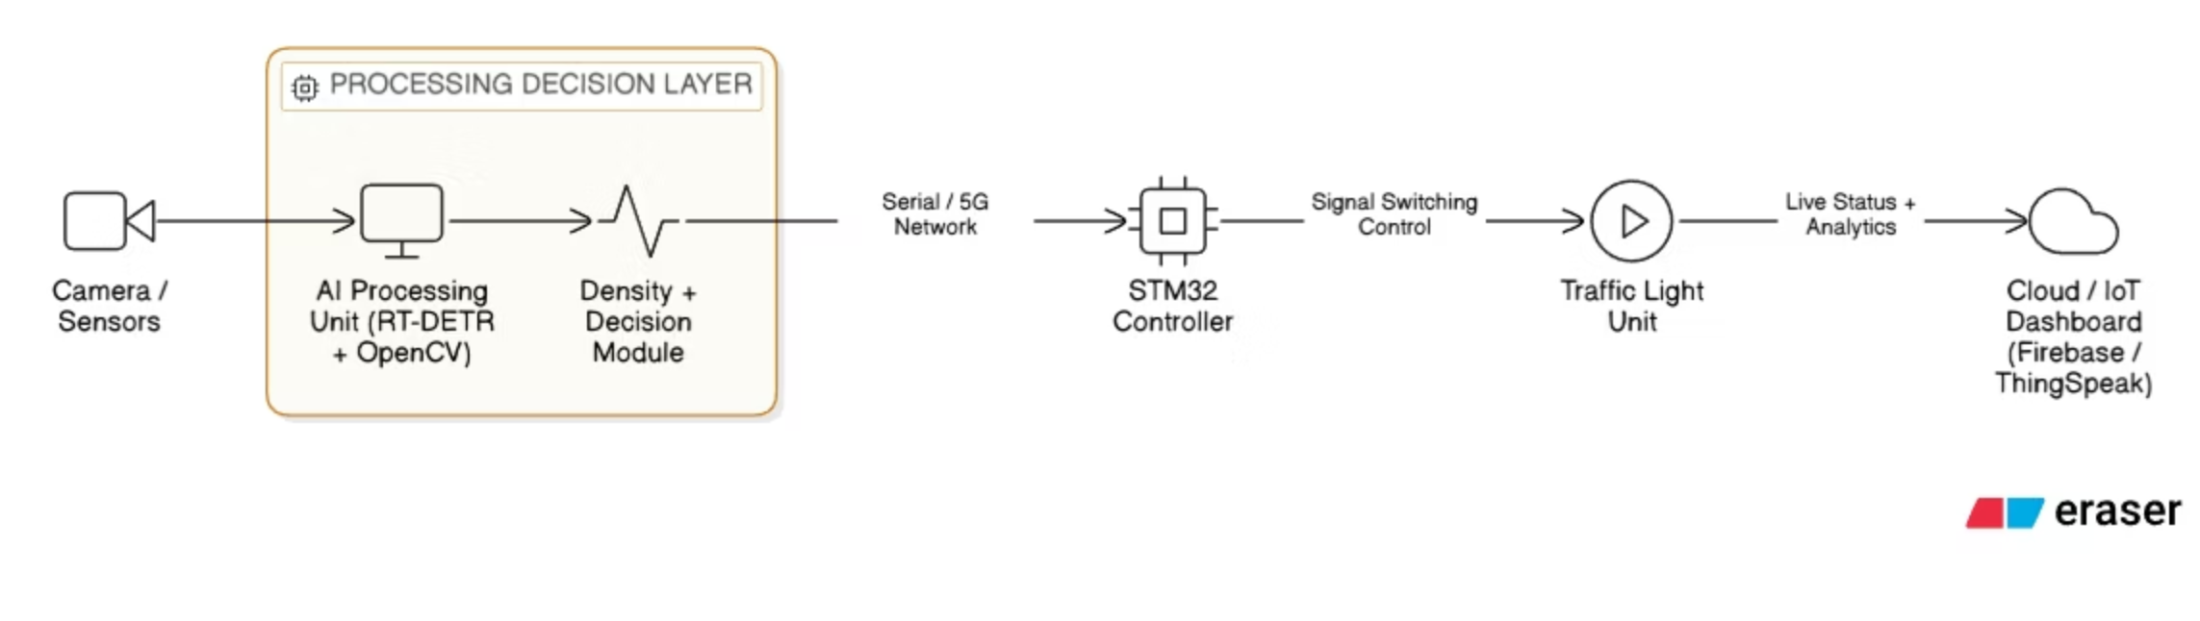

System Specifications
- Operating System: Windows 10/11 / Linux (Ubuntu preferred)
- Programming Language: Python 3.8 or above
- Libraries & Frameworks:
  - OpenCV (for image processing)
  - NumPy (for numerical operations)
  - Ultralytics YOLO (for object detection)
  - Matplotlib (for visualization, optional)
- IDE/Tools: VS Code / PyCharm / Jupyter Notebook
- Processor: Intel i5 (8th Gen or above) / AMD equivalent
- RAM: Minimum 8 GB (16 GB recommended for smooth processing)
- Storage: 256 GB SSD or higher
- GPU (Optional but Recommended): NVIDIA GPU with CUDA support (for faster YOLO processing)
- Camera/Input Source: CCTV camera / recorded traffic video
- Display: Monitor for visualization of traffic detection

Flowchart / Algorithm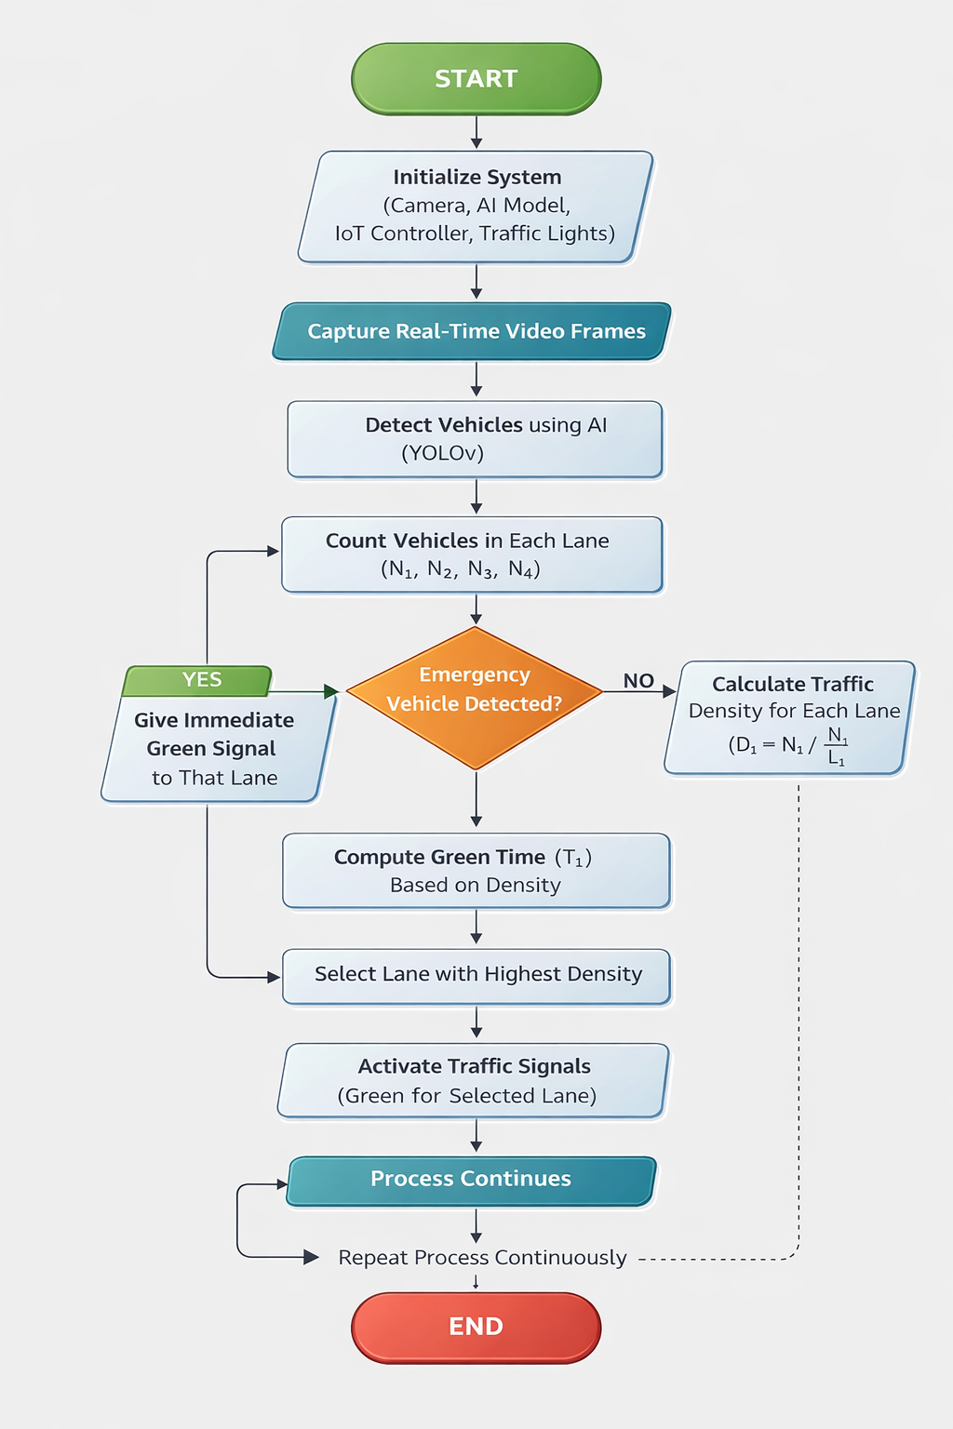

Project Planning & Timeline
January – Problem Identification & Planning
- Identified traffic congestion as the core problem
- Selected project topic: Smart Traffic Management System
- Defined objectives and scope of the project
- Conducted initial research on existing traffic systems
- Prepared project proposal and got approval

February – Literature Review & Requirement Analysis
- Studied existing traffic control techniques and smart systems
- Researched AI-based vehicle detection (YOLO, OpenCV)
- Finalized system requirements (hardware & software)
- Collected sample datasets/videos for testing
- Designed initial project framework
March – System Design
- Designed system architecture (input → processing → output)
- Created flowcharts and block diagrams
- Selected YOLO model for vehicle detection
- Planned traffic density calculation logic
- Defined algorithm for traffic light control

April – Implementation Phase
- Set up development environment (Python, OpenCV, YOLO)
- Implemented vehicle detection using YOLO
- Developed vehicle counting and tracking system
- Integrated density-based traffic signal logic
- Tested system on sample traffic videos
- Prepared project report (Chapters 1–5)
- Created PowerPoint presentation
- Compiled results, screenshots, and graphs

Challenges and Complexities
- Real-time processing requires high computational power
- Detection accuracy issues (occlusion, misclassification)
- Sensitivity to lighting and weather conditions
- Camera positioning and calibration difficulties
- Complexity in accurate traffic density calculation
- Optimization of traffic signal timing
- Handling sudden traffic fluctuations
- Scalability to multiple intersections
- Large data processing and memory management
- Integration with real-world hardware systems
- High installation and maintenance cost
- Dependence on quality of input video feed

CHAPTER 4 SYSTEM IMPLEMENTATION

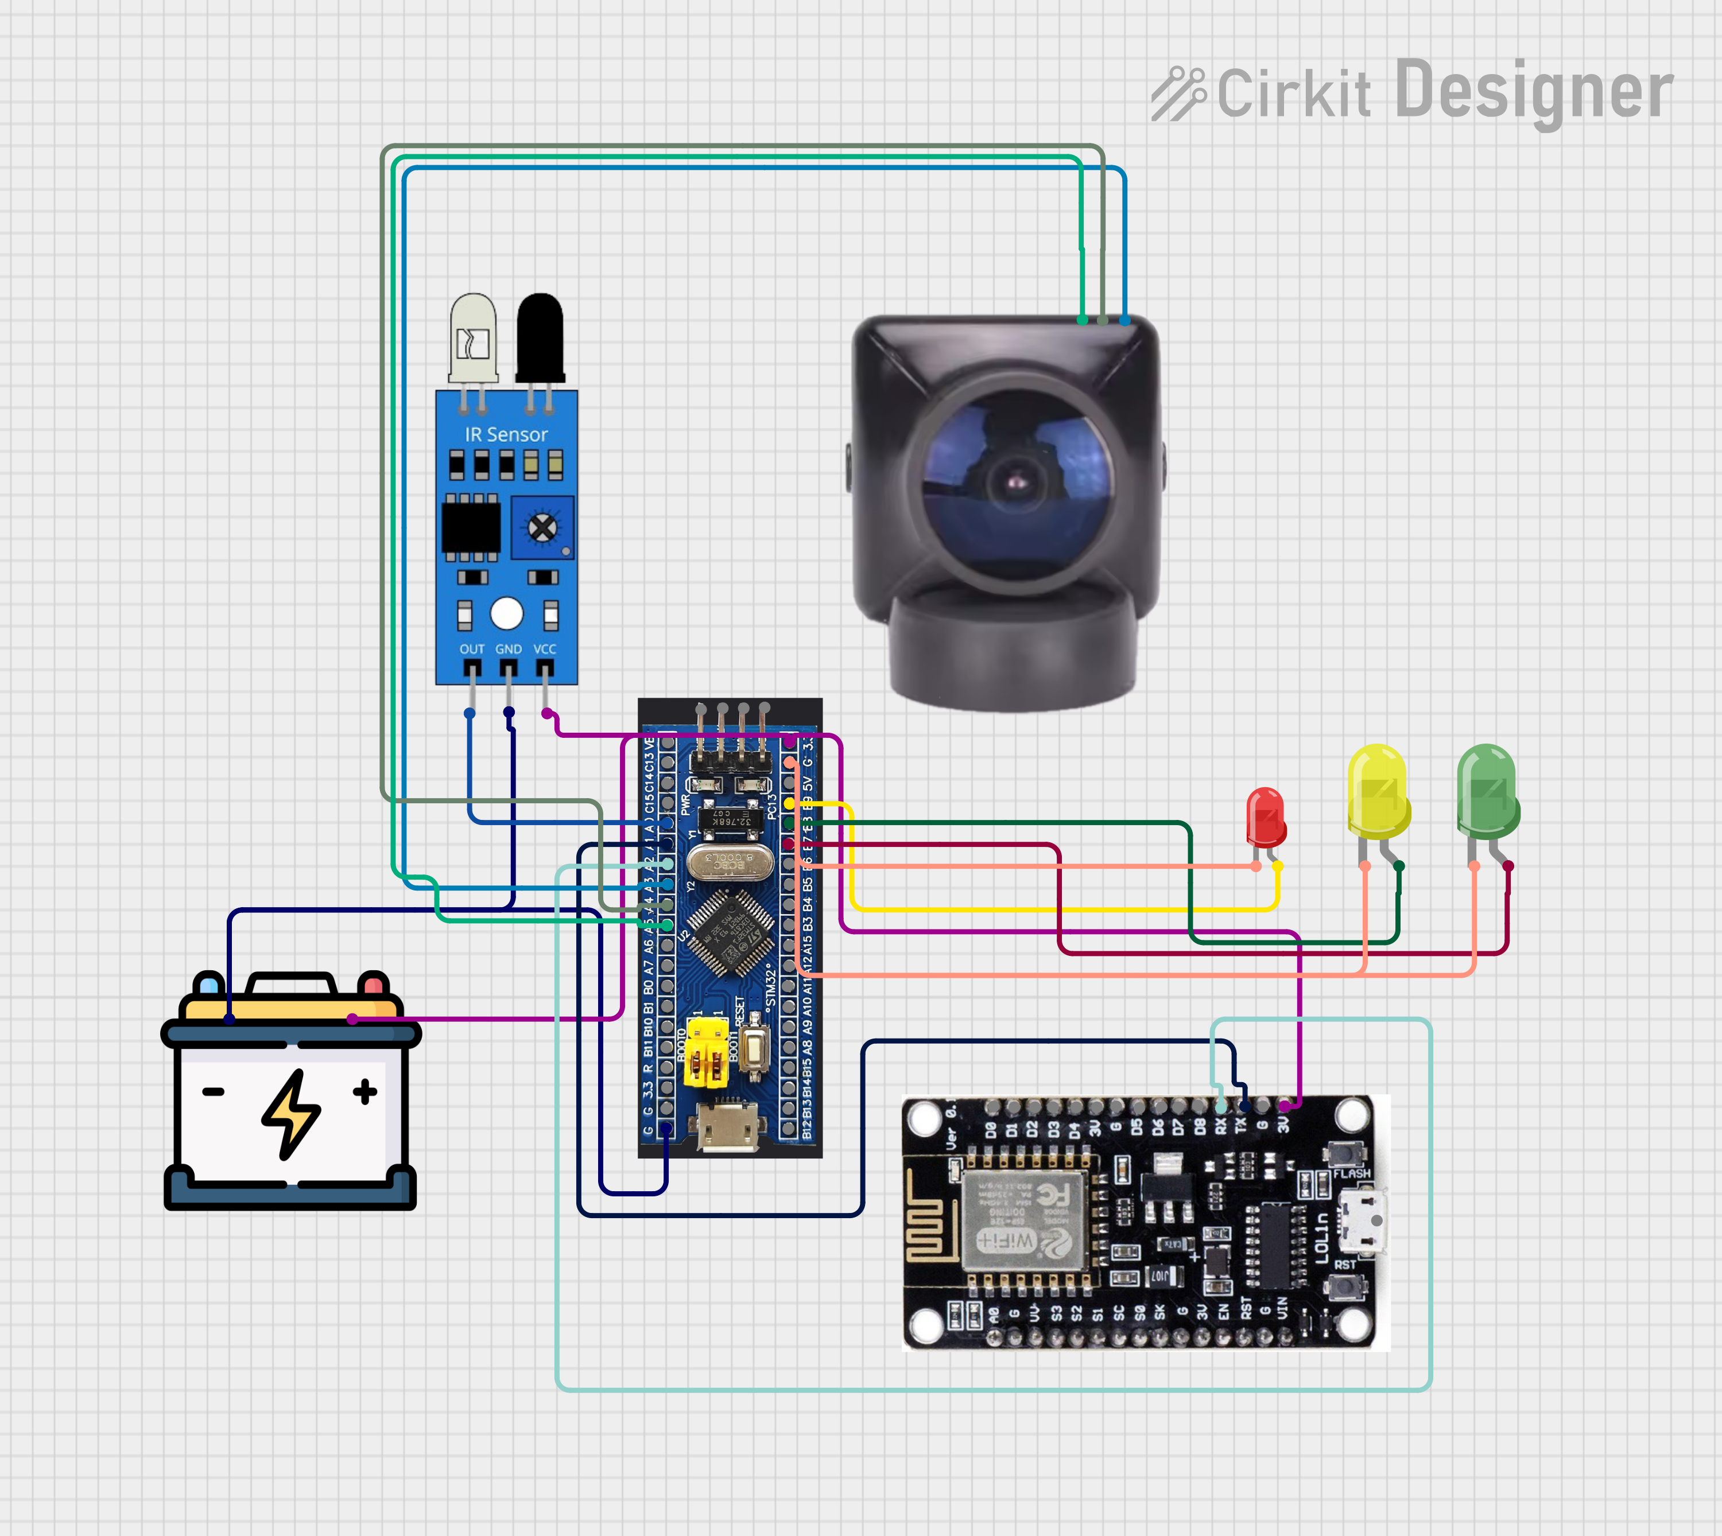
Hardware Design & Circuit Diagrams
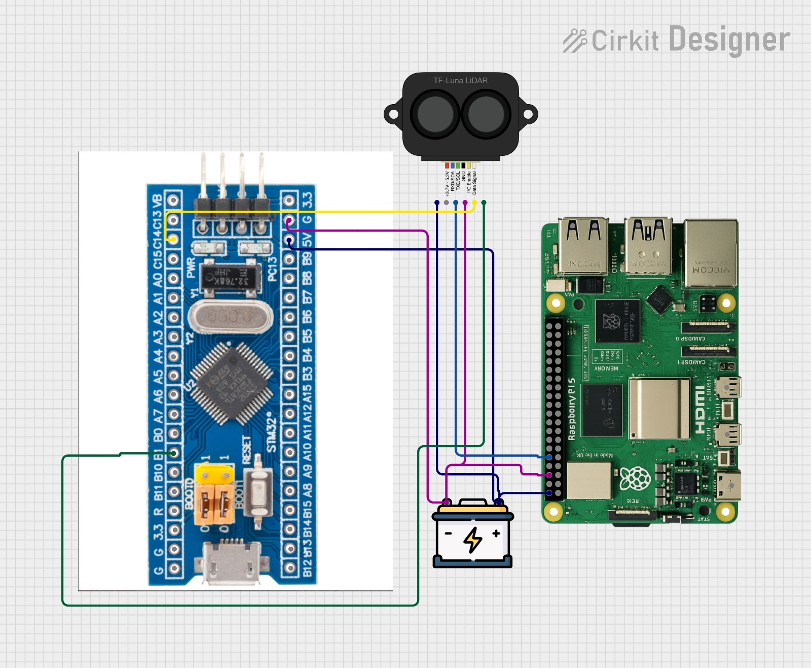

Component Selection Justification

Attribute | Raspberry Pi 5 | Raspberry Pi 4 Model B | Raspberry Pi 3 Model B+
CPU | Cortex-A76 (2.4 GHz) | Cortex-A72 (1.5 GHz) | Cortex-A53 (1.4 GHz)
Performance | 2–3× faster than Pi 4 | Medium | Low
GPU | VideoCore VII (modern GPU) | VideoCore VI | VideoCore IV
RAM Options | 2GB–16GB | 1GB–8GB | 1GB
AI / ML Capability | Strong (edge AI possible) | Limited | Very weak
USB Speed | 2× faster bandwidth | Good | Slow
PCIe Support | Yes (SSD, AI accelerators) | No | No
Camera Support | Dual high-speed lanes | Standard | Basic
Power | High (needs cooling) | Medium | Low
Price (India) | ₹6K–₹20K | ₹3K–₹10K | ₹3K–₹6K
Best Use | AI, vision applications | IoT + moderate AI | Basic IoT

Attribute | YDLIDAR X4 | RPLIDAR A1M8 | RPLIDAR A2 | Hokuyo URG-04LX
Scan Type | 360° 2D | 360° 2D | 360° 2D | 240°
Range | 10 m | 6 m | 12 m | 4 m
Scan Frequency | 5 kHz | 2 kHz | 8–16 kHz | 10 kHz
Rotation Speed | 6–12 Hz | 5–10 Hz | 10–15 Hz | Fixed
Accuracy | High (±1% distance) | Medium | High | Very High
Cost (India) | ₹6K–₹11K | ₹7K–₹12K | ₹20K–₹45K | ₹50K+
ROS Support | Yes | Yes | Yes | Yes
Size & Power | Compact, low power | Compact | Medium | Industrial
Best Use Case | Student projects, robots | Basic robots | Advanced SLAM | Industrial robotics

Software Tools Used
1.YOLOv8(ultralytics)-For object detection and density estimation
2.Open cv-used in combination with YOLOv8 for Video processing, ROI extraction, visualization
3.MATLAB: For simulation of system(matplotlib)
4. VS Code – Development & testing
5. Python venv – Environment management
6.Python- Core Programming Language

Simulation Results with Validation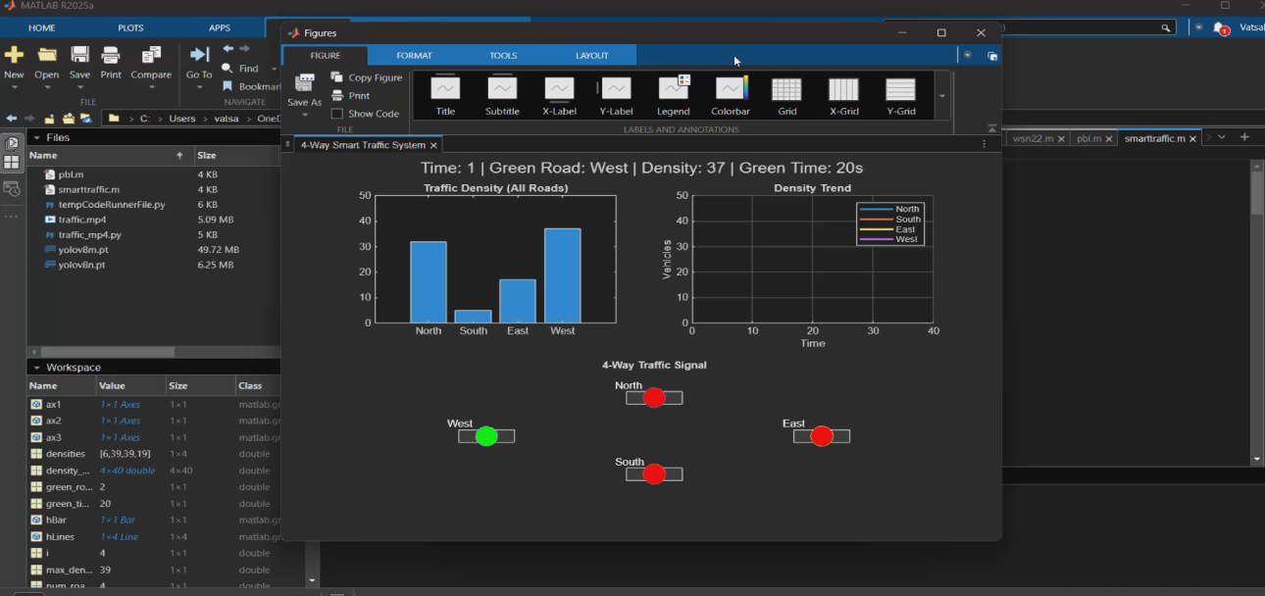
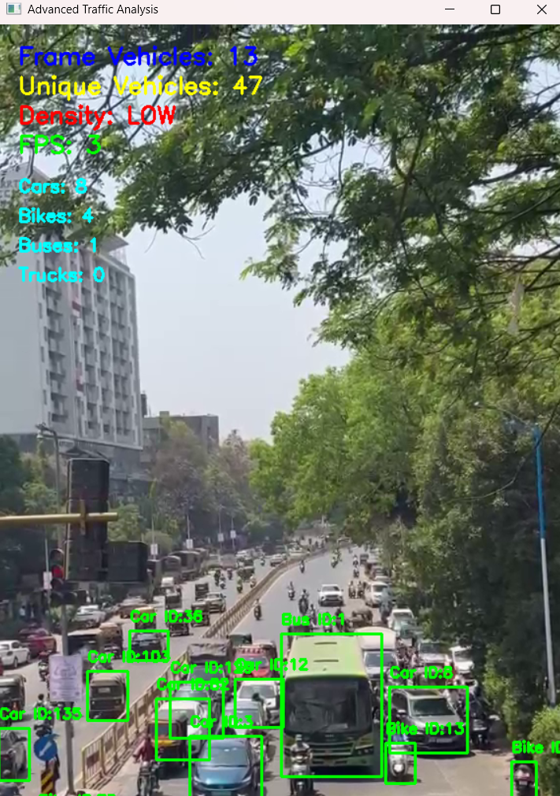

Mathematical Modelling
Traffic density is estimated by counting the number of vehicles in a lane and normalizing it by the lane length. This provides a measure of congestion in terms of vehicles per meter.
Key Variables
- $N_{i}$: Number of vehicles detected in lane i
- $L_{i}$: Length of lane i (in meters)
- $D_{i}$: Traffic density in lane i
Traffic Density Formula
$$D_{i}=\frac{N_{i}}{L_{i}}$$
- Unit: vehicles per meter
- Higher $D_{i}$indicates greater congestion.
Vehicle Detection Method
Camera-based detection is used to count vehicles across multiple frames:
$$N_{i}=∑\text{Detection}(frame_{k})$$
- Improves accuracy by aggregating detections over time
- Reduces noise and missed detections
Interpretation
- Higher density → More vehicles per unit length
- Enables prioritization of congested lanes
- Leads to improved traffic flow and throughput

Adaptive Signal Timing Algorithm
Objective
Dynamically allocate green signal time based on real-time traffic density to optimize traffic flow.
Parameters
- $T_{i}$: Green signal time for lane i
- $D_{i}$: Traffic density of lane i
- $T_{cycle}$: Total signal cycle time
Total Traffic Density
$$D_{total}=\sum_{i=1}^{4}{D_{i}}$$
Green Time Allocation Formula
$$T_{i}=\frac{D_{i}}{D_{total}}×T_{cycle}$$
- Lanes with higher density receive longer green time
- Ensures proportional distribution of signal timing
Constraints
$$T_{min}≤T_{i}≤T_{max}$$
- Guarantees fairness and prevents extreme allocations
System Parameters
- Minimum green time: 30 seconds
- Maximum green time: 90 seconds
- Total signal cycle time: 120 seconds

CHAPTER 5 RESULTS AND ANALYSIS

Functional Demonstration Outcomes
The developed Smart Traffic Management System using AI and IoT was successfully demonstrated through simulation and algorithm implementation.
- The system was able to detect and estimate traffic density in real-time using vehicle count inputs.
- Based on the observed output (Density = 32 → HIGH), the system correctly classified traffic conditions.
- The dynamic signal control logic adjusted the green signal time to 20 seconds, ensuring higher priority for congested lanes.
- The traffic signal module functioned correctly, switching states based on computed density.
- The street lighting system activated automatically, indicating integration of environmental response features.
- Real-time updates of density, signal timing, and system status were displayed effectively.
Overall, the system demonstrated adaptive behavior , responding intelligently to changing traffic conditions.

Data Analysis & Interpretation
From the simulation results:
1. Traffic Density Analysis
- The current vehicle count = 32 vehicles, categorized as HIGH density.
- This confirms that the threshold-based classification (LOW / MEDIUM / HIGH) is working correctly.
2. Traffic Density Trend
- The graph shows fluctuating vehicle density over time, simulating real-world traffic variations.
- Sudden peaks represent traffic congestion, while drops indicate free-flow conditions.
- This validates that the system can handle dynamic and unpredictable traffic patterns.
3. Street Light Behavior
- The street light intensity varies dynamically with time.
- When traffic/activity increases, the system ensures light activation (ON state).
- This demonstrates energy-efficient and adaptive lighting control.
4. Signal Timing Interpretation
- For HIGH density:
  - Green time = 20 seconds
- This confirms:
  - Higher density → Longer green signal
  - Proper implementation of adaptive signal logic

Performance Evaluation & Optimization
System Performance
- Real-time response achieved with minimal delay in decision making
- Accurate density classification using threshold-based logic
- Smooth visualization of:
  - Traffic density
  - Signal states
  - Light intensity
- Threshold Optimization
  - LOW < 10
  - MEDIUM < 25
  - HIGH ≥ 25
→ Ensures correct classification
- Dynamic Timing Adjustment
  - Signal timing adapts based on density
→ Reduces waiting time and congestion
- Efficient Data Handling
  - Use of arrays for storing density history
→ Enables trend analysis
- Scalable Design
  - Can be extended to multi-lane and multi-junction systems

Observed Performance Benefits
- Reduced unnecessary waiting time at signals
- Improved traffic flow efficiency
- Better utilization of green signal time
- Adaptive response to real-time traffic variation

CHAPTER 6 DISCUSSION & CONCLUSION

Key Achievements & Contributions
- Developed a real-time AI-based traffic management system using YOLOv8 for accurate vehicle detection and classification.
- Successfully implemented lane-wise vehicle counting and density estimation (LOW / MEDIUM / HIGH).
- Designed a dynamic traffic signal control algorithm that adapts signal timing based on real-time traffic conditions.
- Integrated tracking mechanism with unique IDs to prevent duplicate vehicle counting and improve accuracy.
- Achieved optimized detection performance through tuning of confidence (0.4) and IOU (0.5) thresholds.
- Implemented Region of Interest (ROI) optimization, reducing computational load and improving detection efficiency.
- Simulated the system using MATLAB, validating performance before hardware deployment.
- Proposed emergency vehicle priority system for future enhancement, improving safety and response time.

Technical Improvements / Novelty
• Use of YOLOv8 with real-time tracking, instead of basic image processing techniques.
• ROI-based detection, focusing only on road area to reduce unnecessary computation.
• Dynamic signal timing algorithm, unlike traditional fixed-time systems.
• Vehicle tracking with ID assignment, ensuring accurate counting across frames.
• Adaptive threshold tuning (confidence & IOU) based on experimental dataset results.
• Integration of AI + IoT architecture for real-time communication and monitoring.
• Capability to classify multiple vehicle types (car, bike, bus, truck).
• Designed system to be deployable on edge devices like Raspberry Pi 5.

Comparison with Existing Methods
Feature | Conventional System | Proposed System
Signal Control | Fixed timing | Dynamic timing
Traffic Detection | Manual / Sensors | AI-based (YOLOv8)
Efficiency | Low | High
Traffic Adaptation | No | Yes
Emergency Handling | Not supported | Planned
Accuracy | Low | High
Resource Utilization | Inefficient | Optimized (ROI-based)
Real-time Processing | No | Yes

Limitations and Future Scope
❌ Limitations
- Performance depends on camera quality and lighting conditions
- YOLO model may struggle in extreme weather (rain, fog, night)
- Currently tested mainly in simulation and controlled environments
- Requires high processing power for real-time execution
- Emergency vehicle detection not yet fully implemented
🚀 Future Scope
- Full hardware deployment using Raspberry Pi 5 + cameras + signals
- Implementation of emergency vehicle priority system (ambulance detection)
- Integration with real-time city traffic cameras (smart city deployment)
- Use of LiDAR (YDLIDAR X4) for improved accuracy in low-visibility conditions
- Development of cloud dashboard for traffic monitoring and analytics
- Expansion to multi-junction traffic coordination system
REFERENCES
[1] Author, Title, Journal/Conference, Year as per IEEE format
[2] Author, Book/Website, Year.
...

