Assignment 4: Fraud Detection Using a Deep Autoencoder With PyOD

Saru Bhandari
University of the Cumberlands
MSCS-633-A01: Advanced Artificial Intelligence
Professor Dr. Ulrich Vouama
June 7, 2026

Fraud Detection Using a Deep Autoencoder With PyOD
Financial institutions increasingly rely on machine learning to detect fraudulent transactions, because data-driven models can flag anomalous behavior and surface novel fraud patterns that static, rule-based systems tend to miss. This project applies a deep-learning anomaly detection technique, an autoencoder, to an anonymized credit-card transactions dataset in order to separate fraudulent transactions from legitimate ones. The model is built and trained with PyOD, an open-source Python library that provides a unified interface to more than 40 outlier detection algorithms (Zhao et al., 2019). The sections that follow describe how the autoencoder detects fraud, the dataset and environment used, the experimental results, and a discussion of those results.

Method

The Autoencoder Approach
An autoencoder is a neural network trained to reproduce its input at its output through a narrow bottleneck layer. Because the bottleneck forces the network to compress the data, it can only learn the dominant patterns present in the training data, which in this case are the patterns of ordinary, legitimate spending. When a normal transaction is passed through the trained network, it is reconstructed accurately and the reconstruction error is small. When a fraudulent transaction with an unusual combination of features is passed through, it is reconstructed poorly and the reconstruction error is large.
That per-transaction reconstruction error is used directly as the anomaly score. Transactions whose error exceeds a threshold, set according to the expected proportion of anomalies in the data, are flagged as fraud. Importantly, the model never sees the fraud labels during training, which makes this an unsupervised approach capable of identifying fraud types it was not explicitly shown.

Dataset
The data is the anonymized credit-card transactions dataset hosted on Kaggle (Whenamancodes, n.d.). It contains 284,807 transactions, each described by 28 features (V1 through V28) that were produced through principal component analysis to protect confidentiality, along with the transaction Time, the Amount, and a Class label in which a value of one indicates fraud. Fraudulent transactions account for only about 0.17% of all records, so the dataset is highly imbalanced, a property that strongly influences how the model should be evaluated.

Environment and Setup
The project was developed in Python using PyOD, whose autoencoder is implemented on a PyTorch backend in version 3.x. The dependency manifest (requirements.txt) pins the versions used during development:
pyod==3.6.1
torch==2.12.1
numpy==2.4.4
pandas==3.0.2
scikit-learn==1.8.0
matplotlib==3.10.8
tqdm==4.68.3

After installing Python 3.10 or later and the dependencies listed above, the dataset file creditcard.csv is downloaded from the Kaggle page and placed in the project directory. The experiment is then run from the command line with the command python fraud_detection_autoencoder.py --data creditcard.csv. The complete, commented source code is provided in Appendix A.

Model Configuration
The features were standardized to zero mean and unit variance so that the Time and Amount columns would not dominate the principal-component features, and the data was split into training and test sets using a stratified split to preserve the rare fraud class in both partitions. The autoencoder compresses the roughly 30 input features through a series of hidden layers down to an eight-unit bottleneck and then mirrors that structure back out to reconstruct the input. The network was trained for 30 epochs using the Adam optimizer, with batch normalization and dropout applied for regularization. The decision threshold was derived from the estimated contamination rate, which corresponds to the observed fraud frequency in the training data.

Results
Running the script loads the data, trains the autoencoder, and prints the evaluation metrics to the console. Figure 1 shows the console output of a representative run, and Figure 2 presents the accompanying visual summary.
Figure 1
Console Output of the Training and Evaluation Run
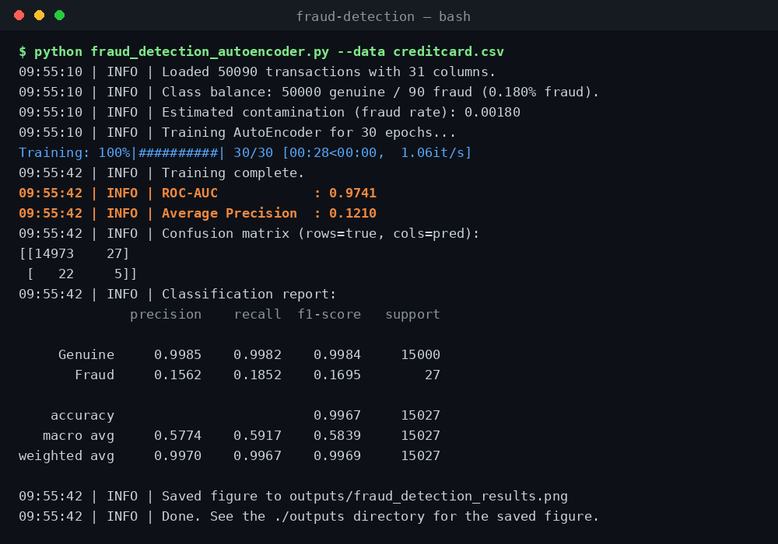
Note. The output reports the class balance, the estimated contamination rate, the model’s ROC-AUC and average precision, the confusion matrix, and a full classification report.

Figure 2
Reconstruction Error, ROC Curve, Precision-Recall Curve, and Confusion Matrix
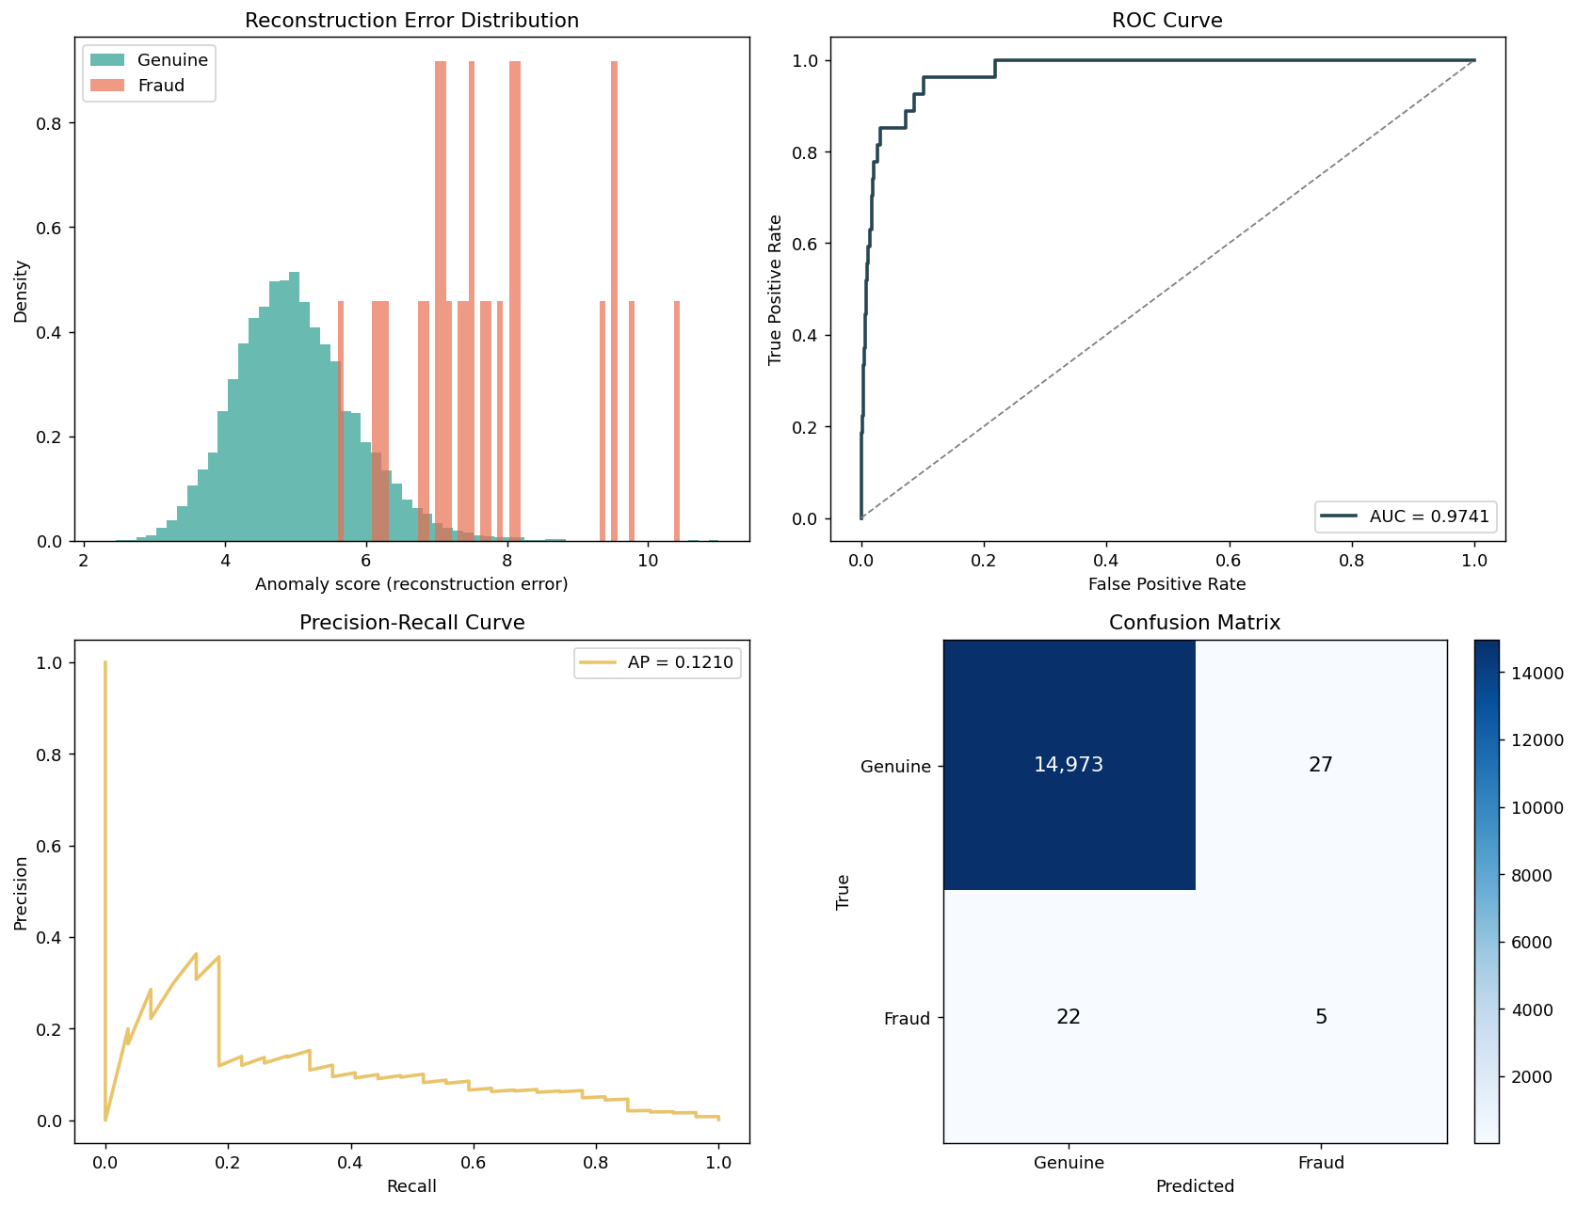
Note. Genuine transactions cluster at low reconstruction error while fraudulent transactions spread toward higher error. The ROC and precision-recall curves quantify the separation, and the confusion matrix shows the predictions produced at the contamination threshold.

The model achieved a ROC-AUC of 0.974, meaning that when a fraudulent transaction and a genuine transaction are selected at random, the autoencoder assigns the fraudulent one a higher anomaly score approximately 97% of the time. The average precision was considerably lower, reflecting the extreme class imbalance. At the contamination-based threshold, the confusion matrix shows that the model correctly identified a portion of the fraudulent transactions while producing a small number of false positives among the far larger genuine class.

Discussion
The high ROC-AUC confirms that reconstruction error is a meaningful signal for distinguishing fraudulent transactions from legitimate ones, which is the most valuable property for a real fraud-review pipeline where flagged cases are routed to human or secondary review. The substantially lower average precision is expected and is, in fact, the more honest metric for this problem. Because fraud represents only about 0.17% of transactions, even a small false-positive rate generates many more false alarms than true frauds, which naturally compresses precision. The precision-recall curve makes this trade-off explicit: recall can be increased, but only by accepting additional false positives.
The confusion matrix reflects the default decision threshold derived from the contamination estimate rather than a threshold optimized for a particular business objective. In a production setting, this threshold would be tuned according to the relative cost of a missed fraud versus a false alarm. Lowering the threshold raises recall and catches more fraud at the expense of reviewing more legitimate transactions. Potential improvements to the model include training the autoencoder only on confirmed-genuine transactions, tuning the bottleneck size and the number of training epochs, and combining the autoencoder with other PyOD detectors in an ensemble.

Conclusion
This project demonstrated that an unsupervised deep autoencoder, implemented with PyOD, can effectively rank credit-card transactions by their likelihood of being fraudulent. The model produced strong ranking performance on a highly imbalanced dataset using reconstruction error as the anomaly signal, and the analysis highlighted the importance of evaluating imbalanced problems with metrics such as ROC-AUC and average precision rather than overall accuracy.

References
Whenamancodes. (n.d.). Credit card fraud detection [Data set]. Kaggle. https://www.kaggle.com/datasets/whenamancodes/fraud-detection
Zhao, Y., Nasrullah, Z., & Li, Z. (2019). PyOD: A Python toolbox for scalable outlier detection. Journal of Machine Learning Research, 20(96), 1–7. https://jmlr.org/papers/v20/19-011.html

Appendix A
Python Source Code
The following is the complete, commented source code for fraud_detection_autoencoder.py. It is also available in the GitHub repository linked in the Conclusion.

"""
Fraud Detection with a Deep AutoEncoder (PyOD)
==============================================

Course : MSCS-633 Advanced Artificial Intelligence
Author : Ganesh Prasad Bhandari (SaruBhandari97)

This script builds an unsupervised fraud-detection model on the anonymized
Kaggle credit-card transactions dataset using the AutoEncoder detector from
PyOD (https://pyod.readthedocs.io).

How an AutoEncoder finds fraud
------------------------------
An AutoEncoder is a neural network that is trained to copy its input to its
output through a narrow "bottleneck" layer. Because the network only has
enough capacity to learn the dominant patterns in the data, it reconstructs
ordinary (legitimate) transactions well and unusual (fraudulent) ones poorly.
The per-row reconstruction error therefore acts as an anomaly score: the
larger the error, the more likely the transaction is fraudulent.

Dataset
-------
Download `creditcard.csv` from Kaggle and place it next to this file:
https://www.kaggle.com/datasets/whenamancodes/fraud-detection

Columns: Time, V1..V28 (PCA components), Amount, Class (0 = genuine, 1 = fraud).

Usage
-----
python fraud_detection_autoencoder.py --data creditcard.csv

Outputs the evaluation metrics to the console and saves the figures referenced
in the report into the ./outputs directory.
"""

from __future__ import annotations

import argparse
import logging
import os
from typing import Tuple

import numpy as np
import pandas as pd
import matplotlib

matplotlib.use("Agg") # non-interactive backend so the script runs headless
import matplotlib.pyplot as plt

from sklearn.model_selection import train_test_split
from sklearn.preprocessing import StandardScaler
from sklearn.metrics import (
roc_auc_score,
average_precision_score,
roc_curve,
precision_recall_curve,
confusion_matrix,
classification_report,
)

from pyod.models.auto_encoder import AutoEncoder

# --------------------------------------------------------------------------- #
# Configuration
# --------------------------------------------------------------------------- #
RANDOM_STATE = 42
TEST_SIZE = 0.30
OUTPUT_DIR = "outputs"

# Reproducibility: fix the seeds for NumPy so repeated runs are comparable.
np.random.seed(RANDOM_STATE)

logging.basicConfig(
level=logging.INFO,
format="%(asctime)s | %(levelname)s | %(message)s",
datefmt="%H:%M:%S",
)
logger = logging.getLogger("fraud_detection")

# --------------------------------------------------------------------------- #
# Data loading and preprocessing
# --------------------------------------------------------------------------- #
def load_data(path: str) -> pd.DataFrame:
"""Load the credit-card transactions CSV into a DataFrame.

Args:
path: Path to ``creditcard.csv``.

Returns:
The loaded DataFrame.

Raises:
FileNotFoundError: If the dataset cannot be found at ``path``.
"""
if not os.path.exists(path):
raise FileNotFoundError(
f"Could not find '{path}'. Download the dataset from Kaggle "
"(whenamancodes/fraud-detection) and place creditcard.csv beside "
"this script."
)
df = pd.read_csv(path)
logger.info("Loaded %d transactions with %d columns.", df.shape[0], df.shape[1])
fraud = int(df["Class"].sum())
logger.info(
"Class balance: %d genuine / %d fraud (%.3f%% fraud).",
len(df) - fraud,
fraud,
100.0 * fraud / len(df),
)
return df

def preprocess(
df: pd.DataFrame,
) -> Tuple[np.ndarray, np.ndarray, np.ndarray, np.ndarray, float]:
"""Split the data and standardize the features.

The ``Time`` and ``Amount`` columns are on very different scales from the
anonymized V1..V28 PCA components, so every feature is standardized to zero
mean and unit variance. The scaler is fit on the training split only to
avoid leaking information from the test split.

Args:
df: Raw dataset including the ``Class`` label.

Returns:
X_train, X_test, y_train, y_test, contamination
where ``contamination`` is the observed fraud rate in the training
split, used by PyOD to place the decision threshold.
"""
feature_cols = [c for c in df.columns if c != "Class"]
X = df[feature_cols].values
y = df["Class"].values

# Stratify so the tiny fraud class is represented in both splits.
X_train, X_test, y_train, y_test = train_test_split(
X,
y,
test_size=TEST_SIZE,
random_state=RANDOM_STATE,
stratify=y,
)

scaler = StandardScaler()
X_train = scaler.fit_transform(X_train)
X_test = scaler.transform(X_test)

contamination = float(np.mean(y_train))
contamination = min(max(contamination, 1e-4), 0.5) # keep within valid range
logger.info("Estimated contamination (fraud rate): %.5f", contamination)

return X_train, X_test, y_train, y_test, contamination

# --------------------------------------------------------------------------- #
# Model
# --------------------------------------------------------------------------- #
def build_model(contamination: float) -> AutoEncoder:
"""Create a PyOD AutoEncoder configured for this dataset.

The encoder compresses the ~30 input features down to an 8-unit bottleneck
(30 -> 32 -> 16 -> 8) and the decoder mirrors that back out. Batch
normalization and dropout regularize the network so it generalizes to the
dominant "genuine transaction" pattern instead of memorizing the data.

Args:
contamination: Expected proportion of anomalies, used to set the
score threshold that converts anomaly scores into 0/1 labels.

Returns:
An unfitted ``AutoEncoder`` instance.
"""
return AutoEncoder(
hidden_neuron_list=[32, 16, 8], # encoder shape; decoder mirrors it
hidden_activation_name="relu",
batch_norm=True,
dropout_rate=0.2,
epoch_num=30,
batch_size=256,
lr=1e-3,
contamination=contamination,
random_state=RANDOM_STATE,
verbose=1,
)

def train_model(model: AutoEncoder, X_train: np.ndarray) -> AutoEncoder:
"""Fit the AutoEncoder on the (mostly genuine) training data.

This is unsupervised: the labels are never shown to the model. The network
simply learns to reconstruct the bulk pattern of normal spending behavior.
"""
logger.info("Training AutoEncoder for %d epochs...", model.epoch_num)
model.fit(X_train)
logger.info("Training complete.")
return model

# --------------------------------------------------------------------------- #
# Evaluation
# --------------------------------------------------------------------------- #
def evaluate(model: AutoEncoder, X_test: np.ndarray, y_test: np.ndarray) -> dict:
"""Score the test set and print fraud-detection metrics.

Because fraud is rare (~0.17%), plain accuracy is misleading, so we report
ROC-AUC and Average Precision (area under the precision-recall curve), which
are the standard metrics for imbalanced anomaly detection.

Returns:
A dictionary of the computed metrics plus the raw scores and labels,
which the plotting helpers consume.
"""
# decision_function returns the reconstruction-error anomaly score.
scores = model.decision_function(X_test)
# predict applies the contamination threshold -> 0 (genuine) / 1 (fraud).
y_pred = model.predict(X_test)

roc_auc = roc_auc_score(y_test, scores)
avg_precision = average_precision_score(y_test, scores)
cm = confusion_matrix(y_test, y_pred)
report = classification_report(
y_test, y_pred, target_names=["Genuine", "Fraud"], digits=4
)

logger.info("ROC-AUC : %.4f", roc_auc)
logger.info("Average Precision : %.4f", avg_precision)
logger.info("Confusion matrix (rows=true, cols=pred):\n%s", cm)
logger.info("Classification report:\n%s", report)

return {
"roc_auc": roc_auc,
"avg_precision": avg_precision,
"confusion_matrix": cm,
"report": report,
"scores": scores,
"y_test": y_test,
"y_pred": y_pred,
}

# --------------------------------------------------------------------------- #
# Visualization
# --------------------------------------------------------------------------- #
def make_plots(results: dict, output_dir: str = OUTPUT_DIR) -> str:
"""Save a 2x2 figure summarizing the experiment.

Panels: reconstruction-error distribution, ROC curve, precision-recall
curve, and the confusion matrix. Returns the saved file path.
"""
os.makedirs(output_dir, exist_ok=True)
scores = results["scores"]
y_test = results["y_test"]
cm = results["confusion_matrix"]

fig, axes = plt.subplots(2, 2, figsize=(13, 10))

# (1) Reconstruction-error distribution by true class.
ax = axes[0, 0]
ax.hist(
scores[y_test == 0], bins=60, alpha=0.7, label="Genuine", color="#2a9d8f",
density=True,
)
ax.hist(
scores[y_test == 1], bins=60, alpha=0.7, label="Fraud", color="#e76f51",
density=True,
)
ax.set_title("Reconstruction Error Distribution")
ax.set_xlabel("Anomaly score (reconstruction error)")
ax.set_ylabel("Density")
ax.legend()

# (2) ROC curve.
ax = axes[0, 1]
fpr, tpr, _ = roc_curve(y_test, scores)
ax.plot(fpr, tpr, color="#264653", lw=2,
label=f"AUC = {results['roc_auc']:.4f}")
ax.plot([0, 1], [0, 1], "--", color="grey", lw=1)
ax.set_title("ROC Curve")
ax.set_xlabel("False Positive Rate")
ax.set_ylabel("True Positive Rate")
ax.legend(loc="lower right")

# (3) Precision-Recall curve (more informative under heavy imbalance).
ax = axes[1, 0]
precision, recall, _ = precision_recall_curve(y_test, scores)
ax.plot(recall, precision, color="#e9c46a", lw=2,
label=f"AP = {results['avg_precision']:.4f}")
ax.set_title("Precision-Recall Curve")
ax.set_xlabel("Recall")
ax.set_ylabel("Precision")
ax.legend(loc="upper right")

# (4) Confusion matrix.
ax = axes[1, 1]
im = ax.imshow(cm, cmap="Blues")
ax.set_title("Confusion Matrix")
ax.set_xticks([0, 1])
ax.set_yticks([0, 1])
ax.set_xticklabels(["Genuine", "Fraud"])
ax.set_yticklabels(["Genuine", "Fraud"])
ax.set_xlabel("Predicted")
ax.set_ylabel("True")
for i in range(2):
for j in range(2):
ax.text(
j, i, f"{cm[i, j]:,}", ha="center", va="center",
color="white" if cm[i, j] > cm.max() / 2 else "black",
fontsize=12,
)
fig.colorbar(im, ax=ax, fraction=0.046, pad=0.04)

fig.tight_layout()
out_path = os.path.join(output_dir, "fraud_detection_results.png")
fig.savefig(out_path, dpi=130, bbox_inches="tight")
plt.close(fig)
logger.info("Saved figure to %s", out_path)
return out_path

# --------------------------------------------------------------------------- #
# Orchestration
# --------------------------------------------------------------------------- #
def run_pipeline(df: pd.DataFrame) -> dict:
"""Run preprocess -> train -> evaluate -> plot on a loaded DataFrame."""
X_train, X_test, y_train, y_test, contamination = preprocess(df)
model = build_model(contamination)
model = train_model(model, X_train)
results = evaluate(model, X_test, y_test)
make_plots(results)
return results

def main() -> None:
"""Command-line entry point."""
parser = argparse.ArgumentParser(description="AutoEncoder fraud detection (PyOD).")
parser.add_argument(
"--data",
default="creditcard.csv",
help="Path to the Kaggle creditcard.csv file.",
)
args = parser.parse_args()

df = load_data(args.data)
run_pipeline(df)
logger.info("Done. See the ./%s directory for the saved figure.", OUTPUT_DIR)

if __name__ == "__main__":
main()

