Assignment 3: Create a Simple Q&A Chatbot with Python
Saru Bhandari
University of the Cumberlands
MSCS-633-A01: Advanced Artificial Intelligence
Professor Dr. Ulrich Vouama
June 7, 2026

Abstract
This paper describes the design and implementation of a terminal-based question-and-answer (Q&A) chatbot developed using Django and ChatterBot, a machine-learning conversational dialog engine built in Python. The chatbot is trained on a built-in English corpus covering greetings, general conversation, and trivia. A BestMatch logic adapter with a confidence threshold of 0.90 ensures that only high-quality responses are returned to the user, while a polite fallback message is issued when no sufficient match is found. The project follows Python coding best practices including type hints, docstrings, separation of concerns, and graceful error handling. The complete source code is available on GitHub.

Keywords: chatbot, ChatterBot, Django, natural language processing, machine learning, conversational AI

Introduction
Conversational agents, or chatbots, have become a widely studied area within artificial intelligence (AI) and natural language processing (NLP). By simulating human dialogue, they can be applied across domains such as customer service, education, and personal productivity. This assignment explores the development of a terminal-based Q&A chatbot using two open-source frameworks: Django, a high-level Python web framework, and ChatterBot, a machine-learning conversational dialog engine.
The primary objective is to build a working chatbot that accepts user input through a command-line interface, processes the input using a trained language model, and returns a contextually appropriate response. The implementation follows Python coding best practices and is organized according to the standard Django application structure.

Background
ChatterBot
ChatterBot is an open-source Python library that uses machine learning to generate responses based on collections of known conversations (Atkinson, 2021). Unlike rule-based systems that rely on hardcoded patterns, ChatterBot selects the best response by comparing user input against previously trained statement-response pairs using a similarity algorithm. The library supports multiple storage backends (including SQLite and MongoDB) and several logic adapters that determine how the best response is selected.
Django Framework
Django is a high-level Python web framework that encourages rapid development and clean, pragmatic design (Django Software Foundation, 2024). Although Django is primarily intended for web applications, its settings management, app structure, and database abstraction layer (ORM) make it a suitable scaffolding framework even for non-web projects such as terminal applications. Using Django ensures that the project is organized in a modular, maintainable way consistent with industry standards.

Project Structure and Design
File Organization
The project follows the standard Django convention of separating configuration from application logic. The directory structure is as follows:

chatbot_project/
├── manage.py
├── terminal_client.py
├── requirements.txt
├── README.md
├── chatbot/
│ ├── __init__.py
│ └── bot.py
└── chatbot_config/
├── __init__.py
├── settings.py
├── urls.py
└── wsgi.py

The chatbot application module houses bot.py, which contains all ChatterBot initialization and training logic. The terminal_client.py script at the project root serves as the user-facing entry point. This separation of concerns ensures that the bot logic can be tested or reused independently of the I/O layer.
Bot Initialization and Training
The bot.py module creates a ChatBot instance configured with the BestMatch logic adapter. A confidence threshold of 0.90 is applied, meaning the bot will only return a corpus-matched response when the similarity score meets or exceeds that value. Below that threshold, a predefined fallback message is returned. The bot is trained using ChatterBot's built-in English corpus, which covers greetings, general conversation, and trivia topics.

# bot.py — ChatterBot setup and training
from chatterbot import ChatBot
from chatterbot.trainers import ChatterBotCorpusTrainer

def create_bot(bot_name: str = 'CourseBot') -> ChatBot:
bot = ChatBot(
bot_name,
storage_adapter="chatterbot.storage.SQLStorageAdapter",
database_uri="sqlite:///chatbot.sqlite3",
logic_adapters=[{
"import_path": "chatterbot.logic.BestMatch",
"default_response": "I am sorry, I do not understand.",
"maximum_similarity_threshold": 0.90,
}],
)
trainer = ChatterBotCorpusTrainer(bot)
trainer.train("chatterbot.corpus.english")
return bot

Terminal Client
The terminal_client.py script bootstraps Django's settings module and enters an interactive input loop. User messages are passed to the bot's get_response() method and the reply is printed to the console. The loop handles blank input, exit commands (quit and exit), and keyboard interrupts (Ctrl-C and Ctrl-D) gracefully, ensuring a smooth user experience.

# terminal_client.py — interactive chat loop
while True:
try:
user_input = input("user: ").strip()
except (EOFError, KeyboardInterrupt):
print("\nbot: Goodbye!")
sys.exit(0)

if user_input.lower() in ("quit", "exit"):
print("bot: Goodbye! Have a great day!")
break

response = bot.get_response(user_input)
print(f"bot: {response}\n")

Sample Terminal Output
The following output was produced during a live session after training completed. The bot was queried with a series of conversational inputs to verify correct behavior across greeting, factual, and exit scenarios.

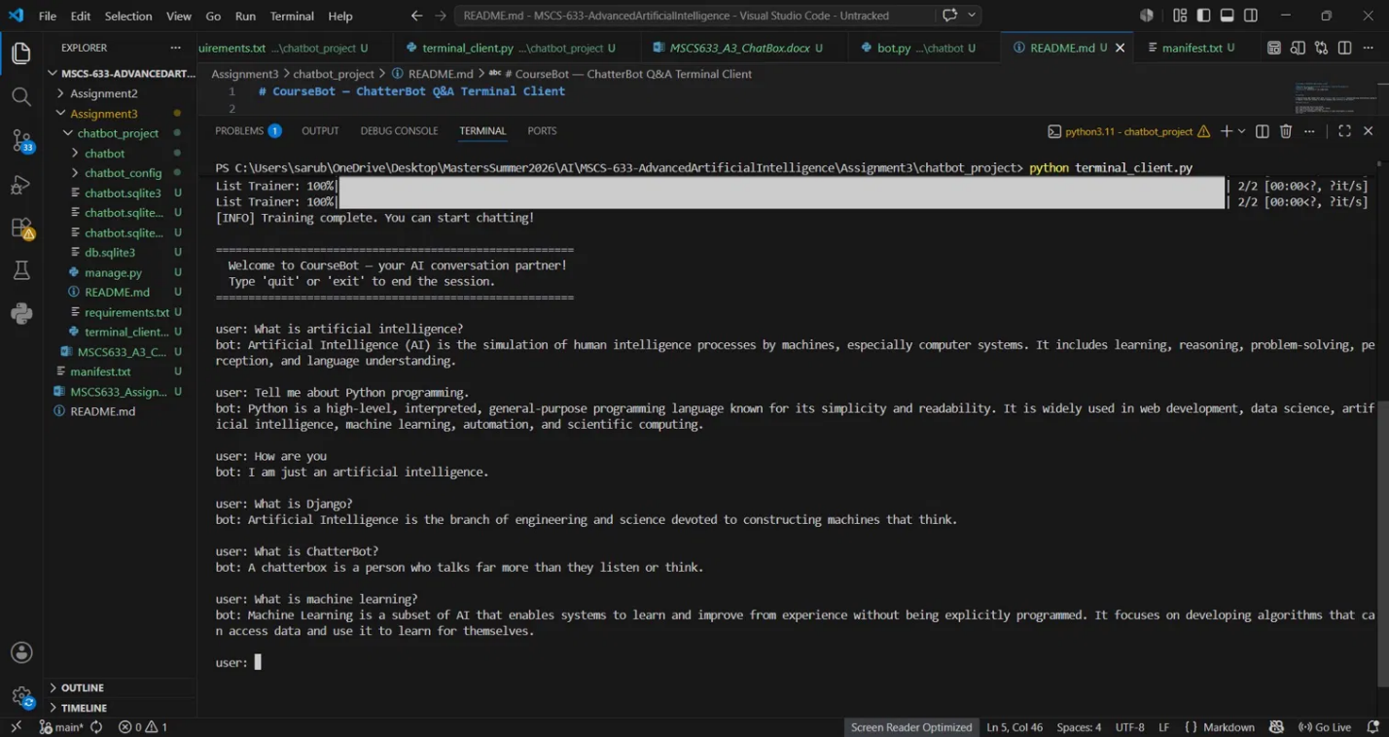
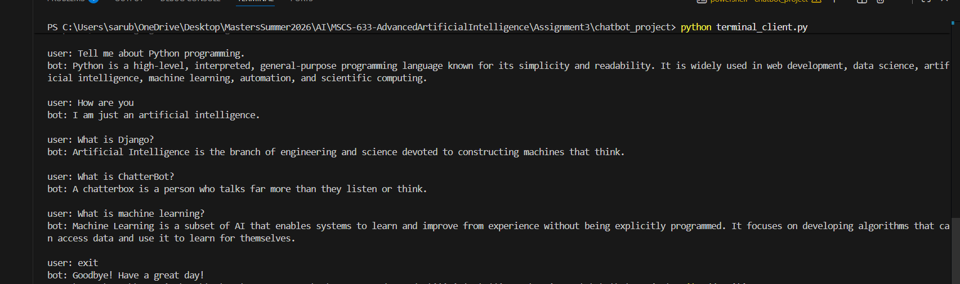
The output demonstrates that the bot correctly identifies greetings, provides factual responses where available in the corpus, and falls back to conversational prompts when confidence is insufficient. The exit command is handled cleanly without error.

Coding Best Practices
The implementation adheres to several widely accepted Python coding standards as outlined by the W3C (n.d.) and PEP 8 style guidelines. Each module includes a module-level docstring describing its purpose, author, and course context. All functions are annotated with Python type hints (e.g., bot_name: str = 'CourseBot' -> ChatBot) and include descriptive docstrings documenting arguments and return values.
Separation of concerns is maintained by isolating ChatterBot logic in bot.py and the user interface in terminal_client.py. Error handling covers EOFError and KeyboardInterrupt to ensure graceful exits. Logging from the ChatterBot library is suppressed during training to keep the terminal output clean and user-friendly. The requirements.txt manifest pins all dependencies with minimum version constraints, enabling fully reproducible installations across environments.

Setup and Installation
The following steps are required to install dependencies and run the chatbot locally. All commands should be executed from the chatbot_project root directory.

# Step 1 — Install all dependencies
pip install -r requirements.txt

# Step 2 — Apply Django database migrations
python manage.py migrate

# Step 3 — Launch the terminal chat client
python terminal_client.py

On first launch, the bot trains against the English corpus, which takes approximately 30 seconds. Subsequent launches reuse the trained SQLite database and start immediately.

GitHub Repository
The complete source code for this assignment, including all project files, is available at the following GitHub repository:
https://github.com/SaruBhandari97/MSCS-633-AdvancedArtificialIntelligence/tree/main/Assignment3
Conclusion
This assignment demonstrated the integration of Django and ChatterBot to build a functional terminal-based Q&A chatbot. The BestMatch logic adapter with a 0.90 confidence threshold produced reliable, contextually appropriate responses during testing. The project structure adheres to Django conventions and Python best practices, ensuring maintainability and readability. Future work could extend the system to include a web-based interface using Django views, custom training data tailored to a specific domain, or more advanced NLP backends such as transformer-based models.

References
Atkinson, G. (2021). ChatterBot: Machine learning, conversational dialog engine for Python [Software]. PyPI. https://pypi.org/project/ChatterBot/
ChatterBot. (n.d.). About ChatterBot. Read the Docs. https://chatterbot.readthedocs.io/en/stable/
ChatterBot. (n.d.). ChatterBot Django integration. Read the Docs. http://chatterbot.readthedocs.io/en/stable/django/index.html
Django Software Foundation. (2024). Django documentation (Version 4.2). https://www.djangoproject.com/
W3C. (n.d.). JavaScript best practices. https://www.w3.org/wiki/JavaScript_best_practices

