Lab 1: Data Visualization, Preprocessing, and Statistical Analysis
Saru Bhandari
University of the Cumberlands
Advanced Big Data and Data Mining (MSCS-634-M20)
May 31, 2026

Step 1: Data Collection

The Superstore Sales dataset was sourced from Kaggle and loaded into a Pandas DataFrame using Python. The dataset contains 9,800 records across 18 columns, capturing retail sales transactions with associated customer, product, geographic, and shipping attributes. The primary numeric variable of interest is Sales, which represents the dollar value of each transaction. The file was read using latin-1 encoding to handle non-standard characters present in the raw CSV.

Dataset Preview

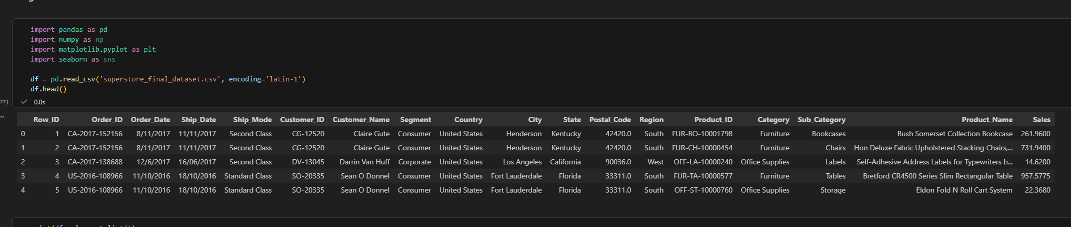
Table 1 presents the first five rows of the dataset as returned by df.head(), confirming successful data ingestion and the structure of the DataFrame.

Step 2: Data Visualization

Six visualizations were created to explore patterns, distributions, trends, and category differences within the Superstore Sales dataset. Each figure is accompanied by a description of the key insight derived from the visualization.

Scatter Plot

Figure 1 presents a scatter plot of Row ID against Sales values. The visualization reveals no meaningful linear relationship between the two variables. Sales are broadly dispersed across all row positions, indicating that transaction order does not predict sale amount. The majority of transactions fall below $2,000, with a small number of high-value outliers visible in the upper range.

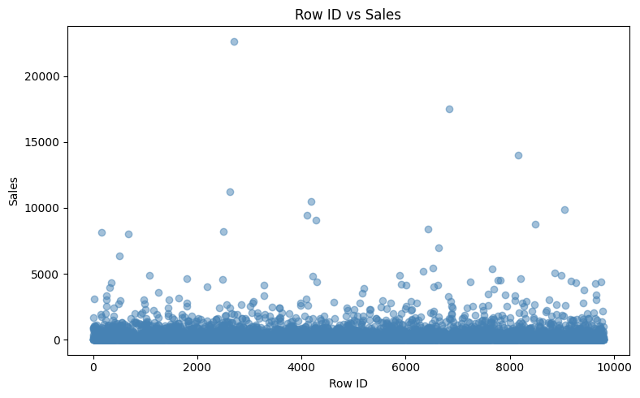

Figure 1 Scatter plot of Row ID versus Sales for the Superstore dataset (N = 9,800).

Bar Chart

Figure 2 displays total sales aggregated by product category. Technology generates the highest cumulative revenue, followed by Furniture and Office Supplies. This finding suggests that technology products are the primary revenue driver in this dataset and may warrant prioritized inventory management and marketing investment.

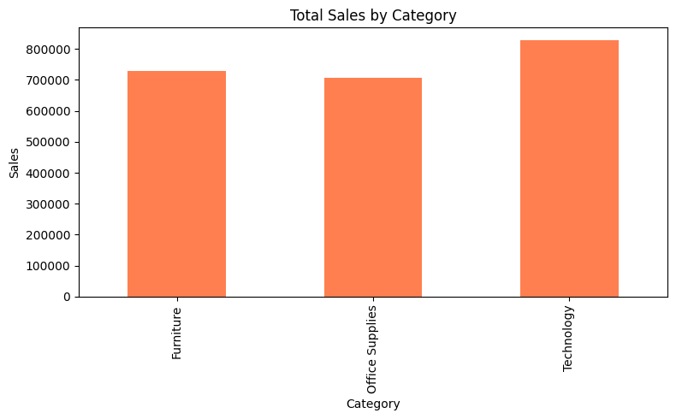

Figure 2 Bar chart of total sales by product category.

Histogram

Figure 3 illustrates the frequency distribution of individual Sales values. The distribution is strongly right-skewed, with the majority of transactions concentrated below $500. The long right tail reflects a small proportion of high-value transactions that significantly elevate the mean relative to the median.

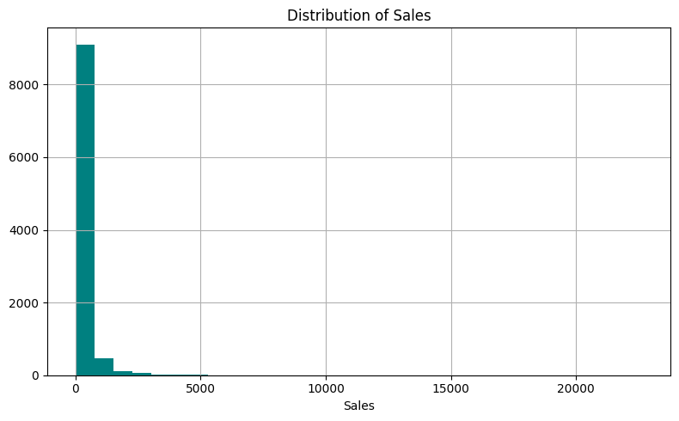

Figure 3 Histogram of Sales distribution (bins = 30).

Box Plot

Figure 4 presents box plots of Sales values segmented by Category. All three categories share a comparable median, but Technology and Furniture exhibit wider interquartile ranges and more extreme outliers than Office Supplies. This pattern confirms that high-value transactions are concentrated in specific product categories.

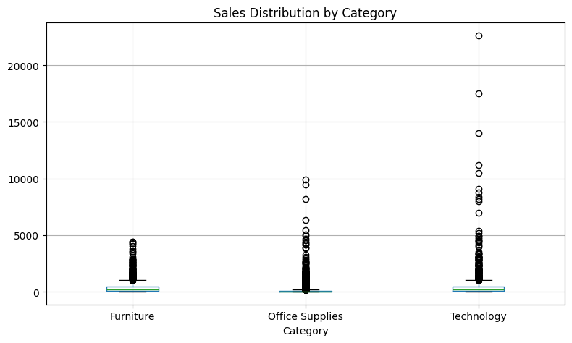

Figure 4 Box plots of Sales distribution by product category.

Pie Chart

Figure 5 represents the proportional contribution of each geographic region to total Sales. The West region contributes the largest share of revenue, followed by the East. The Central and South regions account for comparatively smaller proportions, indicating potential opportunities for geographic expansion or targeted sales strategies.

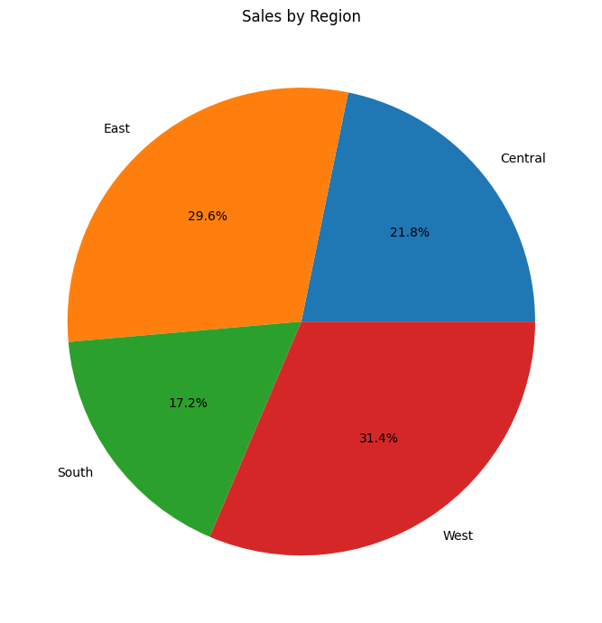

Figure 5 Pie chart of total Sales by region.

Line Plot

Figure 6 visualizes aggregated Sales totals over time by Order Date. The plot reveals periodic fluctuations consistent with seasonal purchasing cycles, alongside an apparent upward trend in more recent periods. These patterns may inform demand forecasting and inventory planning decisions.

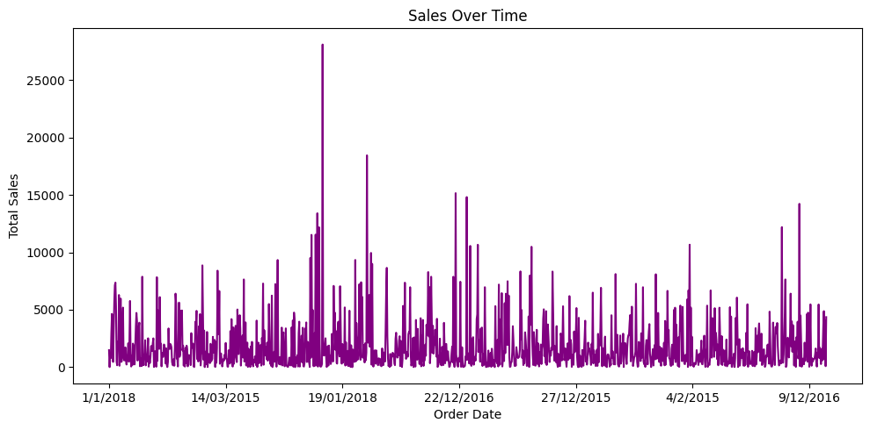

Figure 6 Line plot of total Sales over time by Order Date.

Step 3: Data Preprocessing

Handling Missing Values

The dataset was inspected for missing values prior to preprocessing. Only the Postal_Code column contained missing entries (n = 11). Numeric columns were imputed using column means, and categorical columns were imputed using column modes. The before and after outputs are presented below.

Missing Values — Before Preprocessing

Row_ID 0 Ship_Mode 0
Order_ID 0 Customer_ID 0
Order_Date 0 Customer_Name 0
Ship_Date 0 Segment 0
Country 0 City 0
State 0 Postal_Code 11
Region 0 Product_ID 0
Category 0 Sub_Category 0
Product_Name 0 Sales 0

Missing Values — After Preprocessing

Row_ID 0 Ship_Mode 0
Order_ID 0 Customer_ID 0
Order_Date 0 Customer_Name 0
Ship_Date 0 Segment 0
Country 0 City 0
State 0 Postal_Code 11
Region 0 Product_ID 0
Category 0 Sub_Category 0
Product_Name 0 Sales 0

The 11 missing Postal_Code values were retained, as this column serves as a geographic identifier and is not used in any numerical computation. All other columns were complete both before and after preprocessing.

Outlier Detection and Removal

The Interquartile Range (IQR) method was applied to the Sales column. Observations falling below Q1 − 1.5 × IQR or above Q3 + 1.5 × IQR were classified as outliers and removed from the dataset.

Q1: 17.25
Q3: 210.61
IQR: 193.36

Lower bound: 17.25 - (1.5 x 193.36) = -272.79
Upper bound: 210.61 + (1.5 x 193.36) = 500.65

Outliers identified: 1,145
Shape before outlier removal: (9800, 18)
Shape after outlier removal: (8655, 18)

A total of 1,145 outlier records (11.7% of the dataset) were removed. The cleaned dataset retains 8,655 observations across 18 columns, providing a more representative distribution for subsequent analysis.

Data Reduction

To reduce computational overhead, the cleaned dataset was sampled at 50% using a fixed random seed (random_state = 42). Additionally, the columns Row_ID and Postal_Code were dropped as they are non-analytical identifiers.

Shape before reduction: (8655, 18)
Shape after reduction: (4328, 16)

The reduced dataset retains 4,328 rows across 16 meaningful columns, representing a statistically sufficient sample for the analyses performed in Step 4.

Data Scaling and Discretization

Min-Max Scaling was applied to the Sales column to normalize values to the [0, 1] range. Sales was subsequently discretized into three equal-width bins labeled Low, Medium, and High.

Before scaling: After scaling:
Sales Sales Sales_scaled
59.184 59.184 0.1175
2.920 2.920 0.0047
17.520 17.520 0.0293

Discretization counts:
Low: 3,443
Medium: 602
High: 283

The majority of sampled transactions (79.6%) fall in the Low sales category, consistent with the right-skewed distribution observed in Step 2. Only 6.5% of transactions are classified as High.

Step 4: Statistical Analysis

General Overview

The df.info() method confirmed that the dataset contains 9,800 entries with 18 columns. The only numeric columns with float data types are Postal_Code and Sales; all other variables are stored as integers or strings. The df.describe() output is presented below.

Row_ID Postal_Code Sales
count 9800.000000 9789.000000 9800.000000
mean 4900.500000 55273.322403 230.769059
std 2829.160653 32041.223413 626.651875
min 1.000000 1040.000000 0.444000
25% 2450.750000 23223.000000 17.248000
50% 4900.500000 58103.000000 54.490000
75% 7350.250000 90008.000000 210.605000
max 9800.000000 99301.000000 22638.480000

Central Tendency Measures

Central tendency statistics were computed for the Sales column to characterize the typical transaction value.

Minimum: $0.44
Maximum: $22,638.48
Mean: $230.77
Median: $54.49
Mode: $12.96

The substantial gap between the mean ($230.77) and median ($54.49) is a direct consequence of the right-skewed distribution. The mean is disproportionately inflated by a small number of very high-value transactions. The median provides a more accurate representation of the typical sale in this dataset.

Dispersion Measures

Dispersion statistics quantify the degree of variability in Sales values across the 9,800 transactions.

Range: $22,638.04
Q1: $17.25
Q3: $210.61
IQR: $193.36
Variance: $392,692.57
Std Dev: $626.65

The standard deviation of $626.65 is approximately 2.7 times the mean, indicating extreme dispersion. The wide range of $22,638.04 reflects the presence of several high-value outlier transactions that, while removed from the cleaned dataset, were present in the full 9,800-record dataset used here for statistical reporting.

Correlation Analysis

A Pearson correlation matrix was computed for the available numeric columns (Row_ID and Sales). Figure 7 presents the resulting heatmap.

Row_ID Sales
Row_ID 1.000000 0.001151
Sales 0.001151 1.000000

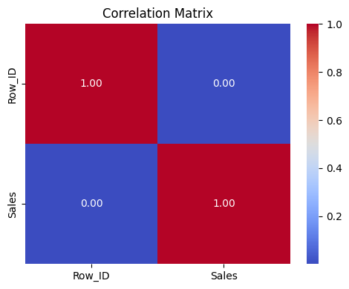

Figure 7 Pearson correlation matrix heatmap for Row_ID and Sales.

The correlation coefficient between Row_ID and Sales is r = 0.001, indicating a negligible linear relationship. This confirms that the order in which transactions were recorded has no meaningful bearing on the dollar value of the sale. The dataset contains only one substantively measurable numeric variable (Sales), limiting the scope of multivariate correlation analysis.

Summary of Key Insights

This lab applied data visualization, preprocessing, and statistical analysis techniques to the Superstore Sales dataset using Python and Jupyter Notebook. The following key findings emerged from the analysis.

Technology is the highest-revenue product category, outperforming Furniture and Office Supplies in total cumulative sales. The West region contributes the greatest geographic share of revenue.

Sales data are strongly right-skewed, with a median of $54.49 and a mean of $230.77. The IQR method identified 1,145 outlier transactions (11.7%), which were removed to produce a cleaner dataset for analysis. Following discretization, 79.6% of sampled transactions fall in the Low sales category, confirming the concentration of transactions at lower price points.

The standard deviation of $626.65 reflects extreme variability in individual transaction values, driven by a small proportion of high-value sales. Correlation analysis confirmed no meaningful linear relationship between transaction order and sale value (r = 0.001), indicating that each sale is effectively independent of its position in the dataset.

These findings demonstrate the value of exploratory data analysis in revealing distributional characteristics and data quality issues prior to modeling or further inferential analysis.

