Advanced Data Mining for Data-Driven Insights and Predictive Modeling
Saru Bhandari
University of the Cumberlands
MSCS-634: Advanced Big Data and Data Mining
Professor: Satish Penmatsa
July 26, 2026

Abstract
This report presents the complete data mining pipeline developed across four project deliverables for MSCS-634. A synthetic retail transactions dataset was cleaned, explored, and used to build regression, classification, clustering, and association rule mining models. Product category emerged as the dominant driver of signal across every technique applied, informing a set of practical business recommendations. The report also addresses ethical considerations related to data privacy, fairness, and bias in the modeling process. Keywords: data mining, regression, classification, clustering, association rule mining, retail analytics

Advanced Data Mining for Data-Driven Insights and Predictive Modeling
Introduction
This report presents the complete data mining pipeline developed over four project deliverables for MSCS-634: Advanced Big Data and Data Mining. The project applies data preprocessing, exploratory data analysis, regression modeling, classification, clustering, and association rule mining to a single retail transactions dataset, following the standard data mining process described by Han et al. (2012), with the goal of demonstrating the full data mining lifecycle end to end and extracting genuinely actionable business insight at each stage.
Rather than treating each deliverable as an isolated exercise, this report emphasizes the throughline that connects them: a single feature, ProductCategory, emerged as the dominant driver of signal across every technique applied — in exploratory analysis, in regression, in classification, and in association rule mining. That consistency across four independent methods is itself one of the project's central findings, and it directly shapes the recommendations in the Practical Recommendations section.
Dataset: Selection and Description
The dataset used throughout this project is a retail transactions dataset comprising 1,038 raw (1,000 after cleaning) individual purchase transactions across 340 customers, with 14 attributes spanning customer demographics (CustomerID, CustomerAge, Gender, State, City), product details (ProductCategory, ProductName), and purchase details (TransactionID, TransactionDate, Quantity, UnitPrice, TotalAmount, PaymentMethod, CustomerSatisfaction).
Rationale for Dataset Selection
- Size and structure. 1,038 records and 14 attributes comfortably exceed the assignment's minimum of 500 records and 8-10 attributes, and mix numeric, categorical, and datetime fields.
- Transactional structure. Each transaction records a CustomerID, ProductCategory, and ProductName, which supports grouping into customer-level baskets for association rule mining.
- Realistic data-quality issues. The dataset was constructed with deliberate missing values, duplicate rows, inconsistent categorical labels (e.g., state name variants), and outliers, providing genuine, documentable cleaning work rather than a dataset that arrives already clean.
- Genuine predictive signal. Category-based pricing bands and an age-to-category preference relationship were built into the data generation process specifically so that regression, classification, and association rule mining would have real, learnable relationships to discover, a design choice disclosed in full in the Ethical Considerations section.
Data Preparation: Cleaning and Exploration
Data Cleaning Steps
- Missing values. CustomerSatisfaction was dropped entirely (approximately 68% missing, too sparse to responsibly impute); CustomerAge (approximately 9% missing) was imputed with the median; Gender (approximately 7% missing) was imputed with the mode.
- Duplicates. Thirty-eight exact duplicate rows (re-exported transactions) were identified and removed.
- Inconsistent data. The State column contained multiple representations of the same state (e.g., “NY”, “New York”, “ny”, “N.Y.”) and was standardized to two-letter USPS codes.
- Noisy data and outliers. A small number of extreme Quantity and UnitPrice values were identified using the interquartile range (IQR) method and capped (winsorized) at the IQR fences rather than removed outright, preserving the rest of each transaction's data; TotalAmount was recomputed afterward to remain internally consistent.
Exploratory Data Analysis: Key Insights
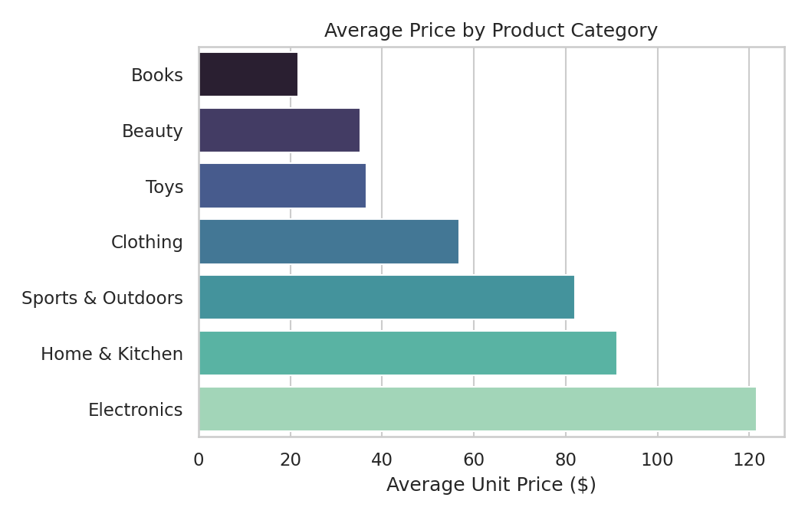
Figure 1 Average Unit Price by Product Category
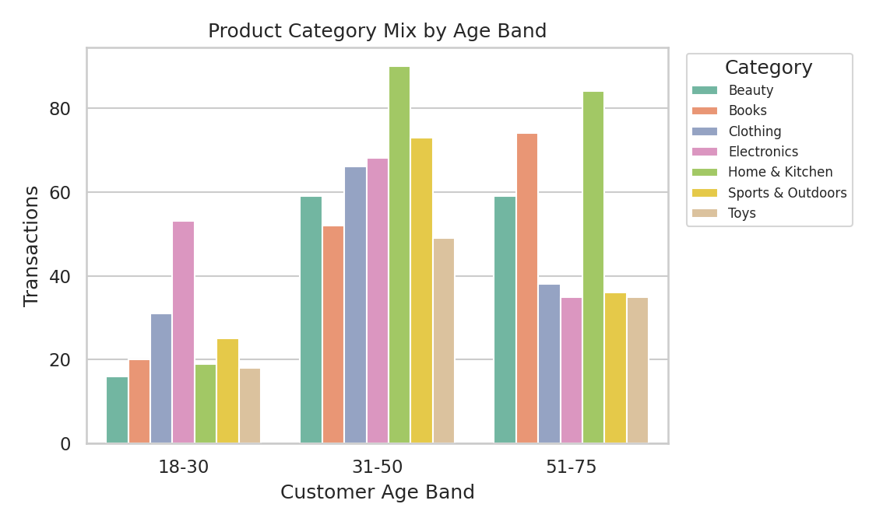
Figure 2 Product Category Mix by Customer Age Band
Figures 1 and 2 summarize the two most important exploratory data analysis (EDA) findings. ProductCategory has a strong relationship with UnitPrice (Electronics and Home & Kitchen command the highest average prices, while Books and Beauty are the lowest), and category preference shifts by customer age (younger customers skew toward Electronics, older customers skew toward Home & Kitchen and Books). Both patterns recur throughout the rest of the project: they explain why ProductCategory turned out to be the strongest predictor in the regression and classification models, and why the association rules cluster around a specific set of categories.
These EDA insights directly guided feature engineering in the regression and classification stages: ProductCategory was one-hot encoded and used as a primary feature in every subsequent model, and Quantity and UnitPrice were deliberately excluded once it was clear they would mechanically determine (leak) the prediction targets derived from TotalAmount. Data preparation and feature engineering followed practices consistent with the pandas library documented by McKinney (2010).
Modeling: Approach and Results
Regression Modeling
The goal of the regression stage was to predict TotalAmount (transaction value) from customer, product-category, and purchase-context features. Quantity and UnitPrice were excluded from the feature set because TotalAmount equals Quantity multiplied by UnitPrice; including them would let a model trivially reconstruct the target rather than learn genuine signal.
Engineered features included Month, DayOfWeek, and IsWeekend (derived from TransactionDate); CustomerTransactionCount (purchase frequency); one-hot encoded ProductCategory, Gender, State, and PaymentMethod; and CustomerAge. Three models, implemented using scikit-learn (Pedregosa et al., 2011), were built and compared using an 80/20 train-test split plus five-fold cross-validation:
Model | Test R² | Test RMSE | CV R² Mean
Linear Regression | 0.130 | $169.84 | 0.153
Ridge Regression | 0.130 | $169.78 | 0.153
Lasso Regression | 0.138 | $169.01 | 0.156

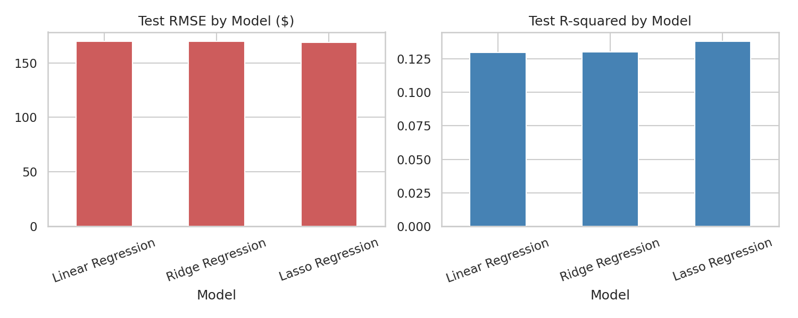
Figure 3 Test RMSE and R² Across the Three Regression Models
Lasso Regression performed best on every metric, though the margin over Linear and Ridge Regression is modest, which is expected given that the feature set is not large or collinear enough for L2 regularization to change much. The modest R² (approximately 0.13 to 0.14) is a deliberate consequence of excluding Quantity and UnitPrice: it reflects genuine signal from category and context features rather than an inflated, leaked score.
Classification
The goal of the classification stage was to predict whether a transaction is “High Value” (TotalAmount above the dataset median of $153.90), using the same engineered features as the regression task. Three models were built: Decision Tree, k-Nearest Neighbors, and Naive Bayes, with hyperparameter tuning applied to the Decision Tree via GridSearchCV (five-fold cross-validation) over max_depth, min_samples_split, and min_samples_leaf.
Model | Accuracy | F1 Score | ROC AUC
Decision Tree (default) | 0.490 | 0.505 | 0.490
Decision Tree (tuned) | 0.575 | 0.569 | 0.639
k-Nearest Neighbors | 0.595 | 0.609 | 0.634
Naive Bayes | 0.595 | 0.640 | 0.678

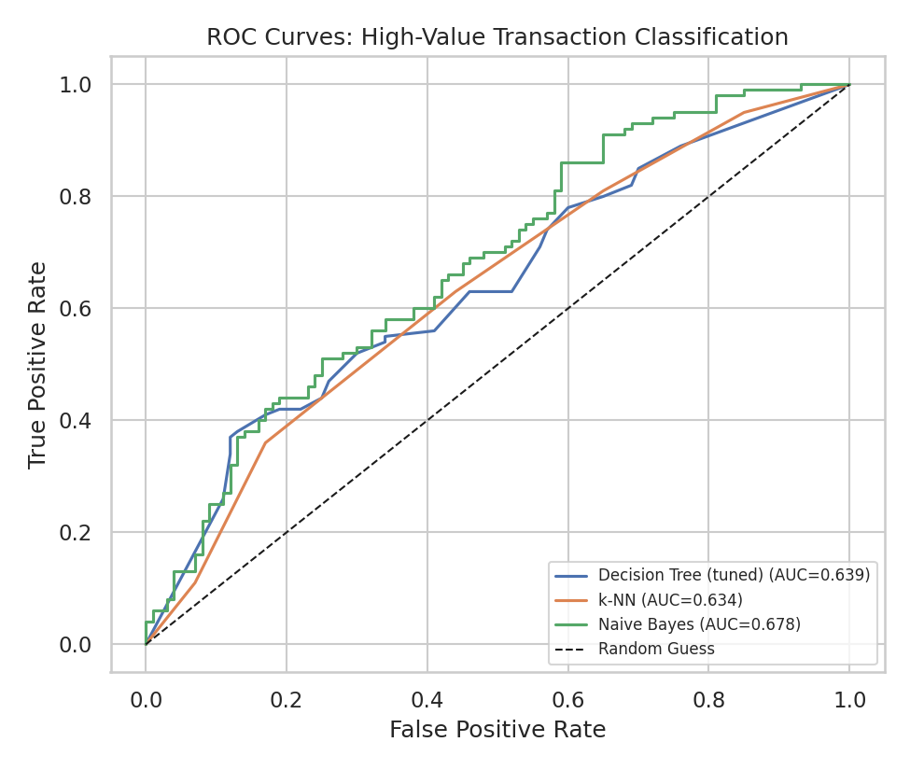
Figure 4 ROC Curves for the Tuned Classification Models
Naive Bayes was the best-performing model overall. Hyperparameter tuning substantially improved the Decision Tree: accuracy rose from 0.490 (barely above chance, indicating the default tree was overfitting) to 0.575, and the area under the receiver operating characteristic curve (AUC) rose from 0.490 to 0.639, driven by the grid search settling on a shallower, more regularized tree (max_depth = 10, min_samples_leaf = 4, min_samples_split = 10). All tuned or otherwise appropriate models sit clearly above the random-guess line, confirming real, if moderate, predictive signal.
Clustering
The goal of the clustering stage was to segment customers, rather than transactions, into behavioral groups using K-means, based on aggregated features: average transaction amount, total spend, transaction count, average quantity, age, and number of unique categories purchased. The number of clusters was chosen using the elbow method together with the silhouette score, which selected k = 2.
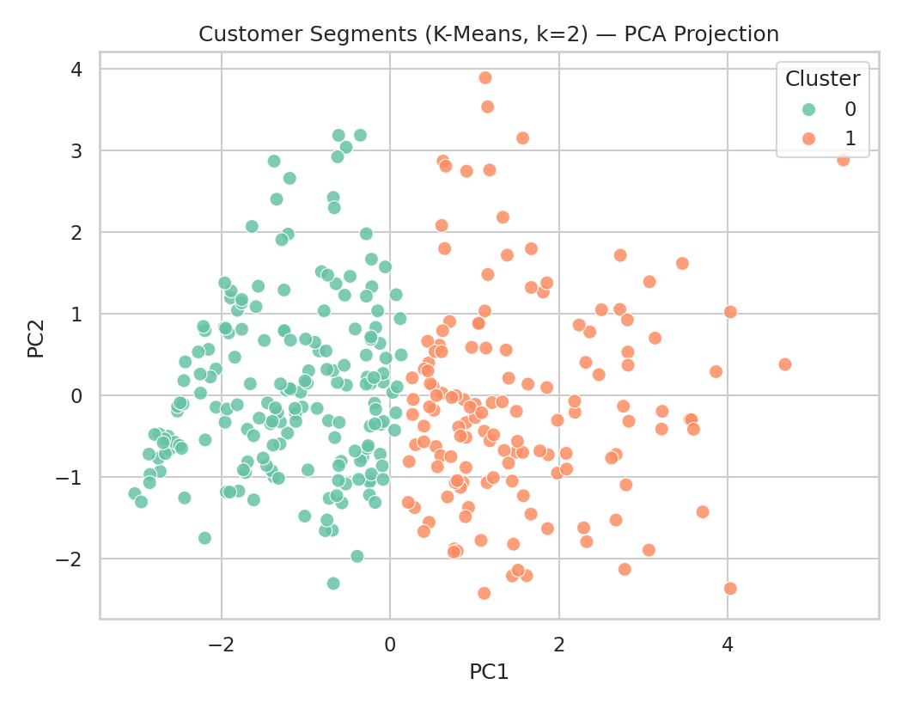
Figure 5 Customer Segments Visualized via Principal Component Analysis Projection
Cluster | Customers | Avg Transaction | Total Spend | Transactions | Unique Categories
0 — Casual / single-category | 184 | $169.5 | $341.3 | 2.1 | 1.8
1 — High-value / diverse-category | 142 | $272.5 | $1,122.3 | 4.4 | 3.4

Customer age is nearly identical across both clusters (approximately 45 to 46 years on average), meaning spend and engagement level, not age, are what separate the segments. This is a more actionable and less demographically sensitive basis for targeting than age- or gender-based segmentation would be.
Association Rule Mining
The goal of the pattern mining stage was to identify which product categories tend to be purchased together by the same customer, using the Apriori algorithm implemented in the mlxtend library (Raschka, 2018). Each customer's full set of purchased product categories was treated as one basket. Apriori was applied with a minimum support of 0.05, followed by association rule generation with a minimum lift threshold of 1.0.
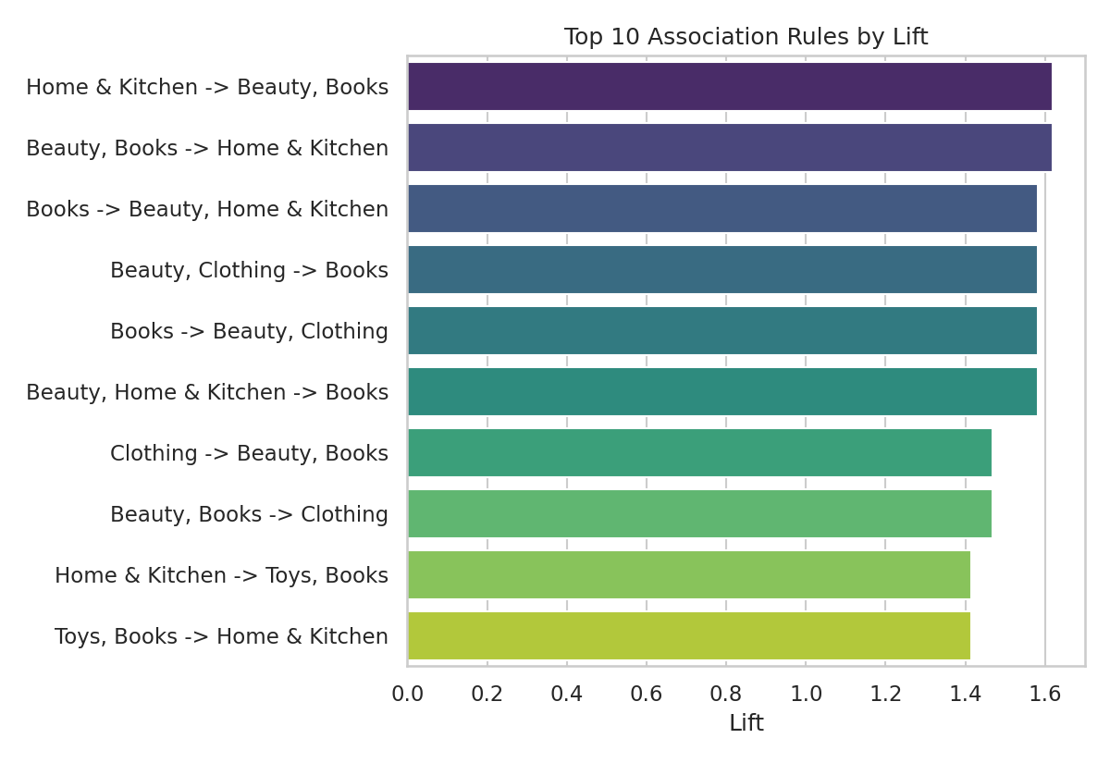
Figure 6 Top Ten Association Rules Ranked by Lift
Fifty-four association rules were found in total. The strongest rules by lift center on Home & Kitchen, Beauty, Books, and Clothing; for example, customers who purchase from both Beauty and Books are notably more likely than average to also purchase Home & Kitchen (lift ≈ 1.62). These category combinations are concrete candidates for cross-category bundling and “customers also bought” recommendations.
Cross-Technique Insights
- ProductCategory is the consistent driver of signal. It is the strongest predictor in the regression model, the dominant feature in the classification models, the basis of the strongest association rules, and the variable most strongly related to price in the EDA. Four independent techniques converging on the same variable is strong evidence that category-level strategy (pricing, promotions, merchandising) is where this business would see the most value from data-driven decisions.
- Model performance is modest but genuine throughout. An R² around 0.13 to 0.14 and classification accuracy around 0.58 to 0.60 reflect an honest modeling choice: excluding Quantity and UnitPrice from the feature set to avoid leaking the prediction targets. The alternative, including them, would have produced near-perfect but meaningless scores.
- Clustering revealed a behavioral, not demographic, segmentation. Customer segments differ by spend and engagement, not by age, suggesting that behavior-based targeting will be more effective and less prone to demographic bias than age- or gender-based targeting.
- Association rules connect directly to the customer segments. The high-value, diverse-category cluster from the clustering analysis is precisely the group most likely to be affected by the cross-category association rules, tying the clustering and pattern-mining results together into one coherent customer-targeting story.
Practical Recommendations
- Prioritize category-level pricing and merchandising strategy. Since ProductCategory is the strongest predictor across every technique, category-level decisions will have more business impact than customer-demographic-level personalization.
- Launch a two-tier loyalty program aligned with the K-means segments. Prioritize the high-value, diverse-category cluster (142 customers, approximately $1,122 average total spend) for a loyalty tier, and target the casual, single-category cluster (184 customers) with re-engagement offers and cross-category discovery incentives.
- Use the classification model to flag likely high-value transactions in real time. Even at modest accuracy (approximately 0.60), the Naive Bayes model provides a usable signal for prioritizing customer service attention or real-time offer targeting.
- Act on the strongest association rules with cross-category bundling. Test bundle or “frequently bought together” promotions starting with the highest-lift category pairs (Home & Kitchen, Beauty, Books).
- Treat all model outputs as directional, not deterministic. Given the modest R² and accuracy figures throughout, these models should support human decision-making rather than fully automate decisions such as denying a discount based on a low-value prediction.
Ethical Considerations
Data Privacy
The dataset used in this project is synthetically generated specifically for this coursework and contains no real customer information, so there is no re-identification risk in this project as submitted. In a real-world deployment of this pipeline, customer age, gender, state, and purchase history would constitute personal data requiring consent for use, data minimization, secure storage, a defined retention period, and access controls on any customer-level model outputs such as cluster assignment or high-value predictions.
Fairness and Bias
The classification and clustering models use Gender, CustomerAge, and State as predictive features. In a real deployment, this raises a fairness question: if high-value customer predictions or loyalty-tier assignments systematically favor or disadvantage a demographic group, that could translate into inequitable treatment, such as differential promotional offers by age or region. Before any real-world use, model outcomes should be audited by demographic subgroup, not just in aggregate, to check for disparate impact.
Bias Introduced by the Synthetic Data Design
Because this dataset was constructed with an explicit age-to-category-preference rule to give the models genuine signal to learn from, the classification and clustering results partly reflect a pattern the data was designed to contain, rather than an independently discovered fact about real customers. This is a disclosed and appropriate design choice for a coursework dataset, but it underscores a general risk in applied data mining: models are only as fair and accurate as the data-generating process behind them. A real deployment would need to validate that any observed age-category or gender-spending relationship reflects genuine customer behavior rather than an artifact of how the training data was collected.
Association Rule Mining and Profiling Risk
Market-basket rules are generally lower risk than individual-level predictions, since they describe aggregate co-purchase patterns rather than predictions about a specific person. Even so, using them to target individual customers (e.g., marketing Home & Kitchen to a customer because they bought Beauty) edges toward individual profiling and should follow the same consent and transparency principles as any other targeted marketing.
Steps Taken in This Project
- Used a fully synthetic dataset with no real personal information.
- Excluded Quantity and UnitPrice from predictive features specifically to avoid a misleadingly inflated (leaked) model that would misrepresent true predictive power.
- Reported all model metrics honestly, including modest R² and accuracy figures, rather than selectively presenting only favorable results.
- Explicitly flagged the synthetic data's built-in age-category relationship as a disclosed limitation rather than presenting it as an organic discovery.
Key Takeaways and Future Improvements
Key Takeaways
- A single retail transactions dataset can support a full data mining pipeline, including regression, classification, clustering, and association rule mining, with each technique surfacing a consistent, mutually reinforcing story centered on ProductCategory.
- Deliberately excluding features that would leak the target produced more honest, lower R² and accuracy numbers than an unconstrained model would, and that honesty was itself a key insight rather than a shortcoming.
- Customer segmentation revealed that spend and engagement, not age or gender, are what separate customer groups in this dataset, a more actionable and less demographically sensitive basis for targeting.
Future Improvements
- Incorporate real transaction data, with appropriate privacy safeguards, to validate whether the patterns found here generalize beyond this synthetic dataset.
- Add time-series and seasonality modeling to support actual demand forecasting.
- Try ensemble methods, such as random forest or gradient boosting, for both the regression and classification tasks.
- Extend the clustering analysis with more customer-level behavioral features (e.g., time between purchases, return rate, channel preference) to find more nuanced segments.
- Run fairness audits by demographic subgroup before any real-world deployment of the classification or clustering models.

References
Han, J., Kamber, M., & Pei, J. (2012). Data mining: Concepts and techniques (3rd ed.). Morgan Kaufmann.
McKinney, W. (2010). Data structures for statistical computing in Python. In S. van der Walt & J. Millman (Eds.), Proceedings of the 9th Python in Science Conference (pp. 56–61).
Pedregosa, F., Varoquaux, G., Gramfort, A., Michel, V., Thirion, B., Grisel, O., Blondel, M., Prettenhofer, P., Weiss, R., Dubourg, V., Vanderplas, J., Passos, A., Cournapeau, D., Brucher, M., Perrot, M., & Duchesnay, E. (2011). Scikit-learn: Machine learning in Python. Journal of Machine Learning Research, 12, 2825–2830.
Raschka, S. (2018). MLxtend: Providing machine learning and data science utilities and extensions to Python's scientific computing stack. Journal of Open Source Software, 3(24), Article 638. https://doi.org/10.21105/joss.00638
Waskom, M. L. (2021). Seaborn: Statistical data visualization. Journal of Open Source Software, 6(60), Article 3021. https://doi.org/10.21105/joss.03021

