# Sanctuary

At the end of the first level hero acquires an artifact/power source that Sophon can use to create the sanctuary. The sanctuary is a self-contained universe, the size of a house, that sophon can access and transport hero to at any time. It’s a safe haven for hero where inventory and the machine can be kept, built, armour can be fashioned here skills learned or allocated etc.

## The Creation

The sanctuary is created by a big bang generated by Sophons access to a power source found at the end of level 1.

Our hero and Sophon disappear at the climax of an intense stand off they would definitely lose. They are outnumbered and are being ambushed. As a last resort and ultimate escape method Sophon triggers the Sanctuary creation.

The screen goes blank and then the iconic big bang. For a few seconds just colours originating from the central bang and then Sophon appears, shooting around the screen, shaping things into the tiny universe that will become the sanctuary. Making straight lines, collecting the energy and shaping it into whatever shapes the sanctuary will contain.

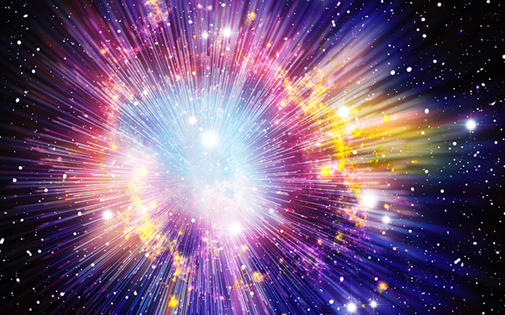

Then Sophon creates a portal that shoots out our hero into the safety of the sanctuary.

**Sophon**: “And on the 6th day He created Man”

**Hero**: “What?”

**Sophon**: “Nothing.....”

**Hero**: “Where are we?”

**Sophon**: “I was able to harness the massive amounts of energy in the *blah* and create this place. It’s a mini universe, the size of a house. I hope you like it....”

**Hero**: “You saved me Sophon.... thanks. So this is a new universe? Outside the space/time continuum of our universe?”

**Sophon**: “Correct. This is not new technology. 4th dimensioners have been able to create mini universes for some time.

**Hero**: “Yeah, good thinking. This will be a nice place to come up with a plan.”

**Sophon**: “Yes, here we’re guaranteed safety as we are the only beings able to access this place.... that we currently know of”

**Hero**: “Ok, lets assume universe hopping beings won’t bother with our little house universe. So, what’s the plan? We need to return to the 4th.”

**Sophon**: “This is beyond my abilities at this time. But I do have an idea. I can access blueprints for a dimension transition machine.”

**Hero**: “oooo yes. One of the dimension bubble makers. Can we make it? Do we have everything we need?”

**Sophon**: “No. Unfortunately it requires technology native to the 4th. Lower dimensional beings would have no chance of having something similar”

**Hero**: “hmmmm..... Can you visualise the anomaly that stranded us here? It was a large event....”

*Some sort of visualitisation of the event is displayed for hero and the player*

**Hero**: “Ok good.... can you trace our trajectory through space time? And now can you trace any other trajectories from the same originating point? We can’t be the only 2 things sent flying. It was a pretty big op”

**Sophon**: “My ability to do so at this time is limited but I may be able to identify some... I have been able to identify the following trajectories in the space time fabric from the same origin point. Are you thinking these events may contain useable materials? ”

**Hero**: “Exactly. At the very least something usable or someone who needs our help... Ok, can you get us there?”

Sophon: “I can. The events have created small anomalies that will let us travel without huge energy consumption. When you’re ready, pick a location on the map”

**END OF DIALOGUE**

## The Dimension Transition Machine

### Whats the machine?

The Dimension Transition Machine (DTM) is the machine that hero and Sophon need to create to return home to the 4th dimension. It’s the ultimate goal of the game. Once the machine is built hero can return and the game ends.

The machine needs to be made in the sanctuary dimension, a safe and secure place.

### How many parts?

The head, the mixer, the air generator, power supply, the bubble mix.

### Stages of completion

To make things interesting for the hero, the abilities of the machine should be made available to the hero in stages. As the machine is built the hero will be able to use the machine, via sophon, in a limited fashion.

* 3rd dimension transportation. The hero is able to move between 2d and 3d via an existing temporal rift. Sophon cannot perform this alone because of the power requirements but can make use of existing rifts to transport from 2D to 3D. In later levels Sophon will gain the ability to do the shift at will but it will be in a controlled environment.
* Temporal rift transportation. Sophon is able to transport to any temporal rift from any location. This will be an early stage ability for use with check pointing and to allow hero to move around the map to save travel time
* Limited position transportation. Without a temporal rift, hero can do a sudden position jump, disappear and reappear several metres away. It’ll be a fun movement ability and a requirement for some level advancement.
* Time transportation. This ability will be required to reach certain levels. E.g. the dinosaur level. AWESOME!!!

## Sanctuary facilities

### Space time map

The space time map is able to show the hero places of interest in the space time fabric relative to the original event that sent the hero and Sophon into the lower dimensions. It needs to be explained that tracking only these events is possible because the fabric is too large and data intensive. Or maybe it doesn’t need to be explained. Keep it simple.

Using the map the hero can travel to these locations.

### Engineering Lab

A place where hybrid equipment can be created for clothing, armour etc. Also weapons and new extensions of Sophon which manifest as floating orbs. Or maybe we can handle that in game...

### The DTM site

The place where the machine is built. As each new part is found and used, the machine will gradually grow and grant hero and sophon abilities in stages

The sanctuary is where the abilities are learned and/or allocated. TBD