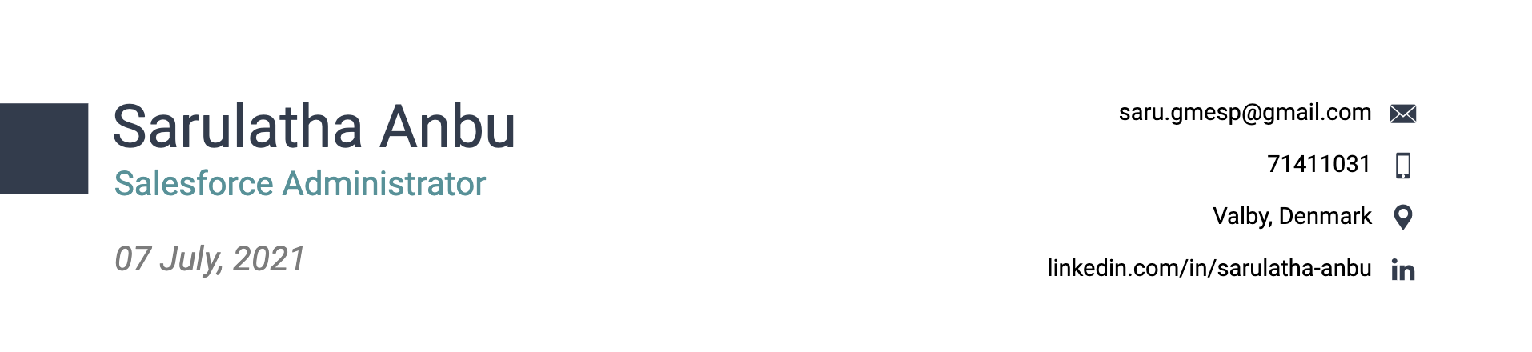

Dear Hiring Manager,

This is to express my interest in “Salesforce Administrator” position that you have advertised on LinkedIn. Given my hands-on experience and excellent qualifications, I would appreciate your consideration for this job.

I am doing my internship at VMware Inc. working as Salesforce Administrator for the past 6 months. I have experience with more than 80 users. I have all the necessary knowledge to configure and manage the system , its objects and reports to satisfy the needs of the company. I managed Salesforce clients and users and also gathered the necessary account requirements to successfully strategies and plan projects, then implement those plans to meet organisational needs.

Over the course of my career as Coordinator for Comet Softwares, I coordinate all aspects of 5+ process improvement projects, this includes providing administrative support to the project manager, organising workflows, budgets, and ensuring compliance with regulatory requirements. My professional experience includes bringing the wireframes of the UX designer to life through HTML5 and CSS3, as well as collaborating with Back End Developers to create a stellar finished product. In my work experience, I learned that strong communication and teamwork are just as crucial as fundamental technical knowledge.

On top of my experience, I am a Certified Salesforce Administrator offering a degree in Bachelor of Engineering in Information Technology. As an accomplished professional with more than 3 years of experience, I possess a breadth of knowledge and talents that will allow me to contribute toward your success through this role.

Thank you for your time and consideration, and I look forward to discussing this position with you further.

Sincerely,

Sarulatha Anbu