3D Shape Editor

Overview
A FSF 3D Shape is a description of what an object looks like in the Virtual World of the simulation. The FSF Shape Editor is a tool for creating and modifying FSF 3D shapes; it is similar in operation to most 3D CAD packages. Please note that the FSF Shape Editor always operates in the 3D co-ordinate system.

BASICS
Co-ordinate Systems
A basic understanding of the 3D co-ordinate system used in FSF is essential. All the points in FSF shapes are defined using an isometric projection (i.e. a scaled rendering of a 3D object in 2D) as outlined in the diagram below:

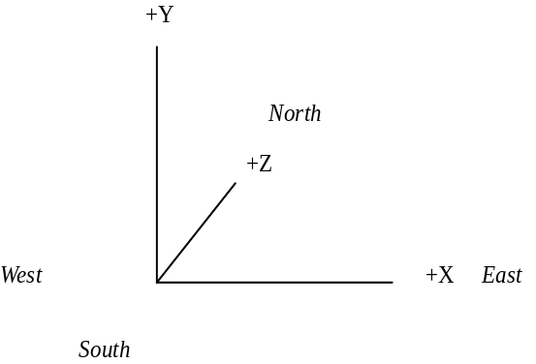

The orientation of the co-ordinate system in the World is shown above, the Z axis runs South-North and the X axis runs East-West. Up is positive Y and down is negative Y. The origin is normally at the centre of the 3D shape (although as we shall see later that is up to you).

The smallest unit in the FSF Virtual World is 1/2 mm, 3D shapes are limited to a maximum of +/- 500M.

Shape Structure
At its most basic level a shape is described in terms of flat surfaces called polygons. A polygon consists of a number of points (3D co-ordinates) at its corners (or vertices) and a base colour. In the FSF Virtual World a lighting model is applied to all objects, the base colours are modified by the amount of light falling on the polygon (from the sun).

The FSF Shape Editor can be used to edit 3D objects at this level, by entering individual polygons as a set of 3D co-ordinates and adjusting the co-ordinates individually. However for a complex shape this is a very time consuming task so the FSF Shape Editor can operate on a higher level structure called a Group.

A Group is a collection of polygons grouped together for editing purposes. So for example one could group together 6 polygons to create a cube, this cube would then be considered as a single object for editing purposes. Groups are used for the convenience of editing only, when the 3D shape is read into the FSF Virtual World the group structure is discarded and the shape is drawn as a collection of polygons.

Polygon definition
A shape is a 3-dimensional structure composed of flat coloured surfaces called polygons. A polygon has a number of points and each point is at a corner or vertex. For example a box has 8 points and 6 polygons. Each polygon in the box has 4 vertices.

Constructing a polygon
A polygon must be flat or it will seem distorted when you view it from some directions. This means that all the points in a polygon must lie in the same plane. For complex shapes you should remember that a triangle is always flat, so it is often easier to use polygons with 3 points.

A polygon has 2 sides, when part of a shape it has an inside and an outside. Usually you only want to see the outside of shapes so you have to define which side of each polygon is the outside. You do this when you create a polygon by joining up points. The front of the polygon is the side created by joining the points in a clockwise direction. If you get this wrong the FSF Shape Editor allows you to flip the orientation of any polygon. A polygon will only be drawn in the simulation if its points are linked in a clockwise direction.

Constructing solid shapes
As indicated above, all solid shapes are comprised of polygons. But it's worth remembering that the Shape Editor gives you access to two shortcuts for producing regular solids:

1. Refer to the three solid entry buttons in the Toolbox (Cuboid - 6-sided solid), Penta (5-sided solid) and Tetra (4 sided solid). These tools work by you placing the points for the base of the solid on the editing grid and the editor automatically extruding the base polygon into a solid shape (the orientation of all the polygons is automatically taken into account by the editor). You can then transfer and group these basic solids together to form complex shapes.

2. A general form of extrusion is available under the advanced menu functions which allows you to select any polygon in your shape and extrude it isometrically (or to a point). You can also control the degree of extrusion. The creation of a complex shape such as an aircraft body becomes just a matter of entering a 6-sided polygon for the cross section of the fuselage and then extruding it by the length of the aircraft!

Polygon construction vs the speed at which the simulation runs
Frame speed is important in a simulator. Speed is measured by the number of screen updates per second. Anything less than about 10 will make the simulation appear jerky and controlling the aircraft more difficult. Your simulation will run faster when it is drawing as few polygons as possible. To help keep the frame rate up shapes in the distance should be drawn with fewer polygons than when they are close. An example of this is an aircraft shape. When close it may have more than 100 polygons, when in the middle distance it may have fewer than 50, and in the far distance 5 lines is usually enough.

Shape Detail
In the FSF Virtual World 3D shapes will be seen from a range of distances. When the 3D shape is close to the viewer a more detailed 3D shape is shown and conversely at a distance a simple lower level model is portrayed. The shape structure supports the definition of shapes at different levels of detail for ranges of viewing distance. The FSF Shape editor allows you to create and edit 3D shapes at a range of levels of detail.

A typical shape will have 3 levels of detail. It is easier to create the most complex level (the bottom level) first and then to create a new level - using the New Child menu option. Copy the complex shape level to the new level (using Copy & Paste menu options) and remove the high detail (i.e. the smallest polygons) from it. Repeat this operation until the number of levels required have been created. But note that it is important to have the centre of each shape level in the same place. Otherwise, when the shape is reproduced in the simulator, it will appear to jump as one level replaces another as you approach the shape.

Shapes of different sizes
The FSF Shape Editor enables you to edit shapes of very different sizes. When you first open a FSF Shape Editor window it shows a default view of 20 Meters across. The largest shape you can create is 1Km. For smaller shapes, zoom in until your shape fills the window. If you're in any doubt and want to check how large a shape is, refer to the grid lines.

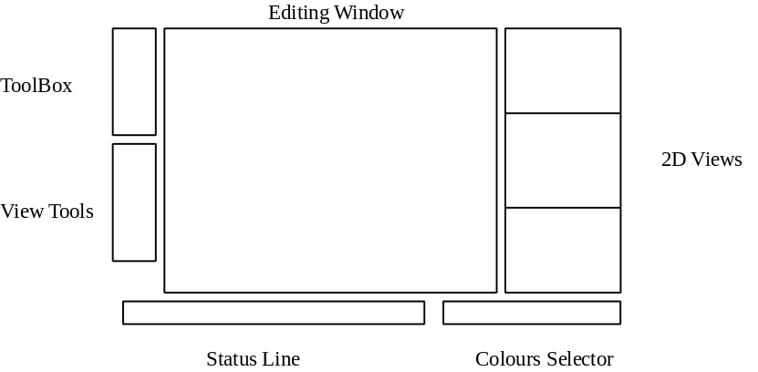

Editing Window
The editing window shows a 3D representation of the shape, it also shows the editing grid in 3D. All editing is done in this window.

2D views
The 2D view windows show the shape in profile view (from the side), plan view (from the top) and elevation view (from the back). The position of the editing grid is also shown in these windows.

ToolBox
The ToolBox is used to select the current editing tool. The current tool button is shown as depressed.

View Tools
The view tool controls the way the shape and editing grid are shown in the editing window.

Status Line (bottom left)
This shows the current editing grid offset from the origin, the position of the mouse in 3D (if it is in the editing window) and the function of the current tool/button.

Colour Selector (bottom right)
Shows and allows selection of the available base shape colours.

The Shape Window
The Shape Grid
All editing operations in the 3D shape tool operate with reference to the editing grid. The grid is always locked to one of the 3 cardinal axis, it is shown in the edit window as a grey grid in the 3D editing space. The grid can be locked to each of the 3 axis using the buttons at the bottom of the view tools box. The grid can also be moved up and down the axis using the +/- buttons.
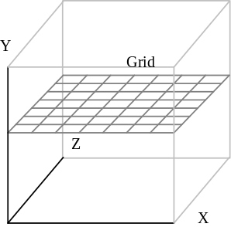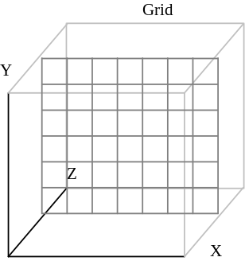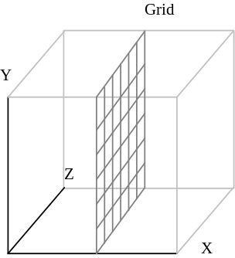

The grid is used for 3 primary purposes:

1 - to enter 3D co-ordinates
2 - as a reference plane when moving groups
3 - the size of the grid is used to determine the size of solids when created.

The grid is initially set to one meter but it can be changed (using the Grid menu items) to anywhere from 1 cm to 10M.

Entering co-ordinates
Co-ordinates are used to specify the vertices (in 3D) of polygons when creating polygons and solids, and also to specify the destination of a paste operation. The co-ordinate is specified by clicking on the grid in the edit window with the mouse; the position of the mouse pointer on the grid supplies two of the 3D co-ordinates and the position of the grid itself supplies the remaining co-ordinate.

Moving Groups/Polygons/Points
Groups/Polygons/Points can be moved in the current edit plane (i.e. two of the three dimensions), moving is accomplished by dragging the object to its new position (select the object tab, hold the mouse button down and move the mouse).

Automatic movement of the edit grid
The edit grid is automatically moved to a selected point or polygon when that selection is made.

Toolbox
The toolbox contains twelve tools. Only one tool is active at any one time. The active tool is indicated by its button icon being depressed.

Selection functions
All these selection functions operate on existing shape structures:

Select Group
This is the default editing tool, it is used to select a group for further editing. To select a group when in this mode click on the centre of the group in the editing window with the left mouse button. The selected group will be displayed in red, a small rectangular tab will also be displayed at the centre of the group, this is used for moving the group. When you have selected a group you can perform the functions under the main menu Group item on the selected group or move the group by dragging (see more later).

Multiple group selection is made by holding the shift key down, at the same time as making the group selection. A multiple group selection can be amalgamated to make one group (for moving, transforming or copying) using the Group>Group menu item.

Select New Polygon
Click on the polygon you want so select in the edit window with the left button. When you have selected a polygon you can perform the functions under the main menu Polygon item on the selected polygon or move the polygon by dragging.

Select Point
Click on the point you want to select in the edit window with the left button. When you have selected a point the only function you can perform is to move it by dragging.

Undo
This item undoes the last operation.

Creation functions
These all create new groups in the shape, the cursor will change to crosshairs when in the edit window to show you that you are in a creation mode.

The following four functions create a group containing a single sided polygon:

Enter Line
Click on the start and end points of the line. You will be returned to select group.

Enter Triangle
Click on the first, second and last points to define the triangle, this will create a single sided polygon. You will be returned to select group.

Enter Square
Click on four points in the edit window grid to define the polygon with the left button. You will be returned to select group.

Enter Polygon
A general polygon may have 2, 3, 4, 5, 6, 7 or 8 points. To create it click on the edit window grid to enter the initial points with the left button and with the right button to enter the last point. You will be returned to select group.

The following three functions create a group containing a number of polygons.

Enter Cuboid
A cuboid is a six sided 3D solid, it is defined by entering the base polygon containing four points in the same manner as entering a square, the base polygon is then automatically extruded, by the size of the grid, to meet an identical top polygon creating a 3D cuboid, you can then use the group menu tool to change its shape.

Enter Penta
A penta or wedge is a five sided 3D solid, it is defined by entering the base polygon containing four points in the same manner as entering a square, the base polygon is then automatically extruded to a ridge by the size of the grid to create a 3D solid, you can then use the group menu tool to change its shape.

Enter Tetra
A tetra or pyramid is a five sided 3D solid, it is defined by entering the base polygon containing four points in the same manner as entering a square, the base polygon is then automatically extruded to a point by the size of the grid to create a 3D solid, you can then use the group menu tool to change its shape.

Paste Group
This function is used in conjunction with the main menu Edit items (Cut, Copy...) and is described in detail in a later section.

View Buttons
There are 16 view control buttons. Clicking on a view button with the left mouse button will control the way the shape and edit grid are displayed in the main window. Holding shift down whilst clicking on the view buttons may modify the effect of the button - known as shifting the control.

Zoom In
Zoom In magnifies the edit window by a factor of two, the zoom is centred about the origin. The zoom function can be modified by holding down the shift key at the same time as clicking on the zoom icon, this will result in the zoom being centred about the currently selected group.

Zoom Out
Zoom Out shrinks the edit window by a factor of two, the zoom is centred about the origin. As with Zoom In the shift key modifies the action. Use the shift button and double click on the control button to keep the selected group, or polygon, or point centred.

Elevation ZX Top view
This tool selects the plan or top view in the edit window so the grid is automatically moved to the ZX plane.

Elevation XY Front view
This tool selects the front view in the edit window so the grid is automatically moved to the XY plane.

Elevation ZY Side view
This tool selects the side view in the edit window so the grid is automatically moved to the ZY plane.

XYZ 3D view
This tool selects a 3D view in the edit window so the grid is not moved.

The next three buttons rotate the view in the edit window about the X, Y and Z axis, clicking on the appropriate button rotates the view about the shape axis by +10 degrees, modifying the button click by holding down the shift key reverses the direction of rotation. The edit window view can also be rotated by clicking in the edit window itself with the right button, clicking towards the right side of the window pushes the shape in that direction, ditto with the left, top and bottom of the window - this provides an intuitive method of rotating the shape.

The next three buttons select the edit plan for the ZX, YX and YZ axes respectively.

The final 3 buttons select the orientation of the grid, the current orientation is shown by the appropriate button being depressed.

The +/- buttons
These move the grid incrementally up and down the axis to which it is locked.
The n button
This opens a Set Grid Offset dialog box which allows the user to enter a value in Meters to move the grid to the level specified. When clicking, use Shift to set the default value shown in the dialog box at 0.

The solid button
This opens a 3D solid view window, if the solid viewer window is already open clicking on this button refreshes the solid window.

Colour window
The shape colour window shows the available base colours for shapes. It is used for colouring shapes and showing the colour of existing polygons. You can create both polygons and solids by using the colour on the far left of the colours window by default. There are two ways of colouring parts of a shape:

1. In Select Group mode, select the group you wish to colour and then select the required colour patch in the colour window. This will then colour every polygon in the group the same colour.
2. In Select Polygon mode, select a polygon and click on a colour patch. This will have the effect of colouring that individual polygon. Remember that its often most efficient to colour the whole shape in its predominant colour - first by making it a single group - and then selectively colouring individual sub-groups and polygons in their colours.

ADVANCED
Menu Operations
File
The File menu items provide access to shape file save/load functions.

New
This item creates a new shape with no points or polygons, any existing shape in the editor is automatically deleted.

Open
This item opens a file interface dialog box, an existing shape name can be typed into the filename subwindow or directly selected from the scrollable file list window. Clicking on OK loads the shape into the FSF Shape Editor.

Save
This item saves the shape; if the shape has no name then the user will be prompted for one with the Save As dialog box.

Save As
This item opens the Save As dialog box, which asks you for a filename to save the shape to, you can select an existing name from the file listing box and edit the name in the filename subwindow or directly type a new name into the filename subwindow. If a file with the name you have selected already exists you are asked is you wish to overwrite the existing file.

Preferences
Show group extents
When this item is selected, a 3D box is drawn defining the maximum extent of the selected group. This is useful when editing a complex shape when the group structure may be unfamiliar. It can also be used to drag a group on a fine grid when it is difficult to see exactly where the group is.

Transform to grid
This item option selects the default behaviour for the 'group transform' functions (i.e. rotate and scale). You can set default behaviour in transform functions to ensure that all the points end up on the current grid (this can be overridden in the transform function dialog boxes).

Always update view
When this item is selected and the solid 3D view is open, every change to the shape is reflected in the 3D view. This can be very useful but on slower machines, or machines with a low resolution display (640 x 480), this process can be cumbersome. In these cases, clicking on the Solid button is more satisfactory.

2D views
This item determines whether the three 2D view windows are shown. Not revealing them obviously saves on screen space but they provide useful orientation information.

Grid box
This item determines whether the 3D editing grid box is displayed.

Reselect tool
This item controls the selection of the editing tool after entering a line, polygon or solid. By default SELECT GROUP becomes the active tool when the last point of a new line or polygon has been entered. When Reselect Tool is set, the existing tool is reselected and further clicking on the editing grid will enter more lines or polygons. This can save time when entering lots of lines, polygons or solids in one session.

Buttons
OK
The OK button accepts any changes made, saves them to the Project and closes the application.

Cancel
The cancel button cancels commands in a dialog box.

Save
The save button saves any changes to the Project to date. It is advisable to save fairly frequently.

About
This item displays information about the FSF Shape Editor.

Exit
This item quits the FSF Shape Editor.

Edit
The Edit menu items provide cut, copy and paste functions which operate on selected groups.

Cut
This item deletes the selected group and copies it into the Shape internal clipboard.

Copy
This item makes a copy of the selected group and places it into the Shape internal clipboard.

Paste
This item is active when there is a copy of a group on the Shape internal clipboard. Selecting Paste moves the editor into Paste mode, the cursor changes to a crosshair when in the edit window and when you click on the edit grid a copy of the clipboard group is made and placed on the grid at that point. The FSF Shape Editor then reverts to Select Group mode.

Copy To
This item makes a copy of the selected group and opens the Save As dialog box asking you for the name of the group, it is then saved onto disk with that name and can subsequently be retrieved in a later editing session.

Paste From
This item opens a dialog box with the names of all saved groups in a listbox, selecting a group name and clicking OK places the shape editor into Paste mode with the selected group. The group is subsequently available for pasting from the internal Shape clipboard.

Select All
This item selects all the groups in the shape, it is used in conjunction with Group->Group to perform operations on the entire shape.

Polygon
The Polygon menu items are available when in Select Polygon mode and when there is a selected polygon.

Flip
This item turns the selected polygon over.

Double Side
This item makes a copy of the selected polygon facing in the opposite direction. The new polygon is created in the same group as the selected polygon.

Extrude
This option allows you to create a 3D shape from any polygon. An extrusion projects a polygon in space to another identical polygon (facing in the opposite direction) and links pairs of the polygon vertices to form a solid object (e.g. extruding a square creates a cube).

When selected, a dialog box is opened requesting the size and direction of the extrusion. Size specifies the distance from the selected polygon that the new end polygon has created. Direction controls the direction of the extrusion. Clockwise extrusion creates the new end polygon size, in meters from the selected polygon, in the direction of the coloured face of the selected polygon. After the extrusion is done, the selected polygon is automatically flipped over to create a solid object. Deselecting the clockwise option extrudes the polygon away from the coloured face of the selected polygon. In this case the selected polygon does not have to be flipped to create a solid shape.
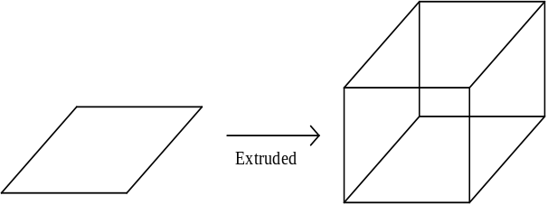

Extrude to Point
This item works in the same manner as Extrude, however the solid created is a projection of the selected polygon to a point, rather than to another polygon.

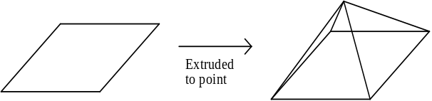

Check Polygons
As long as you are in Select Polygon mode, this item scans through the current shape level and checks for 'illegal' polygons. If any are found, the first is selected and a warning given. You should edit the offending polygon(s), delete the warning message then run the Check Polygons process again as a double-check. Alternatively, use Select Next/Last Polygon buttons (F1, F2) to edit the shapes and prevent any further errors.

Group
The Group menu items provide functions allowing you to create hierarchical group structures and perform transformations on the selected group.

Group
This option is highlighted when more than one group has been selected (see Multiple group selection), selecting group creates a single group which contains all the selected groups in itself. This grouping action can be performed on any group (including one which is itself composed of sub-groups).

Ungroup
This item is available when a single group which has sub-groups is selected, selecting Ungroup results in the selected group being separated into its component sub-groups.

Rotate
This item rotates the currently selected group about a single cardinal axis (X, Y, Z). Select the axis by clicking on the appropriate button in the dialog box. The rotation value of the group can be entered directly into the dialog box (0 - 360 degrees) or alternatively set using the slider. The lock button determines whether the rotated points are moved onto a grid or not (the default state of this button is set in the box). When 'Lock' is selected, all the points which have been rotated will be set on a fixed grid. By default this is the same size as the current editing grid - but it can be changed to any value (by editing the value in the lock value box). Caution: rotating a group onto a coarse grid will result in the distortion of the group!

Mirror
This item transforms all the points in the selected group, you must select the axis for the transformation, all the points in the group are then mirrored along that axis through the centre of the group.
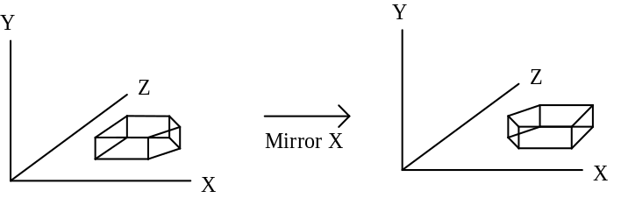

Scale
This item scales the selected group by a percentage. Selecting 200 scale doubles the size of the selected group, the centre of the group remains in the same place in the shape. You can scale the group about selected axis by setting up the axis you want in the scale dialog box, initially all axis are selected. Selecting LOCK TO GRID automatically locks every point in the group to a grid after it is scaled, initially on selecting lock in the dialog box the current grid size is shown next to the lock button, this can be edited.

Break Points
This item ensures that there are no shared points at spatially co-incident polygon vertices. When creating a group (either using the Group->Group menu option or when creating a solid) any points at the vertices of polygons which are in the same position in 3D space are automatically shared, so if you select a point at a joint polygon vertex and move it all the polygons with a point at that location will be changed, selecting Break Points will result in one point per polygon vertex, so you can change the positions of polygon vertices (points) individually.

Merge Points
This item is the inverse of Break Points.

Lock to Grid
This item moves all the points in the selected group so that they are on the current grid in 3D.

Shape
Structure
The structure dialog box shows the number of levels which the shape contains, the transition (or visible) distances between the levels and the number of polygons in each level. The first line shows the top level, which is the level which will be seen from farthest away in the simulation. The following lines are more detailed and show as you get progressively nearer (more detailed levels). Selecting a level in the dialog box with the mouse and clicking on the OK button selects that level as the current level being edited.

Visible Distance
This item opens a dialog box containing the viewing distance threshold for this level in the shape. The viewing distance threshold is the distance in meters at which the shape level will be shown in the Virtual World. The viewing distance of the top level shape determines how far the object (with the associated shape) will be from the viewer when it becomes visible, the visible distances for the levels below the top level govern the transition from showing the level above the current level to showing the current level.

Select Parent
This item selects the parent of the current shape level.

Select Child
This item selects the child of the current shape level.

New Child
This item creates a new child for the current shape level, if a child already exists for the current level the new shape level is inserted between the current level and its current child. The new shape level is selected.

Delete level
This item deletes the currently selected level. But this function does not apply when there is only one level in the shape. Beware, this operation cannot be UNDONE.

Grid
This item specifies the size (in square Meters) of the boxes which appear in the grid and gives the following options:

10 Meters
1 Meters
0.1 Meters

Other
This item opens a dialog box which allows you to enter the size of the new grid in Meters. The maximum size permitted is 99 meters.

Help
This item opens the Windows help.

Key Functions
(access via the keyboard only)

CURSOR keys
(up/down/left/right)
The cursor keys rotate the view of the shape.

DELETE key
Will delete the currently selected group or polygon (depending on tool selected).

TAB or F1
Will select next group or polygon in shape (but an existing selection
must be made).

F2
Will select last group/polygon in shape.

F3, F4
Move up, down level.

