22B4232
Sarvadnya Nandkumar Purkar
Assignment 1
Note :-
The implementation of all the parts including the bonus part is done and is submitted in the zipped folder.
Both the word transcription and phenome transcription is present in the same Text grid file
The audio recordings required are also submitted, along with the plots.

P1)
Here we need to record 5 sentences from the Harvard sentences collection. I am choosing 2, 3, 4, 5, 6 sentences from H1
- Glue the sheet to the dark blue background.
- It’s easy to tell the depth of a well.
- These days a chicken leg is a rare dish.
- Rice is often served in round bowls.
- The juice of lemons makes fine punch.

The SNR is more than 50.

Specifications :-
(taken from praat)
Object id: 1
Associated file: D:\Sarvadnya\IITB_NEW\Semester_8\speech_processing\A1-22B4232\audioA1.wav
Object type: Sound
Object name: audioA1
Date: Fri Feb 6 01:09:24 2026

Number of channels: 1 (mono)
Time domain:
Start time: 0 seconds
End time: 17.60075 seconds
Total duration: 17.60075 seconds
Time sampling:
Number of samples: 281612
Sampling period: 6.25e-05 seconds
Sampling frequency: 16000 Hz
First sample centred at: 3.125e-05 seconds
Amplitude:
Minimum: -0.927947998 Pascal
Maximum: 0.999969482 Pascal
Mean: -3.96917508e-06 Pascal
Root-mean-square: 0.151720144 Pascal
Total energy: 0.405151701 Pascal² sec (energy in air: 0.00101287925 Joule/m²)
Mean power (intensity) in air: 5.75475052e-05 Watt/m² = 77.6 dB
Standard deviation in channel 1: 0.151720413 Pascal

Software: Native phone voice recorder app (later exported as WAV and imported into Praat).
Bit depth: 16-bit PCM
Microphone type: Built-in smartphone microphone.
Recording environment: Quiet room at home, minimal background noise, phone held ~15–20 cm from mouth.

P2
(a)
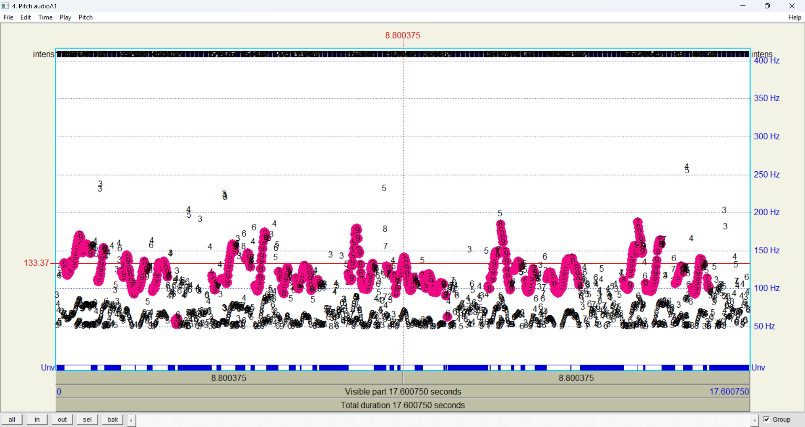
Pitch as a function of time
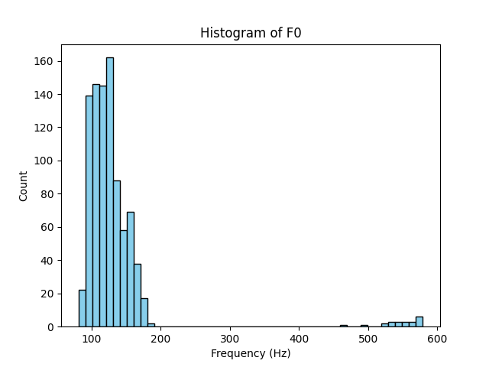
The pitch contour (F0) was extracted using Praat and plotted as a function of time. The average fundamental frequency over the entire recording was found to be 133.18 Hz. A histogram of F0 values shows that most pitch values lie between approximately 100 Hz and 180 Hz, which is typical for normal speech. A small number of higher-frequency outliers were observed due to pitch estimation errors in unvoiced or transitional regions.
(b)
Vowel | F1​ (Hz) | F2​ (Hz) | F3​ (Hz)
A | 714.32 | 1089.15 | 2510.44
E | 492.08 | 1894.62 | 2431.18
I | 291.55 | 2245.8 | 3012.03
O | 538.21 | 912.44 | 2390.55
U | 335.67 | 842.33 | 2215.12

Formant trajectories were extracted using Praat. Vowel segments were identified using the phoneme-level transcription created in P1. For each vowel segment, the average frequencies of the first (F1) and second (F2) formants were computed using the Burg method.
The F1–F2 scatter plot shows a clear vowel triangle. The vowel /i/ appears at low F1 and high F2, vowel /a/ at high F1 and moderate F2, and vowel /u/ at low values of both F1 and F2, which is consistent with the expected articulatory vowel space.

P3
In this question implementation of all the 4 parts is done including the 2 bonus questions, as an answer to part b, the sound doesnot look like I am speaking it, it maybe because we are using the information of only the first 3 formants but if we use the information of further formants then it may sound like my voice.
Q = 6.97
F0 (pitch) = 133.17 Hz

=== Vowel /i/ ===
F1 = 291.55 Hz, B1 = 41.83 Hz
F2 = 2245.80 Hz, B2 = 322.25 Hz
F3 = 3012.03 Hz, B3 = 432.20 Hz
r1 = 0.9677, theta1 = 0.2290
r2 = 0.7764, theta2 = 1.7638
r3 = 0.7122, theta3 = 2.3656

=== Vowel /u/ ===
F1 = 335.67 Hz, B1 = 48.17 Hz
F2 = 842.33 Hz, B2 = 120.87 Hz
F3 = 2215.12 Hz, B3 = 317.85 Hz
r1 = 0.9629, theta1 = 0.2636
r2 = 0.9094, theta2 = 0.6616
r3 = 0.7791, theta3 = 1.7398

=== Vowel /a/ ===
F1 = 714.32 Hz, B1 = 102.50 Hz
F2 = 1089.15 Hz, B2 = 156.28 Hz
F3 = 2510.44 Hz, B3 = 360.23 Hz
r1 = 0.9227, theta1 = 0.5610
r2 = 0.8845, theta2 = 0.8554
r3 = 0.7536, theta3 = 1.9717
