AI Health Assistant - Project Report
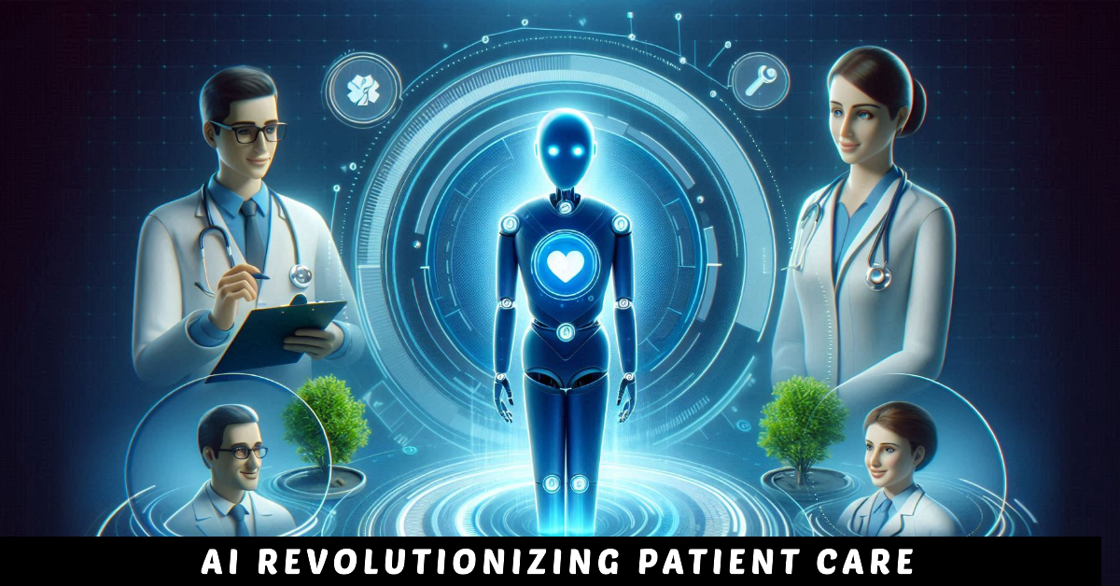
NAME – Sarvagya gupta
Registration No – 25BAI10038

1. Introduction
The AI Health Assistant is a machine learning-based desktop application designed to predict possible diseases based on user-provided symptoms. It integrates Natural Language Processing (NLP), a Random Forest model, and a graphical user interface (GUI) to provide an interactive healthcare assistance tool.

2. Objective

The main objective of this project is to demonstrate how artificial intelligence can be used in healthcare to provide preliminary insights based on symptoms. The system aims to assist users by suggesting possible diseases and recommending basic precautions.

3. Methodology
The project follows a structured pipeline:
• Data Collection: A dataset of symptoms and diseases is created manually.
• Data Preprocessing: Text cleaning techniques such as lowercasing and removal of special characters are applied.
• Feature Extraction: TF-IDF vectorization is used to convert text into numerical features.
• Model Training: A Random Forest classifier is trained on the dataset.
• Prediction: The model predicts probabilities for diseases based on user input.
• User Interface: A GUI built using Tkinter allows user interaction.

4. Features
• Symptom-based disease prediction
• Voice input using speech recognition
• Top 3 disease predictions with probabilities
• Precaution suggestions
• Simple and user-friendly GUI

5. Applications in Real Life
This system can be useful in several real-life scenarios:
• Preliminary health assessment before consulting a doctor
• Healthcare awareness in rural or remote areas
• Educational tool for learning about AI in healthcare
• Assistance for basic symptom analysis at home

6. Advantages
• Easy to use
• Fast predictions
• Integrates multiple technologies (ML, NLP, GUI, Voice)
• Provides immediate feedback

7. Limitations
• Uses a small dataset
• Not medically certified
• Predictions may not always be accurate
• Cannot replace professional medical advice

8. Future Improvements
• Use larger and real medical datasets
• Implement deep learning models
• Deploy as a web or mobile application
• Add multilingual support
• Improve UI/UX design
• Integrate with real healthcare APIs

9. Conclusion
The AI Health Assistant demonstrates the potential of machine learning in healthcare. Although it is a basic prototype, it effectively showcases how AI can assist in early-stage health analysis and user interaction. With further improvements, it can evolve into a more powerful and reliable system.

