Lab - 4

Q1: Ring Communication
Processes | Time (s) | Speedup | Efficiency | Comm %
1 | 0.000010 | 1.00 | 100.00% | 97.01%
2 | 0.000031 | 0.32 | 16.13% | 73.38%
4 | 0.004352 | 0.00 | 0.06% | 99.36%
8 | 0.000009 | 1.11 | 13.89% | 97.05%

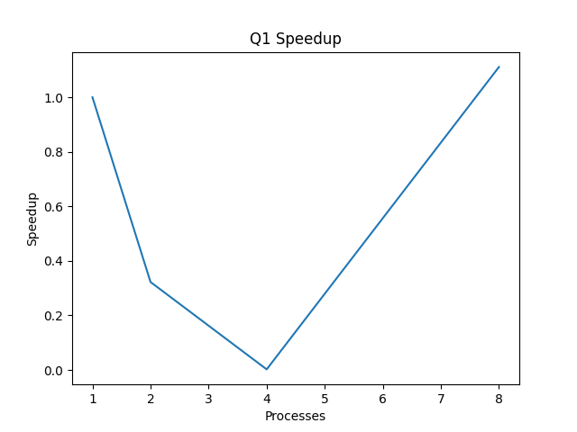

Conclusion
The ring communication experiment demonstrates extremely poor scalability due to its inherently sequential communication pattern. Communication overhead dominates execution time, remaining above 97% for most runs and peaking at 99.36% at 4 processes. The drastic execution time spike at p = 4 (0.004352 s compared to 0.000010 s at p = 1) indicates significant synchronization and latency amplification, likely due to message serialization and scheduling effects. Since only one message circulates in the ring at a time, the program lacks true parallelism, making additional processes ineffective. The workload is overwhelmingly communication-bound, and increasing process count does not yield consistent or meaningful speedup.

Q2: Parallel Array Sum
Processes | Time (s) | Speedup | Efficiency | Comm %
1 | 0.000005 | 1.00 | 100.00% | 80.52%
2 | 0.000019 | 0.26 | 13.16% | 88.50%
4 | 0.000050 | 0.10 | 2.50% | 95.21%
8 | 0.002977 | 0.00 | 0.02% | 90.92%

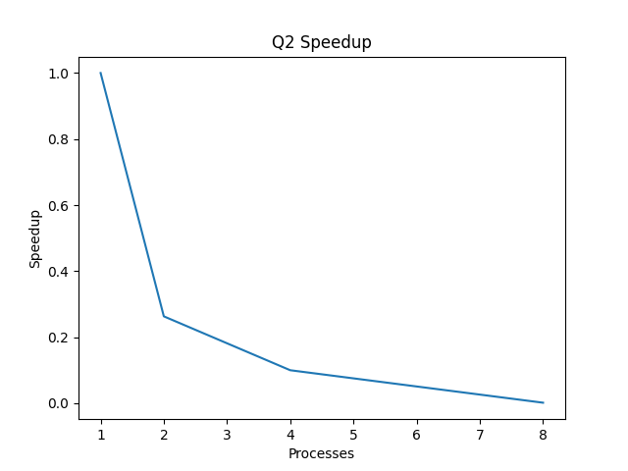

Conclusion
The parallel array sum experiment shows limited scalability due to increasing communication overhead from collective operations (MPI_Scatter and MPI_Reduce). While execution time is small at lower process counts, a significant degradation occurs at p = 8 (0.002977 s compared to 0.000005 s at p = 1), indicating strong communication dominance. Communication percentage steadily rises, reaching above 95%, which confirms that the computational workload per process is too small to offset parallel overhead. The results suggest that the problem size is insufficient for effective parallel scaling, and optimal performance lies at lower process counts.

Q3: Global Maximum and Minimum
Processes | Time (s) | Speedup | Efficiency | Comm %
1 | 0.000005 | 1.00 | 100.00% | 78.20%
2 | 0.000037 | 0.14 | 6.76% | 94.01%
4 | 0.000067 | 0.07 | 1.87% | 95.40%
8 | 0.000918 | 0.01 | 0.07% | 99.20%

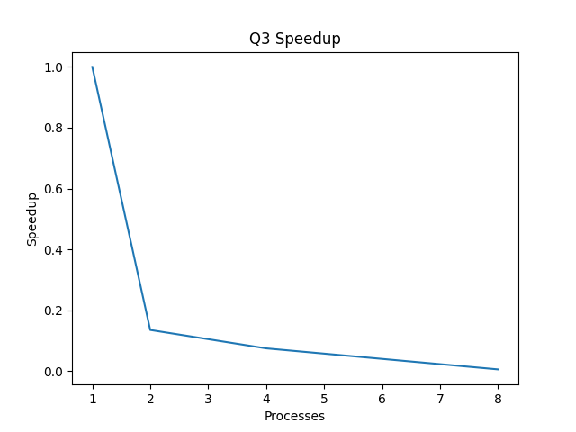

Detailed Conclusion
The reduction-based maximum/minimum experiment exhibits increasing communication overhead with higher process counts, reaching 99.20% at 8 processes. Execution time increases as processes increase, demonstrating negative scaling. Since each process handles only 10 random numbers, computation is negligible compared to collective reduction cost. The dominance of communication confirms that this workload is strongly communication-bound, and parallelization does not improve performance for such a small data size. Effective scalability would require substantially larger local workloads per process.

Q4: Parallel Dot Product
Processes | Time (s) | Speedup | Efficiency | Comm %
1 | 0.000006 | 1.00 | 100.00% | 89.13%
2 | 0.000023 | 0.26 | 13.04% | 91.39%
4 | 0.000045 | 0.13 | 3.33% | 95.52%
8 | 0.000071 | 0.08 | 1.06% | 97.34%

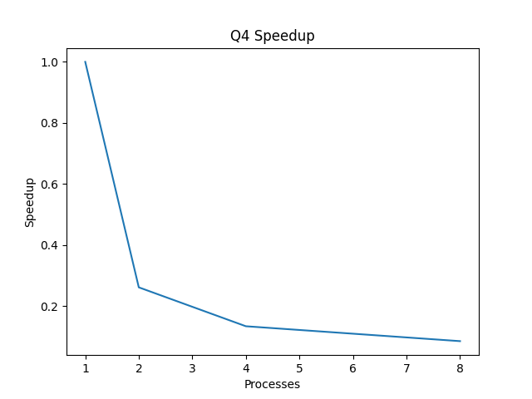

Conclusion
The parallel dot product experiment also demonstrates communication-dominated behavior. Execution time increases progressively from 0.000006 s (p = 1) to 0.000071 s (p = 8), indicating negative scaling. Communication percentage rises from 89.13% to 97.34%, confirming that collective operations overshadow the minimal computation involved in processing only eight vector elements. The results clearly show that parallel overhead exceeds computational gain, making the program inefficient at higher process counts. Scalability would improve only if the vector size were significantly increased to raise the computation-to-communication ratio.

