CUDA Assignment Report

Problem 1: Different Tasks Execution
Objective: Execute different tasks using different threads within a single block.
Task A (Iterative Sum by Thread 0): 524800
Task B (Formula Sum by Thread 1): 524800

Conclusion
The successful execution of this program demonstrates the fundamental flexibility of CUDA's thread hierarchy. By assigning distinct operations to individual threads based on their unique thread index (threadIdx.x), we can branch execution logic within a single warp. Thread 0 seamlessly computed the iterative loop while Thread 1 simultaneously evaluated the closed-form mathematical expression. Both yielded the exact same result of 524,800. This confirms that heterogeneous tasks can be successfully orchestrated across different threads within the same kernel launch without data corruption or synchronization issues, effectively leveraging parallel architecture for independent tasks.

Problem 2: Merge Sort Performance
Objective: Compare CPU pipelined merge sort against GPU parallel merge sort (Array size n=1000).
Implementation | Array Size (N) | Time Taken (ms) | Speedup
CPU (OpenMP) | 1000 | 2.22 ms | -
GPU (CUDA) | 1000 | 0.73 ms | 3.03x

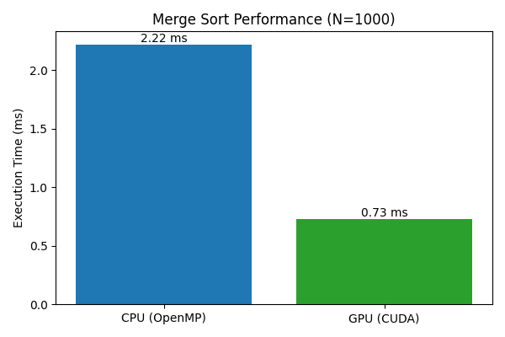

Conclusion
The comparative analysis between the CPU pipelined merge sort and the GPU CUDA-based parallel merge sort reveals a distinct performance advantage for the GPU, even at a relatively small array size of 1,000 elements. The GPU achieved an execution time of 0.73 ms compared to the CPU's 2.22 ms, resulting in a substantial 3.03x speedup. This demonstrates that despite the overhead associated with launching kernels and transferring data between the host and device memory, the highly parallel nature of the CUDA architecture is vastly superior for data-parallel sorting workloads compared to task-based CPU multithreading.

Problem 3: Memory Bandwidth Profiling
Objective: Implement vector addition, profile execution, and compare theoretical vs. measured bandwidth.
Metric | Value
Kernel Execution Time | 0.340 ms
Theoretical Bandwidth | 112.01 GB/s
Measured Bandwidth | 35.25 GB/s
Memory Utilization Efficiency | 31.4%

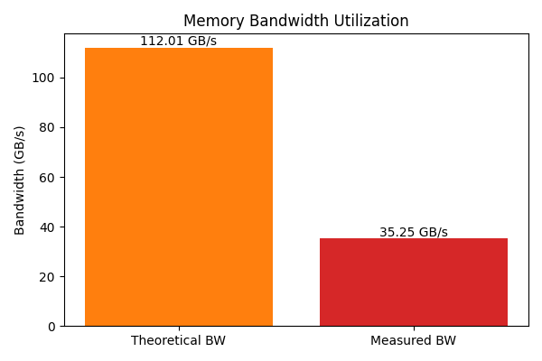

Conclusion
The memory bandwidth profiling of the vector addition kernel provides critical insight into the memory subsystem's efficiency. While the hardware offers a theoretical peak bandwidth of 112.01 GB/s, the measured effective bandwidth during the kernel's execution was 35.25 GB/s. This results in a memory utilization efficiency of approximately 31.4%. This gap between theoretical and measured performance is expected for non-optimized memory access patterns and highlights the overhead of latency, suboptimal coalescing, and pipeline stalls. It clearly underscores the necessity for advanced memory optimization techniques to fully saturate the GPU's memory bus.

