Lab Assignment-3

Correlation Matrix (1000 x 1000)

Metric
Metric | Observation | Impact on Efficiency
Utilization | Increased up to 8 threads, reduced at 16 threads | Oversubscription at 16 threads reduces effective utilization.
CPI | Increased from 0.331 (2T) to 0.360 (16T) | Higher contention and scheduling overhead at higher thread counts.
Time (Elapsed) | Decreased from 0.514 s to 0.120 s | Parallelization significantly reduces execution time.
Page Faults | ~1992 (Seq) to ~2074 (Par at 16T) | Small increase; memory footprint remains stable.

Threads vs Performance
Threads (N) | Execution Time (s) | Speedup (S) | Efficiency (E=S/N)
1 | 0.514 | 1.0 | 100%
2 | 0.392 | 1.31 | 65.5%
4 | 0.208 | 2.43 | 60.8%
8 | 0.132 | 3.91 | 48.86%
16 | 0.12 | 4.28 | 26.77%

Speedup vs Threads Graph
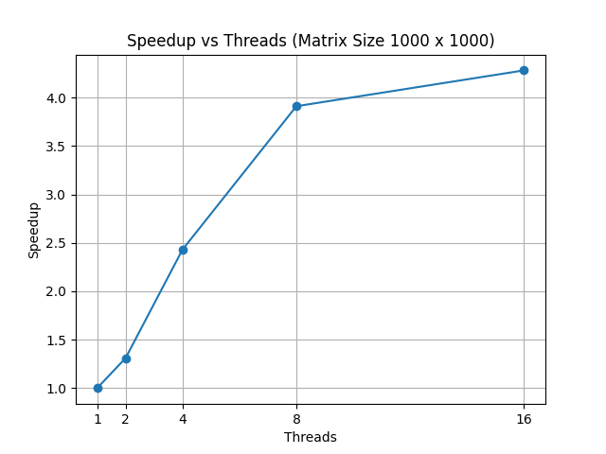

Conclusion
From the experimental results, it is evident that parallelizing the correlation matrix computation significantly improves performance as the number of threads increases. Execution time reduces from 0.514 seconds in the sequential case to 0.120 seconds at 16 threads, achieving a maximum speedup of approximately 4.28×.
However, scaling is not linear. Efficiency decreases from 100% at 1 thread to 26.7% at 16 threads. The best balance between speedup and efficiency is observed between 4 and 8 threads. Beyond this range, additional threads provide diminishing returns.
At 16 threads, the system has only 12 logical CPUs, resulting in thread oversubscription. This leads to increased scheduling overhead, context switching, and resource contention, which explains the drop in CPU utilization and efficiency.
The CPI slightly increases to 0.360 at 16 threads, indicating additional contention in shared resources such as cache and memory bandwidth. L3 cache misses also increase compared to lower thread counts, showing higher cache pressure.
Page faults increase marginally from approximately 1992 to 2074, confirming that the workload remains largely compute-bound and does not introduce significant memory pressure.
Overall, the correlation matrix kernel demonstrates good scalability up to 8 threads. Beyond this point, hardware limitations, OpenMP overhead, cache contention, and Amdahl’s Law limit further performance gains. Therefore, the optimal performance range for this system lies between 4 and 8 threads.

