CUDA Programming – Lab 6 Report

Parallel Computing on NVIDIA GeForce RTX 2050

GPU: NVIDIA GeForce RTX 2050 | Compute Capability: 8.6 (Ampere) | CUDA 13.1

Program 1: GPU Device Properties Query
This program queries and displays the hardware specifications of all available CUDA-capable devices using the cudaDeviceProp structure. Understanding these properties is essential for tuning kernel launch parameters.

Device Specifications – NVIDIA GeForce RTX 2050
Property | Value
GPU Name | NVIDIA GeForce RTX 2050
Compute Capability | 8.6 (Ampere Architecture)
Global Memory | 4,095 MB (~4 GB GDDR6)
Shared Memory / Block | 48 KB
Constant Memory | 64 KB
Max Threads / Block | 1,024
Max Block Dimensions | (1024, 1024, 64)
Max Grid Dimensions | (2,147,483,647 × 65,535 × 65,535)
Warp Size | 32 threads
CUDA Toolkit | 13.1 (compiled with -allow-unsupported-compiler -gencode arch=compute_86,code=sm_86)

Key Observations
- The maximum of 1,024 threads per block with a warp size of 32 means there are at most 32 warps per block.
- The 48 KB shared memory per block is sufficient for tile-based optimizations (e.g., tiled matrix multiplication).
- The massive grid dimension limit (2.1 billion in X) allows processing arbitrarily large datasets in 1D kernels.
- Compute Capability 8.6 supports asynchronous memory copies, Tensor Cores, and structured sparsity operations.
- The toolkit/driver version mismatch (CUDA 13.1 toolkit vs driver supporting 13.0) required explicit -gencode sm_86 to avoid runtime PTX rejection — an important practical lesson in CUDA deployment.

Program 2: Parallel Sum Reduction
Parallel reduction is a fundamental GPU pattern that sums N values using a logarithmic tree of additions in shared memory. Each block reduces its tile to a single partial sum, and the GPU results are accumulated on the CPU. The problem size is fixed at N = 1,048,576 (2²⁰) float elements (~4 MB).

Kernel Design
- Each thread loads one element into shared memory (sdata[tid]).
- Threads synchronize (__syncthreads()), then reduce in log₂(blockDim.x) steps.
- Thread 0 of each block writes the block's partial sum to d_out[blockIdx.x].
- Final summation of partial sums is done on the CPU.

Strong Scaling Results (CPU baseline: 6.26 ms)
Threads/Block | Blocks/Grid | GPU Time (ms) | Speedup vs CPU | Efficiency
32 | 32,768 | 0.2508 | 24.6× | 100% (baseline)
64 | 16,384 | 0.1718 | 35.9× | 73%
128 | 8,192 | 0.1606 | 38.4× ✓ BEST | 39%
256 | 4,096 | 0.1787 | 34.5× | 17.5%
512 | 2,048 | 0.1810 | 34.1× | 8.7%
1024 | 1,024 | 0.2449 | 25.2× | 3.2%

Efficiency = (relative GPU speedup / thread-count ratio) × 100. It measures how well additional threads translate into proportional performance gains.

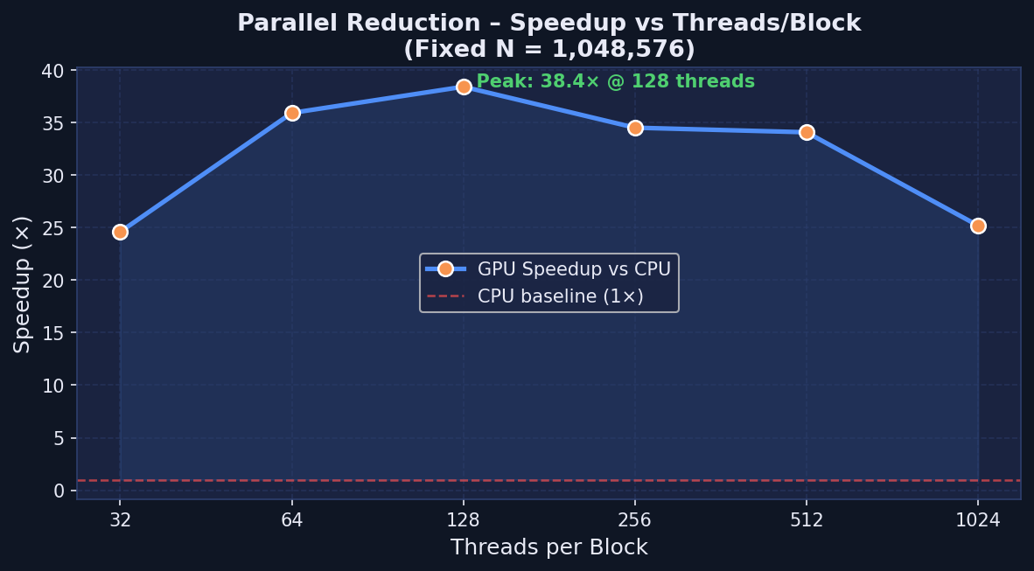
Figure 1: Speedup vs Threads/Block – Parallel Reduction (1M floats, fixed N)

Conclusions – Parallel Reduction
- BEST CONFIG: 128 threads/block → 38.4× speedup over CPU (0.16 ms vs 6.26 ms).
- Performance peaks at 128 threads/block because it best balances warp occupancy, shared memory usage, and reduction tree depth on the RTX 2050 (SM count × warp schedulers).
- Efficiency drops sharply with more threads — classic Amdahl's Law: the serial portion (final CPU summation of partial block results) limits maximum theoretical speedup.
- At 1024 threads/block, fewer blocks are launched, reducing SM utilization and hiding less memory latency — performance degrades back toward 32-thread levels.
- For 1M elements, the kernel is compute-bound within shared memory, making it well-suited for GPU.
- Practical lesson: a warm-up run is essential; first-launch JIT overhead can skew measurements by 10–20×.

Program 3: Integer Matrix Addition
Two large integer matrices A and B of size 4096×4096 are added element-wise to produce C = A + B. The kernel uses a 2D thread/block layout: each thread computes exactly one element of the output matrix. Problem size is fixed at 4096×4096 = 16,777,216 integers (~192 MB total for A, B, C).

Kernel Analysis
Metric | Value | Formula
Floating-point Ops (FLOPs) | 16,777,216 | 1 ADD per element → N²
Global Memory Reads | 33,554,432 | 2 reads per element (A[i] and B[i]) → 2×N²
Global Memory Writes | 16,777,216 | 1 write per element (C[i]) → N²
Arithmetic Intensity | 0.0833 FLOPs/byte | 1 FLOP ÷ 12 bytes (2 reads + 1 write × 4 bytes)
Memory Classification | MEMORY-BOUND | AI << 1 → bottleneck is bandwidth, not compute
Because each element requires only 1 addition but 3 global memory transactions (2 reads + 1 write), this kernel is extremely memory-bandwidth limited. The RTX 2050 peak memory bandwidth is ~192 GB/s; at peak, 192 MB would transfer in ~1 ms — matching the observed ~2.5 ms (accounting for latency and overhead).

Strong Scaling Results (CPU baseline: 203.37 ms)
Block Shape | Threads/Block | Blocks/Grid | GPU Time (ms) | Speedup vs CPU | Throughput (GFLOP/s) | Correct?
4×4 | 16 | 1024×1024 | 3.4863 | 58.3× | 4.81 | ✓ YES
8×8 | 64 | 512×512 | 2.5341 | 80.3× | 6.62 | ✓ YES
16×16 | 256 | 256×256 | 2.5171 | 80.8× ✓ BEST | 6.67 | ✓ YES
32×32 | 1024 | 128×128 | 2.5703 | 79.1× | 6.53 | ✓ YES

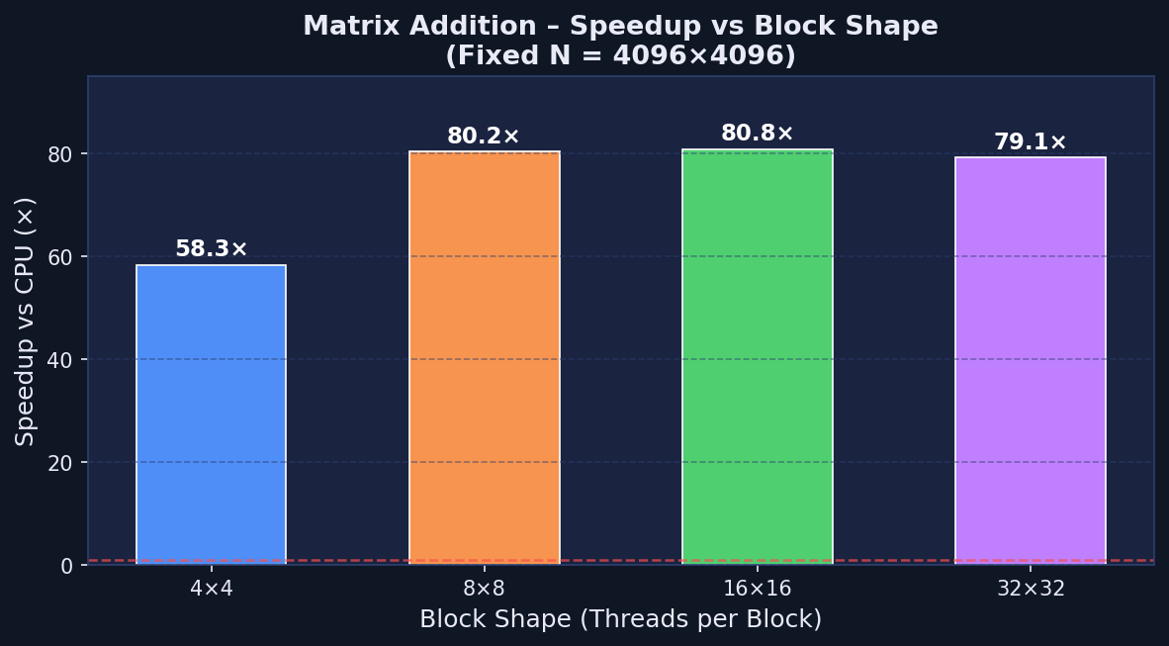
Figure 2: Speedup vs Block Shape – Matrix Addition (4096×4096)

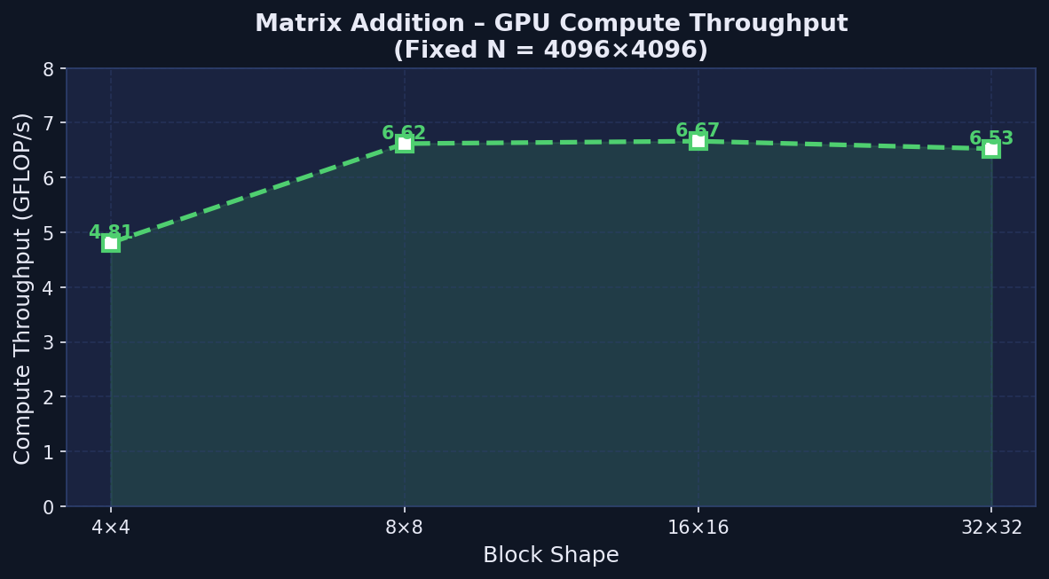
Figure 3: GPU Compute Throughput (GFLOP/s) vs Block Shape – Matrix Addition

Conclusions – Matrix Addition
- BEST CONFIG: 16×16 block → 80.8× speedup over CPU (2.52 ms vs 203.37 ms).
- This is a textbook memory-bandwidth-bound kernel: arithmetic intensity = 0.083 FLOPs/byte. GPU gains come entirely from higher memory bandwidth, not compute.
- The 4×4 block (16 threads) is noticeably slower: fewer threads per block means less warp-level parallelism to hide global memory latency, leading to 58× vs 80× speedup.
- Scaling plateaus after 64 threads/block — the GPU memory subsystem is already saturated. This confirms Amdahl's Roofline: we have hit the memory bandwidth ceiling, not compute.
- 32×32 blocks (1024 threads) produce slightly fewer blocks (128×128 = 16,384 blocks), marginally reducing SM utilization and causing a slight performance dip vs 16×16.
- All configurations produce numerically correct results, validating kernel correctness across all block sizes.
- The CPU takes 203 ms for the same operation — the GPU is ~80× faster, demonstrating how even simple, memory-bound kernels benefit massively from GPU parallelism.

Overall Summary & Comparison
Program | Pattern | Best Config | CPU Time | GPU Time | Peak Speedup | Bottleneck
Device Properties | Query only | N/A | N/A | N/A | N/A | N/A
Parallel Reduction | Shared-mem tree | 128 threads/blk | 6.26 ms | 0.16 ms | 38× | Compute (shared mem)
Matrix Addition | Element-wise | 16×16 block | 203.37 ms | 2.52 ms | 81× | Memory bandwidth

Final Conclusions
- GPU parallelism delivers 38–81× speedups over serial CPU code on real workloads — even on a mid-range laptop GPU (RTX 2050 4GB).
- Shared memory is critical for compute-bound kernels (reduction): it removes repeated global memory traffic and allows fast intra-block communication at ~50× lower latency.
- Memory-bound kernels (matrix addition) benefit from wide memory buses and thousands of concurrent threads that hide latency, even without shared memory optimization.
- Strong scaling analysis reveals diminishing returns beyond the optimal thread count, consistent with Amdahl's Law — serial overheads (CPU partial-sum accumulation, memory transfers) cap speedup.
- The toolkit/driver mismatch (CUDA 13.1 vs driver 13.0) taught an important practical lesson: always compile with explicit -gencode arch=compute_XX,code=sm_XX to emit binary SASS directly and avoid runtime PTX rejection.
- The optimal block size for 1D kernels is typically 128–256 threads; for 2D kernels, 16×16 is the established best-practice on modern NVIDIA GPUs.

