Lab assignment – 1
Q1. DAXPY Loop: D stands for Double precision, A is a scalar value, X
and Y are one-dimensional vectors of size 2^16 each, P stands for Plus.
The operation to be completed in one iteration is X[i] = a*X[i] + Y[i].
Your task is to compare the speedup (in execution time) gained by
increasing the number of threads. Start from a 2 thread implementation.
How many threads give the max speedup? What happens if no. of threads
are increased beyond this point? Why?
SOLN.>
Code:
#include <stdio.h>
#include <stdlib.h>
#include <omp.h>
#include <math.h>

#define VECTOR_SIZE (1 << 16)
#define MAX_THREADS 16
#define NUM_RUNS 100

void daxpy_parallel(double a, double *x, double *y, int num_threads) {
#pragma omp parallel for num_threads(num_threads)
for (int i = 0; i < VECTOR_SIZE; i++) {
x[i] = a * x[i] + y[i];
}
}

int main() {
double *x = (double *)malloc(VECTOR_SIZE * sizeof(double));
double *y = (double *)malloc(VECTOR_SIZE * sizeof(double));
double a = 2.0;

// Initialize vectors with some values
for (int i = 0; i < VECTOR_SIZE; i++) {
x[i] = (double)i;
y[i] = (double)(VECTOR_SIZE - i);
}

printf("Threads\tTime (ms)\tSpeedup\n");
printf("----------------------------------\n");

double base_time = 0;
double max_speedup = 0.0;
int best_thread_count = 1;

for (int t = 1; t <= MAX_THREADS; t++) {
double total_time = 0;

// Warm-up run
daxpy_parallel(a, x, y, t);

// Time the operation
for (int run = 0; run < NUM_RUNS; run++) {
double start = omp_get_wtime();
daxpy_parallel(a, x, y, t);
total_time += (omp_get_wtime() - start) * 1000; // Convert to milliseconds
}

double avg_time = total_time / NUM_RUNS;

if (t == 1) {
base_time = avg_time;
}

double speedup = base_time / avg_time;
printf("%d\t%.6f\t%.2f\n", t, avg_time, speedup);

if (speedup > max_speedup) {
max_speedup = speedup;
best_thread_count = t;
}
}

printf("\nMaximum speedup of %.2fx achieved with %d threads\n", max_speedup, best_thread_count);

free(x);
free(y);
return 0;
}

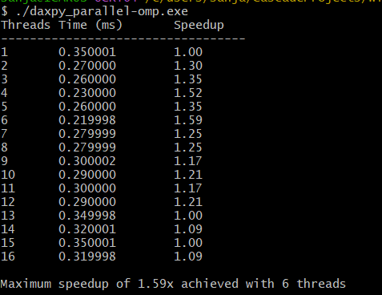
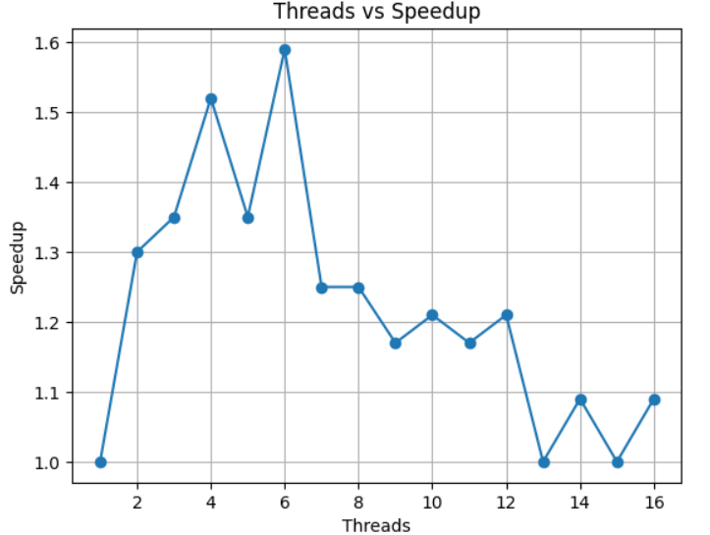
Conclusion:
In this program we have found out the optimal number of threads that give the maximum speedup which occurs at 6 number of threads also the operation on vector is performed multiple times and then averaged to obtain more accurate result. Here in the graph we can see that after optimal number of threads the speedup decreases and upto optimal it increases which
demonstrates that more threads do not always mean better performance.This happens due to the fact that as we increase the threads the thread management overhead increases, also DAXPY is memory-bound as in each iteration we have 2 reads + 1 write which is 24 bytes and has 1 multiplication +1 addition that’s 2FLOPs which makes 0.083 Flops per byte, hence performance also falls due to limited memory bandtwidth and context switching(threads>physical cores).

Q2. Matrix Multiply : Build a parallel implementation of multiplication
of large matrices (Eg. size could be 1000x1000). Repeat the experiment
from the previous question for this implementation. Think about how to
partition the work amongst the threads – which elements of the product
array will be calculated by each thread? Implement 2 version of parallel
implementation for given task. First, use 1D threading(i.e., make a
single loop run in parallel). Second, use 2D threading (i.e., use nested
looping to the most suitable loops to be parallelized).
Soln.>
Code:
#include <stdio.h>
#include <stdlib.h>
#include <omp.h>
#include <string.h>

#define SIZE 1000
#define RUNS 5
#define MAX_THREADS 32

double *A, *B, *C, *C_serial;

// Access matrix element: matrix[i][j] = matrix[i * SIZE + j]
#define MAT(matrix, i, j) (matrix[(i) * SIZE + (j)])

// Allocate contiguous 1D array for matrix
double* allocate_matrix() {
double *matrix = (double*)malloc(SIZE * SIZE * sizeof(double));
if (!matrix) {
fprintf(stderr, "Memory allocation failed!\n");
exit(1);
}
return matrix;
}

// Initialize matrices
void initialize_matrices() {
for (int i = 0; i < SIZE; i++) {
for (int j = 0; j < SIZE; j++) {
MAT(A, i, j) = (double)(i + j);
MAT(B, i, j) = (double)(i - j);
MAT(C, i, j) = 0.0;
}
}
}

// Reset result matrix
void reset_result() {
memset(C, 0, SIZE * SIZE * sizeof(double));
}

// Serial matrix multiplication (baseline)
double serial_matmul() {
double start = omp_get_wtime();

for (int i = 0; i < SIZE; i++) {
for (int j = 0; j < SIZE; j++) {
double sum = 0.0;
for (int k = 0; k < SIZE; k++) {
sum += MAT(A, i, k) * MAT(B, k, j);
}
MAT(C, i, j) = sum;
}
}

return omp_get_wtime() - start;
}

// 1D Parallel: Parallelize outer loop (row-wise partition)
double parallel_1d(int threads) {
omp_set_num_threads(threads);
double start = omp_get_wtime();

#pragma omp parallel for
for (int i = 0; i < SIZE; i++) {
for (int j = 0; j < SIZE; j++) {
double sum = 0.0;
for (int k = 0; k < SIZE; k++) {
sum += MAT(A, i, k) * MAT(B, k, j);
}
MAT(C, i, j) = sum;
}
}

return omp_get_wtime() - start;
}

// 2D Parallel: Parallelize both outer loops (2D block partition)
double parallel_2d(int threads) {
omp_set_num_threads(threads);
double start = omp_get_wtime();

#pragma omp parallel for collapse(2)
for (int i = 0; i < SIZE; i++) {
for (int j = 0; j < SIZE; j++) {
double sum = 0.0;
for (int k = 0; k < SIZE; k++) {
sum += MAT(A, i, k) * MAT(B, k, j);
}
MAT(C, i, j) = sum;
}
}

return omp_get_wtime() - start;
}

// Verify correctness by comparing a few elements
int verify_result(double *expected, double *result) {
for (int i = 0; i < SIZE; i += SIZE/10) {
for (int j = 0; j < SIZE; j += SIZE/10) {
double diff = MAT(expected, i, j) - MAT(result, i, j);
if (diff < 0) diff = -diff;
if (diff > 1e-6) {
printf("Mismatch at [%d][%d]: expected %.2f, got %.2f\n",
i, j, MAT(expected, i, j), MAT(result, i, j));
return 0;
}
}
}
return 1;
}

void print_separator() {
printf("================================================================\n");
}

int main() {
printf("\nAllocating matrices...\n");

// Allocate matrices with error checking
A = allocate_matrix();
B = allocate_matrix();
C = allocate_matrix();
C_serial = allocate_matrix();

printf("Matrices allocated successfully.\n");
printf("Total memory allocated: %.2f MB\n\n",
(4.0 * SIZE * SIZE * sizeof(double)) / (1024.0 * 1024.0));

initialize_matrices();

print_separator();
printf("PARALLEL MATRIX MULTIPLICATION ANALYSIS\n");
print_separator();
printf("Matrix size: %dx%d\n", SIZE, SIZE);
printf("Total elements: %d\n", SIZE * SIZE);
printf("Operations per multiplication: %ld FLOPS\n", (long)2 * SIZE * SIZE * SIZE);
printf("Memory per matrix: %.2f MB\n", (SIZE * SIZE * sizeof(double)) / (1024.0 * 1024.0));
printf("Runs per configuration: %d\n", RUNS);
printf("Max threads to test: %d\n", MAX_THREADS);
printf("Available threads: %d\n", omp_get_max_threads());
print_separator();

// Run serial version for baseline
printf("\nRunning serial version...\n");
double serial_time = 0;
for (int run = 0; run < RUNS; run++) {
printf(" Run %d/%d...\r", run + 1, RUNS);
fflush(stdout);
reset_result();
serial_time += serial_matmul();
}
serial_time /= RUNS;

// Save serial result for verification
memcpy(C_serial, C, SIZE * SIZE * sizeof(double));

printf("\nSerial execution time: %.4f seconds\n", serial_time);
printf("Performance: %.2f GFLOPS\n\n", (2.0 * SIZE * SIZE * SIZE) / (serial_time * 1e9));

print_separator();
printf("1D PARALLEL IMPLEMENTATION (Row-wise partitioning)\n");
print_separator();
printf("Strategy: Each thread processes complete rows\n");
printf("Work distribution: Row i assigned to thread (i %% num_threads)\n");
printf("\nThreads\tTime (s)\tSpeedup\t\tEfficiency\tGFLOPS\n");
printf("-------\t--------\t-------\t\t----------\t------\n");

double max_speedup_1d = 0;
int optimal_threads_1d = 1;

for (int t = 1; t <= MAX_THREADS; t++) {
double total_time = 0;

for (int run = 0; run < RUNS; run++) {
reset_result();
total_time += parallel_1d(t);
}

double avg_time = total_time / RUNS;
double speedup = serial_time / avg_time;
double efficiency = (speedup / t) * 100;
double gflops = (2.0 * SIZE * SIZE * SIZE) / (avg_time * 1e9);

if (speedup > max_speedup_1d) {
max_speedup_1d = speedup;
optimal_threads_1d = t;
}

// Verify correctness
if (t == 2 || t == MAX_THREADS) {
if (!verify_result(C_serial, C)) {
printf("WARNING: Result verification failed for %d threads!\n", t);
}
}

printf("%d\t%.4f\t\t%.2fx\t\t%.2f%%\t\t%.2f\n",
t, avg_time, speedup, efficiency, gflops);
}

printf("\n");
print_separator();
printf("2D PARALLEL IMPLEMENTATION (2D block partitioning)\n");
print_separator();
printf("Strategy: Both i and j loops parallelized with collapse(2)\n");
printf("Work distribution: 2D grid of blocks distributed among threads\n");
printf("Advantage: Better load balancing, more parallelism opportunities\n");
printf("\nThreads\tTime (s)\tSpeedup\t\tEfficiency\tGFLOPS\n");
printf("-------\t--------\t-------\t\t----------\t------\n");

double max_speedup_2d = 0;
int optimal_threads_2d = 1;

for (int t = 1; t <= MAX_THREADS; t++) {
double total_time = 0;

for (int run = 0; run < RUNS; run++) {
reset_result();
total_time += parallel_2d(t);
}

double avg_time = total_time / RUNS;
double speedup = serial_time / avg_time;
double efficiency = (speedup / t) * 100;
double gflops = (2.0 * SIZE * SIZE * SIZE) / (avg_time * 1e9);

if (speedup > max_speedup_2d) {
max_speedup_2d = speedup;
optimal_threads_2d = t;
}

// Verify correctness
if (t == 2 || t == MAX_THREADS) {
if (!verify_result(C_serial, C)) {
printf("WARNING: Result verification failed for %d threads!\n", t);
}
}

printf("%d\t%.4f\t\t%.2fx\t\t%.2f%%\t\t%.2f\n",
t, avg_time, speedup, efficiency, gflops);
}

printf("\n");
print_separator();
printf("PERFORMANCE COMPARISON\n");
print_separator();
printf("\n1D Implementation:\n");
printf(" Optimal threads: %d\n", optimal_threads_1d);
printf(" Maximum speedup: %.2fx\n", max_speedup_1d);

printf("\n2D Implementation:\n");
printf(" Optimal threads: %d\n", optimal_threads_2d);
printf(" Maximum speedup: %.2fx\n", max_speedup_2d);

if (max_speedup_2d > max_speedup_1d) {
printf("\n2D implementation is %.2fx faster than 1D at optimal settings\n",
max_speedup_2d / max_speedup_1d);
} else {
printf("\n1D implementation performs similarly or better (simpler overhead)\n");
}

free(A);
free(B);
free(C);
free(C_serial);

printf("Program completed successfully.\n");

return 0;
}
Outputs:
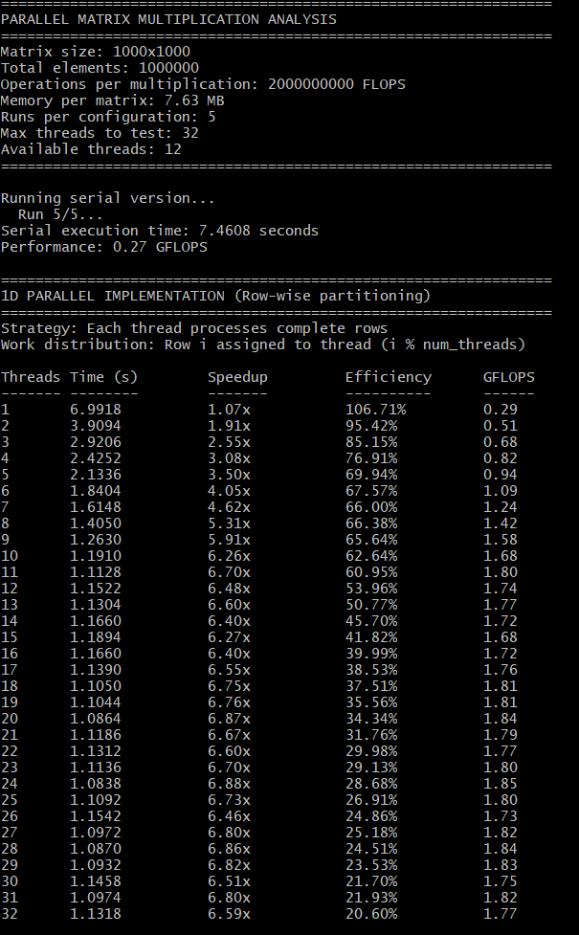

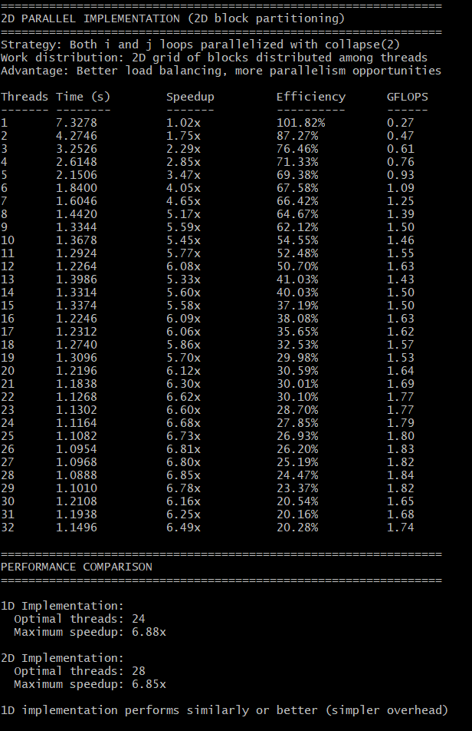

1D implementation
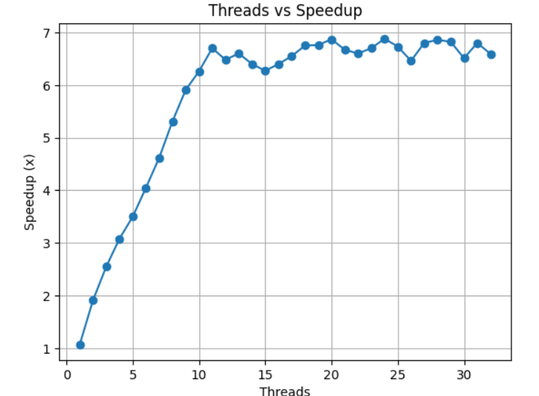
2D implementation
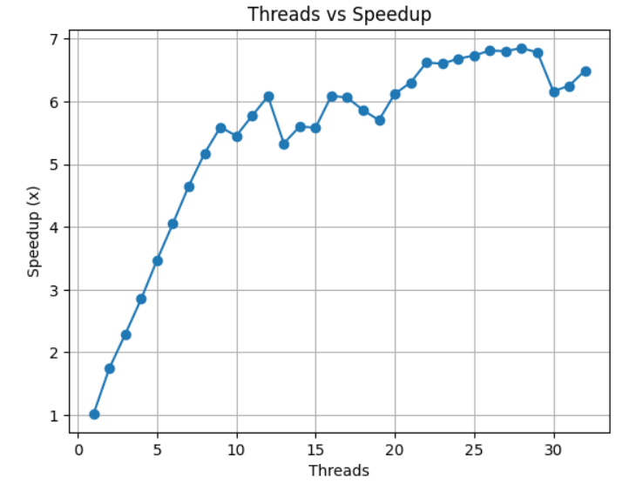
Conclusion:
Here we can observe from the graph that matrix multiplication shows better scalability than DAXPY, whose performance fell after reaching optimal number of threads. Here we had matrix multiplication of size 1000 * 1000 using both 1d(row-wise) and 2d(collapse(2)).This is highly compute-bound as it has 2N³ FLOPs, allowing to perform more work per memory access.From graphs we can see that after some point the speedup saturates this is because of things like limited physical cores(threads> cores) which causes threads to compete for same execution units(tested on 8 core system),memory bandwidth, synchronization overhead, cache capacity , and thread scheduling overhead.
Here 2D threading provides finer and more grainular task distribution and better theoretical load balancing (since it parallelizes the entire $N^{2}$iteration space, flattening the loop to size of N²), the experimental results on this system show that the 1D implementation performs similar to or better than 2D. This is mainly because 1D assigns complete rows to threads, which reduces OpenMP scheduling overhead and provides better cache locality, whereas 2D (collapse(2)) can introduce higher overhead and may increase cache contention as multiple threads update nearby elements of matrix C. 2D implementation would have had its advantages if matrix size was very large.

Q3. Calculation of π: This is the first example where many threads
will cooperate to calculate a computational value. The task of this
program will be arrive at an approximate value of π. The value of π is
given by the following integral:
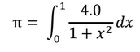
This can be approximated as the sum of the areas of rectangles under the
curve.
Soln.>
Code:
#include <stdio.h>
#include <stdlib.h>
#include <omp.h>
#include <math.h>

#define NUM_STEPS 100000000L // 100 million steps
#define MAX_THREADS 32
#define RUNS 3

double step;

// Serial version (baseline)
double calculate_pi_serial(long num_steps, double *pi_result) {
double sum = 0.0;
double x;
step = 1.0 / (double)num_steps;

double start = omp_get_wtime();

for (long i = 0; i < num_steps; i++) {
x = (i + 0.5) * step;
sum = sum + 4.0 / (1.0 + x * x);
}

*pi_result = step * sum;
return omp_get_wtime() - start;
}

// Parallel version: Private variables + Critical section once per thread
double calculate_pi_parallel(long num_steps, int num_threads, double *pi_result) {
double sum = 0.0;
step = 1.0 / (double)num_steps;

omp_set_num_threads(num_threads);
double start = omp_get_wtime();

#pragma omp parallel
{
double x;
double partial_sum = 0.0; // Private variable - each thread has its own

// Each thread processes its share of iterations independently
#pragma omp for
for (long i = 0; i < num_steps; i++) {
x = (i + 0.5) * step;
partial_sum = partial_sum + 4.0 / (1.0 + x * x);
}

// Critical section: only ONE thread at a time can add to global sum
// This happens only ONCE per thread (not per iteration!)
#pragma omp critical
{
sum = sum + partial_sum;
}
}

*pi_result = step * sum;
return omp_get_wtime() - start;
}

void print_separator() {
printf("================================================================\n");
}

int main() {
printf("\n");
print_separator();
printf("PARALLEL π CALCULATION - SPEEDUP ANALYSIS\n");
print_separator();
printf("Formula: π = ∫₀¹ 4/(1+x²) dx\n");
printf("Method: Riemann sum with private variables + critical section\n");
printf("Number of steps: %ld\n", NUM_STEPS);
printf("Actual value of π: %.15f\n", M_PI);
printf("Available threads: %d\n", omp_get_max_threads());
print_separator();

// Calculate serial baseline
printf("\nCalculating serial baseline...\n");
double serial_time = 0.0;
double pi_value;

for (int run = 0; run < RUNS; run++) {
serial_time += calculate_pi_serial(NUM_STEPS, &pi_value);
}
serial_time /= RUNS;

printf("Serial execution time: %.4f seconds\n", serial_time);
printf("Calculated π value: %.15f\n", pi_value);
printf("Error from actual π: %.2e\n\n", fabs(pi_value - M_PI));

print_separator();
printf("PARALLEL IMPLEMENTATION: PRIVATE + CRITICAL\n");
print_separator();
printf("\nThreads\tTime (s)\tSpeedup\t\tEfficiency\tπ Value\n");
printf("-------\t--------\t-------\t\t----------\t-------\n");

double max_speedup = 0.0;
int optimal_threads = 1;

// Test different thread counts
for (int t = 1; t <= MAX_THREADS; t++) {
double total_time = 0.0;
double pi_result = 0.0;

for (int run = 0; run < RUNS; run++) {
total_time += calculate_pi_parallel(NUM_STEPS, t, &pi_result);
}

double avg_time = total_time / RUNS;
double speedup = serial_time / avg_time;
double efficiency = (speedup / t) * 100.0;

if (speedup > max_speedup) {
max_speedup = speedup;
optimal_threads = t;
}

printf("%d\t%.4f\t\t%.2fx\t\t%.2f%%\t\t%.15f\n",
t, avg_time, speedup, efficiency, pi_result);
}

return 0;
}
Outputs:
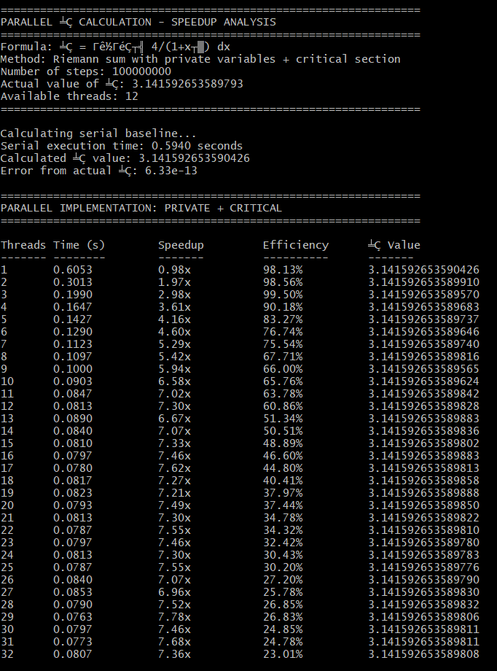
Graph:
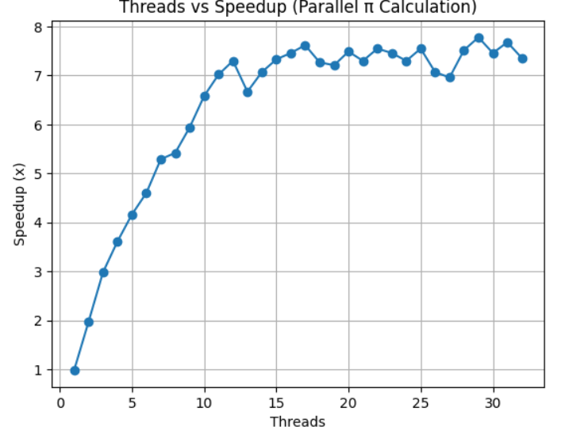

Conclusion:
Here we have used private variables by declaring them inside the parallel section meaning each thread will have its own copy of this variable then we have used critical section which basically puts a restriction that only one thread at a time can execute inside it making the combination ideal for handling race condition.The performance saturates after optimal due to thread management overhead, context switching(threads>cores) and cache contention.

