CODE :

**INDEX.html**

<!DOCTYPE html>

<html>

<head>

<title>Number Submission</title>

</head>

<body>

<h2>Enter Two Numbers</h2>

<form action="process.jsp" method="get">

<label for="num1">Number 1:</label>

<input type="text" id="num1" name="num1" required><br><br>

<label for="num2">Number 2:</label>

<input type="text" id="num2" name="num2" required><br><br>

<input type="submit" value="Submit">

</form>

</body>

</html>

**Process.jsp**

<%@ page language="java" contentType="text/html; charset=UTF-8" pageEncoding="UTF-8" %>

<!DOCTYPE html>

<html>

<head>

<title>Calculation Results</title>

</head>

<body>

<%

// Fetch user inputs

String num1Str = request.getParameter("num1");

String num2Str = request.getParameter("num2");

// Validate inputs

if (num1Str != null && num2Str != null) {

try {

int num1 = Integer.parseInt(num1Str);

int num2 = Integer.parseInt(num2Str);

// Perform calculations

int sum = addNumbers(num1, num2);

int difference = subtractNumbers(num1, num2);

int product = multiplyNumbers(num1, num2);

double quotient = divideNumbers(num1, num2);

%>

<h2>Results:</h2>

<p>Sum: <%= sum %></p>

<p>Difference: <%= difference %></p>

<p>Product: <%= product %></p>

<p>Quotient: <%= quotient %></p>

<%

} catch (NumberFormatException e) {

out.println("<p style='color:red;'>Invalid input. Please enter numeric values.</p>");

}

}

%>

<!-- Declare Methods Correctly -->

<%!

public int addNumbers(int a, int b) {

return a + b;

}

public int subtractNumbers(int a, int b) {

return a - b;

}

public int multiplyNumbers(int a, int b) {

return a * b;

}

public double divideNumbers(int a, int b) {

if (b == 0) {

return 0; // Handling division by zero

}

return (double) a / b;

}

%>

</body>

</html>

**OUTPUT :**

**GET method:**

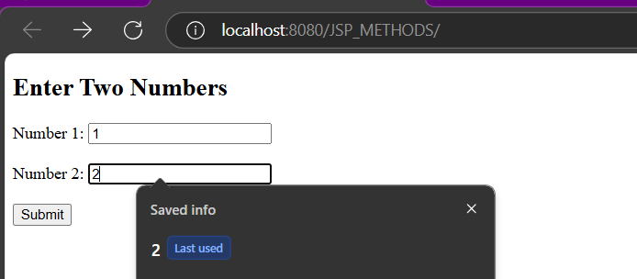

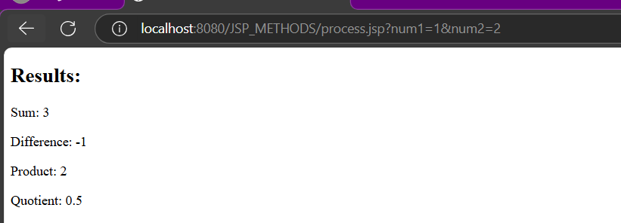

**POST Method**

