|  |  |  |
| --- | --- | --- |
| download | **Marwadi University Faculty of Technology**  **Department of Information and Communication Technology** | |
| **Subject: Advanced Java** | **Aim:** Develop JSP application to perform login - logout(session handling) using cookies, also include sendRedirect and RequestDispacher for forwarding. | |
| **Experiment :- 6** | **Date:- 10-03-2025** | **Enrollment No:- 92200133003** |

**Objective :** Develop JSP application to perform login - logout(session handling) using cookies, also include sendRedirect and RequestDispacher for forwarding.

**CODE:**

**Index.jsp**

<!DOCTYPE html>

<html>

<head><title>Login Page</title></head>

<body>

<h2>Login</h2>

<form method="post" action="login.jsp">

Username: <input type="text" name="username" required /><br>

Password: <input type="password" name="password" required /><br>

<input type="submit" value="Login" />

</form>

</body>

</html>

**Login.jsp**

<%@ page import="javax.servlet.http.*,javax.servlet.*" %>

<%

String user = request.getParameter("username");

String pass = request.getParameter("password");

if("prashant".equals(user) && "admin123".equals(pass)) {

session.setAttribute("user", user);

Cookie cookie = new Cookie("user", user);

cookie.setMaxAge(60*60); // 1 hour

response.addCookie(cookie);

**RequestDispatcher** rd = request.getRequestDispatcher("wc.jsp");

rd.forward(request, response);

} else {

response.**sendRedirect**("error.jsp");

}

%>

**Logout.jsp**

<%

session.invalidate();

Cookie[] cookies = request.getCookies();

if (cookies != null) {

for(Cookie c : cookies){

if(c.getName().equals("user")){

c.setMaxAge(0);

response.addCookie(c);

}

}

}

response.sendRedirect("login.jsp");

%>

**Welcome.jsp**

<%@ page import="javax.servlet.http.*,javax.servlet.*" %>

<%

// Don't redeclare session — it's already available

String user = (String)session.getAttribute("user");

if(user == null) {

response.sendRedirect("index.jsp");

return;

}

%>

<html>

<head><title>Welcome</title></head>

<body>

<h2>Welcome, <%= user %>!</h2>

<p><a href="logout.jsp">Logout</a></p>

</body>

</html>

**Error.jsp**

<html>

<head><title>Login Failed</title></head>

<body>

<h2>Invalid Credentials!</h2>

<a href="index.jsp">Try Again</a>

</body>

</html>

**OUTPUT**

**Without login**

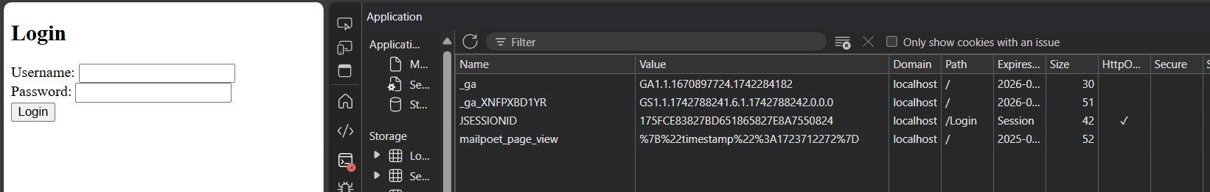

**Cookies Stored**

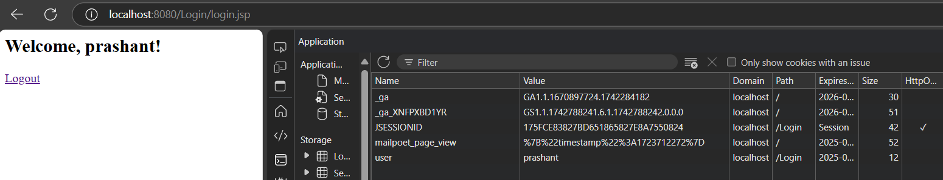

**Cookies Deleted**

