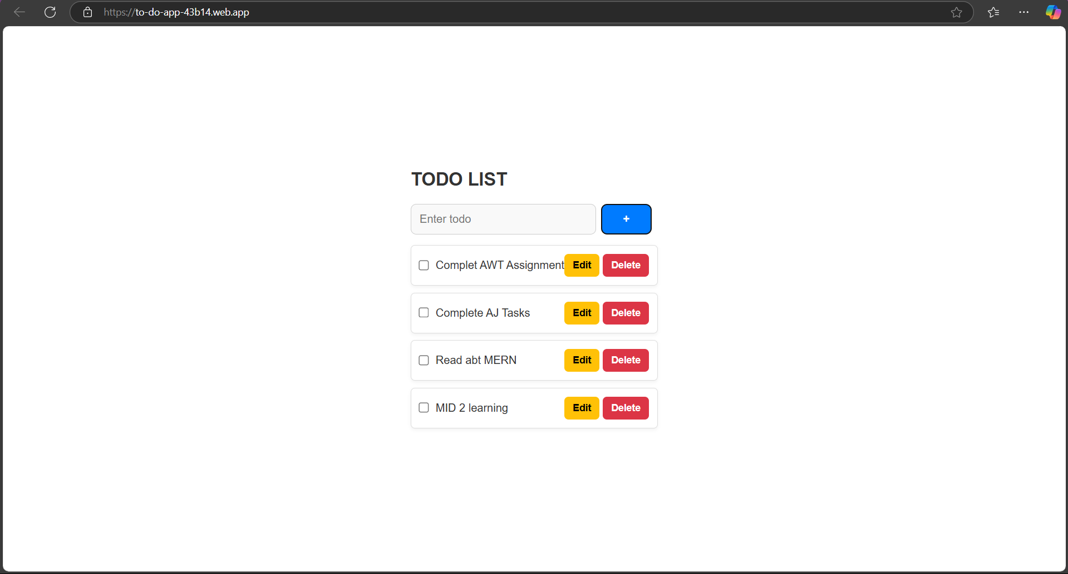

[Vite + React](https://to-do-app-43b14.web.app/)